**USER GUIDE**

1. **Import library**

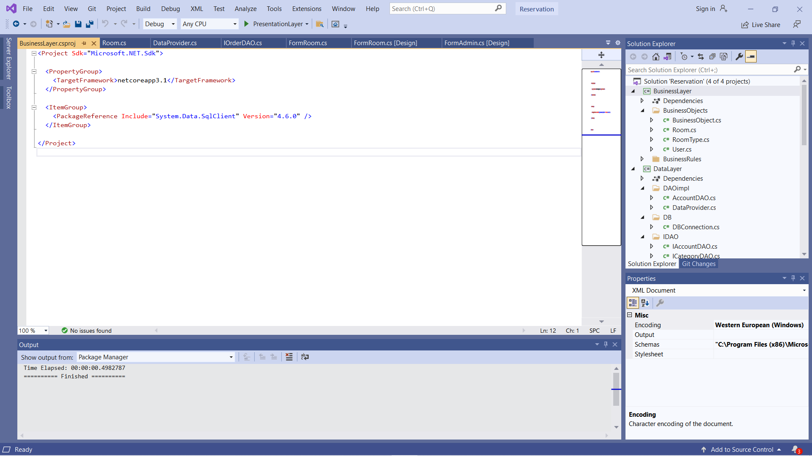

**-** To use this application, developer must import library “System.Data.SqlClient”

1. **Use the function**

**2.1/ Login**

**2.1.1/ Customer**

**2.1.2/ Admin**

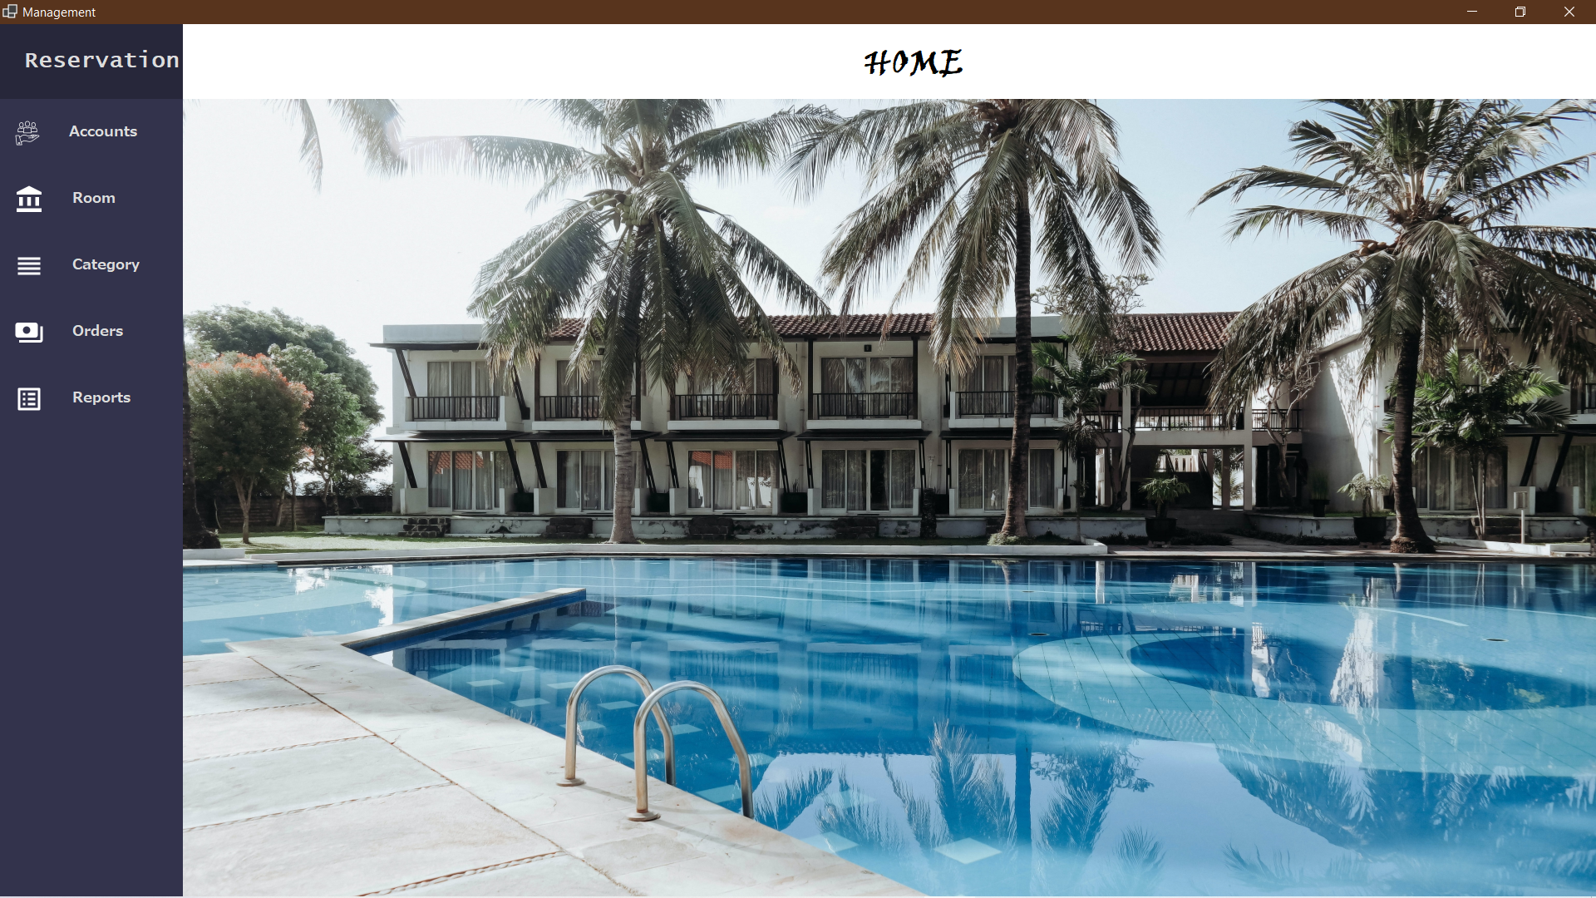

- After login with role Admin, the interface will appear as above. Admin can manage all.

2.1.2.1/ Account (Admin)

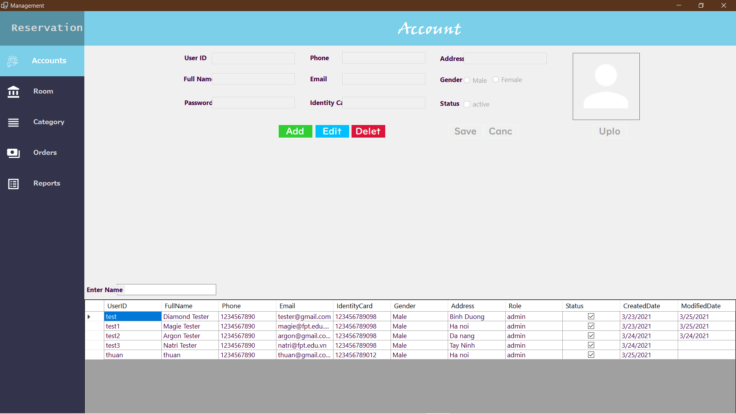

- Admin click any row in table above. The data for that column will be displayed as follows

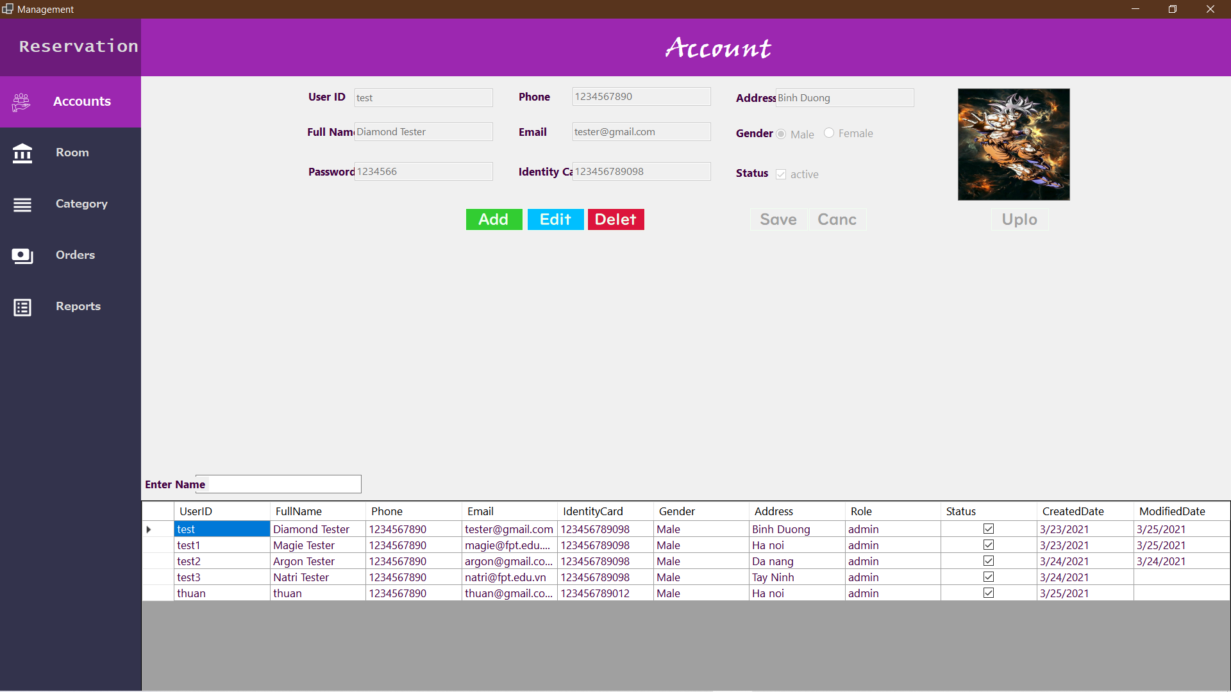

- Admin can Create, Read, Update or Delete. Click Add . The form will be

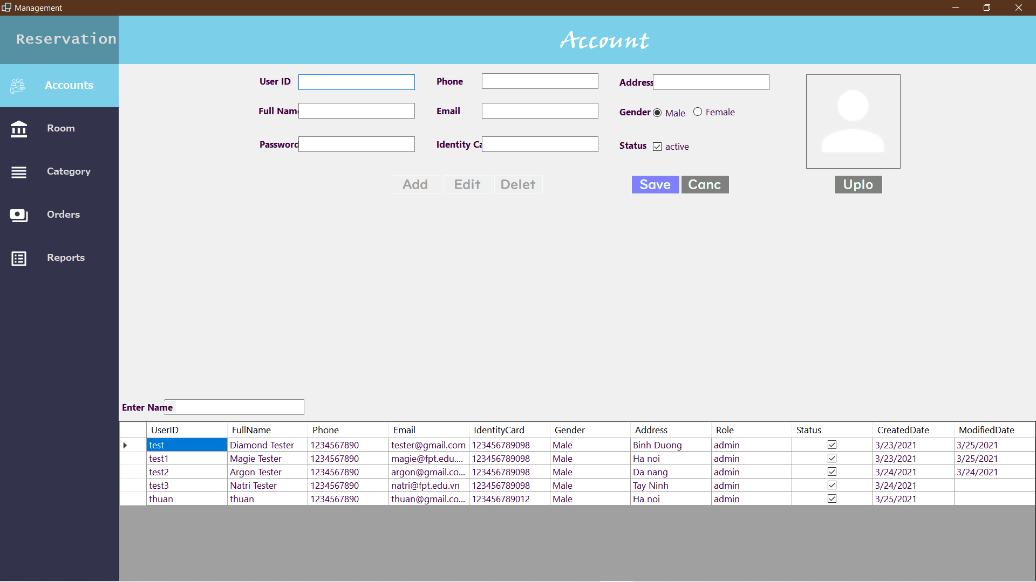

- Complete all of the above information to create an account (Note: Only create an account with admin role). If there is any error, the application will warn the user as follows

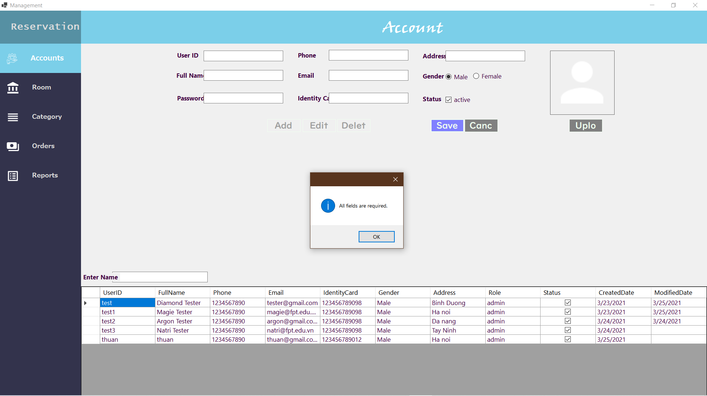

- If all information is correct. And press "Save". Will have the following interface

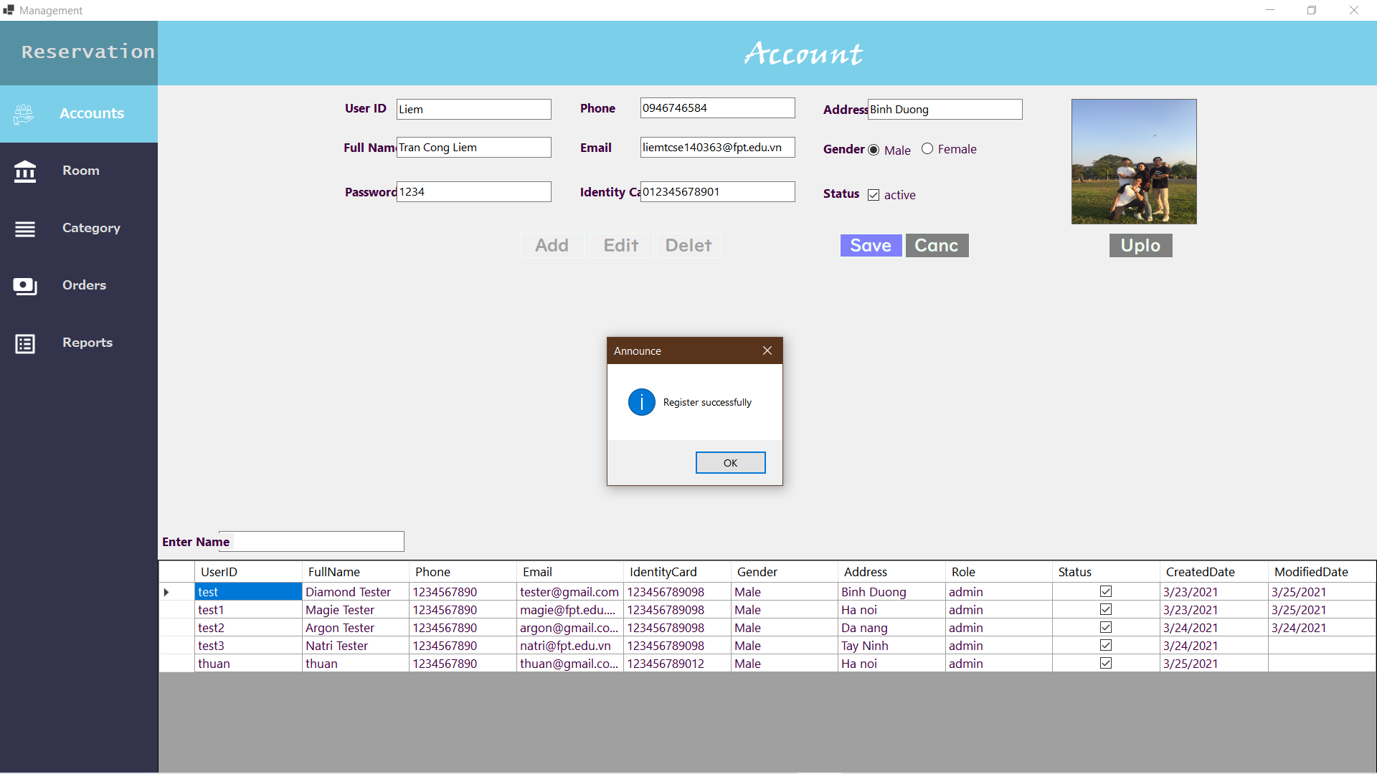

- Register successful

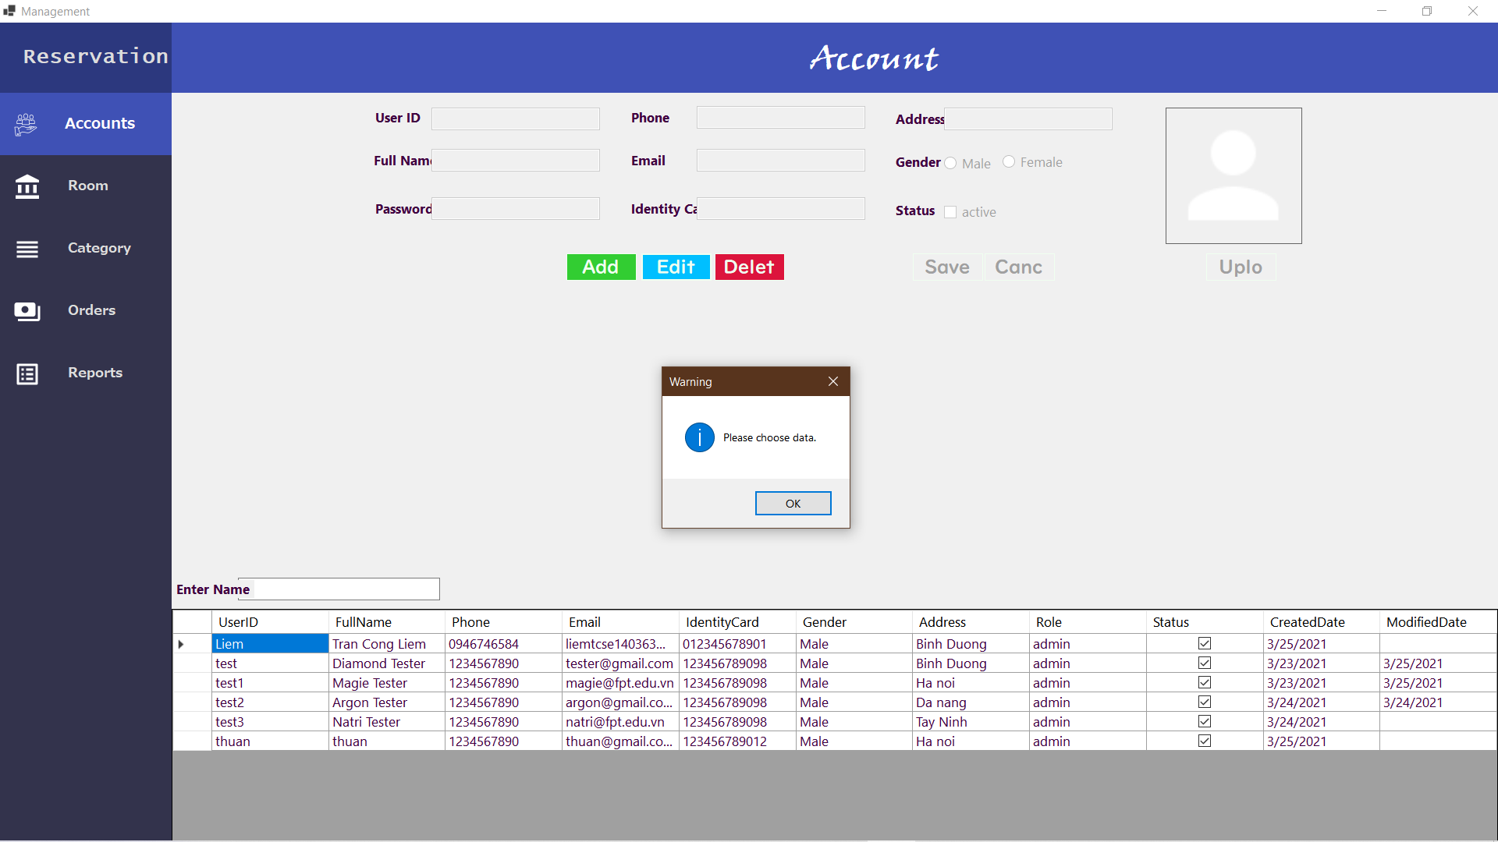

- Click “Edit” button. If the data in the table is not selected, an alert will appear

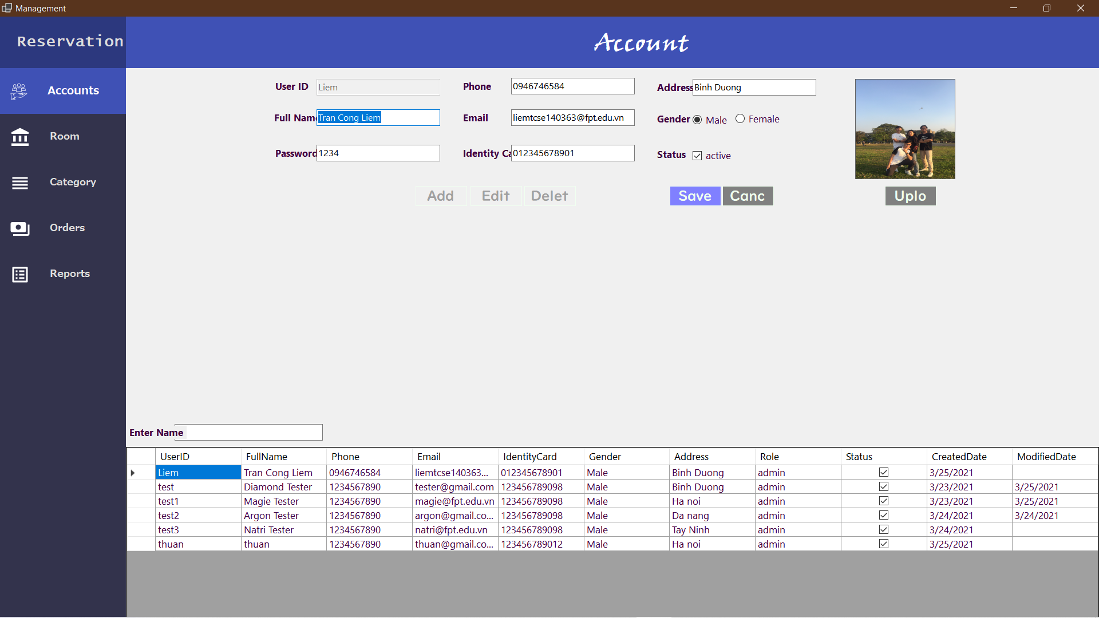

- If data has been selected, the application will allow editing. Note: UserID will not be allowed to edit

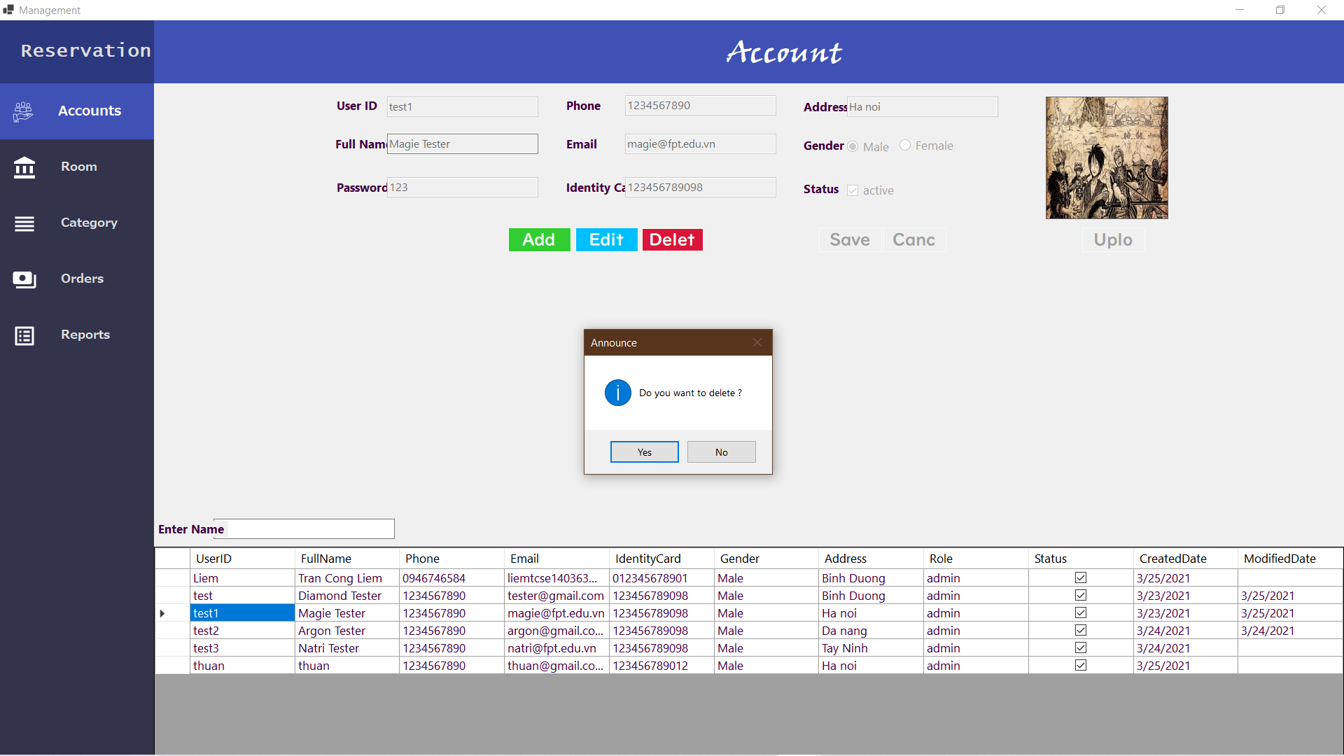

- Click “Delete” button. Must be choose the data on the table to delete. Message confirm box will appear to reconfirm with the user. If click “Yes” the data will be deleted. If click “No”, nothing happen

2.1.2.2/ Room(Admin)

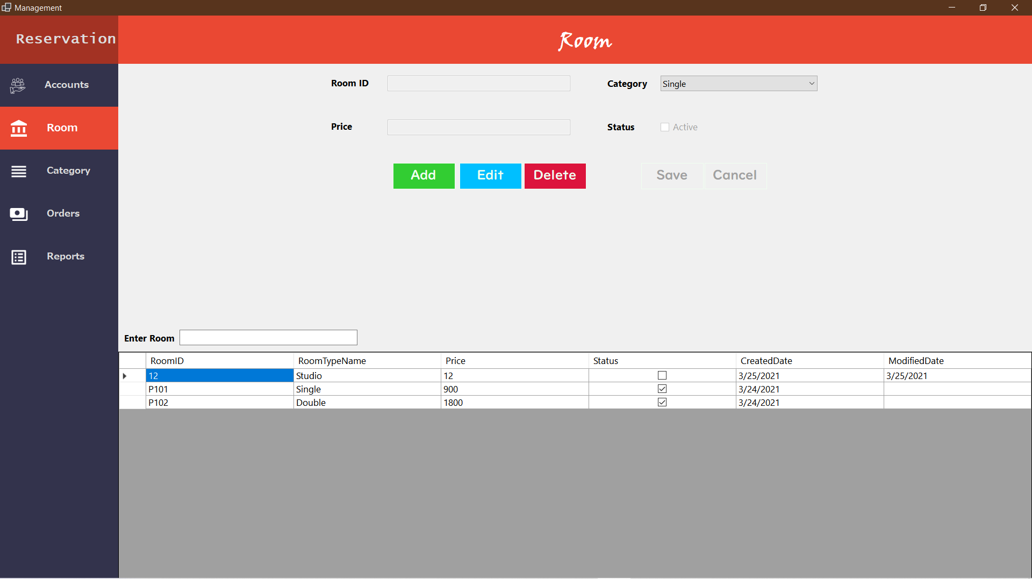

- Click “Room” icon to manage room. The window will appear as above.

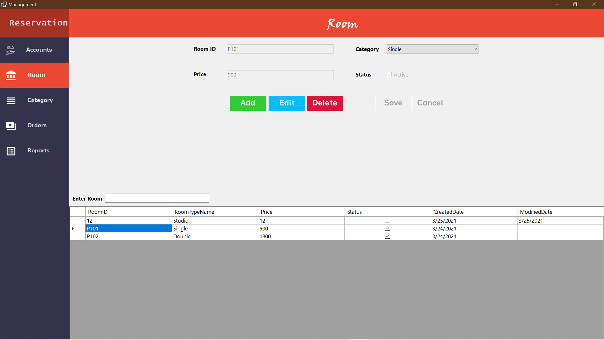

- Click one row on the table. The data will be display.

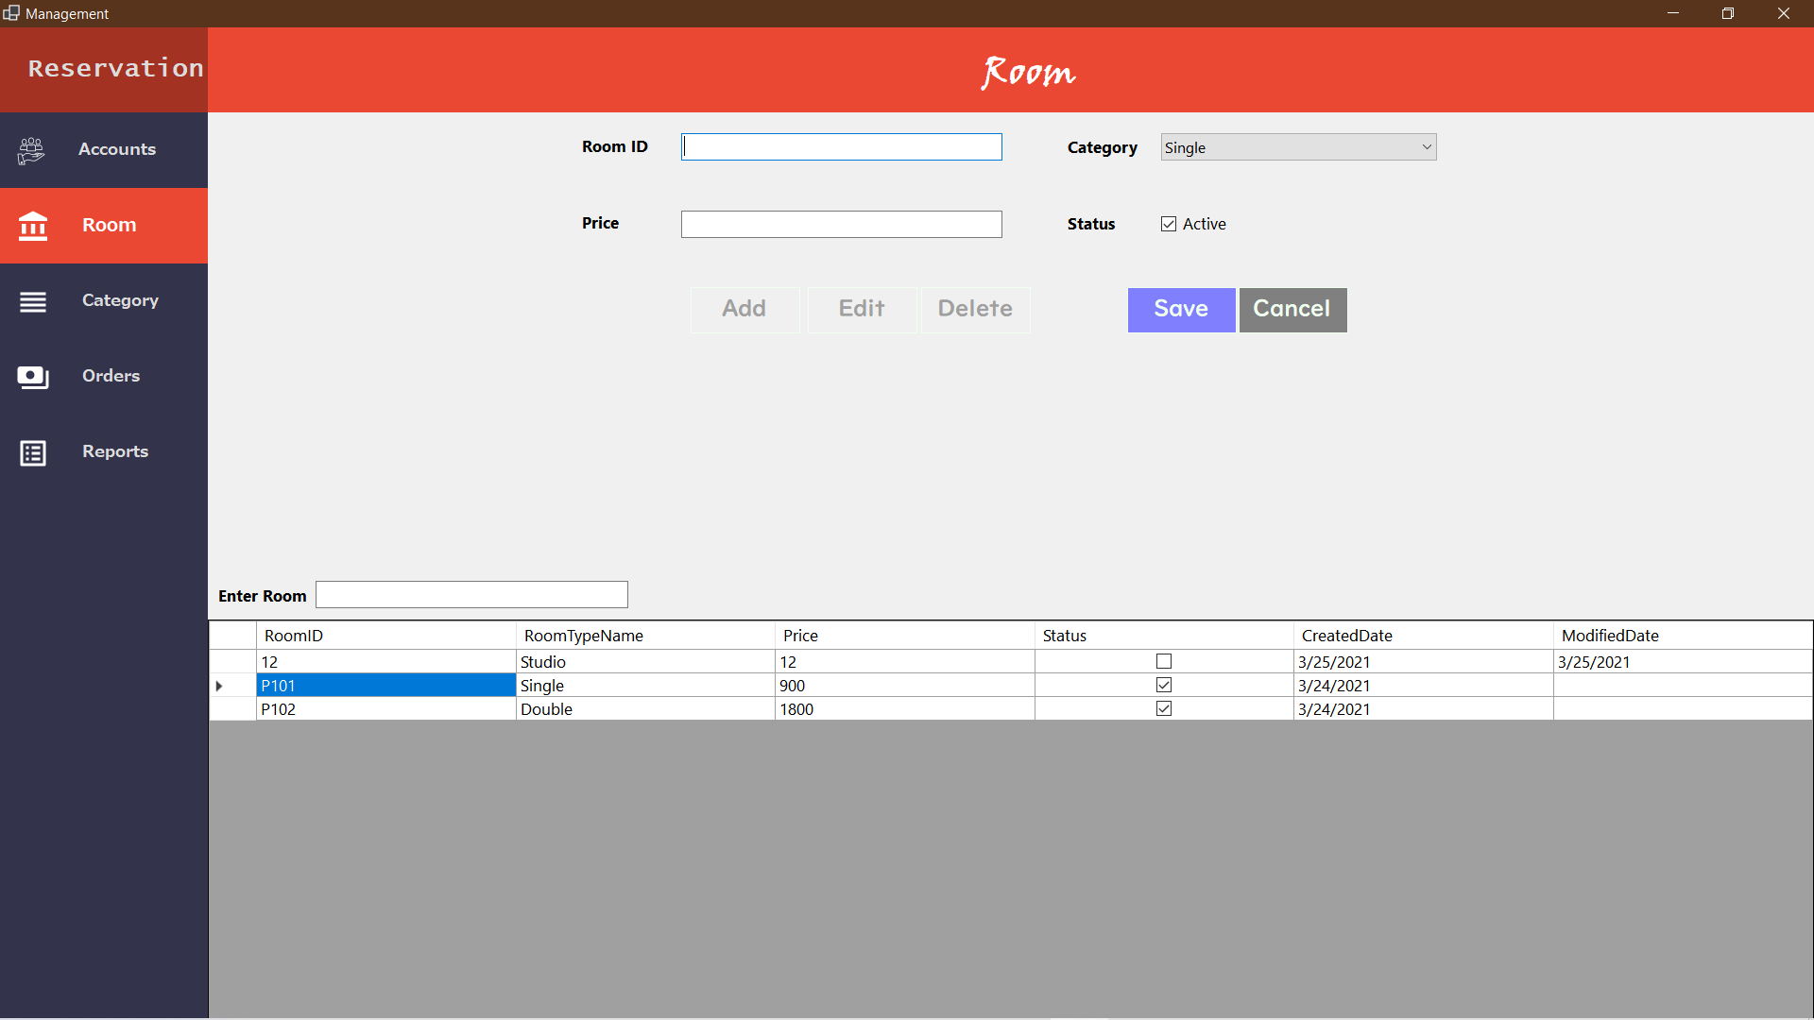

- When click on “Add” button. Fill all information to add.

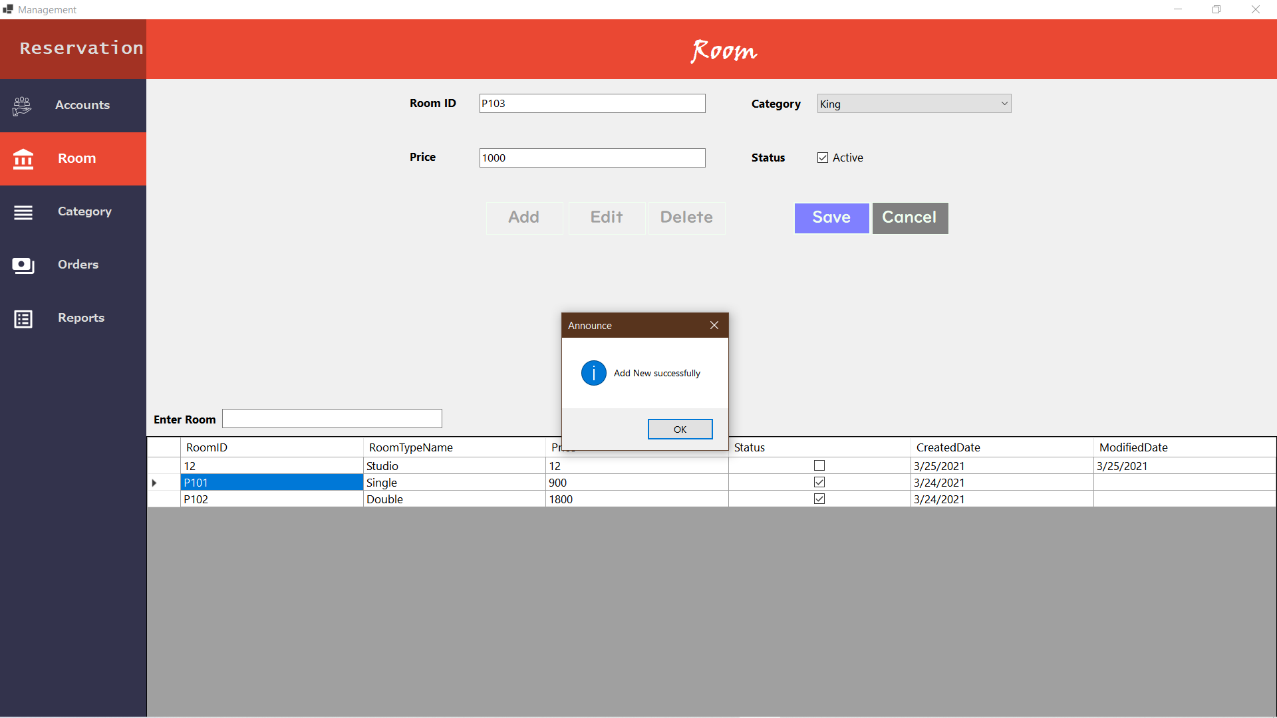

- After fill all information, message box will appear : “Add New Successfully”