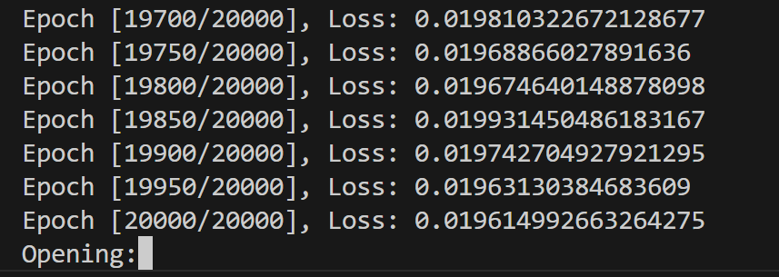

The model has been trained to reach low loss rate and ready to predict next unknown value by getting input of other information.

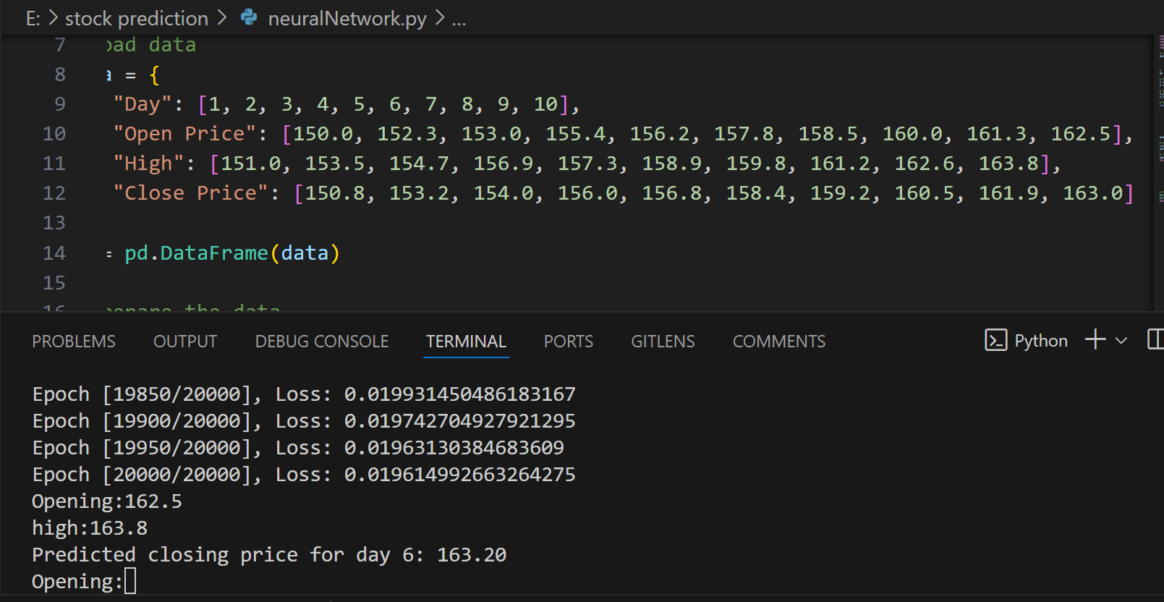

Predicted