Minikube创建集群
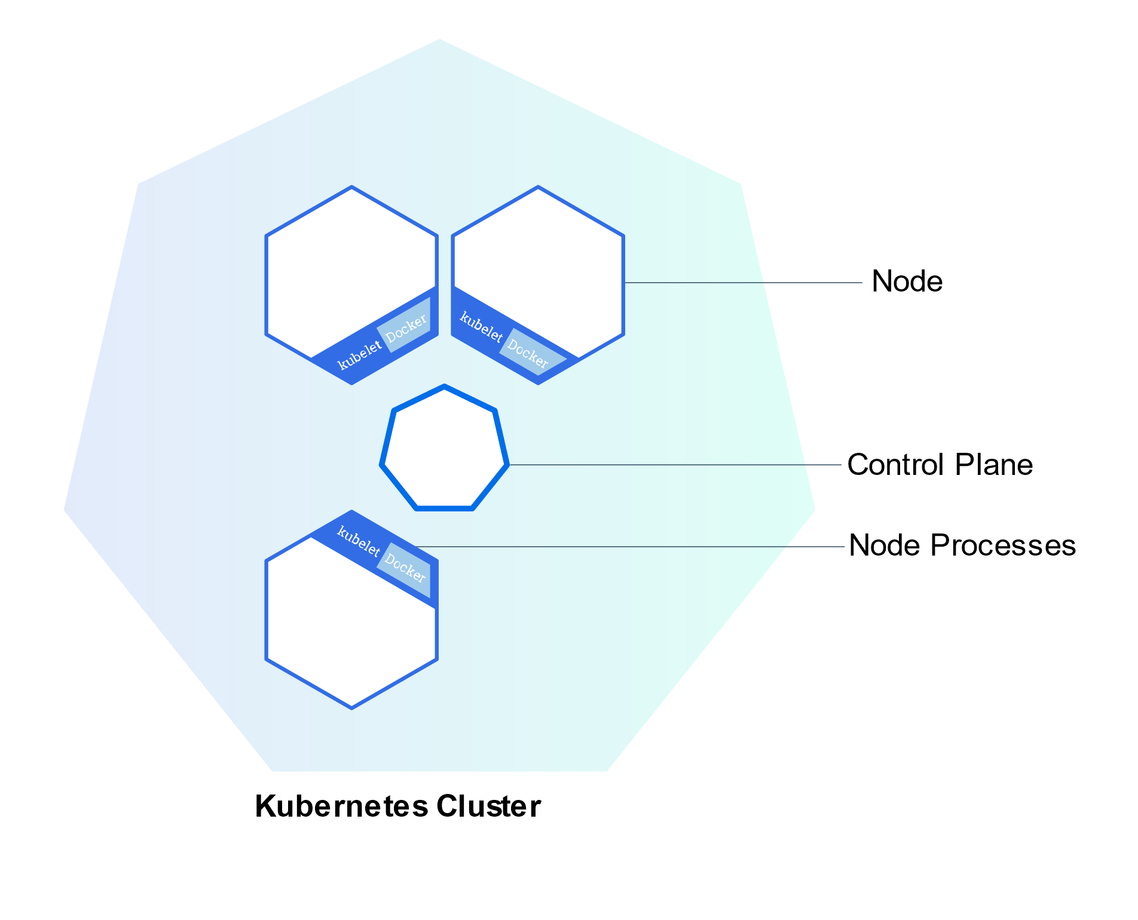
Node是一个集群
minikube version
minikube start
kubectl version
kubectl cluster-info
kubectl get nodes

kubectl创建Deployment
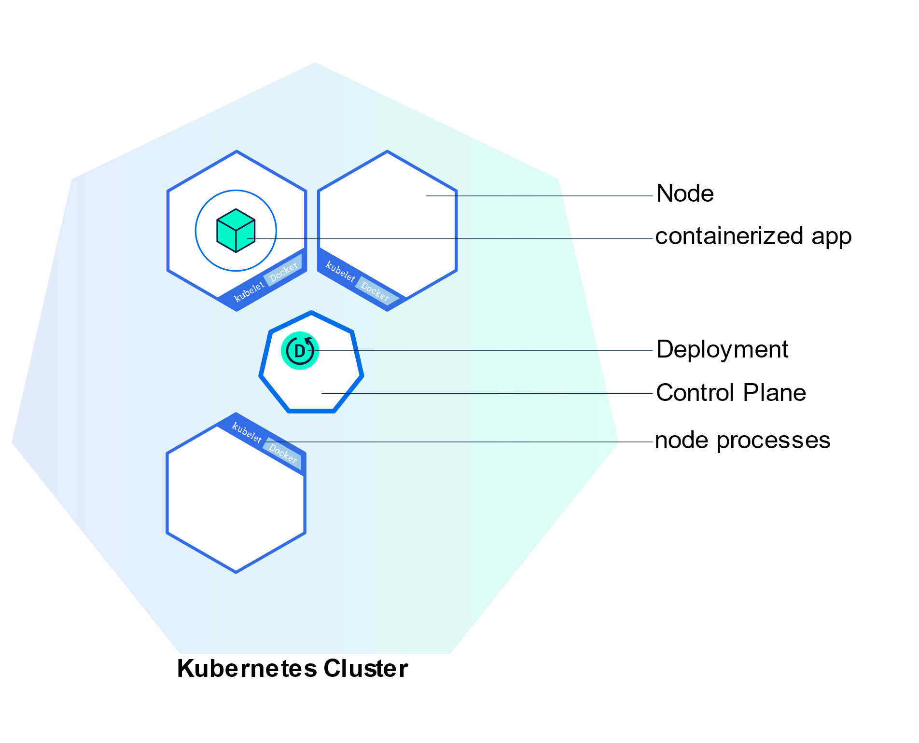
kubectl version
kubectl get nodes
kubectl create deployment kubernetes-bootcamp --image=gcr.io/google-samples/kubernetes-bootcamp:v1
kubectl get deployments

echo -e "\n\n\n\e[92mStarting Proxy. After starting it will not output a response. Please click the first Terminal Tab\n"; kubectl proxy
curl http://localhost:8001/version

export POD_NAME=$(kubectl get pods -o go-template --template '{{range .items}}{{.metadata.name}}{{"\n"}}{{end}}') echo Name of the Pod: $POD_NAME
curl http://localhost:8001/api/v1/namespaces/default/pods/$POD_NAME/

查看pod和工作节点
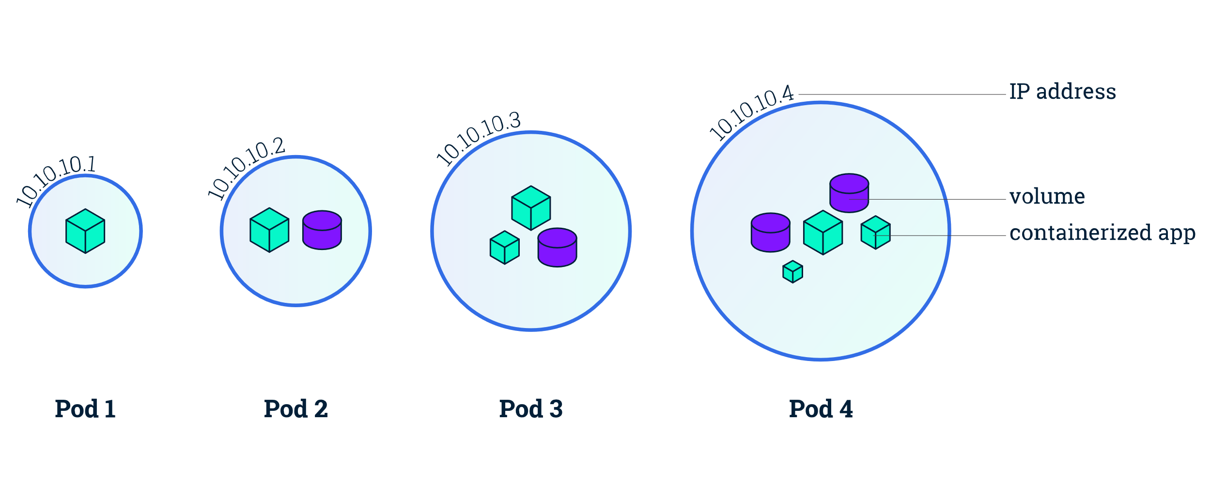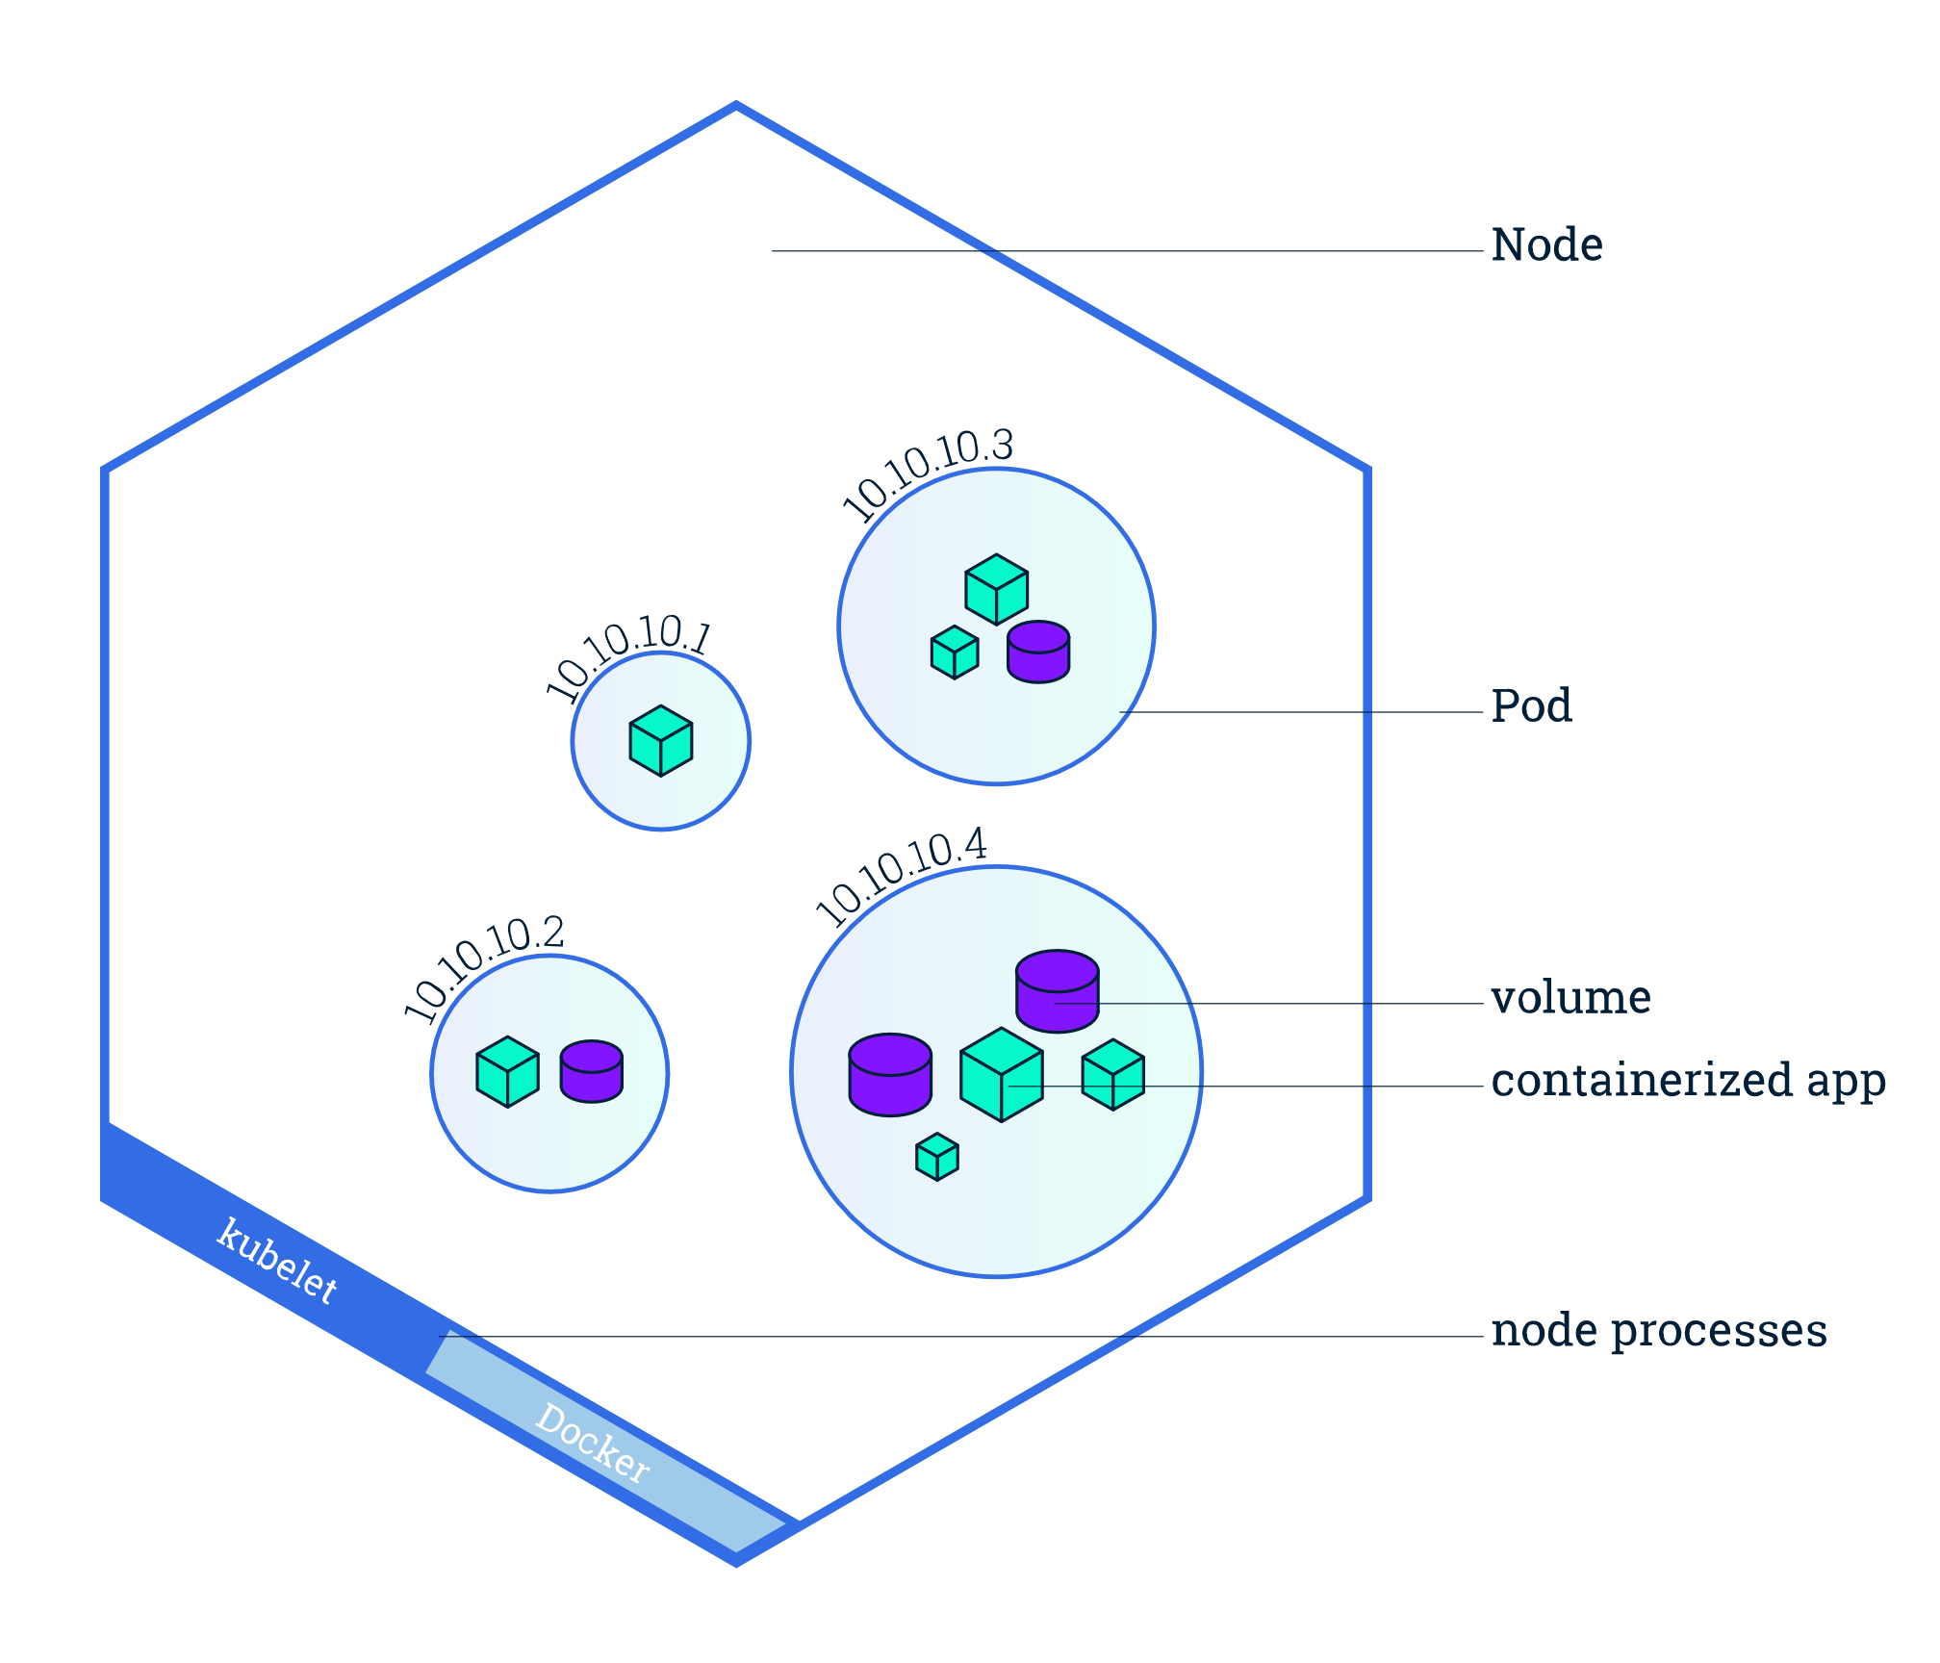
Pod表示一组一个或多个容器和这些容器的共享资源：
- Volume
- Network
- 每个容器的配置信息，如image版本和ports
每个工作节点至少运行：
- Kubelet，负责通信、管理Pod和容器
kubectl get pods
kubectl describe pods

echo -e "\n\n\n\e[92mStarting Proxy. After starting it will not output a response. Please click the first Terminal Tab\n"; kubectl proxy
export POD_NAME=$(kubectl get pods -o go-template --template '{{range .items}}{{.metadata.name}}{{"\n"}}{{end}}') echo Name of the Pod: $POD_NAME
curl http://localhost:8001/api/v1/namespaces/default/pods/$POD_NAME/proxy/
The url is the route to the API of the Pod.

kubectl logs $POD_NAME

kubectl exec $POD_NAME – env
kubectl exec -ti $POD_NAME – bash
cat server.js
curl localhost:8080
exit

Service暴露应用
