- Installing Apache Tomcat Server in Eclipse
1. Download and unzip Apache Tomcat (http://tomcat.apache.org/download-70.cgi )

2. Open Window -> Preferences -> Server -> Installed Runtimes
(to create a Tomcat installed runtime).

3. Click on “Add...” to open the New Server Runtime dialog, then select your runtime under Apache (Apache Tomcat v7.0)

4. Click “Next” , and fill in your Tomcat installation directory :
Ensure the selected JRE is a full JDK and is of a version that will satisfy Apache Tomcat. You can click on Installed JREs... to add JDKs to Eclipse.

5. Click “Finish”.

- Running The Web Service on Apache Tomcat Server

To add your dynamic Web project to the server proceed as follows:

1. Right-click the “Tomcat server entry” in the “Servers View”.
2. Select “Add and Remove....”
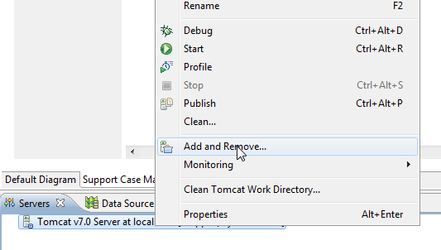

3. In the left pane select your project.
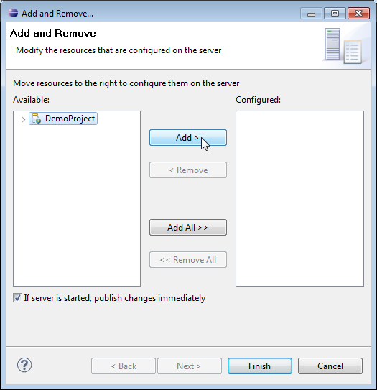
4. Click “Add” to move it to Configured Projects (this only needs to be done once whenever the active project changes).

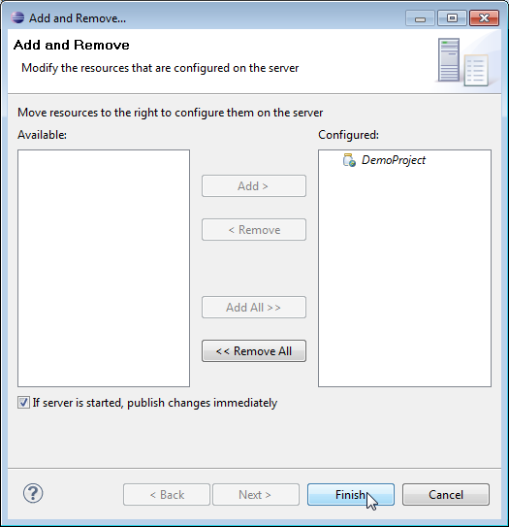
5. Select “Finish”.

