OOP-ARCADE-2019

Version 1.0

written on April 2020

edited by:

**LEHOUX Mai-Ly**

**CHEVALLIER Benjamin**

**FERTIN Timothé**

*Summary:*

* Prerequisites…………………………….. p.3
* Execute.………………………………….. p.4
* Bindings............................. …….….. P.5-p.6
* Interfaces and Types Schema …..…… .p.7

***Prerequisites :***

In order to be able to use the dynamic libraries located in the ‘/lib’ directory on a Fedora 28 system, the following libraries must be installed.

**lib_arcade_sdl.so:**

**SDL2.2**

You can install it via http://www.libsdl.org/download-2.0.php

**lib_arcade_sfml.so:**

**SFML-2.5.1**

**lib_arcade_ncurses.so:**

**ncurses-6.1**

*How to use compatible libraries:*

*At the root of the directory, there are a lib/ and games/ folder, where we must place the .so files of the games and graphical libraries.*

*How to execute Arcade Project:*

To use our arcade binary, you must give the path to a compatible graphical library to the program as a parameter.

./arcade ./*your-lib*.so

*Bindings:*

The events are caught by the Graphical libraries and sent to the Core. It will then send them to the Game to update it.

We have enumerated the different actions on the Arcade project:

|  |  |
| --- | --- |
| Key | Action |
| Arrow Keys | Move |
| Space | Action n°1 |
| Enter | Action n°2 |
| G | Switch Game |
| L | Switch Graphical Library |
| R | Restart Game |
| M | Menu |
| P | Pause |
| Q | Quit |

*Menu:*

*If you want to use the graphical library's Menu, we must follow these instructions:*

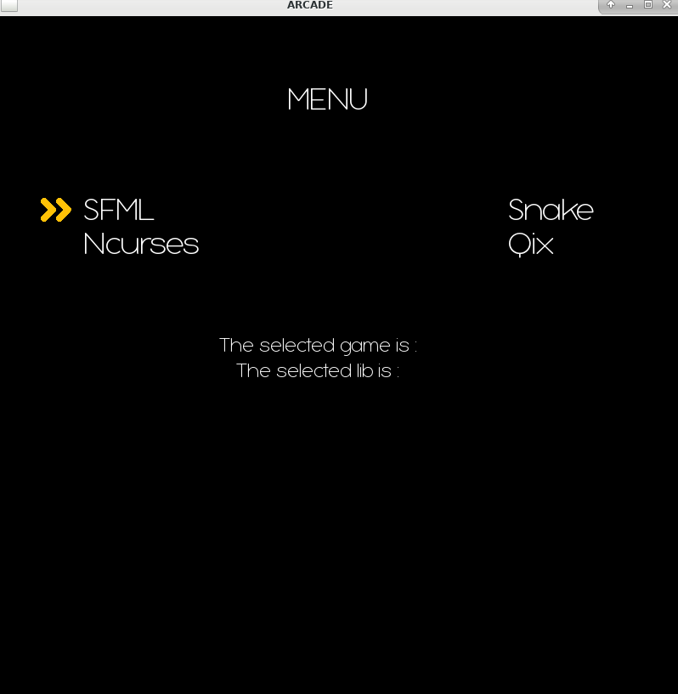

*Functioning:*

**Key Up/Key Down/Key Left/Key Right**

To change the selection

**Key Enter**

To select

When a game AND a library graphical are selected, you can press Key Space to run the game

*Games:*

**NIBBLER**

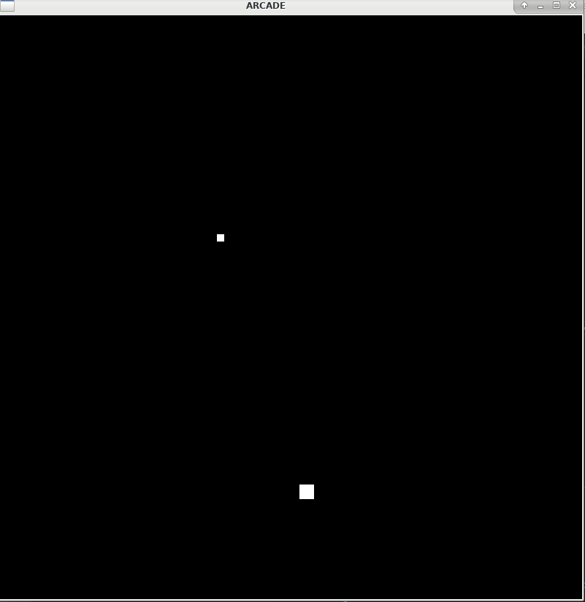

*Interface and type drawings:*

To have a better overview of the architecture of our project you can refer to the class diagram provided in the appendix.

*(Diagram File is on the directory “Documentation” of the repository)*

If you want to create your own game or graphical library, you must create a symbol as an extern “C”, that follows this prototype, and returns and instance of the class. That applies to both IDisplayModule and IGameModule.

