There are some queues we have access to that you didn't list in the doc (all the new-* ones).

The new-* are queues without GPU?

I think, yes. I checked which hosts are inside new* queues:

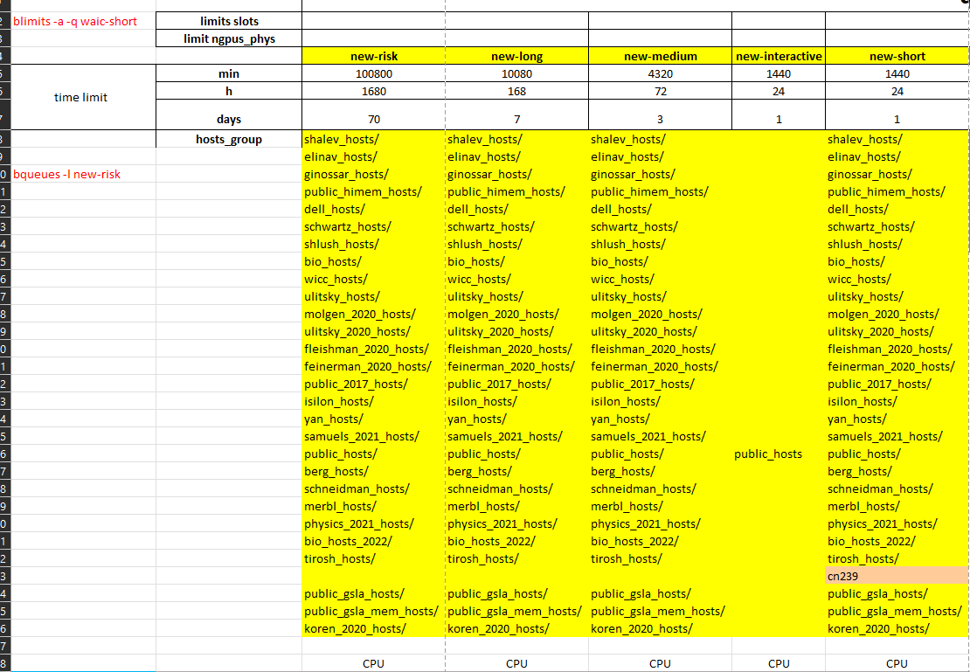

and checked, for example the host group = ginossar_host => it includes two hosts: cn242 and cn243:

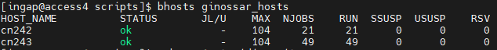

I run the command: ssh cn242 'nvidia-smi' => to see which type of GPU is there => the output was:



or you can run:



so, my conclusion => it is not GPU.

There are additional queue which includes GPU, like yan-gpu with even higher priority than waic* queue:

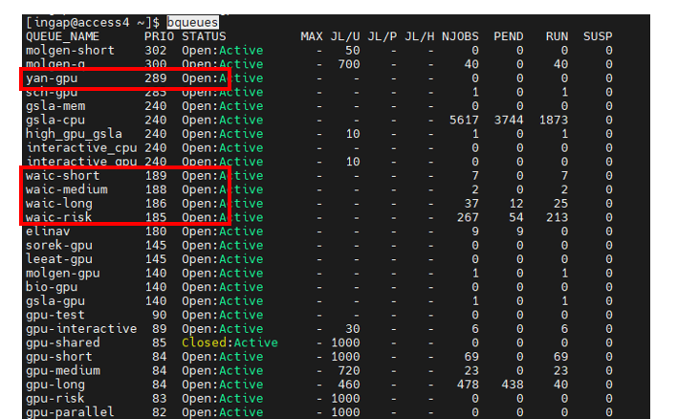

yam-gpu queue includes 2 hosts ibdgx011 and ibdgx012:

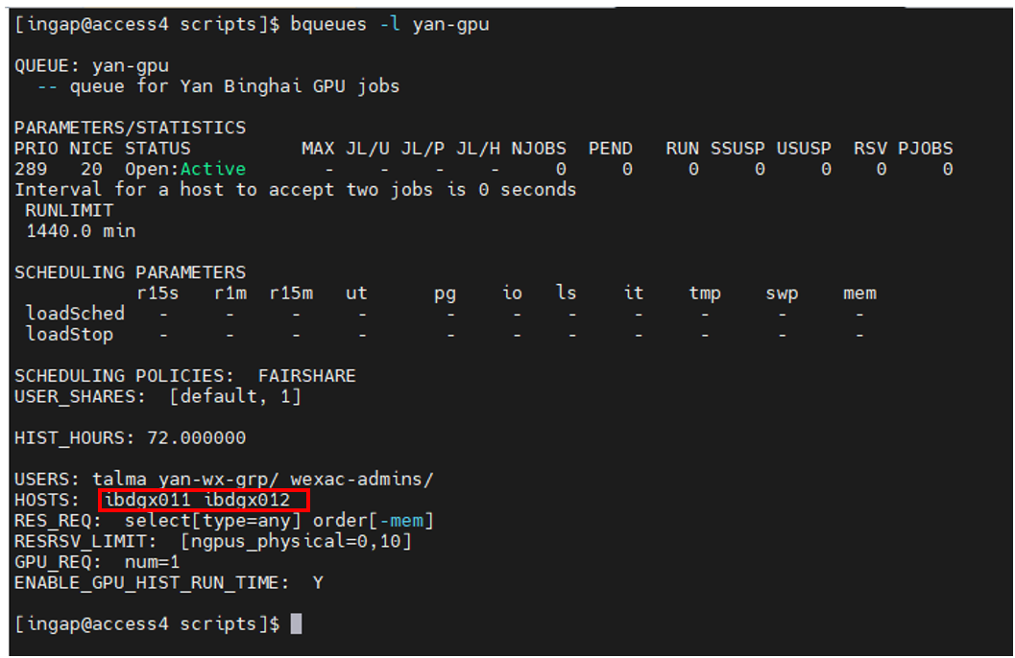

and these hosts are GPUs =>

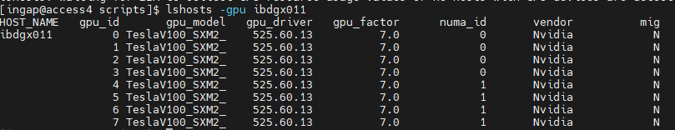

However, we can not use this queue:

so, our GPUs are waic* and gpu*.

I forgot to mention in the Task 3 that waic-risk can be preempted by waic-short/long/medium

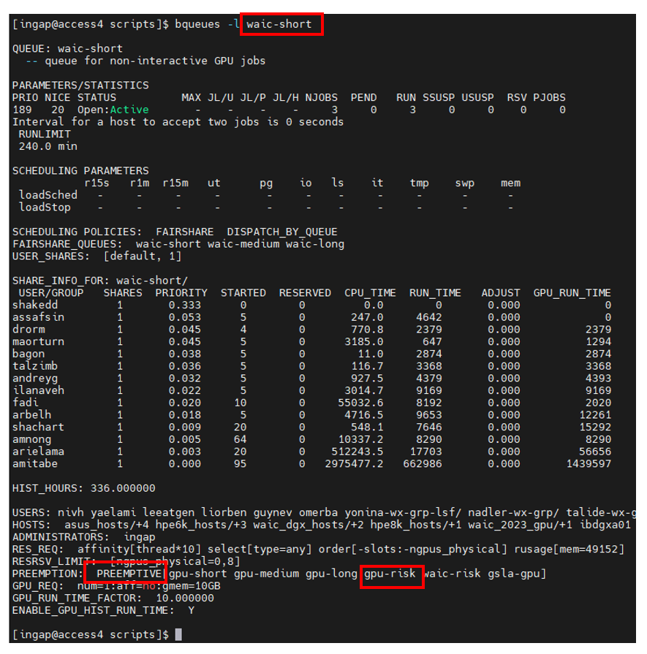

But on the other side waic-risk has not limits 300/60, which we saw for other waic*:

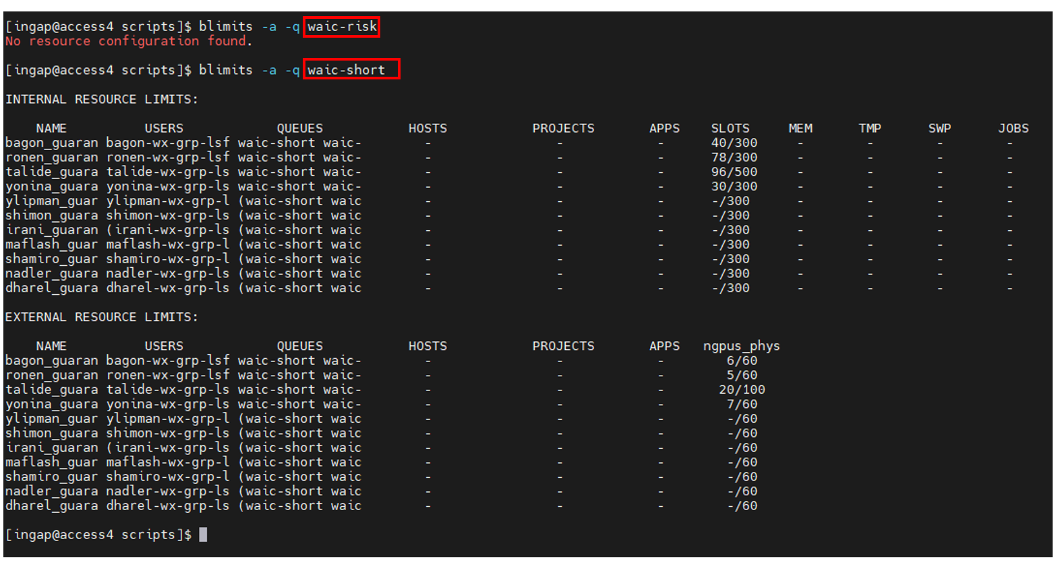

Can you explain how the "Factor" works?

According to IBM LSF manual:

<https://www.ibm.com/docs/en/spectrum-lsf/10.1.0?topic=reference-command>

<https://www.ibm.com/docs/en/spectrum-lsf/10.1.0?topic=reference-bqueues>



The explanation is not clear for me. Don’t know. Lets leave this at his stage.

Does "RESRSV_LIMIT:  [ngpus_physical=0,8]" means we cant use less than 0 gpus or more than 8?

I think yes, this is range for amount of GPU which can be used per job: from 0 till 8.

Can you explain how the "nfs4_editfacl" command works? (the one from the jupyter tutorial in the hpcwiki)

I didn’t have a time yet to read HPC wiki. I will send the task related to Jupyter how I open and work with it => how I do it.