**Final Signal Processing project:**

**Sleep stages through cycles investigation with EEG data**

**By 3-rd year IT&BA students at UCU:**

**Pavelko Roman and Pastukh Yaroslav**

# Part 1

## **1.1 Introduction**

Sleep - is a condition of the body and mind that typically recurs for several hours every night, in which the nervous system is relatively inactive, the eyes closed, the postural muscles relaxed, and consciousness practically suspended. Sleep is characterized by relative immobility and reduced responsiveness to environmental stimuli. This in contrast to the state of wakefulness which is characterized by presumably purposeful motor activity and the ability to respond to environmental stimuli appropriately.

In the contemporary rapidly-evolving tech-era, the importance of sleep cannot be emphasized enough, as people tend to sacrifice the crucial recovery process for extra hours of productivity, causing significant harm to the brain activity, which consequently affects the performance of all other vital functions, which make up for the equality of life from a physiological standpoints.

## **1.2 Role in human’s biological performance**

Among all of the functions sleep is responsible for as a process, the most popular and easy to think of one is restorative: it is during the sleep when humans’ bodies truly relax, when the growth happens. Among the benefits of this activity, the part of the day humans spend a third of their existence in total, are majorly lower risk of cardiovascular diseases, better athletic performance, better memory consolidation and, more widely, better brain cells restoration, and, in the more modern perspective, better concentration and productivity. Most importantly, it is crucial to mention that sleep is important for recovery of the nervous system, as it largely correlates with feelings of fatigue, mood shifts and overall emotional stability.

However, not only does it perform recreational function, but also it takes part in reducing energy expenditure by lowering metabolism and thermoregulation through hypothalamic nuclei. There are cross pathways of circadian rhythms and energy metabolism; however, during REM sleep, there is increased whole-body oxygen consumption.

Researchers also think that sleep brings about memory consolidation and the plasticity of the cognitive neural networks. Learning, behavior, and cognitive performance are improved after sleep, as evidenced by functional magnetic resonance imaging on the visuomotor task performance after normal sleep.

# Part 2

## **2.1 Sleep staging**

The humble beginnings in sleep medicine started with a mere observation and description of various events occurring during sleep and wake. However, it was not until the development of the field of electrophysiology and the invention of electroencephalography (EEG) recordings by Hans Berger in the early part of the 20th century that we began to understand better the complexity of the brain mechanisms characterizing sleep and wake states. Sleep goes through structured and organized cycles through various stages.

The initial overnight sleep recordings were performed by Loomes and his colleagues as they faced the challenging task of describing typical sleep patterns in normal individuals. Several groups improvised this and, in turn, gave rise to the beginnings of sleep staging. However, it was only 17 years later that Aserinsky recognized rapid eye movement (REM) sleep. This led to the birth of modern methods of sleep staging.

In 1968, a committee of experts chaired by Rechtschaffen and Kales established the rules for the scoring of sleep in normal human adults. From this coding, 5 sleep stages were identified: 1 REM stage and 4 NREM sleep stages. Each stage consists of a number of physiological variables, which tend to occur in concert. Subsequently, in 2004, a revision of the sleep scoring rules was commissioned by the American Academy of Sleep Medicine (AASM), which included rules for the scoring of arousals, respiratory events, sleep-related movement disorders, and cardiac events. The magnitude and distribution of the standard sleep parameters reflect the macrostructure of sleep.

## **2.2 Macrostructure of Sleep**

Based on sleep macrostructure, sleep can be classified into 2 main stages: ***Non-Rapid Eye Movement (NREM)*** and ***Rapid Eye Movement (REM)*** sleep. Typically, as one goes to sleep, the low-voltage fast EEG pattern of wakefulness gradually gives way to slower frequencies, as NREM sleep goes from stage *N1* (decrease in alpha) to stage *N2* (spindles, K-complexes) to stage *N3* (increasing amplitude and regularity of delta rhythm). Stage N3 is referred to as slow-wave sleep (SWS). SWS is interrupted by periods of rapid eye movement (REM, i.e., active or paradoxical) sleep. Polysomnography (PSG) is a multiparametric study that has been traditionally used to assess the architecture of sleep.

Sleep goes through multiple discrete cycles of NREM and REM sleep through any given night. In normal adults, each cycle lasts for about 90 to 120 minutes, and there are about 4 to 5 such cycles that occur during a normal 8 hour night sleep. The percentage of NREM sleep is maximum in the first part of the night, while REM sleep predominates in the second half.

### **Stage wake (W)** is characterized by the presence of a predominant beta rhythm over the anterior leads, and there is a posterior progression to a posterior dominant alpha rhythm over the occipital regions. This anteroposterior progression is best observed with the eyes closed and is attenuated by eye-opening. Eye blinks are frequently observed in this stage which appear as conjugate eye movements consisting of 0.5 to 2 Hz. During the transition to drowsiness, one of the first things to appear is slow lateral eye movements typically less than 0.5 Hz, and there is greater prominence of alpha rhythm with intermittent beta rhythm.

### **Stage 1 (N1)** is characterized typically by the disappearance of the alpha rhythm and appearance of roving eye movements, which are slow, conjugate, to and fro deflections usually lasting approximately 500 milliseconds. The EEG shows medium amplitude, mixed frequency predominantly of 4 to 7 Hz activity, and irregularly spaced bursts of slow waves.

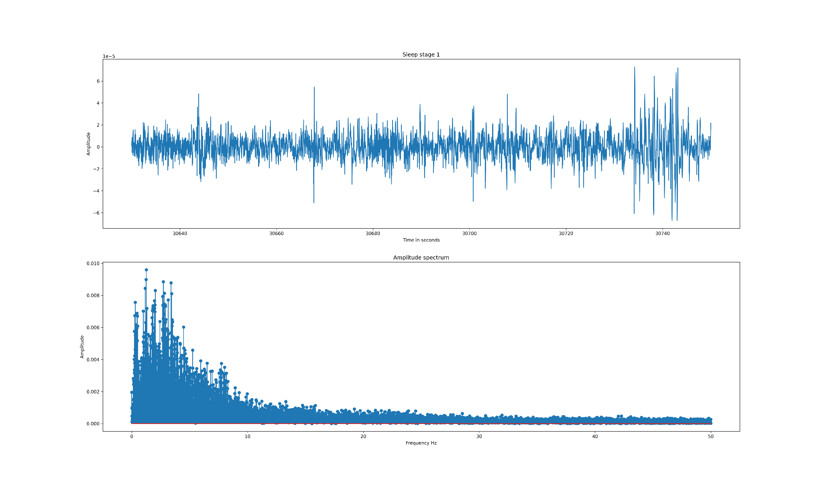

### **Stage 2 (N2)** is characterized by the presence of bilaterally synchronous theta activity accompanied by sleep spindles or K-complexes, or both. K complexes are defined by the occurrence of a complex pattern of negative sharp wave immediately followed by a positive wave (V-shaped) standing out from the background EEG, lasting 0.5 seconds, and is most prominent in the fronto-central derivations.