**GUOWEI (Peter) LU**

[bjfubjfu@gmail.com](mailto:bjfubjfu@gmail.com) • [Github](https://github.com/pasu) • DoB: 1983

**PROFILE**

I got my master’s degree at Utrecht University in 2020. Before that, I was a GIS engineer in China. My research interests include Physically based rendering and light transport simulation.

**EDUCATION**

**Utrecht University, the Netherlands** Sep. 2018 – Sep.2020

M.Sc. in Computer Science, Game and Media

* Relevant Courses: Advanced Graphics, Optimization and Vectorization, Game Physics, Computer Vision, Geometric Algorithm, Motion and Manipulation, Crowd Simulation
* Master Thesis: ‘Gradient-Domain Volume Rendering’(grade: 8.5/10)
* GPA: 4.0/4.0

**Beijing Forestry University, China** Sep. 2002 - Jun. 2006

B.Sc. in Information Management & Information System

**EMPLOYMENT**

Engineer, R&D Department, SuperMap, Beijing/Chengdu, China Jul. 2006 - Jun. 2018

* Virtual Earth: real-time massive 3D content rendering in the Browser.
* Map Module: map rendering

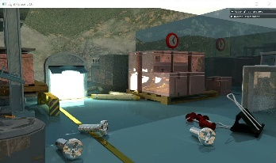**PROJECTS PORTFOLIO [](https://github.com/pasu/CV/blob/master/G.Lu_Project_portfolio.pdf)**

**[SBDPT](https://github.com/jbikker/lighthouse2)** •Project• C++, Cuda • 2019

A streaming BDPT render system. It supports energy conservation, caustic, and Optix wavefront pipeline.

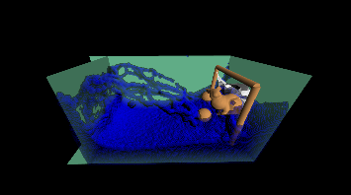[**Fluid Simulation**](https://github.com/YakaAhSon/PositionBasedFluidSimulation)•Project•C++, Compute shader • 2019

Position Based Fluid Simulation. It supports the collision among rigid body, clothes, and fluid.

**Action Recognition** •Project•Python, Keras, tensorflow • 2019

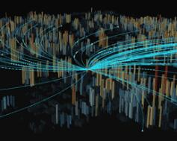A CNN architecture to classify human actions of the Stanford-40 dataset. It supports data augmentation, transfer learning and automatic model search.

[**Examples for Cesium**](https://github.com/pasu/ExamplesforCesium)•Hobby**,** JS, WebGL • 2017

A demo gallery of Cesium. It supports vector tile rendering, height map terrain and dynamic data visualization.

**ACHIEVEMENTS**

Master’s degree with cum laude2020

SuperMap Innovation Award (Team) 2016/2008

National 3rd prize of National High School Mathematics League2001

**MISCELLANEOUS**

**Programming Language** C++, JS, Python, CUDA, WebGL

**Oral & Written** English(medium, IELTS 7), Mandarin(Native)

**Hobbies** Physically Based Rendering, Virtual Earth, LEGO