**GUOWEI (Peter) LU**

[peter6.lu@gmail.com](mailto:peter6.lu@gmail.com) • [Github](https://github.com/pasu) • DoB: 1983

**PROFILE**

I am a PhD student at the Computer Graphics and Visualization group under the supervision of Prof. Elmar Eisemann. My research focuses primarily on real-time rendering, realistic material, and lighting models. In addition, I am interested in in offline/differentiable rendering. Before this, I was a 3D GIS engineer in China working on the production about virtual earth.

**EMPLOYMENT**

PhD student, CGV Group, TU Delft, the Netherlands June 2022 – Now

* VR Renovate Project: The goal of this project is to research and test effective real-time graphics and visualization technology based on virtual reality displays, intended to provide an accurate depiction, and understanding of the results of sustainable home renovations.
* Teachers Assistant, Applied Image Processing

Architect/Engineer, R&D Department, SuperMap, Beijing/Chengdu, China Jul. 2006 – May 2022

* 3D GIS: I am working on real-time rendering and WebGL, striving to constantly improve the visual quality and performance. My responsibilities include spatial 3D model specifications (terrain, oblique photography, point cloud, BIM. etc.), LOD scheduling, rendering (PBR material, shadow, post processing etc.), and GPU/CPU optimization.
* Map Module: I worked on the map module, including styled vector, text rendering, anti-aliasing, and cross-platform capability (Windows, Linux, Android, Unix).

**EDUCATION**

**Utrecht University, the Netherlands** Sep. 2018 – Sep.2020

M.Sc. in Computer Science, Graduation with Cum Laude

* Courses: Advanced Graphics, Optimization and Vectorization, Game Physics, Computer Vision, Geometric Algorithm, Motion and Manipulation, Crowd Simulation, and Scientific perspective
* Master Thesis: ‘Gradient-Domain Volume Rendering’
* GPA: 8.73/10

**Beijing Forestry University, China** Sep. 2002 - Jun. 2006

B.Sc. in Information Management & Information System

**PROJECTS**

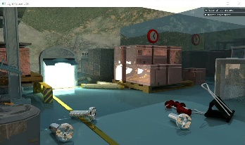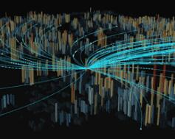[**SBDPT**](https://github.com/jbikker/lighthouse2)•C++, CUDA • 2019

A streaming bidirectional path tracing rendering system. #**Optix**, **wavefront****.**

[**Fluid Simulation**](https://github.com/YakaAhSon/PositionBasedFluidSimulation)•C++, Compute shader • 2019

Position Based Fluid Simulation. #**collision, rigid body, clothes.**

[**Action Recognition**](https://github.com/pasu/ComputerVision/tree/master/A5)•Python, Keras, tensorflow • 2019

A CNN architecture to classify human actions #**Stanford-40 dataset, data augmentation, transfer learning.**

[**Cesium tutorial(Chinese)**](https://www.cnblogs.com/fuckgiser/p/5706842.html) **&** [**Demos**](https://github.com/pasu/ExamplesforCesium)•JS, WebGL • 2017

Cesium tutorials written in Chinese and a gallery of Cesium demos. #**MapBox vector tile, height map terrain, dynamic data visualization.**

*\*For all projects, please visit my* [*project portfolio*](https://pasu.github.io/CV/project_portfolio.html)*.*

**ACHIEVEMENTS**

Innovation Award (Company, team) 2016/2008

National High School Mathematics League, National 3rd prize, Provincial 1st prize 2001

Data format for spatial 3D model (Social Organization Standard T/ CAGIS 1—2019) 2021

**MISCELLANEOUS**

**Programming Language** C++, JS, Python, WebGL/OpenGL, CUDA

**Oral & Written** English(medium, IELTS 7), Mandarin(Native)