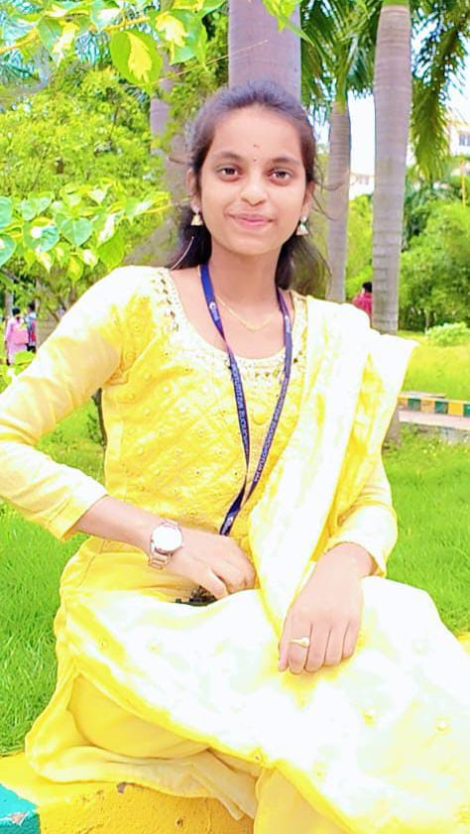



- ggaa
ABOUT ME

Computer science undergraduate (B. Tech 2024-2028) at Lendi institute of Engineering with basic fundamentals in c and Data structure. Intermediate in python, HTML focus on writing efficient, optimized solutions. Eager to apply technical skills to real-world challenges and grow as a developer.

Technical skills
Vizianagaram, A.P, India
pasupuletigayathri@gamil.com
6305612820

Pasupuleti Gayathri

EDUCATION
CSE (Bachelor of Technology) Lendi Institute of Engineering. & Tech. 2024-2028
- English (Intermediate)
- Telugu (Fluent)
- Hindi (Intermediate)
Languages
- C programming
- Python programming
- SQL

ACHIEVEMENTS
Upskill Certificate: Awarded as Grade A2
DECLARATION
CERTIFICATES

I hereby declare that the details mentioned above are the true to the best of my knowledge.
Cyber security COURSE - CYBER THREYA
HACKERRANK COURSE -PYTHON(BASICS)
GEEKSFORGEEKS -DATA STRUCTURES
- Communication skills
- Problem -solving skills
- Quick learner
- Team work and collaboration
- Self-motivated
- Time management
OTHER SKILLS
Class X
Chandra vidya Niketan school
2021-2022
score :476/600(79.3%)
Class xii (Board of Intermediate)
Sri Narayana junior college
2022-2024
Score:916/1000(91.6%)

