Assisted Practice: 3.1 Configuration of Hibernate
Configure Hibernate in Eclipse IDE.
- Set up Eclipse to work with Hibernate
- Create an HTML page to call a servlet
- Create a servlet that will initialize Hibernate and then close it

Step 3.1.1: Creating a dynamic web project
- Open Eclipse
- Go the File menu. Choose New->Dynamic Web Project
- Enter the project name as hibernatedemo1. Click on Next
- Enter nothing in the next screen and click on Next
- Check the checkbox Generate web.xml deployment descriptor and click on Finish
- This will create the project files in the Project Explorer

Step 3.1.2: Adding the jar files for Hibernate and its dependencies
- Hibernate.jar file is already present in your practice lab. (Refer FSD: Lab guide - Phase 2)
- Take hibernate.jar from folder mentioned in the lab guide for phase 2 and add it to your project’s WebContent/WEB-INF/lib folder
- mysql-connector-java.jar file is present in your practice lab. (Refer FSD: Lab Guide - Phase 2)
- Take mysql-connector-java.jar file from the folder mentioned in the lab guide for phase 2 and add it to your project’s WebContent/WEB-INF/lib folder
- Go to http://www.java2s.com/Code/Jar/j/Downloadjta11jar.htm
- Click on jta-1_1.jar.zip link to download it
- Extract jta-1_1.jar from it and add it to your project’s WebContent/WEB-INF/lib folder
- Go to http://www.java2s.com/Code/Jar/j/Downloadjavaxxmlbindjar.htm
- Click on javax.xml/javax.xml.bind.jar.zip link to download it
- Extract javax.xml.bind.jar from it and add it to your project’s WebContent/WEB-INF/lib folder
- Go to https://jar-download.com/artifacts/com.sun.xml.bind
- Click on the button Download jaxb-osgi.jar to download it
- Extract jaxb-osgi-2.4.0-b180830.0438.jar from it and add it to your project’s WebContent/WEB-INF/lib folder

Step 3.1.3: Configuring Hibernate with hibernate.cfg.xml
- In the Project Explorer, expand hibernatedemo1->Java Resources
- Right click on src and choose New->Other
- Select General->File and click Next
- In filename, enter hibernate.cfg.xml and click on Finish
- Enter the following code:
<?xml version='1.0' encoding='utf-8'?>
<!DOCTYPE hibernate-configuration PUBLIC
"-//Hibernate/Hibernate Configuration DTD 3.0//EN"
"http://www.hibernate.org/dtd/hibernate-configuration-3.0.dtd">
<hibernate-configuration>
<session-factory>
<!-- Database connection settings -->
<property name="connection.driver_class">com.mysql.jdbc.Driver</property>
<property name="connection.url">jdbc:mysql://localhost:3306/ecommerce</property>
<property name="connection.username">root</property>
<property name="connection.password">root</property>

</session-factory>
</hibernate-configuration>

Step 3.1.4: Creating an HTML page index.html
- In the Project Explorer, expand the project hibernatedemo1
- Expand WebContent. Right click on WebContent. Choose New->HTML File
- Enter the filename as index.html and click on Finish
- Enter the following code:

<!DOCTYPE html>
<html>
<head>
<meta charset="ISO-8859-1">
<title>Hibernate Configuration Example </title>
</head>
<body>
<h3>Hibernate Configuration Example </h3>
<a href="init">Initialize Hibernate</a><br>

</body>
</html>

- Click on the Save icon

Step 3.1.5: Creating a HibernateUtil class to initiate Hibernate in code
- In the Project Explorer, expand hibernatedemo1->Java Resources
- Right click on src and choose New->Class
- In Package Name, enter pack1 and in Name enter HibernateUtil and click on Finish
- Enter the following code:

import org.hibernate.SessionFactory;
import org.hibernate.boot.Metadata;
import org.hibernate.boot.MetadataSources;
import org.hibernate.boot.registry.StandardServiceRegistry;
import org.hibernate.boot.registry.StandardServiceRegistryBuilder;

public class HibernateUtil {
private static final SessionFactory sessionFactory;

static {
try {
StandardServiceRegistry standardRegistry = new StandardServiceRegistryBuilder()
.configure("hibernate.cfg.xml").build();

Metadata metaData = new MetadataSources(standardRegistry).getMetadataBuilder().build();
sessionFactory = metaData.getSessionFactoryBuilder().build();

} catch (Throwable th) {
throw new ExceptionInInitializerError(th);
}
}

public static SessionFactory getSessionFactory() {
return sessionFactory;
}

}

Step 3.1.6: Creating an initdemo servlet
- In the Project Explorer, expand hibernatedemo1->Java Resources
- Right click on src and choose New->Servlet
- In Class Name, enter initdemo and click on Finish
- Enter the following code:

import java.io.IOException;
import java.io.PrintWriter;

import javax.servlet.ServletException;
import javax.servlet.annotation.WebServlet;
import javax.servlet.http.HttpServlet;
import javax.servlet.http.HttpServletRequest;
import javax.servlet.http.HttpServletResponse;

import org.hibernate.Session;
import org.hibernate.SessionFactory;

@WebServlet("/init")
public class Initdemo extends HttpServlet {
private static final long serialVersionUID = 1L;

protected void doGet(HttpServletRequest request, HttpServletResponse response)
throws ServletException, IOException {

PrintWriter out = response.getWriter();
out.println("<html><body>");

// STEP 1: Get a Session (connection) from the Session Factory class
SessionFactory factory = HibernateUtil.getSessionFactory();

Session session = factory.openSession();

out.println("Hibernate Session opened.<br>");

session.close();

out.println("Hibernate Session closed.<br>");

// STEP 2 execute the HQL commands
// for now we will only test if the connection is establised with MySQL server.

out.println("</body></html>");

}

}

Step 3.1.7: Checking for servlet-api.jar
- Before building the project, we need to add servlet-api.jar to the project
- Servlet-api.jar file is already present in your practice lab. (Refer FSD: Lab Guide - Phase 2)
- To add it to the project, follow the below mentioned steps:
  - In the Project Explorer, right click on hibernatedemo1 and choose Properties
  - Select Java Build Path from the options on the left
  - Click on Libraries tab on the right
  - Under ClassPath, expand the node that says Apache Tomcat
  - If there is an existing entry for servlet-api.jar, then click on Cancel and exit the window
  - If it is not there, then click on Classpath entry and click on Add External JARs button on the right
  - From the file list, select servlet-api.jar file and click on Ok
  - Click on Apply and Close

Step 3.1.8: Building the project
- From the Project menu at the top, click on Build
- If any compile errors are shown, fix them as required

Step 3.1.9: Publishing and starting the project
- If you do not see the Servers tab near the bottom of the IDE, go to Window menu and click Show View->Servers
- Right click on the Server entry and choose Add and Remove
- Click the Add button to move hibernatedemo1 from the Available list to the Configured list
- Click on Finish
- Right click on the Server entry and click on Publish
- Right click on the Server entry and click on Start
- This will start the server

Step 3.1.10: Running the project
- To run the project, open a web browser and type:
http://localhost:8080/ hibernatedemo1

Output:
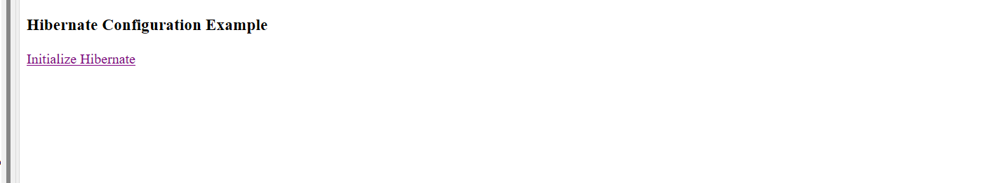

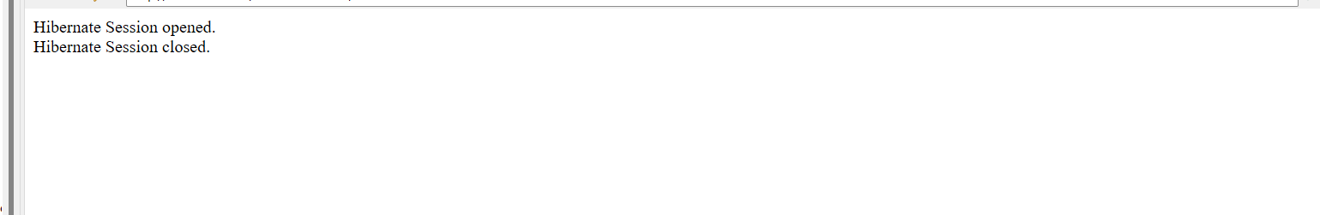
Assisted Practice: 3.2 Hibernate Configuration Using XML in Eclipse
Configure Hibernate using XML in Eclipse IDE.
- Set up Eclipse to work with Hibernate
- Create a database and a table in MySQL
- Configure Hibernate using XML to work with the table
- Create an HTML page to call a servlet
- Create a servlet that will display rows from the table

Step 3.2.1: Creating a database in MySQL
- MySQL is already installed in your practice lab.
- Login to the MySQL command line console
- Type CREATE DATABASE ecommerce and press Enter
- Type USE ecommerce and press Enter
- Type CREATE TABLE eproduct (ID bigint primary key auto_increment, name varchar(100), price decimal(10,2), date_added timestamp default now()) and press Enter
- We will now add some rows to the table
- Type INSERT INTO eproduct(name, ‘HP Laptop ABC’, 12000) and press Enter
- Type INSERT INTO eproduct(name, ‘Dell pc ABC’, 19000) and press Enter
- Type INSERT INTO eproduct(name, ‘Samsung Laptop PQR’, 22000) and press Enter
- Type SELECT * from eproduct and press Enter to confirm that the rows have been added
- Type EXIT to exit the MySQL command console

Step 3.2.2: Creating a dynamic web project
- Open Eclipse
- Go the File menu. Choose New->Dynamic Web Project
- Enter the project name as hibernateconfig. Click on Next
- Enter nothing in the next screen and click on Next
- Check the checkbox Generate web.xml deployment descriptor and click on Finish
- This will create the project files in the Project Explorer

Step 3.2.3: Adding the jar files for Hibernate and its dependencies
- Hibernate.jar file is already present in your practice lab. (Refer FSD: Lab Guide - Phase 2)
- Take hibernate.jar from folder mentioned in the lab guide for phase 2 and add it to your project’s WebContent/WEB-INF/lib folder
- mysql-connector-java.jar file is present in your practice lab. (Refer FSD: Lab Guide - Phase 2)
- Take mysql-connector-java.jar file from the folder mentioned in the lab guide for phase 2 and add it to your project’s WebContent/WEB-INF/lib folder
- Go to http://www.java2s.com/Code/Jar/j/Downloadjta11jar.htm
- Click on jta-1_1.jar.zip link to download it
- Extract jta-1_1.jar from it and add it to your project’s WebContent/WEB-INF/lib folder
- Go to http://www.java2s.com/Code/Jar/j/Downloadjavaxxmlbindjar.htm
- Click on javax.xml/javax.xml.bind.jar.zip link to download it
- Extract javax.xml.bind.jar from it and add it to your project’s WebContent/WEB-INF/lib folder
- Go to https://jar-download.com/artifacts/com.sun.xml.bind
- Click on the button Download jaxb-osgi.jar to download it
- Extract jaxb-osgi-2.4.0-b180830.0438.jar from it and add it to your project’s WebContent/WEB-INF/lib folder

Step 3.2.4: Configuring Hibernate with hibernate.cfg.xml
- In the Project Explorer, expand hibernateconfig ->Java Resources
- Right click on src and choose New->Other
- Select General->File and click on Next
- In filename, enter hibernate.cfg.xml and click on Finish
- Enter the following code:

<?xml version='1.0' encoding='utf-8'?>
<!DOCTYPE hibernate-configuration PUBLIC
"-//Hibernate/Hibernate Configuration DTD 3.0//EN"
"http://www.hibernate.org/dtd/hibernate-configuration-3.0.dtd">
<hibernate-configuration>
<session-factory>
<!-- Database connection settings -->
<property name="connection.driver_class">com.mysql.jdbc.Driver</property>
<property name="connection.url">jdbc:mysql://localhost:3306/ecommerce</property>
<property name="connection.username">root</property>
<property name="connection.password">root</property>

<!-- Mapping files -->
<mapping resource="pack1/Eproduct.hbm.xml"/>
</session-factory>
</hibernate-configuration>

Step 3.2.5: Creating a HibernateUtil class to initiate Hibernate in code
- In the Project Explorer, expand hibernateconfig ->Java Resources
- Right click on src and choose New->Class
- In Package Name, enter pack1 and in Name enter HibernateUtil and click on Finish
- Enter the following code:

import org.hibernate.SessionFactory;
import org.hibernate.boot.Metadata;
import org.hibernate.boot.MetadataSources;
import org.hibernate.boot.registry.StandardServiceRegistry;
import org.hibernate.boot.registry.StandardServiceRegistryBuilder;

public class Hibernateutil {
private static final SessionFactory sessionFactory;

static {
try {
StandardServiceRegistry standardRegistry = new StandardServiceRegistryBuilder().configure("hibernate.cfg.xml").build();
Metadata metaData = new MetadataSources(standardRegistry).getMetadataBuilder().build();
sessionFactory = metaData.getSessionFactoryBuilder().build();
} catch (Throwable th) {
throw new ExceptionInInitializerError(th);
}
}

public static SessionFactory getSessionFactory() {
return sessionFactory;
}
}

Step 3.2.6: Creating an HTML page index.html
- In the Project Explorer, expand the project hibernateconfig
- Expand WebContent. Right click on WebContent. Choose New->HTML File
- Enter the filename as index.html and click on Finish
- Enter the following code:

<!DOCTYPE html>
<html>
<head>
<meta charset="ISO-8859-1">
<title>Hibernate Configuration</title>
</head>
<body>
<h3>Hibernate Configuration using xml</h3>
<a href = "ProductServlet">List Products</a>
</body>
</html>

- Click on the Save icon

Step 3.2.7: Creating a Java class Eproduct to act as the Data Access Object (DAO) for the table
- In the Project Explorer, expand hibernateconfig ->Java Resources
- Right click on src and choose New->Class
- In Package, enter pack1 and in Class Name enter Eproduct and click on Finish
- Enter the following code:

import java.math.BigDecimal;
import java.util.Date;

public class Eproduct {
private long ID;
private String name;
private BigDecimal price;
private Date date_added;

public Eproduct() {
// Default constructor
}

public Eproduct(long iD, String name, BigDecimal price, Date date_added) {
super();
ID = iD;
this.name = name;
this.price = price;
this.date_added = date_added;
}
public long getID() {
return ID;
}
public void setID(long iD) {
ID = iD;
}
public String getName() {
return name;
}
public void setName(String name) {
this.name = name;
}
public BigDecimal getPrice() {
return price;
}
public void setPrice(BigDecimal price) {
this.price = price;
}
public Date getDate_added() {
return date_added;
}
public void setDate_added(Date date_added) {
this.date_added = date_added;
}

}

Step 3.2.8: Creating a ProductServlet servlet
- In the Project Explorer, expand hibernateconfig ->Java Resources
- Right click on src and choose New->Servlet
- In Class Name, enter ProductServlet and click on Finish
- Enter the following code:

import java.io.IOException;
import java.io.PrintWriter;
import java.util.List;

import javax.servlet.ServletException;
import javax.servlet.annotation.WebServlet;
import javax.servlet.http.HttpServlet;
import javax.servlet.http.HttpServletRequest;
import javax.servlet.http.HttpServletResponse;

import org.hibernate.Session;
import org.hibernate.SessionFactory;

@WebServlet("/ProductServlet")
public class ProductServlet extends HttpServlet {
private static final long serialVersionUID = 1L;

protected void doGet(HttpServletRequest request, HttpServletResponse response) throws ServletException, IOException {

try {
SessionFactory factory = Hibernateutil.getSessionFactory();

Session session = factory.openSession();
// using HQL
List<Eproduct> list = session.createQuery("from Eproduct").list();

session.close();

PrintWriter out = response.getWriter();
out.println("<html><body>");
out.println("<b>Product Listing</b><br>");
for(Eproduct p: list) {
out.println("ID: " + String.valueOf(p.getID()) + ", Name: " + p.getName() +
", Price: " + String.valueOf(p.getPrice()) + ", Date Added: " + p.getDate_added().toString() + "<br>");
}

out.println("</body></html>");

} catch (Exception ex) {
throw ex;
}

}

}

Step 3.2.9: Configuring the table in Hibernate with a .hbm.xml file
- In the Project Explorer, expand hibernateconfig ->Java Resources->src
- Right click on pack1 and choose New->Other
- Select General->File and click on Next
- In filename, enter Eproduct.hbm.xml and click on Finish
- Enter the following code:

<?xml version="1.0" encoding="UTF-8"?>
<!DOCTYPE hibernate-mapping PUBLIC
"-//Hibernate/Hibernate Mapping DTD 3.0//EN"
"http://www.hibernate.org/dtd/hibernate-mapping-3.0.dtd">
<hibernate-mapping package="pack1">
<class name="Eproduct" table="eproduct">
<id name="ID" column="ID">
<generator class="increment"/>
</id>
<property name="name" type="string" column="NAME"/>
<property name="price" type="big_decimal" column="PRICE"/>
<property name="date_added" type="timestamp" column="DATE_ADDED"/>

</class>
</hibernate-mapping>

Step 3.2.10: Checking for servlet-api.jar
- Before building the project, we need to add servlet-api.jar to the project
- Servlet-api.jar file is already present in your practice lab. (Refer FSD: Lab Guide - Phase 2)
- To add it to the project, follow the below mentioned steps:
  - In the Project Explorer, right click on hibernateconfig and choose Properties
  - Select Java Build Path from the options on the left
  - Click on Libraries tab on the right
  - Under ClassPath, expand the node that says Apache Tomcat
  - If there is an existing entry for servlet-api.jar, then click on Cancel and exit the window
  - If it is not there, then click on Classpath entry and click on Add External JARs button on the right
  - From the file list, select servlet-api.jar file and click on Ok
  - Click on Apply and Close

Step 3.2.11: Building the project
- From the Project menu at the top, click on Build
- If any compile errors are shown, fix them as required

Step 3.2.12: Publishing and starting the project
- If you do not see the Servers tab near the bottom of the IDE, go to Window menu and click on Show View->Servers
- Right click on the Server entry and choose Add and Remove
- Click the Add button to move hibernateconfig from the Available list to the Configured list
- Click on Finish
- Right click on the Server entry and click on Publish
- Right click on the Server entry and click on Start
- This will start the server

Step 3.2.13: Running the project
- To run the project, open a web browser and type:
http://localhost:8080/ hibernateconfig

Output:
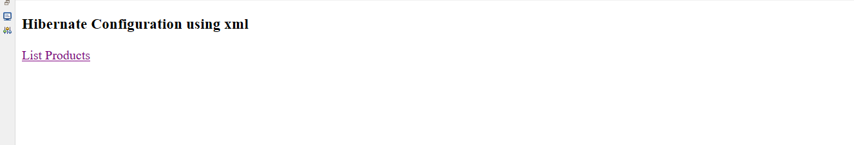

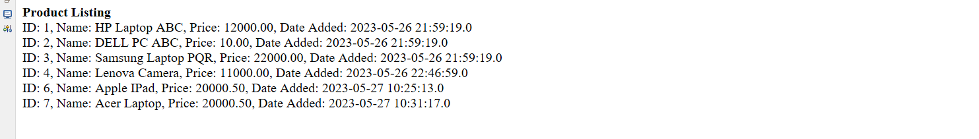
Assisted Practice: 3.3 Hibernate Configuration Using Annotations in Eclipse
Configure Hibernate using Annotations in Eclipse IDE.
- Set up Eclipse to work with Hibernate
- Create a database and a table in MySQL
- Configure Hibernate using annotations to work with the table
- Create an HTML page to call a servlet
- Create a servlet that will display rows from the table

Step 3.3.1: Creating a database in MySQL
- MySQL is already installed in your practice lab. (Refer FSD: Lab Guide - Phase 2)
- Login to the MySQL command line console
- Type CREATE DATABASE ecommerce and press Enter
- Type USE ecommerce and press Enter
- Type CREATE TABLE eproduct (ID bigint primary key auto_increment, name varchar(100), price decimal(10,2), date_added timestamp default now()) and press Enter
- We will now add some rows into the table
- Type INSERT INTO eproduct(name, ‘HP Laptop ABC’, 12000) and press Enter
- Type INSERT INTO eproduct(name, ‘Dell pc ABC’, 19000) and press Enter
- Type INSERT INTO eproduct(name, ‘Samsung Laptop PQR’, 22000) and press Enter
- Type SELECT * from eproduct and press Enter to confirm that the rows have been added
- Type EXIT to exit the MySQL command console

Step 3.3.2: Creating a dynamic web project
- Open Eclipse
- Go the File menu. Choose New->Dynamic Web Project
- Enter the project name as HibernateAnnotations. Click on Next
- Enter nothing in the next screen and click on Next
- Check the checkbox Generate web.xml deployment descriptor and click on Finish
- This will create the project files in the Project Explorer

Step 3.3.3: Adding the jar files for Hibernate and its dependencies
- Hibernate.jar file is already present in your practice lab. (Refer FSD: Lab Guide - Phase 2)
- Take hibernate.jar from folder mentioned in the lab guide for phase 2 and add it to your project’s WebContent/WEB-INF/lib folder
- mysql-connector-java.jar file is present in your practice lab. (Refer FSD: Lab Guide - Phase 2)
- Take mysql-connector-java.jar file from the folder mentioned in the lab guide for phase 2 and add it to your project’s WebContent/WEB-INF/lib folder
- Go to http://www.java2s.com/Code/Jar/j/Downloadjta11jar.htm
- Click on jta-1_1.jar.zip link to download it
- Extract jta-1_1.jar from it and add it to your project’s’ WebContent/WEB-INF/lib folder
- Go to http://www.java2s.com/Code/Jar/j/Downloadjavaxxmlbindjar.htm
- Click on javax.xml/javax.xml.bind.jar.zip link to download it
- Extract javax.xml.bind.jar from it and add it to your project’s WebContent/WEB-INF/lib folder
- Go to https://jar-download.com/artifacts/com.sun.xml.bind
- Click on the button Download jaxb-osgi.jar to download it
- Extract jaxb-osgi-2.4.0-b180830.0438.jar from it and add it to your project’s WebContent/WEB-INF/lib folder

Step 3.3.4: Configuring Hibernate with hibernate.cfg.xml
- In the Project Explorer, expand HibernateAnnotations->Java Resources
- Right click on src and choose New->Other
- Select General->File and click on Next
- In filename, enter hibernate.cfg.xml and click on Finish
- Enter the following code:

<!DOCTYPE hibernate-configuration PUBLIC
"-//Hibernate/Hibernate Configuration DTD 3.0//EN"
"http://www.hibernate.org/dtd/hibernate-configuration-3.0.dtd">
<hibernate-configuration>
<session-factory>
<!-- Database connection settings -->
<property name="connection.driver_class">com.mysql.jdbc.Driver</property>
<property name="connection.url">jdbc:mysql://localhost:3306/ecommerce</property>
<property name="connection.username">root</property>
<property name="connection.password">root</property>

<!-- Mapping files -->
<mapping class="pack1.Eproduct"/>
</session-factory>
</hibernate-configuration>

Step 3.3.5: Creating a HibernateUtil class to initiate Hibernate in code
- In the Project Explorer, expand HibernateAnnotations->Java Resources
- Right click on src and choose New->Class
- In Package Name, enter pack1 and in Name enter HibernateUtil and click on Finish
- Enter the following code:

import org.hibernate.SessionFactory;
import org.hibernate.boot.Metadata;
import org.hibernate.boot.MetadataSources;
import org.hibernate.boot.registry.StandardServiceRegistry;
import org.hibernate.boot.registry.StandardServiceRegistryBuilder;

public class HibernateUtil {
private static final SessionFactory sessionFactory;

static {
try {
StandardServiceRegistry standardRegistry = new StandardServiceRegistryBuilder().configure("hibernate.cfg.xml").build();
Metadata metaData = new MetadataSources(standardRegistry).getMetadataBuilder().build();
sessionFactory = metaData.getSessionFactoryBuilder().build();
} catch (Throwable th) {
throw new ExceptionInInitializerError(th);
}
}

public static SessionFactory getSessionFactory() {
return sessionFactory;
}

}

Step 3.3.6: Creating an HTML page index.html
- In the Project Explorer, expand the project HibernateAnnotations
- Expand WebContent. Right click on WebContent. Choose New->HTML File
- Enter the filename as index.html and click on Finish
- Enter the following code:

<!DOCTYPE html>
<html>
<head>
<meta charset="ISO-8859-1">
<title>Hibernate Annotations</title>
</head>
<body>
<h1>Hibernate Annotation Query</h1>
<a href = "ProductServlet">List Products</a>
</body>
</html>

- Click on the Save icon

Step 3.3.7: Creating a Java class Eproduct to act as the Data Access Object (DAO) for the table
- In the Project Explorer, expand HibernateAnnotations->Java Resources
- Right click on src and choose New->Class
- In Package, enter pack1 and in Class Name enter Eproduct and click on Finish
- Enter the following code:

import java.math.BigDecimal;
import java.util.Date;

import javax.persistence.Column;
import javax.persistence.Entity;
import javax.persistence.GeneratedValue;
import javax.persistence.Id;
import javax.persistence.Table;

@Entity
@Table(name= "eproduct")
public class Eproduct {

@Id @GeneratedValue
@Column(name = "ID")
private long ID;

@Column(name = "name")
private String name;

@Column(name = "price")
private BigDecimal price;

@Column(name = "date_added")
private Date date_added;

public Eproduct() {

}
public long getID() {
return ID;
}
public void setID(long iD) {
ID = iD;
}
public String getName() {
return name;
}
public void setName(String name) {
this.name = name;
}
public BigDecimal getPrice() {
return price;
}
public void setPrice(BigDecimal price) {
this.price = price;
}
public Date getDate_added() {
return date_added;
}
public void setDate_added(Date date_added) {
this.date_added = date_added;
}

}

Step 3.3.8: Creating a ProductServlet servlet
- In the Project Explorer, expand HibernateAnnotations->Java Resources
- Right click on src and choose New->Servlet
- In Class Name, enter ProductServlet and click on Finish
- Enter the following code:

import java.io.IOException;
import java.io.PrintWriter;
import java.util.List;

import javax.servlet.ServletException;
import javax.servlet.annotation.WebServlet;
import javax.servlet.http.HttpServlet;
import javax.servlet.http.HttpServletRequest;
import javax.servlet.http.HttpServletResponse;

import org.hibernate.Session;
import org.hibernate.SessionFactory;

@WebServlet("/ProductServlet")
public class ProductServlet extends HttpServlet {
private static final long serialVersionUID = 1L;

protected void doGet(HttpServletRequest request, HttpServletResponse response) throws ServletException, IOException {
try {
SessionFactory factory = HibernateUtil.getSessionFactory();

Session session = factory.openSession();
// using HQL
List<Eproduct> list = session.createQuery("from Eproduct").list();

session.close();

PrintWriter out = response.getWriter();
out.println("<html><body>");
out.println("<b>Product Listing</b><br>");
for(Eproduct p: list) {
out.println("ID: " + String.valueOf(p.getID()) + ", Name: " + p.getName() +
", Price: " + String.valueOf(p.getPrice()) + ", Date Added: " + p.getDate_added().toString() + "<br>");
}

out.println("</body></html>");

} catch (Exception ex) {
throw ex;
}
}

}

Step 3.3.9: Checking for servlet-api.jar
- Before building the project, we need to add servlet-api.jar to the project
- Servlet-api.jar file is already present in your practice lab. (Refer FSD: Lab Guide - Phase 2)
- To add it to the project, follow the below mentioned steps:
  - In the Project Explorer, right click on HibernateAnnotations and choose Properties
  - Select Java Build Path from the options on the left
  - Click on Libraries tab on the right
  - Under ClassPath, expand the node that says Apache Tomcat
  - If there is an existing entry for servlet-api.jar, then click on Cancel and exit the window
  - If it is not there, then click on Classpath entry and click on Add External JARs button on the right
  - From the file list, select servlet-api.jar file and click on Ok
  - Click on Apply and Close

Step 3.3.10: Building the project
- From the Project menu at the top, click on Build
- If any compile errors are shown, fix them as required

Step 3.3.11: Publishing and starting the project
- If you do not see the Servers tab near the bottom of the IDE, go to Window menu and click Show View->Servers
- Right click on the Server entry and choose Add and Remove
- Click the Add button to move HibernateAnnotations from the Available list to the Configured list
- Click on Finish
- Right click on the Server entry and click on Publish
- Right click on the Server entry and click on Start
- This will start the server

Step 3.3.12: Running the project
- To run the project, open a web browser and type: http://localhost:8080/HibernateAnnotations

Output:
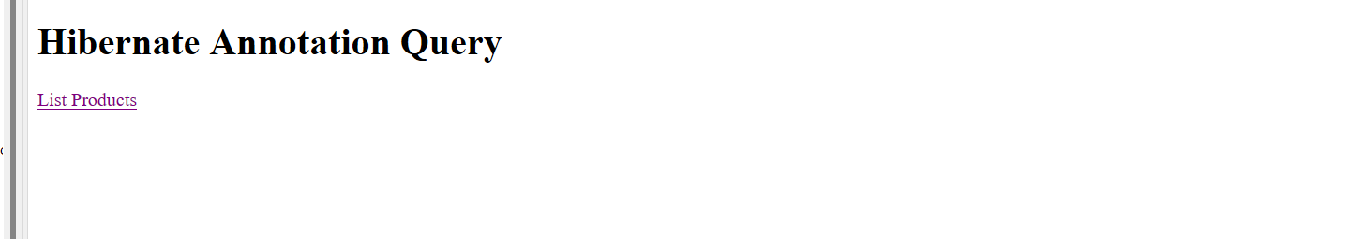

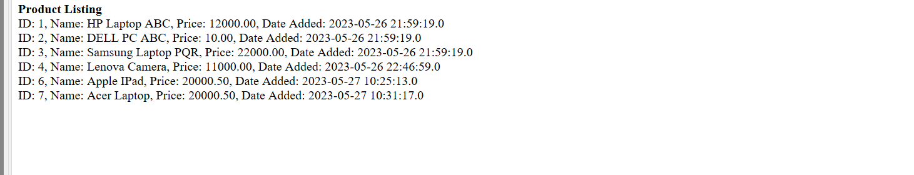
Assisted Practice: 3.4 Hibernate Logging by Log4j
Demonstrate Hibernate logging by Log4j.
- Set up Eclipse to work with Hibernate
- Configure log4j to do logging
- Create an HTML page to call a servlet
- Create a servlet that will initialize Hibernate with enabled logging and then close it

Step 3.4.1: Creating a dynamic web project
- Open Eclipse
- Go the File menu. Choose New->Dynamic Web Project
- Enter the project name as hibernateconfig. Click on Next
- Enter nothing in the next screen and click on Next
- Check the checkbox Generate web.xml deployment descriptor and click on Finish
- This will create the project files in the Project Explorer

Step 3.4.2: Adding the jar files for Hibernate and its dependencies
- Hibernate.jar file is already present in your practice lab. (Refer FSD: Lab Guide - Phase 2)
- Take hibernate.jar from folder mentioned in the lab guide for phase 2 and add it to your project’s WebContent/WEB-INF/lib folder
- mysql-connector-java.jar file is present in your practice lab. (Refer FSD: Lab Guide - Phase 2)
- Take mysql-connector-java.jar file from the folder mentioned in the lab guide for phase 2 and add it to your project’s WebContent/WEB-INF/lib folder
- Go to http://www.java2s.com/Code/Jar/j/Downloadjta11jar.htm
- Click on jta-1_1.jar.zip link to download it
- Extract jta-1_1.jar from it and put it to your project’s WebContent/WEB-INF/lib folder
- Go to http://www.java2s.com/Code/Jar/j/Downloadjavaxxmlbindjar.htm
- Click on javax.xml/javax.xml.bind.jar.zip link to download it
- Extract javax.xml.bind.jar from it and add it to your project’s WebContent/WEB-INF/lib folder
- Go to https://jar-download.com/artifacts/com.sun.xml.bind
- Click on the button Download jaxb-osgi.jar to download it
- Extract jaxb-osgi-2.4.0-b180830.0438.jar from it and add it to your project’s WebContent/WEB-INF/lib folder.
- Go to http://java2s.com/Code/Jar/s/Downloadslf4jlog4j12jar.htm
- Click on the link slf4j-log4j12/slf4j-log4j12.jar.zip( 7 k) to download it
- Extract all 3 jar files in the zip and add them to your project’s WebContent/WEB-INF/lib folder

Step 3.4.3: Configuring Hibernate with hibernate.cfg.xml
- In the Project Explorer, expand hibernateconfig ->Java Resources
- Right click on src and choose New->Other
- Select General->File and click on Next
- In filename, enter hibernate.cfg.xml and click on Finish
- Enter the following code:

<?xml version='1.0' encoding='utf-8'?>
<!DOCTYPE hibernate-configuration PUBLIC
"-//Hibernate/Hibernate Configuration DTD 3.0//EN"
"http://www.hibernate.org/dtd/hibernate-configuration-3.0.dtd">
<hibernate-configuration>
<session-factory>
<!-- Database connection settings -->
<property name="connection.driver_class">com.mysql.jdbc.Driver</property>
<property name="connection.url">jdbc:mysql://localhost:3306/ecommerce</property>
<property name="connection.username">root</property>
<property name="connection.password">root</property>

<!-- Mapping files -->
<mapping resource="pack1/Eproduct.hbm.xml"/>
</session-factory>
</hibernate-configuration>

Step 3.4.4: Configuring log4j with log4j.properties
- In the Project Explorer, expand hibernateconfig ->Java Resources
- Right click on src and choose New->Other
- Select General->File and click on Next
- In filename, enter log4j.properties and click on Finish
- Enter the following code:

log4j.rootLogger=DEBUG, Appender1,Appender2

log4j.appender.Appender1=org.apache.log4j.ConsoleAppender
log4j.appender.Appender1.layout=org.apache.log4j.PatternLayout
log4j.appender.Appender1.layout.ConversionPattern=%-7p %d [%t] %c %x - %m%n

log4j.appender.Appender2=org.apache.log4j.FileAppender
log4j.appender.Appender2.File=E:\hibernatelog.txt
log4j.appender.Appender2.layout=org.apache.log4j.PatternLayout
log4j.appender.Appender2.layout.ConversionPattern=%-7p %d [%t] %c %x - %m%n

# Log everything. Good for troubleshooting
log4j.logger.org.hibernate=INFO

# Log all JDBC parameters
log4j.logger.org.hibernate.type=ALL

- Be sure to change the path of the log file log4j.appender.file.File=xxxxx to an actual path in your disk

Step 3.4.5: Creating an HTML page index.html
- In the Project Explorer, expand the project hibernateconfig
- Expand WebContent. Right click on WebContent. Choose New->HTML File
- Enter the filename as index.html and click on Finish
- Enter the following code:

<!DOCTYPE html>
<html>
<head>
<meta charset="ISO-8859-1">
<title>Hibernate Configuration</title>
</head>
<body>
<h3>Hibernate Configuration using xml</h3>
<a href = "ProductServlet">List Products</a>
</body>
</html>

- Click on the Save icon

Step 3.4.6: Creating a HibernateUtil class to initiate Hibernate in code
- In the Project Explorer, expand hibernateconfig ->Java Resources
- Right click on src and choose New->Class
- In Package Name, enter pack1 and in Name enter HibernateUtil and click on Finish
- Enter the following code:

import org.hibernate.SessionFactory;
import org.hibernate.boot.Metadata;
import org.hibernate.boot.MetadataSources;
import org.hibernate.boot.registry.StandardServiceRegistry;
import org.hibernate.boot.registry.StandardServiceRegistryBuilder;

public class Hibernateutil {
private static final SessionFactory sessionFactory;

static {
try {
StandardServiceRegistry standardRegistry = new StandardServiceRegistryBuilder().configure("hibernate.cfg.xml").build();
Metadata metaData = new MetadataSources(standardRegistry).getMetadataBuilder().build();
sessionFactory = metaData.getSessionFactoryBuilder().build();
} catch (Throwable th) {
throw new ExceptionInInitializerError(th);
}
}

public static SessionFactory getSessionFactory() {
return sessionFactory;
}
}

Step 3.2.7: Creating a Java class Eproduct to act as the Data Access Object (DAO) for the table
- In the Project Explorer, expand hibernateconfig ->Java Resources
- Right click on src and choose New->Class
- In Package, enter pack1 and in Class Name enter Eproduct and click on Finish
- Enter the following code:

import java.math.BigDecimal;
import java.util.Date;

public class Eproduct {
private long ID;
private String name;
private BigDecimal price;
private Date date_added;

public Eproduct() {
// Default constructor
}

public Eproduct(long iD, String name, BigDecimal price, Date date_added) {
super();
ID = iD;
this.name = name;
this.price = price;
this.date_added = date_added;
}
public long getID() {
return ID;
}
public void setID(long iD) {
ID = iD;
}
public String getName() {
return name;
}
public void setName(String name) {
this.name = name;
}
public BigDecimal getPrice() {
return price;
}
public void setPrice(BigDecimal price) {
this.price = price;
}
public Date getDate_added() {
return date_added;
}
public void setDate_added(Date date_added) {
this.date_added = date_added;
}

}

Step 3.2.8: Creating a ProductServlet servlet
- In the Project Explorer, expand hibernateconfig ->Java Resources
- Right click on src and choose New->Servlet
- In Class Name, enter ProductServlet and click on Finish
- Enter the following code:

import java.io.IOException;
import java.io.PrintWriter;
import java.util.List;

import javax.servlet.ServletException;
import javax.servlet.annotation.WebServlet;
import javax.servlet.http.HttpServlet;
import javax.servlet.http.HttpServletRequest;
import javax.servlet.http.HttpServletResponse;

import org.hibernate.Session;
import org.hibernate.SessionFactory;

@WebServlet("/ProductServlet")
public class ProductServlet extends HttpServlet {
private static final long serialVersionUID = 1L;

protected void doGet(HttpServletRequest request, HttpServletResponse response) throws ServletException, IOException {

try {
SessionFactory factory = Hibernateutil.getSessionFactory();

Session session = factory.openSession();
// using HQL
List<Eproduct> list = session.createQuery("from Eproduct").list();

session.close();

PrintWriter out = response.getWriter();
out.println("<html><body>");
out.println("<b>Product Listing</b><br>");
for(Eproduct p: list) {
out.println("ID: " + String.valueOf(p.getID()) + ", Name: " + p.getName() +
", Price: " + String.valueOf(p.getPrice()) + ", Date Added: " + p.getDate_added().toString() + "<br>");
}

out.println("</body></html>");

} catch (Exception ex) {
throw ex;
}

}

}

Step 3.2.9: Configuring the table in Hibernate with a .hbm.xml file
- In the Project Explorer, expand hibernateconfig ->Java Resources->src
- Right click on pack1 and choose New->Other
- Select General->File and click on Next
- In filename, enter Eproduct.hbm.xml and click on Finish
- Enter the following code:

<?xml version="1.0" encoding="UTF-8"?>
<!DOCTYPE hibernate-mapping PUBLIC
"-//Hibernate/Hibernate Mapping DTD 3.0//EN"
"http://www.hibernate.org/dtd/hibernate-mapping-3.0.dtd">
<hibernate-mapping package="pack1">
<class name="Eproduct" table="eproduct">
<id name="ID" column="ID">
<generator class="increment"/>
</id>
<property name="name" type="string" column="NAME"/>
<property name="price" type="big_decimal" column="PRICE"/>
<property name="date_added" type="timestamp" column="DATE_ADDED"/>

</class>
</hibernate-mapping>

Step 3.4.10: Checking for servlet-api.jar
- Before building the project, we need to add servlet-api.jar to the project
- Servlet-api.jar file is already present in your practice lab. (Refer FSD: Lab Guide - Phase 2)
- To add it to the project, follow the below mentioned steps:
  - In the Project Explorer, right click on hibernateconfig and choose Properties
  - Select Java Build Path from the options on the left
  - Click on Libraries tab on the right
  - Under ClassPath, expand the node that says Apache Tomcat
  - If there is an existing entry for servlet-api.jar, then click on Cancel and exit the window
  - If it is not there, then click on Classpath entry and click on Add External JARs button on the right
  - From the file list, select servlet-api.jar file and click on Ok
  - Click on Apply and Close

Step 3.4.11: Building the project
- From the Project menu at the top, click on Build
- If any compile errors are shown, fix them as required

Step 3.4.12: Publishing and starting the project
- If you do not see the Servers tab near the bottom of the IDE, go to Window menu and click on Show View->Servers
- Right click on the Server entry and choose Add and Remove
- Click the Add button to move hibernateconfig from the Available list to the Configured list
- Click on Finish
- Right click on the Server entry and click on Publish
- Right click on the Server entry and click on Start
- This will start the server

Step 3.4.13: Running the project
- To run the project, open a web browser and type:
http://localhost:8080/ hibernateconfig

Output:
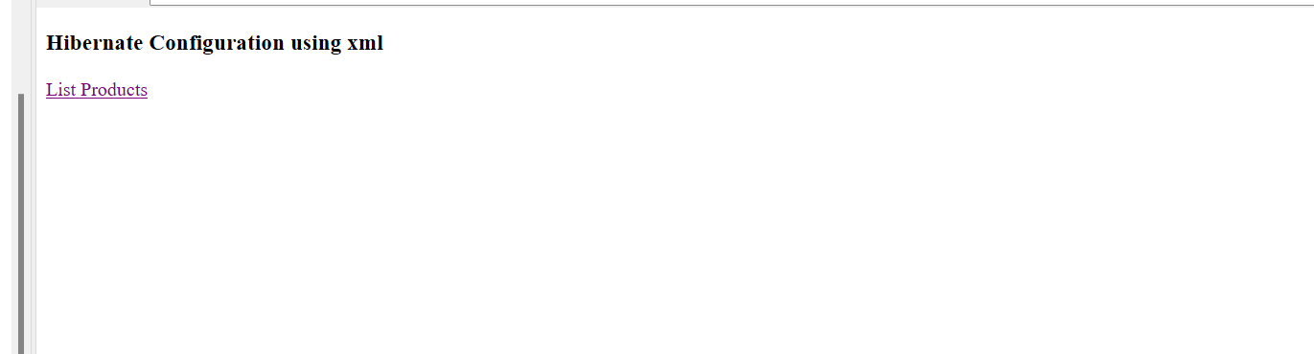

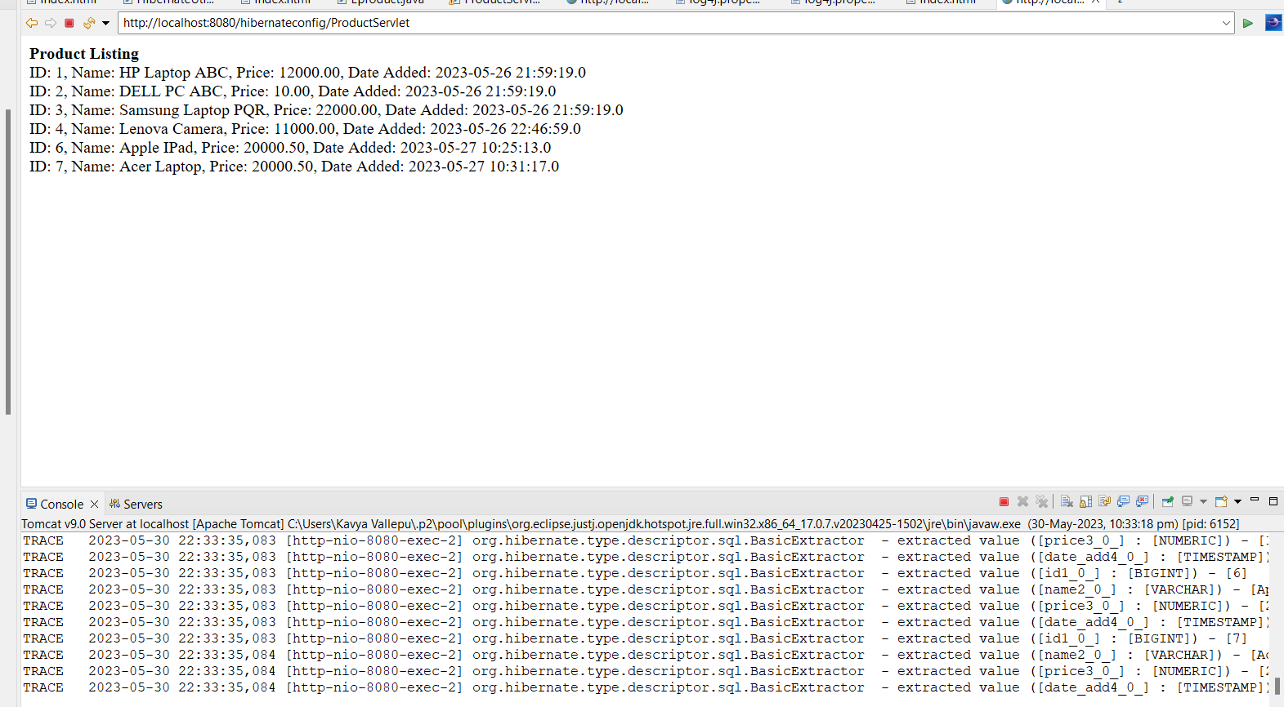

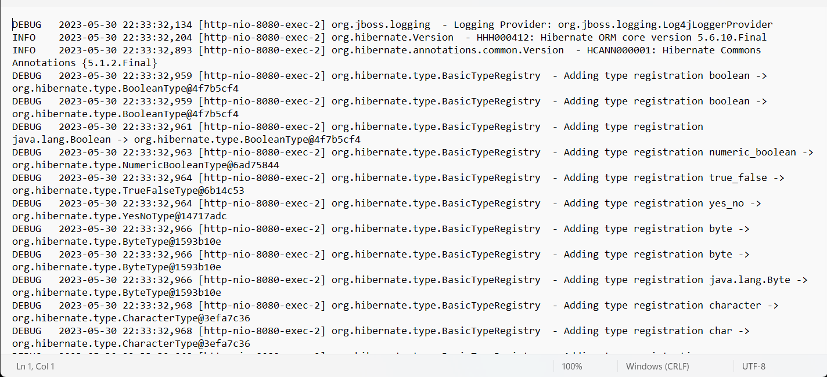
Assisted Practice 3.5 Collection Mapping in Hibernate
Demonstrate mapping List, Set, Bag, and Map in collection using XML file.
- Set up Eclipse to work with Hibernate
- Set up database tables to do collection mapping
- Create an HTML page to call a servlet
- Create a servlet that will display data from the tables using collection mapping

Step 3.5.1: Creating a dynamic web project
- Open Eclipse
- Go the File menu. Choose New->Dynamic Web Project
- Enter the project name as CollectionMappingDemo. Click on Next
- Enter nothing in the next screen and click on Next
- Check the checkbox Generate web.xml deployment descriptor and click on Finish
- This will create the project files in the Project Explorer

Step 3.5.2: Adding the jar files for Hibernate and its dependencies
- Hibernate.jar file is already present in your practice lab. (Refer FSD: Lab Guide - Phase 2)
- Take hibernate.jar from folder mentioned in the lab guide for phase 2 and add it to your project’s WebContent/WEB-INF/lib folder
- mysql-connector-java.jar file is present in your practice lab. (Refer FSD: Lab Guide - Phase 2)
- Take mysql-connector-java.jar file from the folder mentioned in the lab guide for phase 2 and add it to your project’s WebContent/WEB-INF/lib folder
- Go to http://www.java2s.com/Code/Jar/j/Downloadjta11jar.htm
- Click on jta-1_1.jar.zip link to download it
- Extract jta-1_1.jar from it and add it to your project’s WebContent/WEB-INF/lib folder
- Go to http://www.java2s.com/Code/Jar/j/Downloadjavaxxmlbindjar.htm
- Click on javax.xml/javax.xml.bind.jar.zip link to download it
- Extract javax.xml.bind.jar from it and add it to your project’s WebContent/WEB-INF/lib folder
- Go to https://jar-download.com/artifacts/com.sun.xml.bind
- Click on the button Download jaxb-osgi.jar to download it
- Extract jaxb-osgi-2.4.0-b180830.0438.jar from it and add it to your project’s WebContent/WEB-INF/lib folder

Step 3.5.3: Creating tables in MySQL: colors, eproduct, finance, os, screensizes in the database and filling them with sample data
- MySQL is already installed in your practice lab. (Refer FSD: Lab Guide - Phase 2)
- Login to the MySQL command line console
- Type CREATE DATABASE ecommerce and press Enter
- Type USE ecommerce and press Enter
- Enter the following script and execute it:

use ecommerce;
CREATE TABLE `colors` (
`ID` bigint(20) NOT NULL AUTO_INCREMENT,
`color_name` varchar(40) DEFAULT NULL,
`idx` int(11) DEFAULT NULL,
`product_id` bigint(20) DEFAULT NULL,
PRIMARY KEY (`ID`)
);

INSERT INTO `colors` VALUES (1,'Red',0,1),(2,'Silver',1,1),(3,'Gray',0,2),(4,'White',1,2),(5,'Maroon',0,3);

use ecommerce;

CREATE TABLE `screensizes` (
`ID` bigint(20) NOT NULL AUTO_INCREMENT,
`size` varchar(10) DEFAULT NULL,
`product_id` bigint(20) DEFAULT NULL,
PRIMARY KEY (`ID`)
) ;

INSERT INTO `screensizes` VALUES (1,'12 in',1),(2,'14.5 in',2),(3,'14.9 in',2),(4,'15.5 in',3);

CREATE TABLE `os` (
`ID` bigint(20) NOT NULL AUTO_INCREMENT,
`name` varchar(30) DEFAULT NULL,
`product_id` bigint(20) DEFAULT NULL,
PRIMARY KEY (`ID`)
);

INSERT INTO `os` VALUES (1,'Windows 10',1),(2,'Windows 10',2), (3,'FreeDOS',2),(4,'RedHat Linux',2),(5,'Windows 10',3);

CREATE TABLE `finance` (
`ID` bigint(20) NOT NULL AUTO_INCREMENT,
`ftype` varchar(10) DEFAULT NULL,
`name` varchar(30) DEFAULT NULL,
`product_id` bigint(20) DEFAULT NULL,
PRIMARY KEY (`ID`)
) ;

INSERT INTO `finance` VALUES (1,'CREDITCARD','EMI on Citibank Card',1),(3,'BANK','40% finance from SBI',2), (4,'BANK','60% finance from ICICI',3), (5,'BANK','20% finance from ICICI',1);

Step 3.5.4: Creating a class Color
- In the Project Explorer, expand CollectionMappingDemo ->Java Resources
- Right click on src and choose New->Class
- In Package, enter pack1 and in Name, enter Color and click on Finish
- Enter the following code:

public class Color {
private long colorId;
private String name;
Color() {
super();
// TODO Auto-generated constructor stub
}
public long getColorId() {
return colorId;
}
public void setColorId(long colorId) {
this.colorId = colorId;
}
public String getName() {
return name;
}
public void setName(String name) {
this.name = name;
}

}

Step 3.5.5: Creating a class Eproduct
- In the Project Explorer, expand CollectionMappingDemo ->Java Resources
- Right click on src and choose New->Class
- In Package, enter pack1 and in Name, enter Eproduct and click on Finish
- Enter the following code:

import java.math.BigDecimal;
import java.util.Collection;
import java.util.Date;
import java.util.List;
import java.util.Map;
import java.util.Set;

public class Eproduct {
private long ID;
private String name;
private BigDecimal price;
private Date dateAdded;

private List<Color> Colors;

private Set<OS> os;

private Collection<ScreenSizes> screensizes;

private Map finance;
public Eproduct() {

}
public long getID() {
return ID;
}
public void setID(long iD) {
ID = iD;
}
public String getName() {
return name;
}
public void setName(String name) {
this.name = name;
}
public BigDecimal getPrice() {
return price;
}
public void setPrice(BigDecimal price) {
this.price = price;
}
public Date getDateAdded() {
return dateAdded;
}
public void setDateAdded(Date dateAdded) {
this.dateAdded = dateAdded;
}
public List<Color> getColors() {
return Colors;
}
public void setColors(List<Color> colors) {
Colors = colors;
}
public Set<OS> getOs() {
return os;
}
public void setOs(Set<OS> os) {
this.os = os;
}
public Collection<ScreenSizes> getScreensizes() {
return screensizes;
}
public void setScreensizes(Collection<ScreenSizes> screensizes) {
this.screensizes = screensizes;
}
public Map getFinance() {
return finance;
}
public void setFinance(Map finance) {
this.finance = finance;
}

}

Step 3.5.6: Creating a class Finance
- In the Project Explorer, expand CollectionMappingDemo ->Java Resources
- Right click on src and choose New->Class
- In Package, enter pack1 and in Name, enter Finance and click on Finish
- Enter the following code:

public class Finance {
private long FINANCEID;
private String name;
private String ftype;
public Finance()
{

}
public Finance(long fINANCEID, String name, String ftype) {
super();
FINANCEID = fINANCEID;
this.name = name;
this.ftype = ftype;
}
public long getFINANCEID() {
return FINANCEID;
}
public void setFINANCEID(long fINANCEID) {
FINANCEID = fINANCEID;
}
public String getName() {
return name;
}
public void setName(String name) {
this.name = name;
}
public String getFtype() {
return ftype;
}
public void setFtype(String ftype) {
this.ftype = ftype;
}

}

Step 3.5.7: Creating a class OS
- In the Project Explorer, expand CollectionMappingDemo ->Java Resources
- Right click on src and choose New->Class
- In Package, enter pack1 and in Name, enter OS and click on Finish
- Enter the following code:

public class OS {
private long OSID;
private String name;
public OS() {

}
public OS(long oSID, String name) {
super();
OSID = oSID;
this.name = name;
}
public long getOSID() {
return OSID;
}
public void setOSID(long oSID) {
OSID = oSID;
}
public String getName() {
return name;
}
public void setName(String name) {
this.name = name;
}

}

Step 3.5.8: Creating a class ScreenSizes
- In the Project Explorer, expand HibernateListMapping->Java Resources
- Right click on src and choose New->Class
- In Package, enter pack1 and in Name, enter ScreenSizes and click on Finish
- Enter the following code:

public class ScreenSizes {
private long SCREENID;
private String size;

public ScreenSizes() {

}
public ScreenSizes(long sCREENID, String size) {
super();
SCREENID = sCREENID;
this.size = size;
}
public long getSCREENID() {
return SCREENID;
}
public void setSCREENID(long sCREENID) {
SCREENID = sCREENID;
}
public String getSize() {
return size;
}
public void setSize(String size) {
this.size = size;
}

}

Step 3.5.9: Creating a HibernateUtil class to initiate Hibernate in code
- In the Project Explorer, expand CollectionMappingDemo ->Java Resources
- Right click on src and choose New->Class
- In Package, enter pack1 and in Name, enter HibernateUtil and click on Finish
- Enter the following code:

import org.hibernate.SessionFactory;
import org.hibernate.boot.Metadata;
import org.hibernate.boot.MetadataSources;
import org.hibernate.boot.registry.StandardServiceRegistry;
import org.hibernate.boot.registry.StandardServiceRegistryBuilder;

public class HibernateUtil {
private static final SessionFactory sessionFactory;

static {
try {
StandardServiceRegistry standardRegistry = new StandardServiceRegistryBuilder().configure("hibernate.cfg.xml").build();
Metadata metaData = new MetadataSources(standardRegistry).getMetadataBuilder().build();
sessionFactory = metaData.getSessionFactoryBuilder().build();
} catch (Throwable th) {
throw new ExceptionInInitializerError(th);
}
}

public static SessionFactory getSessionFactory() {
return sessionFactory;
}

}

Step 3.5.10: Creating hibernate table configuration file Color.hbm.xml
- In the Project Explorer, expand CollectionMappingDemo ->Java Resources
- Right click on src and choose New->Other
- Select General->File and click on Next
- In filename, enter Color.hbm.xml and click on Finish
- Enter the following code:

<?xml version="1.0"?>
<!DOCTYPE hibernate-mapping PUBLIC
"-//Hibernate/Hibernate Mapping DTD 3.0//EN"
"http://www.hibernate.org/dtd/hibernate-mapping-3.0.dtd">
<hibernate-mapping package="pack1">
<class name="Color" table="colors">
<id name="colorId" type="long" column="ID">
<generator class="identity"/>
</id>
<property name="name" type="string" column="COLOR_NAME"/>
</class>
</hibernate-mapping>

Step 3.5.11: Creating hibernate table configuration file Eproduct.hbm.xml
- In the Project Explorer, expand CollectionMappingDemo ->Java Resources
- Right click on src and choose New->Other
- Select General->File and click on Next
- In filename, enter Eproduct.hbm.xml and click on Finish
- Enter the following code:

<?xml version="1.0"?>
<!DOCTYPE hibernate-mapping PUBLIC
"-//Hibernate/Hibernate Mapping DTD 3.0//EN"
"http://www.hibernate.org/dtd/hibernate-mapping-3.0.dtd">
<hibernate-mapping package="pack1">
<class name="Eproduct" table="eproduct">
<id name="ID" type="long" column="ID">
<generator class="identity"/>
</id>
<property name="name" type="string" column="NAME"/>
<property name="price" type="big_decimal" column="PRICE"/>
<property name="dateAdded" type="timestamp" column="DATE_ADDED"/>

<list name="colors" cascade="all">
<key column="product_id" />
<list-index column="idx" />
<one-to-many class="pack1.Color" />
</list>

<bag name="screensizes" cascade="all">
<key column="product_id"></key>
<one-to-many class="pack1.ScreenSizes"/>
</bag>

<set name = "os" cascade="all">
<key column = "product_id"/>
<one-to-many class="OS"/>
</set>

<map name = "finance" cascade="all">
<key column = "product_id"/>
<index column = "ftype" type = "string"/>
<one-to-many class="pack1.Finance"/>
</map>
</class>
</hibernate-mapping>

Step 3.5.12: Creating hibernate table configuration file Finance.hbm.xml
- In the Project Explorer, expand CollectionMappingDemo ->Java Resources
- Right click on src and choose New->Other
- Select General->File and click on Next
- In filename, enter Finance.hbm.xml and click on Finish
- Enter the following code:

<?xml version="1.0"?>
<!DOCTYPE hibernate-mapping PUBLIC
"-//Hibernate/Hibernate Mapping DTD 3.0//EN"
"http://www.hibernate.org/dtd/hibernate-mapping-3.0.dtd">
<hibernate-mapping package="pack1">
<class name="Finance" table="finance">
<id name="FINANCEID" type="long" column="ID">
<generator class="identity"/>
</id>
<property name="name" type="string" column="NAME"/>
<property name="ftype" type="string" column="FTYPE"/>
</class>
</hibernate-mapping>

Step 3.5.13: Creating hibernate table configuration file Os.hbm.xml
- In the Project Explorer, expand CollectionMappingDemo ->Java Resources
- Right click on src and choose New->Other
- Select General->File and click on Next
- In filename, enter Os.hbm.xml and click on Finish
- Enter the following code:

<?xml version="1.0"?>
<!DOCTYPE hibernate-mapping PUBLIC
"-//Hibernate/Hibernate Mapping DTD 3.0//EN"
"http://www.hibernate.org/dtd/hibernate-mapping-3.0.dtd">
<hibernate-mapping package="pack1">
<class name="OS" table="os">
<id name="OSID" type="long" column="ID">
<generator class="identity"/>
</id>
<property name="name" type="string" column="NAME"/>
</class>
</hibernate-mapping>

Step 3.5.14: Creating hibernate table configuration file ScreenSizes.hbm.xml
- In the Project Explorer, expand CollectionMappingDemo ->Java Resources
- Right click on src and choose New->Other
- Select General->File and click on Next
- In filename, enter ScreenSizes.hbm.xml and click on Finish
- Enter the following code:

<?xml version="1.0"?>
<!DOCTYPE hibernate-mapping PUBLIC
"-//Hibernate/Hibernate Mapping DTD 3.0//EN"
"http://www.hibernate.org/dtd/hibernate-mapping-3.0.dtd">
<hibernate-mapping package="pack1">
<class name="ScreenSizes" table="screensizes">
<id name="SCREENID" type="long" column="ID">
<generator class="identity"/>
</id>
<property name="size" type="string" column="SIZE"/>
</class>
</hibernate-mapping>

Step 3.5.15: Configuring Hibernate with hibernate.cfg.xml
- In the Project Explorer, expand CollectionMappingDemo ->Java Resources
- Right click on src and choose New->Other
- Select General->File and click on Next
- In filename, enter hibernate.cfg.xml and click on Finish
- Enter the following code:

<?xml version='1.0' encoding='utf-8'?>
<!DOCTYPE hibernate-configuration PUBLIC
"-//Hibernate/Hibernate Configuration DTD 3.0//EN"
"http://www.hibernate.org/dtd/hibernate-configuration-3.0.dtd">
<hibernate-configuration>
<session-factory>
<!-- Database connection settings -->
<property name="connection.driver_class">com.mysql.jdbc.Driver</property>
<property name="connection.url">jdbc:mysql://localhost:3306/ecommerce</property>
<property name="connection.username">root</property>
<property name="connection.password">kavya@2312</property>
<mapping resource="pack1/Eproduct.hbm.xml"/>
<mapping resource="pack1/Color.hbm.xml"/>
<mapping resource="pack1/ScreenSizes.hbm.xml"/>
<mapping resource="pack1/OS.hbm.xml"/>
<mapping resource="pack1/Finance.hbm.xml"/>
</session-factory>
</hibernate-configuration>

Step 3.5.16: Creating an HTML page index.html
- In the Project Explorer, expand the project CollectionMappingDemo
- Expand WebContent. Right click on WebContent. Choose New->HTML File
- Enter the filename as index.html and click on Finish
- Enter the following code:

<!DOCTYPE html>
<html>
<head>
<meta charset="ISO-8859-1">
<title>Hibernate collection mapping</title>
</head>
<body>
<h3>Hibernate Collection Mapping</h3>
<a href="ProductServlet">Product Details</a><br>
</body>
</html>

- Click on the Save icon

Step 3.5.17: Creating a ProductServlet servlet
- In the Project Explorer, expand CollectionMappingDemo ->Java Resources
- Right click on src and choose New->Servlet
- In Class Name, enter ProductServlet and click on Finish
- Enter the following code:

import java.io.IOException;
import java.io.PrintWriter;
import java.util.Collection;
import java.util.List;
import java.util.Map;
import java.util.Set;

import javax.servlet.ServletException;
import javax.servlet.annotation.WebServlet;
import javax.servlet.http.HttpServlet;
import javax.servlet.http.HttpServletRequest;
import javax.servlet.http.HttpServletResponse;

import org.hibernate.Session;
import org.hibernate.SessionFactory;

@WebServlet("/ProductServlet")
public class ProductServlet extends HttpServlet {
private static final long serialVersionUID = 1L;

protected void doGet(HttpServletRequest request, HttpServletResponse response) throws ServletException, IOException {
PrintWriter out = response.getWriter();
out.println("<html><body>");

// STEP 1: Get a Session (connection) from the Session Factory class
SessionFactory factory = HibernateUtil.getSessionFactory();
// STEP 2 Session
Session session = factory.openSession();

// STEP 32 execute the HQL commands
// for now we will only test if the connection is establised with MySQL server.
List<Eproduct> eproducts = session.createQuery("from Eproduct").list();

out.println("<br> Data from the eproduct table<table border=1>");
out.println("<th> ID <th> NAME <th> PRICE <th> DATE ADDED <th> COLORS <th> Screen Sizes <th> OS <th> FINANCE OPTIONS </th> ");
for (Eproduct prod : eproducts) {

// Display Core properties/details
out.println("<tr><td>" + prod.getID() + "<td>" + prod.getName() + "<td>" + prod.getPrice() + "<td>"
+ prod.getDateAdded());

// Display the available colors
List<Color> colors = prod.getColors();
out.println("<td> ");
for(Color color: colors)
out.println(color.getName() + " &nbsp;");

// Display the available screensizes
Collection<ScreenSizes> screenSizes = prod.getScreensizes();
out.println("<td> " );
for(ScreenSizes sSize: screenSizes)
out.println(sSize.getSize() + " &nbsp;");

// Display the available OSes
Set<OS> OSes = prod.getOs();
out.println("<td> ");
for(OS os: OSes)
out.println(os.getName() + " &nbsp;");

// Display the available finance options
Map finances = prod.getFinance();
out.println("<td> ");
if (finances .get("CREDITCARD") != null) {
Finance f = (Finance) finances .get("CREDITCARD");
out.println(f.getName() + " &nbsp;");
}
if (finances .get("BANK") != null) {
Finance f = (Finance) finances .get("BANK");
out.println(f.getName() + " &nbsp;");
}

}

session.close();

out.println("</body></html>");

}

}

Step 3.5.18: Checking for servlet-api.jar
- Before building the project, we need to add servlet-api.jar to the project
- Servlet-api.jar file is already present in your practice lab. (Refer FSD: Lab Guide - Phase 2)
- To add it to the project, follow the below mentioned steps:
  - In the Project Explorer, right click on CollectionMappingDemo and choose Properties
  - Select Java Build Path from the options on the left
  - Click on Libraries tab on the right
  - Under ClassPath, expand the node that says Apache Tomcat
  - If there is an existing entry for servlet-api.jar, then click on Cancel and exit the window
  - If it is not there, then click on Classpath entry and click on Add External JARs button on the right
  - From the file list, select servlet-api.jar file and click on Ok
  - Click on Apply and Close

Step 3.5.29: Building the project
- From the Project menu at the top, click on Build
- If any compile errors are shown, fix them as required

Step 3.5.20: Publishing and starting the project
- If you do not see the Servers tab near the bottom of the IDE, go to Window menu and click on Show View->Servers
- Right click on the Server entry and choose Add and Remove
- Click the Add button to move CollectionMappingDemo from the Available list to the Configured list
- Click on Finish
- Right click on the Server entry and click on Publish
- Right click on the Server entry and click on Start
- This will start the server

Step 3.5.21: Running the project
- To run the project, open a web browser and type:
http://localhost:8080/ CollectionMappingDemo

Output:

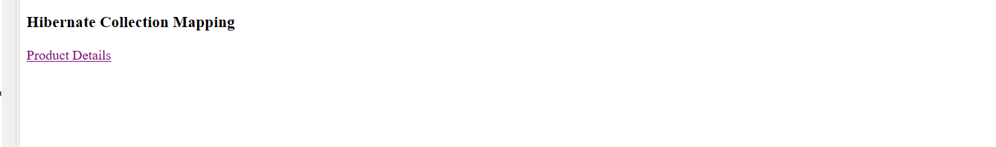

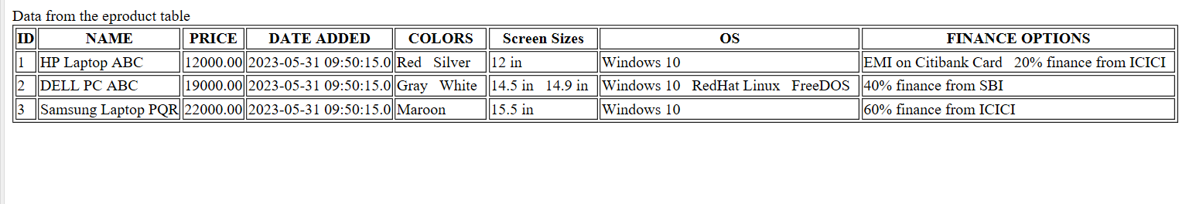
Assisted Practice: 3.6 Hibernate Lazy Collection
Demonstrate mapping List, Set, Bag, and Map in collection using XML file.
- Set up Eclipse to work with Hibernate
- Set up database tables to do collection mapping
- Create an HTML page to call a servlet
- Create a servlet that will display data from the tables using collection mapping

Step 3.6.1: Creating a dynamic web project
- Open Eclipse
- Go the File menu. Choose New->Dynamic Web Project
- Enter the project name as LazyCollectionMapping. Click on Next
- Enter nothing in the next screen and click on Next
- Check the checkbox Generate web.xml deployment descriptor and click on Finish
- This will create the project files in the Project Explorer

Step 3.6.2: Adding the jar files for Hibernate and its dependencies
- Hibernate.jar file is already present in your practice lab. (Refer FSD: Lab Guide - Phase 2)
- Take hibernate.jar from folder mentioned in the lab guide for phase 2 and add it to your project’s WebContent/WEB-INF/lib folder
- mysql-connector-java.jar file is present in your practice lab. (Refer FSD: Lab Guide - Phase 2)
- Take mysql-connector-java.jar file from the folder mentioned in the lab guide for phase 2 and add it to your project’s WebContent/WEB-INF/lib folder
- Go to http://www.java2s.com/Code/Jar/j/Downloadjta11jar.htm
- Click on jta-1_1.jar.zip link to download it
- Extract jta-1_1.jar from it and add it to your project’s WebContent/WEB-INF/lib folder
- Go to http://www.java2s.com/Code/Jar/j/Downloadjavaxxmlbindjar.htm
- Click on javax.xml/javax.xml.bind.jar.zip link to download it
- Extract javax.xml.bind.jar from it and add it to your project’s WebContent/WEB-INF/lib folder
- Go to https://jar-download.com/artifacts/com.sun.xml.bind
- Click on the button Download jaxb-osgi.jar to download it
- Extract jaxb-osgi-2.4.0-b180830.0438.jar from it and add it to your project’s WebContent/WEB-INF/lib folder

Step 3.6.3: Creating tables in MySQL: colors, eproduct, finance, os, screensizes in the database and filling them with sample data
- MySQL is already installed in your practice lab. (Refer FSD: Lab Guide - Phase 2)
- Login to the MySQL command line console
- Type CREATE DATABASE ecommerce and press Enter
- Type USE ecommerce and press Enter
- Enter the following script and execute it:

use ecommerce;
CREATE TABLE `colors` (
`ID` bigint(20) NOT NULL AUTO_INCREMENT,
`color_name` varchar(40) DEFAULT NULL,
`idx` int(11) DEFAULT NULL,
`product_id` bigint(20) DEFAULT NULL,
PRIMARY KEY (`ID`)
);

INSERT INTO `colors` VALUES (1,'Red',0,1),(2,'Silver',1,1),(3,'Gray',0,2),(4,'White',1,2),(5,'Maroon',0,3);

use ecommerce;

CREATE TABLE `screensizes` (
`ID` bigint(20) NOT NULL AUTO_INCREMENT,
`size` varchar(10) DEFAULT NULL,
`product_id` bigint(20) DEFAULT NULL,
PRIMARY KEY (`ID`)
) ;

INSERT INTO `screensizes` VALUES (1,'12 in',1),(2,'14.5 in',2),(3,'14.9 in',2),(4,'15.5 in',3);

CREATE TABLE `os` (
`ID` bigint(20) NOT NULL AUTO_INCREMENT,
`name` varchar(30) DEFAULT NULL,
`product_id` bigint(20) DEFAULT NULL,
PRIMARY KEY (`ID`)
);

INSERT INTO `os` VALUES (1,'Windows 10',1),(2,'Windows 10',2), (3,'FreeDOS',2),(4,'RedHat Linux',2),(5,'Windows 10',3);

CREATE TABLE `finance` (
`ID` bigint(20) NOT NULL AUTO_INCREMENT,
`ftype` varchar(10) DEFAULT NULL,
`name` varchar(30) DEFAULT NULL,
`product_id` bigint(20) DEFAULT NULL,
PRIMARY KEY (`ID`)
) ;

INSERT INTO `finance` VALUES (1,'CREDITCARD','EMI on Citibank Card',1),(3,'BANK','40% finance from SBI',2), (4,'BANK','60% finance from ICICI',3), (5,'BANK','20% finance from ICICI',1);

Step 3.6.4: Creating a class Color
- In the Project Explorer, expand LazyCollectionMapping ->Java Resources
- Right click on src and choose New->Class
- In Package, enter pack1 and in Name, enter Color and click on Finish
- Enter the following code:

public class Color {
private long colorId;
private String name;
Color() {
super();
// TODO Auto-generated constructor stub
}
public long getColorId() {
return colorId;
}
public void setColorId(long colorId) {
this.colorId = colorId;
}
public String getName() {
return name;
}
public void setName(String name) {
this.name = name;
}

}

Step 3.6.5: Creating a class Eproduct
- In the Project Explorer, expand LazyCollectionMapping ->Java Resources
- Right click on src and choose New->Class
- In Package, enter pack1 and in Name, enter Eproduct and click on Finish
- Enter the following code:

import java.math.BigDecimal;
import java.util.Collection;
import java.util.Date;
import java.util.List;
import java.util.Map;
import java.util.Set;

public class Eproduct {
private long ID;
private String name;
private BigDecimal price;
private Date dateAdded;

private List<Color> Colors;

private Set<OS> os;

private Collection<ScreenSizes> screensizes;

private Map finance;
public Eproduct() {

}
public long getID() {
return ID;
}
public void setID(long iD) {
ID = iD;
}
public String getName() {
return name;
}
public void setName(String name) {
this.name = name;
}
public BigDecimal getPrice() {
return price;
}
public void setPrice(BigDecimal price) {
this.price = price;
}
public Date getDateAdded() {
return dateAdded;
}
public void setDateAdded(Date dateAdded) {
this.dateAdded = dateAdded;
}
public List<Color> getColors() {
return Colors;
}
public void setColors(List<Color> colors) {
Colors = colors;
}
public Set<OS> getOs() {
return os;
}
public void setOs(Set<OS> os) {
this.os = os;
}
public Collection<ScreenSizes> getScreensizes() {
return screensizes;
}
public void setScreensizes(Collection<ScreenSizes> screensizes) {
this.screensizes = screensizes;
}
public Map getFinance() {
return finance;
}
public void setFinance(Map finance) {
this.finance = finance;
}

}

Step 3.6.6: Creating a class Finance
- In the Project Explorer, expand LazyCollectionMapping ->Java Resources
- Right click on src and choose New->Class
- In Package, enter pack1 and in Name, enter Finance and click on Finish
- Enter the following code:

public class Finance {
private long FINANCEID;
private String name;
private String ftype;
public Finance()
{

}
public Finance(long fINANCEID, String name, String ftype) {
super();
FINANCEID = fINANCEID;
this.name = name;
this.ftype = ftype;
}
public long getFINANCEID() {
return FINANCEID;
}
public void setFINANCEID(long fINANCEID) {
FINANCEID = fINANCEID;
}
public String getName() {
return name;
}
public void setName(String name) {
this.name = name;
}
public String getFtype() {
return ftype;
}
public void setFtype(String ftype) {
this.ftype = ftype;
}

}

Step 3.6.7: Creating a class OS
- In the Project Explorer, expand LazyCollectionMapping ->Java Resources
- Right click on src and choose New->Class
- In Package, enter pack1 and in Name, enter OS and click on Finish
- Enter the following code:

public class OS {
private long OSID;
private String name;
public OS() {

}
public OS(long oSID, String name) {
super();
OSID = oSID;
this.name = name;
}
public long getOSID() {
return OSID;
}
public void setOSID(long oSID) {
OSID = oSID;
}
public String getName() {
return name;
}
public void setName(String name) {
this.name = name;
}

}

Step 3.6.8: Creating a class ScreenSizes
- In the Project Explorer, expand LazyCollectionMapping ->Java Resources
- Right click on src and choose New->Class
- In Package, enter pack1 and in Name, enter ScreenSizes and click on Finish
- Enter the following code:

public class ScreenSizes {
private long SCREENID;
private String size;

public ScreenSizes() {

}
public ScreenSizes(long sCREENID, String size) {
super();
SCREENID = sCREENID;
this.size = size;
}
public long getSCREENID() {
return SCREENID;
}
public void setSCREENID(long sCREENID) {
SCREENID = sCREENID;
}
public String getSize() {
return size;
}
public void setSize(String size) {
this.size = size;
}

}

Step 3.6.9: Creating a HibernateUtil class to initiate Hibernate in code
- In the Project Explorer, expand LazyCollectionMapping ->Java Resources
- Right click on src and choose New->Class
- In Package, enter pack1 and in Name, enter HibernateUtil and click on Finish
- Enter the following code:

import org.hibernate.SessionFactory;
import org.hibernate.boot.Metadata;
import org.hibernate.boot.MetadataSources;
import org.hibernate.boot.registry.StandardServiceRegistry;
import org.hibernate.boot.registry.StandardServiceRegistryBuilder;

public class HibernateUtil {
private static final SessionFactory sessionFactory;

static {
try {
StandardServiceRegistry standardRegistry = new StandardServiceRegistryBuilder().configure("hibernate.cfg.xml").build();
Metadata metaData = new MetadataSources(standardRegistry).getMetadataBuilder().build();
sessionFactory = metaData.getSessionFactoryBuilder().build();
} catch (Throwable th) {
throw new ExceptionInInitializerError(th);
}
}

public static SessionFactory getSessionFactory() {
return sessionFactory;
}

}

Step 3.6.10: Creating hibernate table configuration file Color.hbm.xml
- In the Project Explorer, expand LazyCollectionMapping ->Java Resources
- Right click on src and choose New->Other
- Select General->File and click on Next
- In filename, enter Color.hbm.xml and click on Finish
- Enter the following code:

<?xml version="1.0"?>
<!DOCTYPE hibernate-mapping PUBLIC
"-//Hibernate/Hibernate Mapping DTD 3.0//EN"
"http://www.hibernate.org/dtd/hibernate-mapping-3.0.dtd">
<hibernate-mapping package="pack1">
<class name="Color" table="colors">
<id name="colorId" type="long" column="ID">
<generator class="identity"/>
</id>
<property name="name" type="string" column="COLOR_NAME"/>
</class>
</hibernate-mapping>

Step 3.6.11: Creating hibernate table configuration file Eproduct.hbm.xml
- In the Project Explorer, expand LazyCollectionMapping ->Java Resources
- Right click on src and choose New->Other
- Select General->File and click on Next
- In filename, enter Eproduct.hbm.xml and click on Finish
- Enter the following code:

<?xml version="1.0"?>
<!DOCTYPE hibernate-mapping PUBLIC
"-//Hibernate/Hibernate Mapping DTD 3.0//EN"
"http://www.hibernate.org/dtd/hibernate-mapping-3.0.dtd">
<hibernate-mapping package="pack1">
<class name="Eproduct" table="eproduct">
<id name="ID" type="long" column="ID">
<generator class="identity"/>
</id>
<property name="name" type="string" column="NAME"/>
<property name="price" type="big_decimal" column="PRICE"/>
<property name="dateAdded" type="timestamp" column="DATE_ADDED"/>

<list name="colors" cascade="all" lazy="true">
<key column="product_id" />
<list-index column="idx" />
<one-to-many class="pack1.Color" />
</list>

<bag name="screensizes" cascade="all" lazy="true">
<key column="product_id"></key>
<one-to-many class="pack1.ScreenSizes"/>
</bag>

<set name="os" cascade="all" lazy="true">
<key column = "product_id"/>
<one-to-many class="OS"/>
</set>

<map name = "finance" cascade="all">
<key column = "product_id"/>
<index column = "ftype" type = "string"/>
<one-to-many class="pack1.Finance"/>
</map>
</class>
</hibernate-mapping>

Step 3.6.12: Creating hibernate table configuration file Finance.hbm.xml
- In the Project Explorer, expand LazyCollectionMapping ->Java Resources
- Right click on src and choose New->Other
- Select General->File and click on Next
- In filename, enter Finance.hbm.xml and click on Finish
- Enter the following code:

<?xml version="1.0"?>
<!DOCTYPE hibernate-mapping PUBLIC
"-//Hibernate/Hibernate Mapping DTD 3.0//EN"
"http://www.hibernate.org/dtd/hibernate-mapping-3.0.dtd">
<hibernate-mapping package="pack1">
<class name="Finance" table="finance">
<id name="FINANCEID" type="long" column="ID">
<generator class="identity"/>
</id>
<property name="name" type="string" column="NAME"/>
<property name="ftype" type="string" column="FTYPE"/>
</class>
</hibernate-mapping>

Step 3.6.13: Creating hibernate table configuration file Os.hbm.xml
- In the Project Explorer, expand LazyCollectionMapping ->Java Resources
- Right click on src and choose New->Other
- Select General->File and click on Next
- In filename, enter Os.hbm.xml and click on Finish
- Enter the following code:

<?xml version="1.0"?>
<!DOCTYPE hibernate-mapping PUBLIC
"-//Hibernate/Hibernate Mapping DTD 3.0//EN"
"http://www.hibernate.org/dtd/hibernate-mapping-3.0.dtd">
<hibernate-mapping package="pack1">
<class name="OS" table="os">
<id name="OSID" type="long" column="ID">
<generator class="identity"/>
</id>
<property name="name" type="string" column="NAME"/>
</class>
</hibernate-mapping>

Step 3.6.14: Creating hibernate table configuration file ScreenSizes.hbm.xml
- In the Project Explorer, expand LazyCollectionMapping ->Java Resources
- Right click on src and choose New->Other
- Select General->File and click on Next
- In filename, enter ScreenSizes.hbm.xml and click on Finish
- Enter the following code:

<?xml version="1.0"?>
<!DOCTYPE hibernate-mapping PUBLIC
"-//Hibernate/Hibernate Mapping DTD 3.0//EN"
"http://www.hibernate.org/dtd/hibernate-mapping-3.0.dtd">
<hibernate-mapping package="pack1">
<class name="ScreenSizes" table="screensizes">
<id name="SCREENID" type="long" column="ID">
<generator class="identity"/>
</id>
<property name="size" type="string" column="SIZE"/>
</class>
</hibernate-mapping>

Step 3.6.15: Configuring Hibernate with hibernate.cfg.xml
- In the Project Explorer, expand LazyCollectionMapping ->Java Resources
- Right click on src and choose New->Other
- Select General->File and click on Next
- In filename, enter hibernate.cfg.xml and click on Finish
- Enter the following code:

<?xml version='1.0' encoding='utf-8'?>
<!DOCTYPE hibernate-configuration PUBLIC
"-//Hibernate/Hibernate Configuration DTD 3.0//EN"
"http://www.hibernate.org/dtd/hibernate-configuration-3.0.dtd">
<hibernate-configuration>
<session-factory>
<!-- Database connection settings -->
<property name="connection.driver_class">com.mysql.jdbc.Driver</property>
<property name="connection.url">jdbc:mysql://localhost:3306/ecommerce</property>
<property name="connection.username">root</property>
<property name="connection.password">kavya@2312</property>
<mapping resource="pack1/Eproduct.hbm.xml"/>
<mapping resource="pack1/Color.hbm.xml"/>
<mapping resource="pack1/ScreenSizes.hbm.xml"/>
<mapping resource="pack1/OS.hbm.xml"/>
<mapping resource="pack1/Finance.hbm.xml"/>
</session-factory>
</hibernate-configuration>

Step 3.6.16: Creating an HTML page index.html
- In the Project Explorer, expand the project LazyCollectionMapping
- Expand WebContent. Right click on WebContent. Choose New->HTML File
- Enter the filename as index.html and click on Finish
- Enter the following code:

<!DOCTYPE html>
<html>
<head>
<meta charset="ISO-8859-1">
<title>Hibernate collection mapping</title>
</head>
<body>
<h3>Hibernate Collection Mapping</h3>
<a href="ProductServlet">Product Details</a><br>
</body>
</html>

- Click on the Save icon

Step 3.6.17: Creating a ProductServlet servlet
- In the Project Explorer, expand LazyCollectionMapping ->Java Resources
- Right click on src and choose New->Servlet
- In Class Name, enter ProductServlet and click on Finish
- Enter the following code:

import java.io.IOException;
import java.io.PrintWriter;
import java.util.Collection;
import java.util.List;
import java.util.Map;
import java.util.Set;

import javax.servlet.ServletException;
import javax.servlet.annotation.WebServlet;
import javax.servlet.http.HttpServlet;
import javax.servlet.http.HttpServletRequest;
import javax.servlet.http.HttpServletResponse;

import org.hibernate.Session;
import org.hibernate.SessionFactory;

@WebServlet("/ProductServlet")
public class ProductServlet extends HttpServlet {
private static final long serialVersionUID = 1L;

protected void doGet(HttpServletRequest request, HttpServletResponse response) throws ServletException, IOException {
PrintWriter out = response.getWriter();
out.println("<html><body>");

// STEP 1: Get a Session (connection) from the Session Factory class
SessionFactory factory = HibernateUtil.getSessionFactory();
// STEP 2 Session
Session session = factory.openSession();

// STEP 32 execute the HQL commands
// for now we will only test if the connection is establised with MySQL server.
List<Eproduct> eproducts = session.createQuery("from Eproduct").list();

out.println("<br> Data from the eproduct table<table border=1>");
out.println("<th> ID <th> NAME <th> PRICE <th> DATE ADDED <th> COLORS <th> Screen Sizes <th> OS <th> FINANCE OPTIONS </th> ");
for (Eproduct prod : eproducts) {

// Display Core properties/details
out.println("<tr><td>" + prod.getID() + "<td>" + prod.getName() + "<td>" + prod.getPrice() + "<td>"
+ prod.getDateAdded());

// Display the available colors
List<Color> colors = prod.getColors();
out.println("<td> ");
for(Color color: colors)
out.println(color.getName() + " &nbsp;");

// Display the available screensizes
Collection<ScreenSizes> screenSizes = prod.getScreensizes();
out.println("<td> " );
for(ScreenSizes sSize: screenSizes)
out.println(sSize.getSize() + " &nbsp;");

// Display the available OSes
Set<OS> OSes = prod.getOs();
out.println("<td> ");
for(OS os: OSes)
out.println(os.getName() + " &nbsp;");

// Display the available finance options
Map finances = prod.getFinance();
out.println("<td> ");
if (finances .get("CREDITCARD") != null) {
Finance f = (Finance) finances .get("CREDITCARD");
out.println(f.getName() + " &nbsp;");
}
if (finances .get("BANK") != null) {
Finance f = (Finance) finances .get("BANK");
out.println(f.getName() + " &nbsp;");
}

}

session.close();

out.println("</body></html>");

}

}

Step 3.6.18: Checking for servlet-api.jar
- Before building the project, we need to add servlet-api.jar to the project
- Servlet-api.jar file is already present in your practice lab. (Refer FSD: Lab Guide - Phase 2)
- To add it to the project, follow the below mentioned steps:
  - In the Project Explorer, right click on LazyCollectionMapping and choose Properties
  - Select Java Build Path from the options on the left
  - Click on Libraries tab on the right
  - Under ClassPath, expand the node that says Apache Tomcat
  - If there is an existing entry for servlet-api.jar, then click on Cancel and exit the window
  - If it is not there, then click on Classpath entry and click on Add External JARs button on the right
  - From the file list, select servlet-api.jar file and click on Ok
  - Click on Apply and Close

Step 3.6.29: Building the project
- From the Project menu at the top, click on Build
- If any compile errors are shown, fix them as required

Step 3.6.20: Publishing and starting the project
- If you do not see the Servers tab near the bottom of the IDE, go to Window menu and click on Show View->Servers
- Right click on the Server entry and choose Add and Remove
- Click the Add button to move LazyCollectionMapping from the Available list to the Configured list
- Click on Finish
- Right click on the Server entry and click on Publish
- Right click on the Server entry and click on Start
- This will start the server

Step 3.6.21: Running the project
- To run the project, open a web browser and type:
http://localhost:8080/ LazyCollectionMapping
Output:

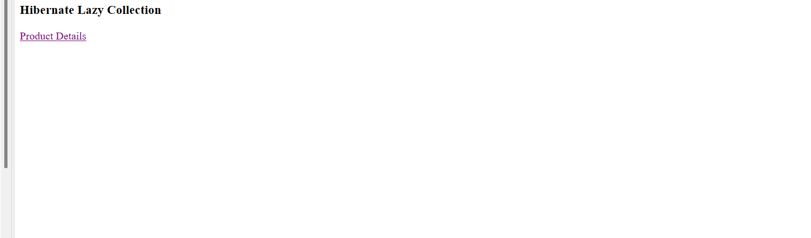
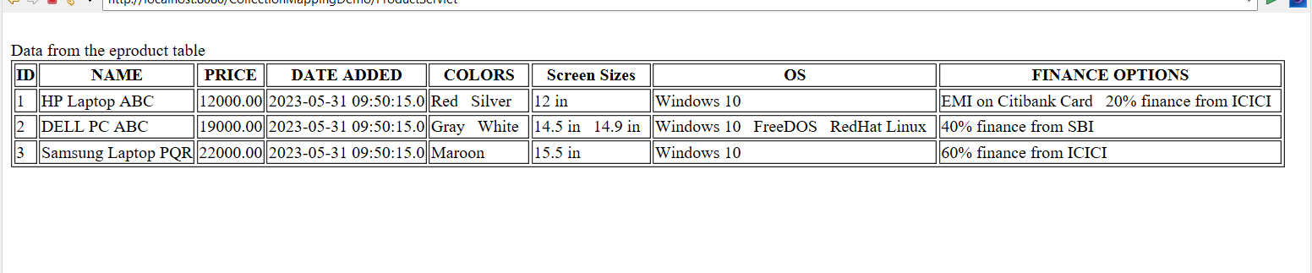
Assisted Practice: 3.7 Component Mapping
Demonstrate component mapping in Hibernate.
- Set up Eclipse to work with Hibernate
- Set up database tables to do collection mapping using XML
- Create an HTML page to call a servlet
- Create a servlet that will display data from the tables using Component Mapping

Step 3.7.1: Creating a dynamic web project
- Open Eclipse
- Go the File menu. Choose New->Dynamic Web Project
- Enter the project name as ComponentMapping. Click on Next
- Enter nothing in the next screen and click on Next
- Check the checkbox Generate web.xml deployment descriptor and click on Finish
- This will create the project files in the Project Explorer

Step 3.7.2: Adding the jar files for Hibernate and its dependencies
- Hibernate.jar file is already present in your practice lab. (Refer FSD: Lab Guide - Phase 2)
- Take hibernate.jar from folder mentioned in the lab guide for phase 2 and add it to your project’s WebContent/WEB-INF/lib folder
- mysql-connector-java.jar file is present in your practice lab. (Refer FSD: Lab Guide - Phase 2)
- Take mysql-connector-java.jar file from the folder mentioned in the lab guide for phase 2 and add it to your project’s WebContent/WEB-INF/lib folder
- Go to http://www.java2s.com/Code/Jar/j/Downloadjta11jar.htm
- Click on jta-1_1.jar.zip link to download it
- Extract jta-1_1.jar from it and add it to your project’s WebContent/WEB-INF/lib folder
- Go to http://www.java2s.com/Code/Jar/j/Downloadjavaxxmlbindjar.htm
- Click on javax.xml/javax.xml.bind.jar.zip link to download it
- Extract javax.xml.bind.jar from it and add it to your project’s WebContent/WEB-INF/lib folder
- Go to https://jar-download.com/artifacts/com.sun.xml.bind
- Click on the button Download jaxb-osgi.jar to download it
- Extract jaxb-osgi-2.4.0-b180830.0438.jar from it and add it to your project’s WebContent/WEB-INF/lib folder

Step 3.7.3: Creating a table eproduct in the database and filling it with sample data
- MySQL is already installed in your practice lab. (Refer FSD: Lab Guide - Phase 2)
- Login to the MySQL command line console
- Type CREATE DATABASE ecommerce and press Enter
- Type USE ecommerce and press Enter
- Enter the following script and execute it:

use ecommerce;
CREATE TABLE `eproduct` (
`ID` bigint(20) NOT NULL AUTO_INCREMENT,
`name` varchar(100) DEFAULT NULL,
`price` decimal(10,2) DEFAULT NULL,
`date_added` timestamp NOT NULL DEFAULT CURRENT_TIMESTAMP,
`parts_hdd` varchar(10) DEFAULT NULL,
`parts_cpu` varchar(10) DEFAULT NULL,
`parts_ram` varchar(10) DEFAULT NULL,
PRIMARY KEY (`ID`));
INSERT INTO `eproduct` VALUES (1,'HP Laptop ABC',21900.00,'2019-06-04 07:18:57','2 Gb HDD','AMD Phenom','4 Gb'),
(2,'Acer Laptop ABC',23300.00,'2019-06-04 07:19:07','500 Gb HDD','Core-i7','4 Gb'),
(3,'Lenovo Laptop ABC',33322.00,'2019-06-04 07:19:19','1 Tb HDD','Core-i7','8 Gb');
select * from eproduct;

Step 3.7.4: Creating a class Eproduct
- In the Project Explorer, expand ComponentMapping ->Java Resources
- Right click on src and choose New->Class
- In Package, enter pack1 and in Name enter Eproduct and click on Finish
- Enter the following code:

import java.math.BigDecimal;
import java.util.Date;

public class Eproduct {
private long ID;
private String name;
private BigDecimal price;
private Date date_added;
private Productparts parts;

public Eproduct() {

}
public long getID() {
return ID;
}
public void setID(long iD) {
ID = iD;
}
public String getName() {
return name;
}
public void setName(String name) {
this.name = name;
}
public BigDecimal getPrice() {
return price;
}
public void setPrice(BigDecimal price) {
this.price = price;
}
public Date getDate_added() {
return date_added;
}
public void setDate_added(Date date_added) {
this.date_added = date_added;
}
public Productparts getParts() {
return parts;
}
public void setParts(Productparts parts) {
this.parts = parts;
}

}

Step 3.7.5: Creating a class Productparts
- In the Project Explorer, expand ComponentMapping ->Java Resources
- Right click on src and choose New->Class
- In Package, enter pack1 and in Name enter Productparts and click on Finish
- Enter the following code:

public class Productparts
{
private String hdd;
private String cpu;
private String ram;
public String getHdd() {
return hdd;
}
public void setHdd(String hdd) {
this.hdd = hdd;
}
public String getCpu() {
return cpu;
}
public void setCpu(String cpu) {
this.cpu = cpu;
}
public String getRam() {
return ram;
}
public void setRam(String ram) {
this.ram = ram;
}

}

Step 3.7.6: Creating a HibernateUtil class to initiate Hibernate in code
- In the Project Explorer, expand ComponentMapping ->Java Resources
- Right click on src and choose New->Class
- In Package, enter com.ecommerce and in Name enter HibernateUtil and click on Finish
- Enter the following code:
import org.hibernate.SessionFactory;
import org.hibernate.boot.Metadata;
import org.hibernate.boot.MetadataSources;
import org.hibernate.boot.registry.StandardServiceRegistry;
import org.hibernate.boot.registry.StandardServiceRegistryBuilder;

public class HibernateUtil {
private static final SessionFactory sessionFactory;

static {
try {
StandardServiceRegistry standardRegistry = new StandardServiceRegistryBuilder().configure("hibernate.cfg.xml").build();
Metadata metaData = new MetadataSources(standardRegistry).getMetadataBuilder().build();
sessionFactory = metaData.getSessionFactoryBuilder().build();
} catch (Throwable th) {
throw new ExceptionInInitializerError(th);
}
}

public static SessionFactory getSessionFactory() {
return sessionFactory;
}

}

Step 3.7.7: Creating a hibernate table configuration file Eproduct.hbm.xml
- In the Project Explorer, expand ComponentMapping ->Java Resources
- Right click on src and choose New->Other
- Select General->File and click on Next
- In filename, enter Eproduct.hbm.xml and click on Finish
- Enter the following code:
<?xml version="1.0" encoding="UTF-8"?>
<!DOCTYPE hibernate-mapping PUBLIC
"-//Hibernate/Hibernate Mapping DTD 3.0//EN"
"http://www.hibernate.org/dtd/hibernate-mapping-3.0.dtd">
<hibernate-mapping package="pack1">
<class name="Eproduct" table="eproduct">
<id name="ID" column="ID">
<generator class="increment"/>
</id>
<property name="name" type="string" column="NAME"/>
<property name="price" type="big_decimal" column="PRICE"/>
<property name="date_added" type="timestamp" column="DATE_ADDED"/>

<component name="parts" class="pack1.Productparts">
<property name="hdd" column="parts_hdd" type="string" />
<property name="cpu" column="parts_cpu" type="string" />
<property name="ram" column="parts_ram" type="string" />
</component>

</class>
</hibernate-mapping>

Step 3.7.8: Configuring Hibernate with hibernate.cfg.xml
- In the Project Explorer, expand ComponentMapping ->Java Resources
- Right click on src and choose New->Other
- Select General->File and click on Next
- In filename, enter hibernate.cfg.xml and click on Finish
- Enter the following code:

<?xml version='1.0' encoding='utf-8'?>
<!DOCTYPE hibernate-configuration PUBLIC
"-//Hibernate/Hibernate Configuration DTD 3.0//EN"
"http://www.hibernate.org/dtd/hibernate-configuration-3.0.dtd">
<hibernate-configuration>
<session-factory>
<!-- Database connection settings -->
<property name="connection.driver_class">com.mysql.jdbc.Driver</property>
<property name="connection.url">jdbc:mysql://localhost:3306/ecommerce</property>
<property name="connection.username">root</property>
<property name="connection.password">kavya@2312</property>

<!-- Mapping files -->
<mapping resource="pack1/Eproduct.hbm.xml"/>
</session-factory>
</hibernate-configuration>

Step 3.7.9: Creating an HTML page index.html
- In the Project Explorer, expand the project ComponentMapping
- Expand WebContent. Right click on WebContent. Choose New->HTML File
- Enter the filename as index.html and click on Finish
- Enter the following code:

<!DOCTYPE html>
<html>
<head>
<meta charset="ISO-8859-1">
<title>Insert title here</title>
</head>
<body>
<h3> Hibernate component Mapping </h3>
<a href="ProductServlet"> Hibernate component Mapping</a><br>
</body>
</html>

Step 3.7.10: Creating a ProductServlet servlet
- In the Project Explorer, expand ComponentMapping ->Java Resources
- Right click on src and choose New->Servlet
- In Class Name, enter ProductServlet and click on Finish
- Enter the following code:

import java.io.IOException;
import java.io.PrintWriter;
import java.util.List;

import javax.servlet.ServletException;
import javax.servlet.annotation.WebServlet;
import javax.servlet.http.HttpServlet;
import javax.servlet.http.HttpServletRequest;
import javax.servlet.http.HttpServletResponse;

import org.hibernate.Session;
import org.hibernate.SessionFactory;

@WebServlet("/ProductServlet")
public class ProductServlet extends HttpServlet {
private static final long serialVersionUID = 1L;

protected void doGet(HttpServletRequest request, HttpServletResponse response) throws ServletException, IOException {
try {
SessionFactory factory = HibernateUtil.getSessionFactory();

Session session = factory.openSession();

List<Eproduct> list = session.createQuery("from Eproduct").list();

PrintWriter out = response.getWriter();
out.println("<html><body>");

out.println("<b>Component Mapping</b><br>");
for(Eproduct p: list) {
out.println("ID: " + String.valueOf(p.getID()) + ", Name: " + p.getName() +
", Price: " + String.valueOf(p.getPrice()) + ", Date Added: " + p.getDate_added().toString());
Productparts parts = p.getParts();
out.println("Parts =" + parts.getCpu() + ", " + parts.getHdd() + ", " + parts.getRam());
out.println("<hr>");
}

session.close();

out.println("</body></html>");

} catch (Exception ex) {
throw ex;
}

}

}

Step 3.7.11: Checking for servlet-api.jar
- Before building the project, we need to add servlet-api.jar to the project
- Servlet-api.jar file is already present in your practice lab. (Refer FSD: Lab Guide - Phase 2)
- To add it to the project, follow the below mentioned steps:
  - In the Project Explorer, right click on ComponentMapping and choose Properties
  - Select Java Build Path from the options on the left
  - Click on Libraries tab on the right
  - Under ClassPath, expand the node that says Apache Tomcat
  - If there is an existing entry for servlet-api.jar, then click on Cancel and exit the window
  - If it is not there, then click on Classpath entry and click on Add External JARs button on the right
  - From the file list, select servlet-api.jar file and click on Ok
  - Click on Apply and Close

Step 3.7.12: Building the project
- From the Project menu at the top, click on Build
- If any compile errors are shown, fix them as required

Step 3.7.13: Publishing and starting the project
- If you do not see the Servers tab near the bottom of the IDE, go to Window menu and click on Show View->Servers
- Right click the Server entry and choose Add and Remove
- Click the Add button to move ComponentMapping from the Available list to the Configured list
- Click on Finish
- Right click the Server entry and click on Publish
- Right click the Server entry and click on Start
- This will start the server

Step 3.7.14: Running the project
- To run the project, open a web browser and type:
http://localhost:8080/ ComponentMapping

Output:
