Assisted Practice: Configuring a Servlet with Eclipse
2. Configure a servlet in Eclipse IDE.
Step 2.1: Creating a dynamic web project
- Open Eclipse
- Go the File menu. Choose New->Dynamic Web Project
- Enter the project name as MyFirstServlet. Click on Next
- Enter nothing in the next screen and click on Next
- Check the checkbox Generate web.xml deployment descriptor and click on Finish
- This will create the project files in the Project Explorer

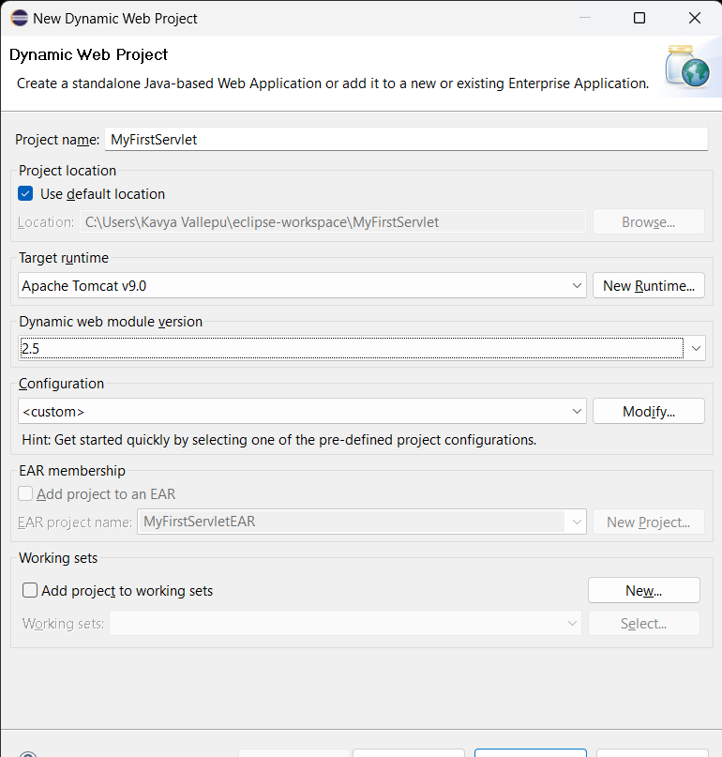

Step 2.2: Creating a servlet MyServlet.java
- In the Project Explorer, expand MyFirstServlet ->Java Resources
- Right click src and choose New->Servlet
- In Class Name, enter MyServlet and click on Finish

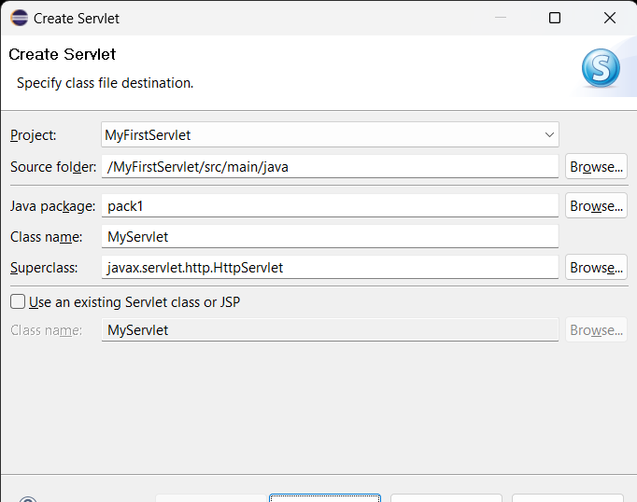
Enter the following code:
package pack1;

import java.io.IOException;
import java.io.PrintWriter;

import javax.servlet.ServletException;
import javax.servlet.http.HttpServlet;
import javax.servlet.http.HttpServletRequest;
import javax.servlet.http.HttpServletResponse;

public class MyServlet extends HttpServlet {
private static final long serialVersionUID = 1L;

protected void doGet(HttpServletRequest request, HttpServletResponse response) throws ServletException, IOException {
PrintWriter out=response.getWriter();
out.print("hello,doGet method");
}
}

- Click on the Save icon

Step 2.3: Configuring web.xml
- In the Project Explorer, expand MyFirstServlet->WebContent->WEB-INF
- Double click web.xml to open it in the editor
- Enter the following script:
<?xml version="1.0" encoding="UTF-8"?>
<web-app xmlns:xsi="http://www.w3.org/2001/XMLSchema-instance" xmlns="http://java.sun.com/xml/ns/javaee" xsi:schemaLocation="http://java.sun.com/xml/ns/javaee http://java.sun.com/xml/ns/javaee/web-app_2_5.xsd" id="WebApp_ID" version="2.5">
<display-name>MyFirstServlet</display-name>
<welcome-file-list>
<welcome-file>index.html</welcome-file>
<welcome-file>index.jsp</welcome-file>
<welcome-file>index.htm</welcome-file>
<welcome-file>default.html</welcome-file>
<welcome-file>default.jsp</welcome-file>
<welcome-file>default.htm</welcome-file>
</welcome-file-list>
<servlet>
<description></description>
<display-name>MyServlet</display-name>
<servlet-name>MyServlet</servlet-name>
<servlet-class>pack1.MyServlet</servlet-class>
</servlet>
<servlet-mapping>
<servlet-name>MyServlet</servlet-name>
<url-pattern>/MyServlet</url-pattern>
</servlet-mapping>
</web-app>

Step 2.4: Checking for servlet-api.jar
- Before building the project, we need to add servlet-api.jar to the project
- Servlet-api.jar file is already present in your practice lab. (Refer FSD: Lab Guide - Phase 2)
- To add it to the project, follow the below mentioned steps:
  - In the Project Explorer, right click on MyFirstServlet and choose Properties
  - Select Java Build Path from the options on the left
  - Click on Libraries tab on the right
  - Under ClassPath, expand the node that says Apache Tomcat
  - If there is an existing entry for servlet-api.jar, then click on Cancel and exit the window
  - If it is not there, then click on Classpath entry and click on Add External JARs button on the right
  - From the file list, select servlet-api.jar file and click Ok
  - Click on Apply and Close

Step 2.5: Building the project
- From the Project menu at the top, click on Build
- If any compile errors are shown, fix them as required

Step 2.6: Publishing and starting the project
- If you do not see the Servers tab near the bottom of the IDE, go to Window menu and click on Show View->Servers
- Right click on the Server entry and choose Add and Remove
- Click the Add button to move MyFirstServlet from the Available list to the Configured list
- Click on Finish
- Right click on the Server entry and click on Publish
- Right click on the Server entry and click on Start
- This will start the server

Step 2.7: Running the project
- To run the project, open a web browser and type:
http://localhost:8080/MyFirstServlet/MyServlet
Output:
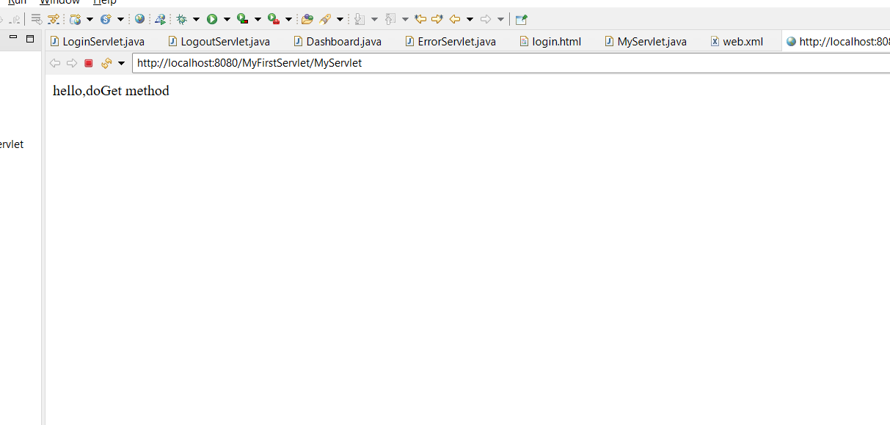
Assisted Practice: 1.4 Servlet Classes and Interfaces
Write a program to demonstrate the concept of Servlet Classes and Interfaces.
- Create an HTML file to initiate a servlet
- Create a servlet that implements the servlet interface

Step 4.1: Creating a dynamic web project
- Open Eclipse
- Go the File menu. Choose New->Dynamic Web Project
- Enter the project name as InterfaceDemo. Click on Next
- Enter nothing in the next screen and click on Next
- Check the checkbox Generate web.xml deployment descriptor and click on Finish
- This will create the project files in the Project Explorer

Step 4.2: Creating an HTML page
- In the Project Explorer, expand the project InterfaceDemo
- Expand WebContent. Right click on WebContent . Choose New->HTML File
- Enter the filename as index.html and click on Finish
- Enter the following code:

<!DOCTYPE html>
<html>
<head>
<meta charset="ISO-8859-1">
<title>Interface Demo</title>
</head>
<body>
<center>
<h1>Interface demo</h1>
<form name=frm method=POST action="InterfaceDemo">
Name<input name="name" id="name" ><br>
Address <input name="address" id="address" ><br>
<button>Submit</button>
</form>
</center>

</body>
</html>

- Click on the Save icon

Step 4.3: Creating a servlet InterfaceDemo.java
- In the Project Explorer, expand InterfaceDemo ->Java Resources
- Right click on src and choose New->Servlet
- In Class Name, enter InterfaceDemo and click on Finish
- Enter the following code:

import java.io.IOException;
import java.io.PrintWriter;

import javax.servlet.Servlet;
import javax.servlet.ServletConfig;
import javax.servlet.ServletException;
import javax.servlet.ServletRequest;
import javax.servlet.ServletResponse;

public class InterfaceDemo implements Servlet
{
private ServletConfig config;

public void init(ServletConfig config) throws ServletException {
this.config = config;
}

public void service(ServletRequest request, ServletResponse response) throws ServletException, IOException {
response.setContentType("text/html");
PrintWriter out = response.getWriter();
out.println("<html><body>");
out.println("<h2>Implementing Servlet Interface</h2>");

String name = request.getParameter("name");
String address = request.getParameter("address");

out.println("<p>Name: " + name + "</p>");
out.println("<p>Address: " + address + "</p>");

out.println("</body></html>");
}

public void destroy() {
// Cleanup resources, if any
}

public ServletConfig getServletConfig() {
return config;
}

public String getServletInfo() {
return "InterfaceDemo";
}
}

Step 4.4: Configuring web.xml
- In the Project Explorer, expand InterfaceDemo ->WebContent->WEB-INF
- Double click on web.xml to open it in the editor
- Enter the following script:

<?xml version="1.0" encoding="UTF-8"?>
<web-app xmlns:xsi="http://www.w3.org/2001/XMLSchema-instance" xmlns="http://java.sun.com/xml/ns/javaee" xsi:schemaLocation="http://java.sun.com/xml/ns/javaee http://java.sun.com/xml/ns/javaee/web-app_2_5.xsd" id="WebApp_ID" version="2.5">
<display-name>InterfaceDemo</display-name>
<welcome-file-list>
<welcome-file>index.html</welcome-file>
<welcome-file>index.jsp</welcome-file>
<welcome-file>index.htm</welcome-file>
<welcome-file>default.html</welcome-file>
<welcome-file>default.jsp</welcome-file>
<welcome-file>default.htm</welcome-file>
</welcome-file-list>
<servlet>
<description></description>
<display-name>InterfaceDemo</display-name>
<servlet-name>InterfaceDemo</servlet-name>
<servlet-class>pack1.InterfaceDemo</servlet-class>
</servlet>
<servlet-mapping>
<servlet-name>InterfaceDemo</servlet-name>
<url-pattern>/InterfaceDemo</url-pattern>
</servlet-mapping>
</web-app>

Step 4.5: Checking for servlet-api.jar
- Before building the project, we need to add servlet-api.jar to the project
- Servlet-api.jar file is already present in your practice lab. (Refer FSD: Lab Guide - Phase 2)
- To add it to the project, follow the below mentioned steps:
  - In the Project Explorer, right click on InterfaceDemo and choose Properties
  - Select Java Build Path from the options on the left
  - Click on Libraries tab on the right
  - Under ClassPath, expand the node that says Apache Tomcat
  - If there is an existing entry for servlet-api.jar, then click on Cancel and exit the window
  - If it is not there, then click on Classpath entry and click on Add External JARs button on the right
  - From the file list, select servlet-api.jar file and click on Ok
  - Click on Apply and Close

Step 4.6: Building the project
- From the Project menu at the top, click on Build
- If any compile errors are shown, fix them as required

Step 4.7: Publishing and starting the project
- If you do not see the Servers tab near the bottom of the IDE, go to Window menu and click on Show View->Servers
- Right click on the Server entry and choose Add and Remove
- Click the Add button to move ServletInterfaces from the Available list to the Configured list
- Click on Finish
- Right click on the Server entry and click on Publish
- Right click on the Server entry and click on Start
- This will start the server

Step 4.8: Running the project
- To run the project, open a web browser and type:
http://localhost:8080/InterfaceDemo

output:
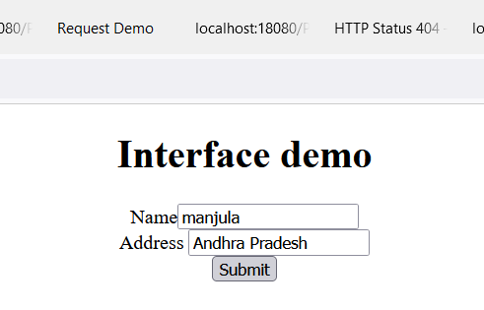

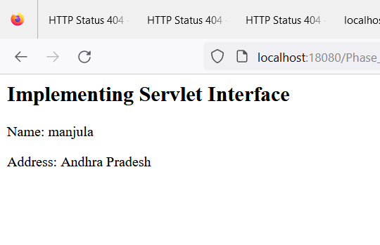

Assisted Practice: Generic Servlets
3. Write a program to demonstrate the concept of Generic Servlets.
- Create an HTML form to input name
- Send the form data to a servlet
- Display the name in the browser from the servlet
Step 3.1: Creating a dynamic web project
- OpenEclipse
- Go the File menu. Choose New->Dynamic Web Project
- Enter the project name as MyGenericServlet. Click on Next
- Enter nothing in the next screen and click on Next
- Check the checkbox Generate web.xml deployment descriptor and click on Finish
- This will create the project files in the Project Explorer

Step 3.2: Creating an HTML page
- In the Project Explorer, expand the project ‘MyGenericServlet’
- Expand WebContent. Right click on WebContent . Choose New->HTML File
- Enter the filename as index.html and click on Finish
- Enter the following code:
<!DOCTYPE html>
<html>
<head>
<meta charset="ISO-8859-1">
<title>My Generic Servlet</title>
</head>
<body>
<center>
<h1>Generic Servlet</h1>
<form name=frm method=POST action="MyServlet">

Fname<input name="fname" id="fname" maxlength=100><br>
Lname <input name="lname" id="lname" maxlenght=50><br>
<button>Submit</button>
</form>
</center>
</body>
</html>

- Click on the Save icon

Step 3.3: Creating a servlet
- In the Project Explorer, expand ServletConcept->Java Resources
- Right click on src and choose New->Servlet
- In Class Name, enter MyServlet and click on Finish
- Enter the following code:
import java.io.IOException;
import java.io.PrintWriter;

import javax.servlet.GenericServlet;
import javax.servlet.ServletException;
import javax.servlet.ServletRequest;
import javax.servlet.ServletResponse;

public class MyServlet extends GenericServlet {
private static final long serialVersionUID = 1L;

public void service(ServletRequest request, ServletResponse response) throws ServletException, IOException {

String fname = request.getParameter("fname");
String lname = request.getParameter("lname");

String fullname=fname+" "+lname;

PrintWriter out = response.getWriter();
out.println("Your full name is "+fullname);

}

}

Step 3.4: Configuring web.xml
- In the Project Explorer, expand MyGenericServlet >WebContent->WEB-INF
- Double click on web.xml to open it in the editor
- Enter the following script:
<?xml version="1.0" encoding="UTF-8"?>
<web-app xmlns:xsi="http://www.w3.org/2001/XMLSchema-instance" xmlns="http://java.sun.com/xml/ns/javaee" xsi:schemaLocation="http://java.sun.com/xml/ns/javaee http://java.sun.com/xml/ns/javaee/web-app_2_5.xsd" id="WebApp_ID" version="2.5">
<display-name>MyGenericServlet</display-name>
<welcome-file-list>
<welcome-file>index.html</welcome-file>
<welcome-file>index.jsp</welcome-file>
<welcome-file>index.htm</welcome-file>
<welcome-file>default.html</welcome-file>
<welcome-file>default.jsp</welcome-file>
<welcome-file>default.htm</welcome-file>
</welcome-file-list>
<servlet>
<description></description>
<display-name>MyServlet</display-name>
<servlet-name>MyServlet</servlet-name>
<servlet-class>pack1.MyServlet</servlet-class>
</servlet>
<servlet-mapping>
<servlet-name>MyServlet</servlet-name>
<url-pattern>/MyServlet</url-pattern>
</servlet-mapping>
</web-app>

Step 3.5: Checking for servlet-api.jar
- Before building the project, we need to add servlet-api.jar to the project
- Servlet-api.jar file is already present in your practice lab. (Refer FSD: Lab Guide - Phase 2)
- To add it to the project, follow the below mentioned steps:
  - In the Project Explorer, right click on MyGenericServlet and choose Properties
  - Select Java Build Path from the options on the left
  - Click on Libraries tab on the right
  - Under ClassPath, expand the node that says Apache Tomcat
  - If there is an existing entry for the servlet-api.jar, then click on Cancel and exit the window
  - If it is not there, then click on Classpath entry and click on Add External JARs button on the right
  - From the file list, select servlet-api.jar file and click on Ok
  - Click on Apply and Close

Step 3.6: Building the project
- From the Project menu at the top, click on Build
- If any compile errors are shown, fix them as required

Step 3.7: Publishing and starting the project
- If you do not see the Servers tab near the bottom of the IDE, go to Window menu and click on Show View->Servers
- Right click on the Server entry and choose Add and Remove
- Click the Add button to move MyGenericServlet from the Available list to the Configured list
- Click on Finish
- Right click on the Server entry and click on Publish
- Right click the Server entry and click on Start
- This will start the server

Step 3.8: Running the project
- To run the project, open a web browser and type:
http://localhost:8080/MyGenericServlet/MyServlet

Output:
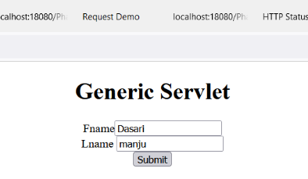

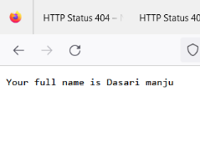
Assisted Practice: Servlet Filters
5. Write a program to demonstrate a Servlet Filter.
- Create an HTML page to send different requests via hyperlinks
- Create servlets to handle each request
- Show the output of the servlet showing whether the request came through a filter or not
Step 5.1: Creating a dynamic web project
- Open Eclipse
- Go the File menu. Choose New->Dynamic Web Project
- Enter the project name as FilterDemo1. Click on Next
- Enter nothing in the next screen and click on Next
- Check the checkbox Generate web.xml deployment descriptor and click on Finish
- This will create the project files in the Project Explorer

Step 5.2: Creating an HTML page
- In the Project Explorer, expand the project FilterDemo1
- Expand WebContent. Right click on WebContent. Choose New->HTML File
- Enter the filename as index.html and click on Finish
- Enter the following code:

<!DOCTYPE html>
<html>
<head>
<meta charset="ISO-8859-1">
<title>Filter demo</title>
</head>
<body>
<h2>Filter Demo</h2>

<a href="dashboard?userid=kavya">Account Dashboard servlet (allow filter)</a>
<br><br>
<a href="profile?userid=kavya">Account Profile servlet (allow filter)</a>
<br><br>
<a href="dashboard">Account Dashboard servlet (block filter)</a>
<br><br>
<a href="info">Info Page servlet </a>
<br>
</body>
</html>
- Click on the Save icon
Step 5.3: Creating an AccountProfile servlet
- In the Project Explorer, expand FilterDemo1->Java Resources
- Right click on src and choose New->Servlet
- In Class Name, enter AccountProfile and click on Finish
- Enter the following code:

import java.io.IOException;
import java.io.PrintWriter;

import javax.servlet.ServletException;
import javax.servlet.annotation.WebServlet;
import javax.servlet.http.HttpServlet;
import javax.servlet.http.HttpServletRequest;
import javax.servlet.http.HttpServletResponse;

@WebServlet("/profile")
public class AccountProfile extends HttpServlet {
private static final long serialVersionUID = 1L;

protected void doGet(HttpServletRequest request, HttpServletResponse response)
throws ServletException, IOException {
PrintWriter out = response.getWriter();
out.println("I am in Account Profile after passing through LoginFilter");

}

protected void doPost(HttpServletRequest request, HttpServletResponse response)
throws ServletException, IOException {

doGet(request, response);
}

}

Step 5.4: Creating an AccountDashboard servlet
- In the Project Explorer, expand FilterDemo1->Java Resources
- Right click on src and choose New->Servlet
- In Class Name, enter AccountDashboard and click on Finish
- Enter the following code:

import java.io.IOException;
import java.io.PrintWriter;

import javax.servlet.ServletException;
import javax.servlet.annotation.WebServlet;
import javax.servlet.http.HttpServlet;
import javax.servlet.http.HttpServletRequest;
import javax.servlet.http.HttpServletResponse;

@WebServlet("/dashboard")
public class AccountDashboard extends HttpServlet {
private static final long serialVersionUID = 1L;

protected void doGet(HttpServletRequest request, HttpServletResponse response)
throws ServletException, IOException {
PrintWriter out = response.getWriter();
out.println("I am in Account Dashboard after passing through 1

}

protected void doPost(HttpServletRequest request, HttpServletResponse response)
throws ServletException, IOException {

doGet(request, response);
}
}

Step 5.5: Creating an InfoServlet servlet
- In the Project Explorer, expand FilterDemo1->Java Resources
- Right click on src and choose New->Servlet
- In Class Name, enter InfoServlet and click on Finish
- Enter the following code:

import java.io.IOException;
import java.io.PrintWriter;

import javax.servlet.ServletException;
import javax.servlet.annotation.WebServlet;
import javax.servlet.http.HttpServlet;
import javax.servlet.http.HttpServletRequest;
import javax.servlet.http.HttpServletResponse;

@WebServlet("/info")
public class InfoServlet extends HttpServlet {
private static final long serialVersionUID = 1L;
protected void doGet(HttpServletRequest request, HttpServletResponse response)
throws ServletException, IOException {
PrintWriter out = response.getWriter();
out.println("I am in Info Servlet. No filter is in front of me");

}

protected void doPost(HttpServletRequest request, HttpServletResponse response)
throws ServletException, IOException {

doGet(request, response);
}
}

Step 5.6: Creating a LoginFilter filter
- In the Project Explorer, expand FilterDemo1->Java Resources
- Right click on src and choose New->Filter
- In Class Name, enter LoginFilter and click on Finish
- Enter the following code:
import java.io.IOException;
import java.io.PrintWriter;

import javax.servlet.Filter;
import javax.servlet.FilterChain;
import javax.servlet.FilterConfig;
import javax.servlet.ServletException;
import javax.servlet.ServletRequest;
import javax.servlet.ServletResponse;
import javax.servlet.http.HttpFilter;

public class LoginFilter extends HttpFilter implements Filter {

public void doFilter(ServletRequest request, ServletResponse response, FilterChain chain)
throws IOException, ServletException {
PrintWriter out = response.getWriter();

String userId = request.getParameter("userid");

if (userId != null)
chain.doFilter(request, response);

else
out.println("Userid not present. So request is blocked!");

}

public void init(FilterConfig fConfig) throws ServletException {

}

public void destroy() {

}

}

Step 5.7: Configuring web.xml
- In the Project Explorer, expand FilterDemo1->WebContent->WEB-INF
- Double click on web.xml to open it in the editor
- Enter the following script:

<?xml version="1.0" encoding="UTF-8"?>
<web-app xmlns:xsi="http://www.w3.org/2001/XMLSchema-instance" xmlns="http://java.sun.com/xml/ns/javaee" xsi:schemaLocation="http://java.sun.com/xml/ns/javaee http://java.sun.com/xml/ns/javaee/web-app_2_5.xsd" id="WebApp_ID" version="2.5">
<display-name>FilterDemo1</display-name>
<welcome-file-list>
<welcome-file>index.html</welcome-file>
<welcome-file>index.jsp</welcome-file>
<welcome-file>index.htm</welcome-file>
<welcome-file>default.html</welcome-file>
<welcome-file>default.jsp</welcome-file>
<welcome-file>default.htm</welcome-file>
</welcome-file-list>
<servlet>
<description></description>
<display-name>AccountProfile</display-name>
<servlet-name>AccountProfile</servlet-name>
<servlet-class>pack1.AccountProfile</servlet-class>
</servlet>
<servlet-mapping>
<servlet-name>AccountProfile</servlet-name>
<url-pattern>/AccountProfile</url-pattern>
</servlet-mapping>
<servlet>
<description></description>
<display-name>AccountDashboard</display-name>
<servlet-name>AccountDashboard</servlet-name>
<servlet-class>pack1.AccountDashboard</servlet-class>
</servlet>
<servlet-mapping>
<servlet-name>AccountDashboard</servlet-name>
<url-pattern>/AccountDashboard</url-pattern>
</servlet-mapping>
<servlet>
<description></description>
<display-name>InfoServlet</display-name>
<servlet-name>InfoServlet</servlet-name>
<servlet-class>pack1.InfoServlet</servlet-class>
</servlet>
<servlet-mapping>
<servlet-name>InfoServlet</servlet-name>
<url-pattern>/InfoServlet</url-pattern>
</servlet-mapping>
<filter>
<filter-name>LoginFilter</filter-name>
<filter-class>pack2.LoginFilter</filter-class>
</filter>

<filter-mapping>
<filter-name>LoginFilter</filter-name>
<url-pattern>/profile</url-pattern>
<url-pattern>/dashboard</url-pattern>
</filter-mapping>
</web-app>

Step 5.8: Checking for servlet-api.jar
- Before building the project, we need toadd servlet-api.jar to the project
- Servlet-api.jar file is already present in your practice lab. (Refer FSD: Lab Guide - Phase 2)
- To add it to the project, follow the below mentioned steps:
  - In the Project Explorer, right click on FilterDemo1 and choose Properties
  - Select Java Build Path from the options on the left
  - Click on Libraries tab on the right
  - Under ClassPath, expand the node that says Apache Tomcat
  - If there is an existing entry for the servlet-api.jar, then click on Cancel and exit the window
  - If it is not there, then click on Classpath entry and click on Add External JARs button on the right
  - From the file list, select the servlet-api.jar file and click on Ok
  - Click on Apply and Close

Step 5.9: Building the project
- From the Project menu at the top, click on Build
- If any compile errors are shown, fix them as required

Step 5.10: Publishing and starting the project
- If you do not see the Servers tab near the bottom of the IDE, go to Window menu and click on Show View->Servers
- Right click on the Server entry and choose Add and Remove
- Click the Add button to move FilterDemo1 from the Available list to the Configured list
- Click on Finish
- Right click on the Server entry and click on Publish
- Right click on the Server entry and click on Start
- This will start the server

Step 5.11: Running the project
- To run the project, open a web browser and type: http://localhost:8080/FilterDemo1

Output:
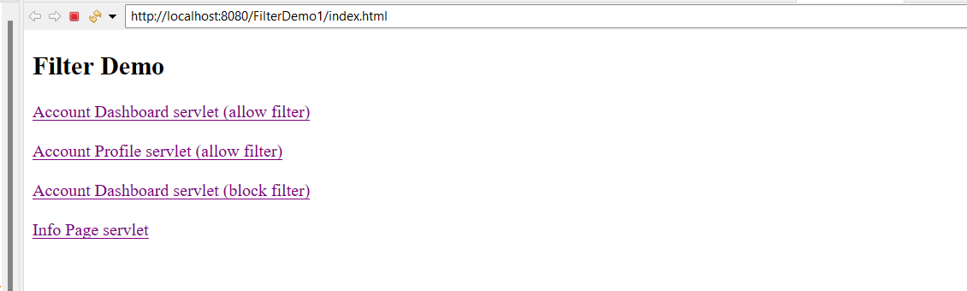

//Account Dashboard (allow filter)
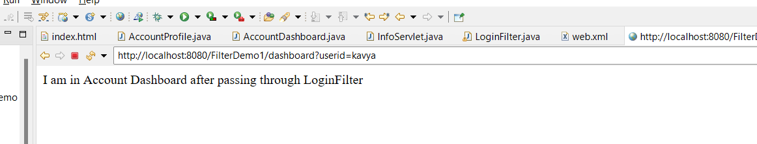
//Account profile (allow filter)
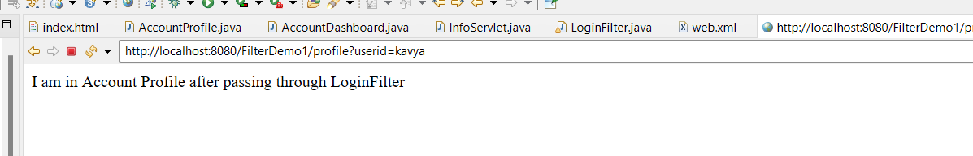
//Account Dashboard (block filter)
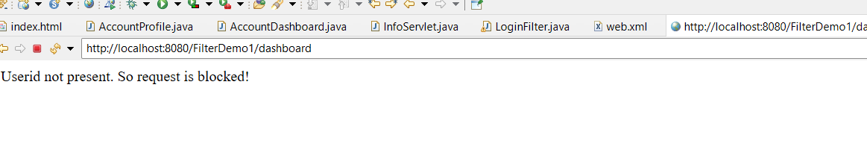
//info servlet (no filter)
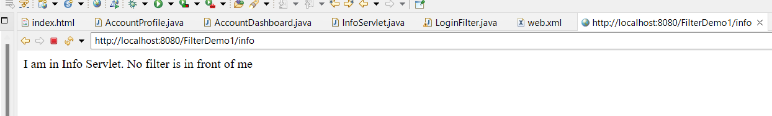
Assisted Practice: Difference between GET and POST

1.Write a program to demonstrate the differences between GET and POST using Servlet.
- Create an HTML page to send a GET request and a POST request
- Create a servlet to handle the GET request
- Create a servlet to handle the POST request

Step 1.1: Creating a dynamic web project
- Open Eclipse
- Go the File menu. Choose New->Dynamic Web Project
- Enter the project name as GetPostRequest. Click on Next
- Enter nothing in the next screen and click on Next
- Check the checkbox Generate web.xml deployment descriptor and click on Finish
- This will create the project files in the Project Explorer

Step 1.2: Creating an HTML page
- In the Project Explorer, expand the project GetPostRequest
- Expand WebContent. Right click on WebContent. Choose New->HTML File
- Enter the filename as index.html and click on Finish
- Enter the following code:
<!DOCTYPE html>
<html>
<head>
<meta charset="ISO-8859-1">
<title>Request Demo</title>
</head>
<body>
<h1>Request Demo</h1>

<!-- GET request form -->
<h2>GetServlet Request</h2>
<form action="GetServelet" method="GET">
<label for="name">Name:</label>
<input type="text" id="name" name="name">
<br>
<label for="age">Age:</label>
<input type="text" id="age" name="age">
<br>
<input type="submit" value="Submit GET Request">
</form>

<br>

<!-- POST request form -->
<h2>PostServlet Request</h2>
<form action="PostServelet" method="POST">
<label for="email">Email:</label>
<input type="email" id="email" name="email">
<br>
<label for="mobilenumber">Mobile number:</label>
<input type="number" id="mobilenumber" name="mobilenumber">
<br>
<input type="submit" value="Submit POST Request">
</form>

</body>
</html>

- Click on the Save icon
Step 1.3: Creating a servlet GetServelet.java
- In the Project Explorer, expand GetPostRequest->Java Resources
- Right click src and choose New->Servlet
- In Class Name, enter GetServelet and click on Finish
- Enter the following code:

import java.io.IOException;
import javax.servlet.ServletException;
import javax.servlet.http.HttpServlet;
import javax.servlet.http.HttpServletRequest;
import javax.servlet.http.HttpServletResponse;

public class GetServelet extends HttpServlet {
private static final long serialVersionUID = 1L;

protected void doGet(HttpServletRequest request, HttpServletResponse response) throws ServletException, IOException {
String name = request.getParameter("name");
String age = request.getParameter("age");

response.setContentType("text/html");
response.getWriter().println("<h2>This is " + name + "!</h2>");
response.getWriter().println("<h2>I am " +age+" years old...</h2>");

}

}
- Click on the Save icon
Step 1.4: Creating a servlet PostServelet.java
- In the Project Explorer, expand GetPostRequest->Java Resources
- Right click src and choose New->Servlet
- In Class Name, enter PostServelet and click on Finish
- Enter the following code:
import java.io.IOException;
import javax.servlet.ServletException;
import javax.servlet.http.HttpServlet;
import javax.servlet.http.HttpServletRequest;
import javax.servlet.http.HttpServletResponse;

public class PostServelet extends HttpServlet {
private static final long serialVersionUID = 1L;

protected void doPost(HttpServletRequest request, HttpServletResponse response) throws ServletException, IOException {
String email = request.getParameter("email");
String number = request.getParameter("mobilenumber");

response.setContentType("text/html");
response.getWriter().println("<h2>This is my email: " + email + "</h2>");
response.getWriter().println("<h2>This is my mobile number: " + number + "</h2>");

}

}
- Click on the Save icon

Step 1.5: Configuring web.xml
- In the Project Explorer, expand ServletGetPost->WebContent->WEB-INF
- Double click web.xml to open it in the editor
- Enter the following script:

<?xml version="1.0" encoding="UTF-8"?>
<web-app xmlns:xsi="http://www.w3.org/2001/XMLSchema-instance" xmlns="http://java.sun.com/xml/ns/javaee" xsi:schemaLocation="http://java.sun.com/xml/ns/javaee http://java.sun.com/xml/ns/javaee/web-app_2_5.xsd" id="WebApp_ID" version="2.5">
<display-name>AssitedPracticeProject</display-name>
<welcome-file-list>
<welcome-file>index.html</welcome-file>
<welcome-file>index.jsp</welcome-file>
<welcome-file>index.htm</welcome-file>
<welcome-file>default.html</welcome-file>
<welcome-file>default.jsp</welcome-file>
<welcome-file>default.htm</welcome-file>
</welcome-file-list>
<servlet>
<description></description>
<display-name>GetServelet</display-name>
<servlet-name>GetServelet</servlet-name>
<servlet-class>com.pack1.GetServelet</servlet-class>
</servlet>
<servlet-mapping>
<servlet-name>GetServelet</servlet-name>
<url-pattern>/GetServelet</url-pattern>
</servlet-mapping>
<servlet>
<description></description>
<display-name>PostServelet</display-name>
<servlet-name>PostServelet</servlet-name>
<servlet-class>com.pack1.PostServelet</servlet-class>
</servlet>
<servlet-mapping>
<servlet-name>PostServelet</servlet-name>
<url-pattern>/PostServelet</url-pattern>
</servlet-mapping>
</web-app>

Step 1.6: Checking for servlet-api.jar
- Before building the project, we need to add servlet-api.jar to the project
- Servlet-api.jar file is already present in your practice lab. (Refer FSD: Lab Guide - Phase 2)
- To add it to the project, follow the below mentioned steps:
  - In the Project Explorer, right click on GetPostRequest and choose Properties
  - Select Java Build Path from the options on the left
  - Click on Libraries tab on the right
  - Under ClassPath, expand the node that says Apache Tomcat
  - If there is an existing entry for servlet-api.jar, then click on Cancel and exit the window
  - If it is not there, then click on Classpath entry and click on Add External JARs button on the right
  - From the file list, select servlet-api.jar file and click Ok
  - Click on Apply and Close

Step 1.7: Building the project
- From the Project menu at the top, click on Build
- If any compile errors are shown, fix them as required

Step 1.8: Publishing and starting the project
- If you do not see the Servers tab near the bottom of the IDE, go to the Window menu and click Show View->Servers
- Right click on the Server entry and choose Add and Remove
- Click the Add button to move GetPostRequest from the Available list to the Configured List
- Click Finish
- Right click on the Server entry and click on Publish
- Right click on the Server entry and click on Start
- This will start the server
Step 1.9: Running the project
- To run the project, open a web browser and type: http://localhost:8080/GetPostRequest
Output:
//GetServelet request
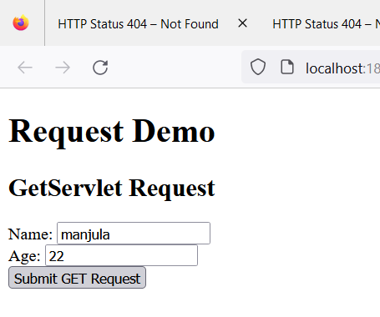
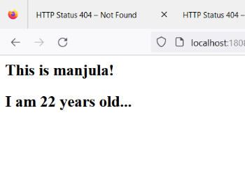

//PostServelet Request
