Zomato Sales Analytics Project

Dataset
File: Zomato_Sales_Advanced_Project.xlsx Rows: 5,000
Columns: Order_ID, Order_Date, City, Restaurant_Name, Food_Category, Item_Name, Quantity, Unit_Price, Discount, Delivery_Fee, GST, Total_Sales, Delivery_Time_Min, Payment_Method, Order_Status, Customer_Rating, Delivery_Partner.

SQL Practice Questions

For creating table: CREATE TABLE zomato_sales (

order_id INT PRIMARY KEY,

order_date DATE,

city VARCHAR(100),

restaurant_name VARCHAR(150),

food_category VARCHAR(100),

item_name VARCHAR(150),

quantity INT,

unit_price NUMERIC(10,2),

discount NUMERIC(10,2),

delivery_fee NUMERIC(10,2),

gst NUMERIC(10,2),

total_sales NUMERIC(10,2),

delivery_time_min INT,

payment_method VARCHAR(50),

order_status VARCHAR(50),

customer_rating NUMERIC(2,1),

delivery_partner VARCHAR(100)

);

Different SQL Query:-
1.Calculate the total revenue and number of completed orders.

select sum(total_sales) as total_sale,
count(quantity) as delivered_orders from zomato_sales
where order_status='Delivered';

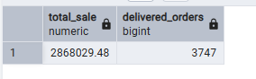

2.Identify the highest revenue-generating restaurants.

select total_sales, restaurant_name
from zomato_sales
order by total_sales desc limit 1;

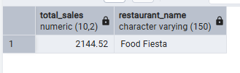

3.Find the food category with the highest quantity sold.

select food_category,quantity
from zomato_sales
order by quantity desc limit 1;

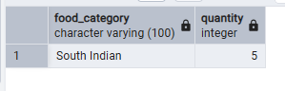

4.Calculate the average order amount for each city.

select city, avg(total_sales)
from zomato_sales
group by city;
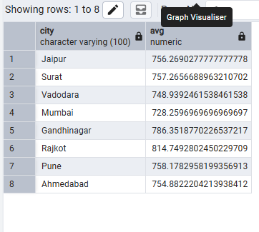
5.Measure the average delivery time for each restaurant.

select restaurant_name,avg(delivery_time_min)
from zomato_sales
group by restaurant_name;
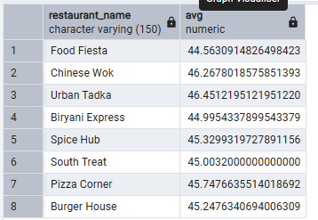

6.Find restaurants with an average customer rating above 4.5.

SELECT restaurant_name, AVG(customer_rating)
FROM zomato_sales
WHERE customer_rating >= 4.5
GROUP BY restaurant_name;

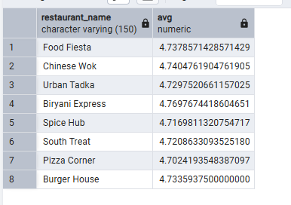

7.Determine the maximum discount offered by each restaurant.

select restaurant_name,max(discount)
from zomato_sales
group by restaurant_name;
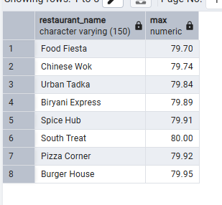

8.Identify the orders with the highest order values.

SELECT * FROM zomato_sales
WHERE total_sales = (
SELECT MAX(total_sales)
FROM zomato_sales);

