**INDEX**

Exploratory data analysis 2

Shape of train and test data 2

i. Univariate analysis 3

Fare_amount 3

Passenger_count 4

Pickup_datetime 7

Feature engineering 9

Pickup_latitude/pickup_longitude/drop_off_latitude/dropoff_longitude 10

Model creation 16

i. Normalization 16

ii. Boxcox transformation 16

Chi-square analysis 17

Model 17

Model Tuning 18

i. RandomForestRegressor 18

ii. KNN 18

iii. Linear regression 20

K folds 21

Objects for runnning the algorithm 21

Fitting and evaluating models 21

Results 21

LinearRegression results analysis 23

RandomForest feature importance 23

Best model: 24

Predicting the results 25

**REPORT :** This project is about predicting the fare of a cab ride, given the coordinates of pick/drop off, along with the pickup timestamp

# Exploratory data analysis

## Shape of train and test data

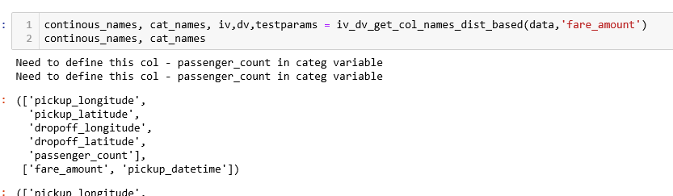

* Passenger_count is given as numeric, but we will treat it as categorical, since a very few and discrete values exists
* Fare_amount is numeric
* Pickup_datetime is given as string –
* Had to remove a few mis formatted strings and convert to float
* Then parse it as a TimeStamp object and store

**Missing value analysis**

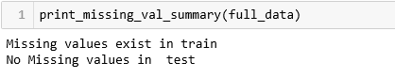

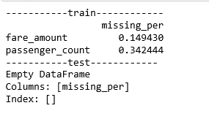

* Missing values in Fare_amount are replaced with median, since it fares are heavily right skewed and median is not affected by outliers unlike mean
* Missing values in passenger_count should be replaced by mode(since categorical variable), but then the result will be baised towards passenger count 1
  + Instead I checked the fare statistics in the subset dataframe where passenger count was missing and mapped out the records with same fare range and replaced the passenger count from those.
  + However the passenger count turned out to be 1 , even by this method

## Univariate analysis

### Fare_amount

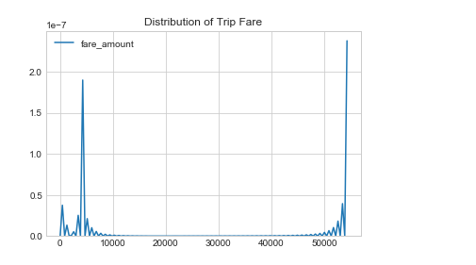

Fare_Amount has outliers where fare is 40k,50k for the ride in city.

Below is the skew and kurtosis value for fare_amount

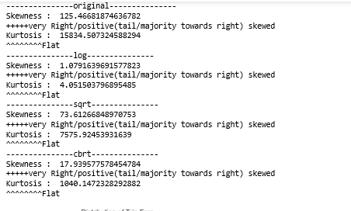

These can’t be explained by the predictors given to us, for eg for the same distance and same passenger_Count, how can the fare be varying so highly? Unless there are other factors like

### Passenger_count

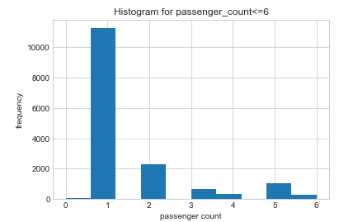

passenger_Count =1 is the maximum occurring

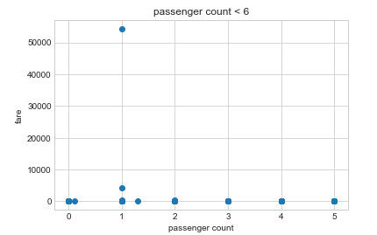

Fares are lying closely, except for a outlier (for passenger_Count<=6)

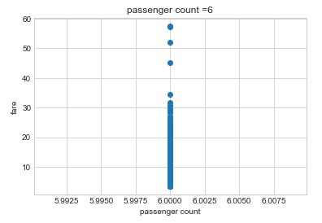

Few fares are high with passenger count=6

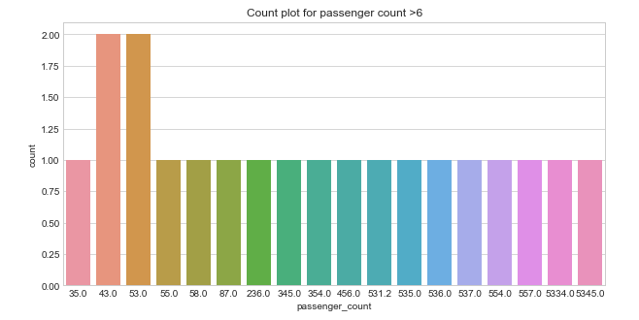

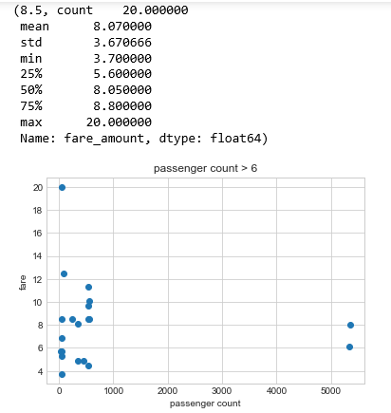

* In records where passenger count is above 6/10, the Fares are normally distributed,(see mean and median almost equal).
  + This suggests that we should not delete these records, but rather correct the passenger count (referring records with valid passenger count where fare is between 8-9, since here the mean exits around that range)

### Pickup_datetime

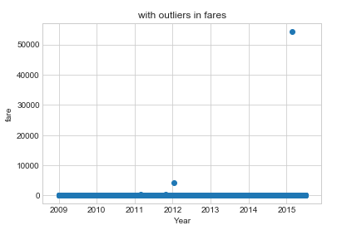

We see a flat line, with a few outliers

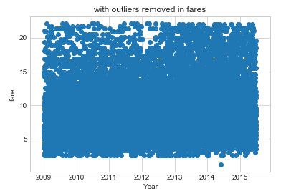

Now we can see it more clearly

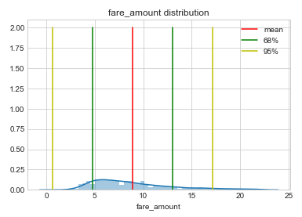

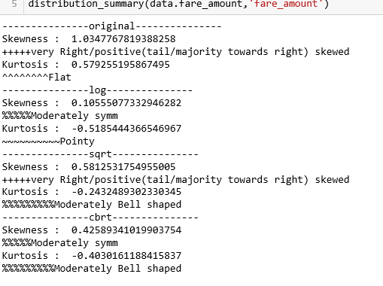

We can see fare_amount is now flat and right skewed

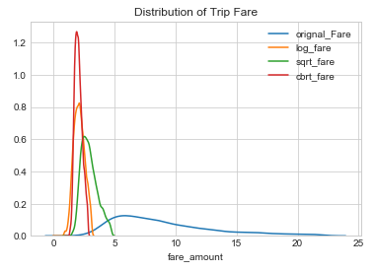

Cbrt gives the best distribution here

### Feature engineering

Derive new features from date timestamp, let us see

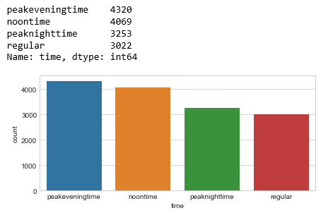

The data has maximum records for peakevening time( 5pm-9pm), followed by noon time(11am-4pm), peak night time(10pm-4am) and rest of the times are regular hours

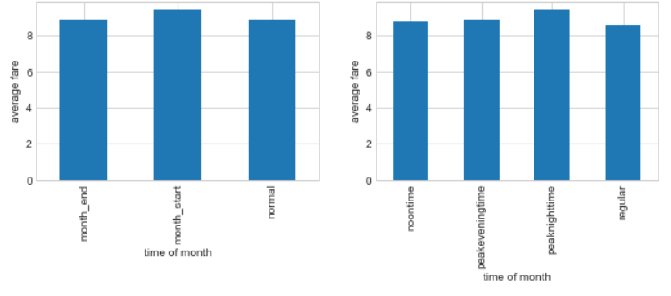

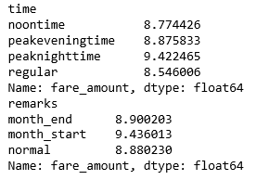

* Month_start recorded the highest average fare, followed by month_end, but overall they are very close, showing less significance on fare price
* Peak night time recorded highest average fare in a day as expected and it is quite significantly larger than others groups, showing night hours will impact the fares

### Pickup_latitude/pickup_longitude/drop_off_latitude/dropoff_longitude

Manhattan vs Euclidian

Mahattan distance is calculated when we have a mix of conitinous and categorical variables, whereas eucudian distance is the shortest distance between 2 points and hence can be used when you have only continous variables

Below I have plotted original fare_amount vs distance in 1st figure, and right hand side shows sqrt_fare, fare_max100(fare with cap 100) and fare_maxboxplot(fares with max 22.5 according to boxplot)

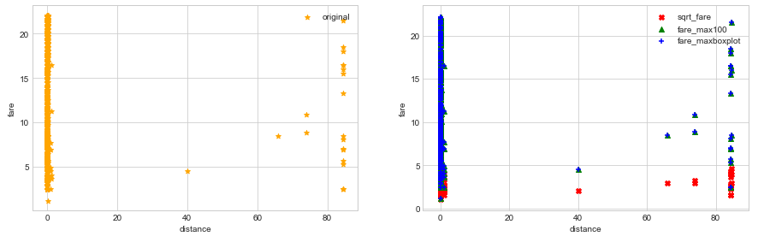

* With constant distance also the fares are increasing, there has to be a other factors which are not considered, like the Other independent factors like dropoff timestamp, waiting time, cab type(luxury/hatch back/suv).
* But since we dont have that as independent variable to access, we will ignore these observations as they will mislead our model

Now I have 2 datsets

* Original – with invalid passenger_counts mapped to 1
* Cleaned- with invalid dataset removed

Now few records show distance of 0, let us see

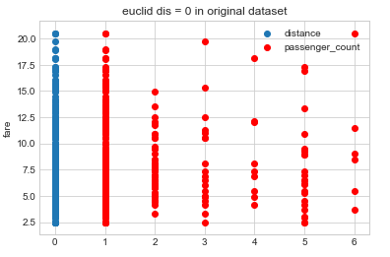

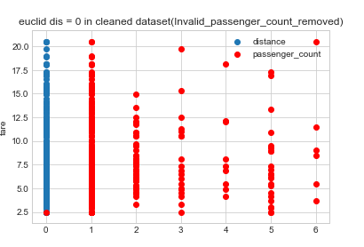

In cleaned dataset, passenger count =0 also

#### Impute Euclid_dis now

Let us the statistics for euclid_dis where fare is in around 6.90(mean of this datset with eculid_dis=0)

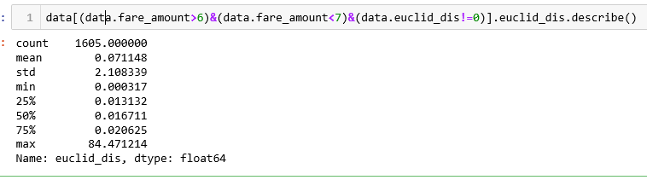

* Again this is right skewed since mean>median, I am using median value(0.017 rounded off) for the Euclid distance in these records
* In cleaned dataset, I deleted these records

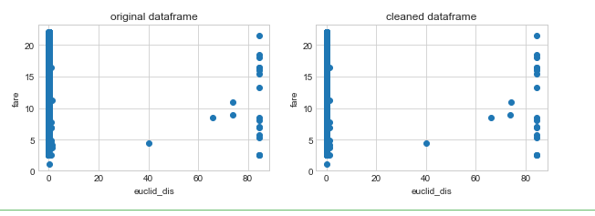

T he no of observations which are differing are very small in number and hence not much visible

There are outliers in distances, let us fix those

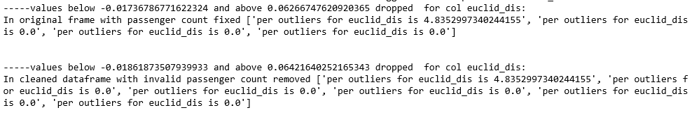

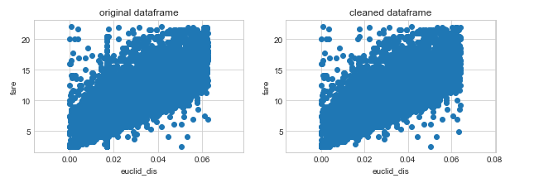



Cleaned dataframe shows more correlation with fare_amount, so I am going to build a model with that.

#### Why higher fares for keeping distance as constant

Plot high fares(>6.9)

For original dataset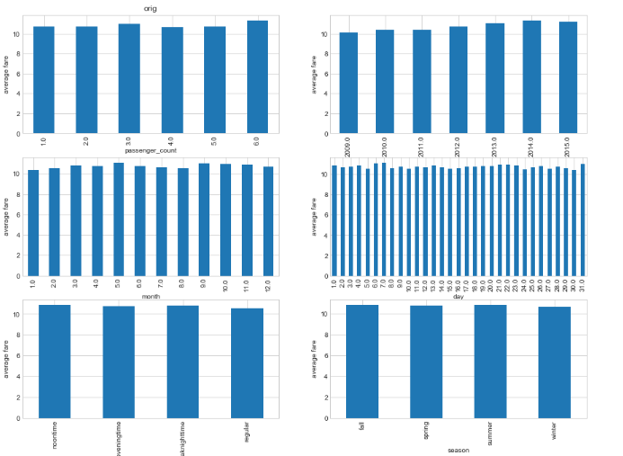

In cleaned dataset

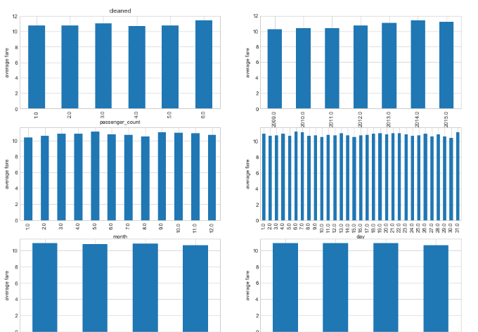

* cleaned dataframe gives better variations in time bar chart
* year effects the most
* month wise also fluctuting
* days also needs to be introspected
* passenger count 6 has highest fares
* season or time of day not effecting the high fares

#### few rides with passenger count as NA also

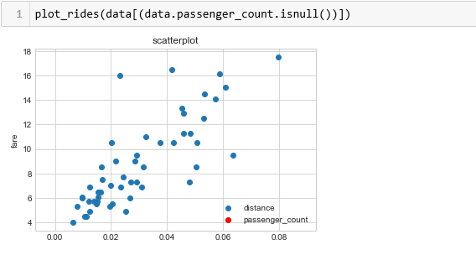

In original dataset, replaced these observations with passenger_Count =1

In cleaned dataset, dropped these records



We will continue with cleaned dataframe, since the correlation is higher with fare_amount

# Model creation

### Normalization

In one model I used Normalizing mont,day,Euclid_dis for Linear model

### Boxcox transformation

In one model, used boxcox method to normalize these fields

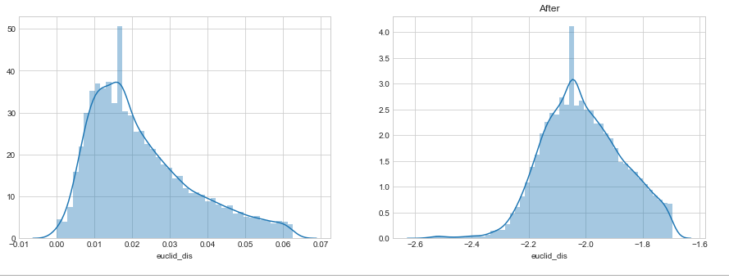

### Chi-square analysis

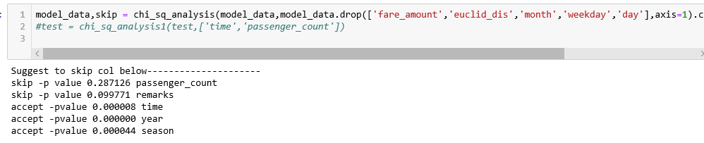

## Model

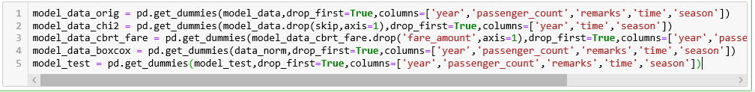

Created 4 dataframes for testing purpose

Model_data_chi2- skip the columna s per suggested by chi-sq analysis

Model_data_cbrt- has cbrt_log instead of fare_Amount

Model_data_boxcox- has dataset normalized with boxcox

## Model Tuning

### RandomForestRegressor

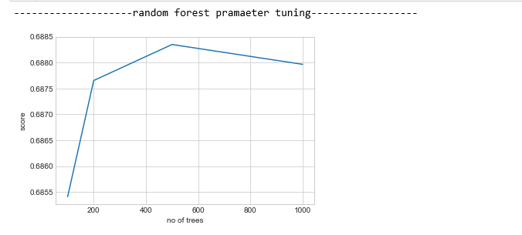

Performance is max with no of trees as 500

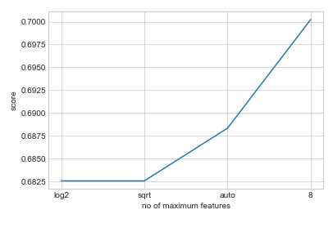

Performing most at no of max features as 8

### KNN

For k =4, the rmse is the least and also that makes the elbow of the curve

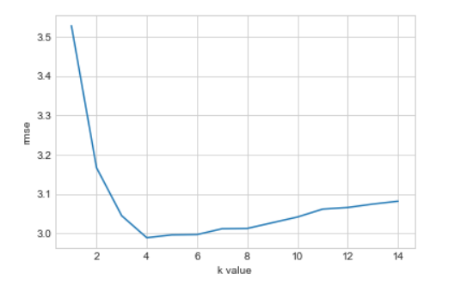

### Linear regression

The vif is below 10 for model_data_orig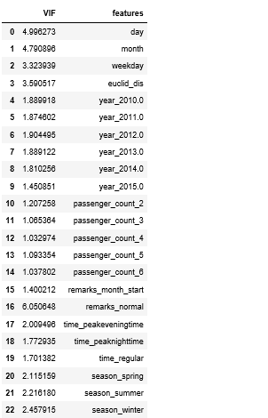

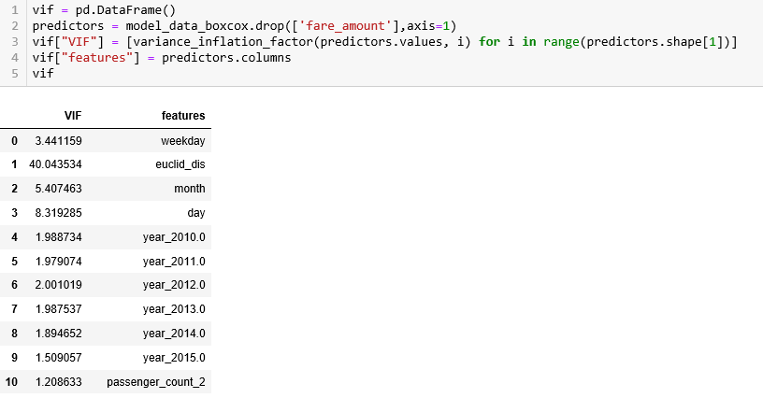

For model_data_boxcox, the variation inflation factor is 40, so going to not use this model for evaluation

## K folds

Used folds=5 to get the results

## Objects for runnning the algorithm

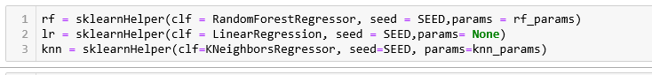

Using the skleanrhelper, I have created a wrapper class, to run the models

## Fitting and evaluating models

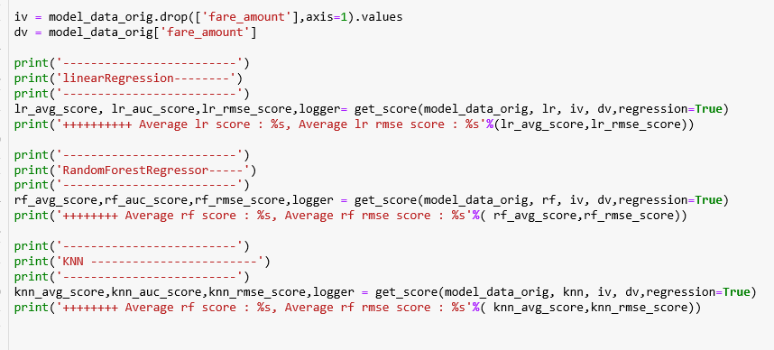

## Results

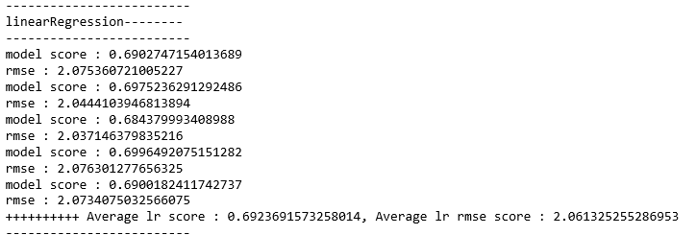

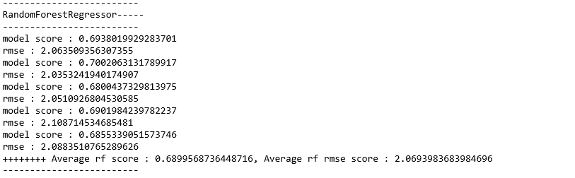

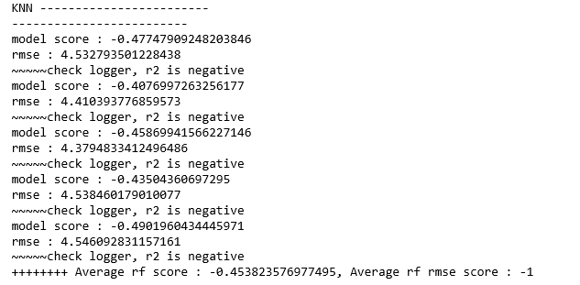

KNN performs very poor, score is negative, it is even worse thean mean fit line

### LinearRegression results analysis

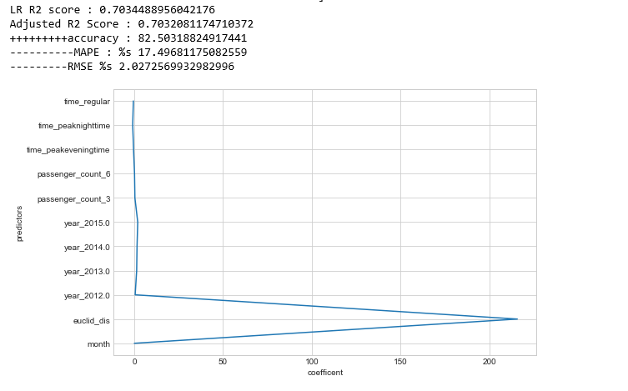

### 

### RandomForest feature importance

Euclid_dis shows the highest peak

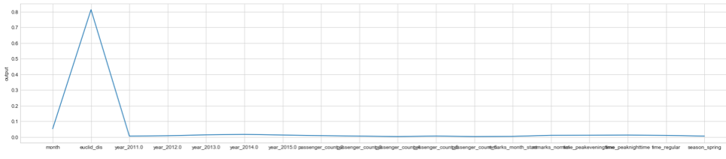

### Best model:

Model_fare_cbrt_fare gives the best result with linearregression

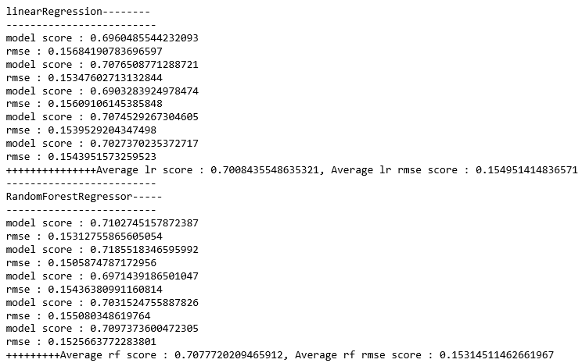

## Predicting the results

