**CS551 Advanced Software Engineering**

**Challenge -1 : (Hackathon)**

**Report**

**Submitted by**: SG9

**Team Members:** Suresh Yarra(Class id:48), Prudhvi Raj Atluri(Class id: 3)

1. **Design:**

**(a)** **Architecture Diagram**

Architecture Diagram shows the specific tradeoffs in the structure and design, the diagram is shown below

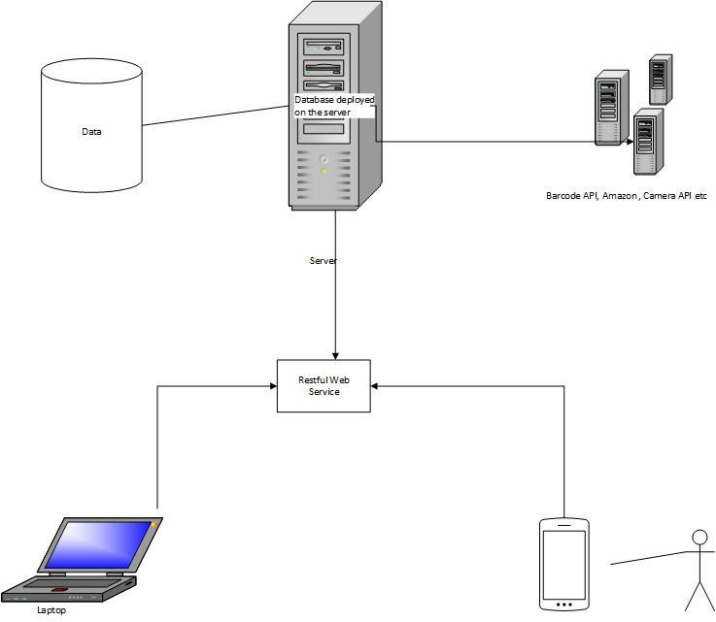

**(b)** **Class Diagram:**

The representation provided below is our class diagram.

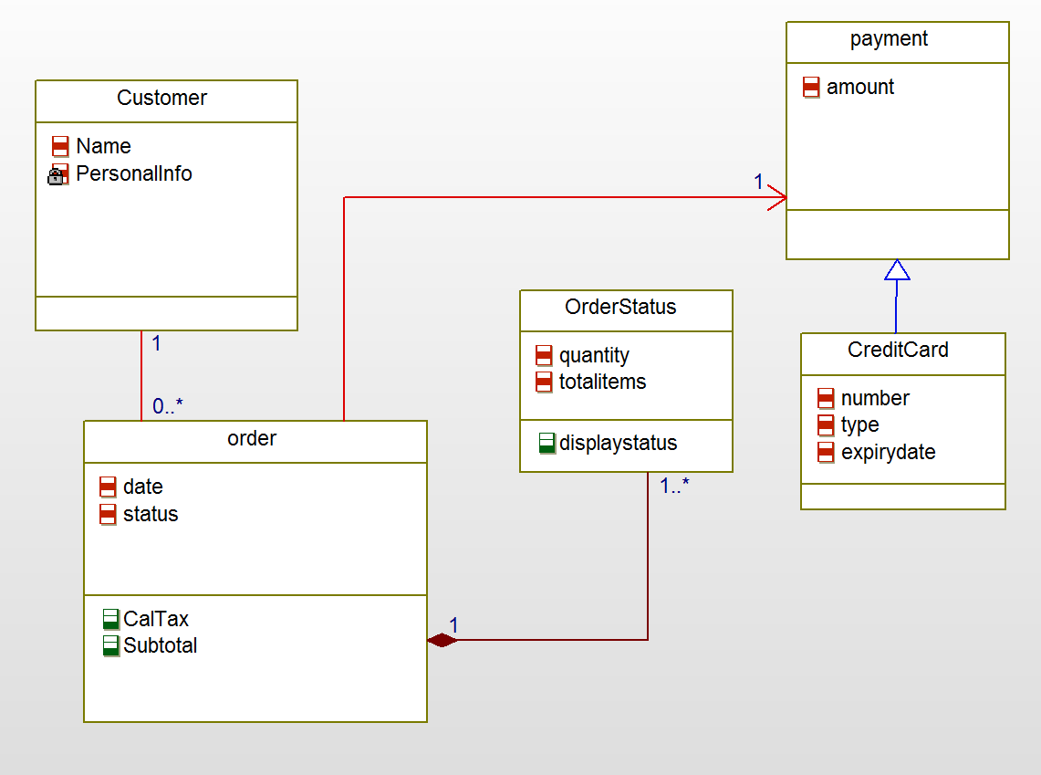

1. **WebServices:**

**a.** **Web services:**

First we collected some grocery data from the web, and saved that in the local database first, in general we need a service to get that data. here we developed an Rest web service with database using WCF in C#. this web service uses a GET request to get the data from the database that was placed on the server.

1. **Databases:**

We collected data from the web, and then created a MS SQL database (.mdf) . for this we use two tables in the database , one table gives the data about the grocery like itemname, price, weight (i.e Description) and where we got that item information we retrieved this data is in the JSON format. we called that rest URL in the iOS coding environment to get the grocery data.

1. **Mobile User Interface:**

To make application is user friendly we simplified the interface and tried to minimize the no.of views to make it run efficiently. we followed MVC architecture in development. initially we thought the user interface like this.

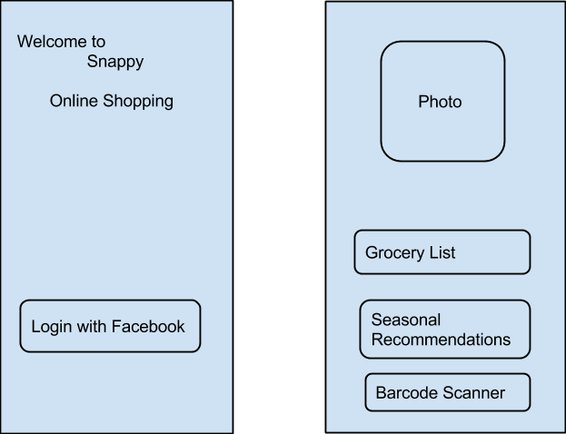

1. **ScreenShots of Features:**

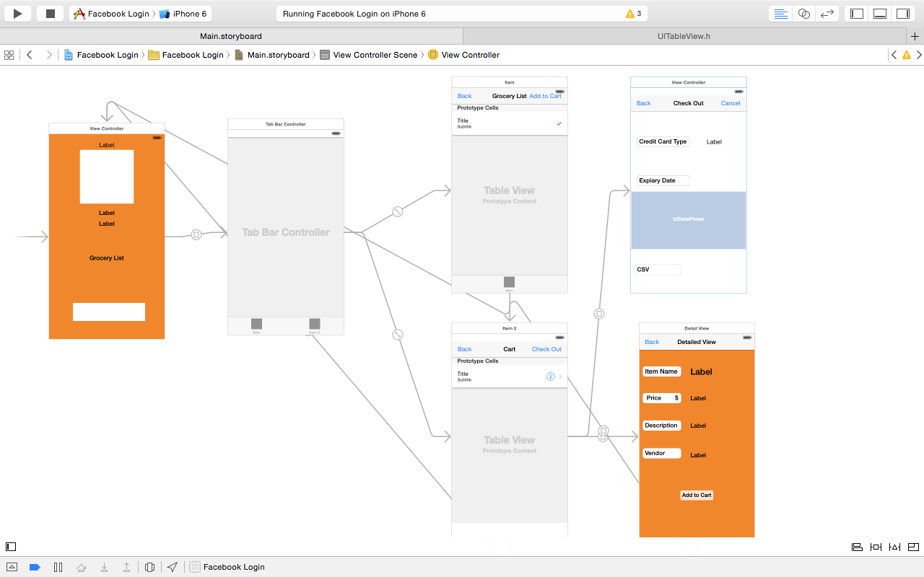

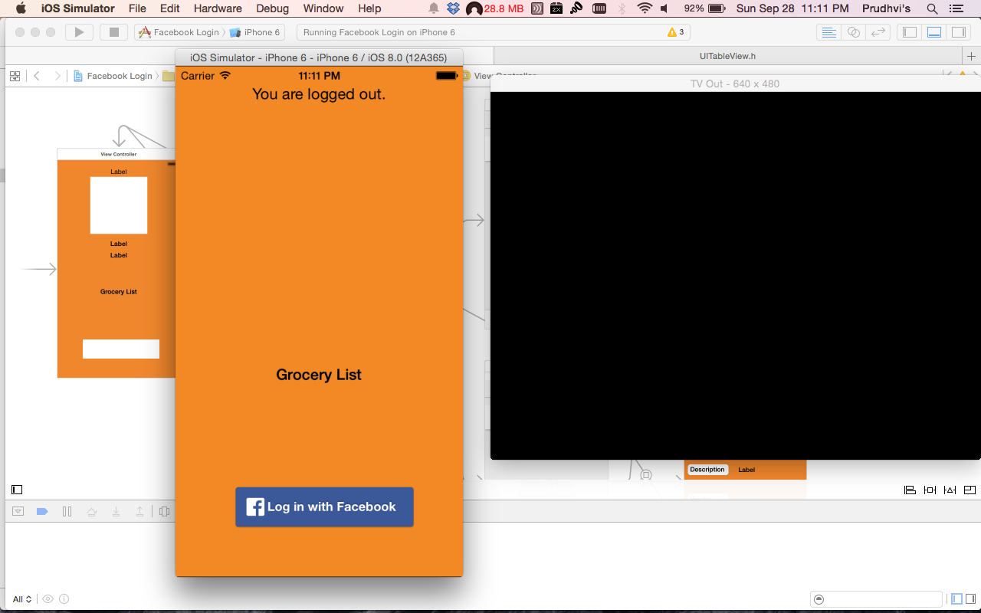

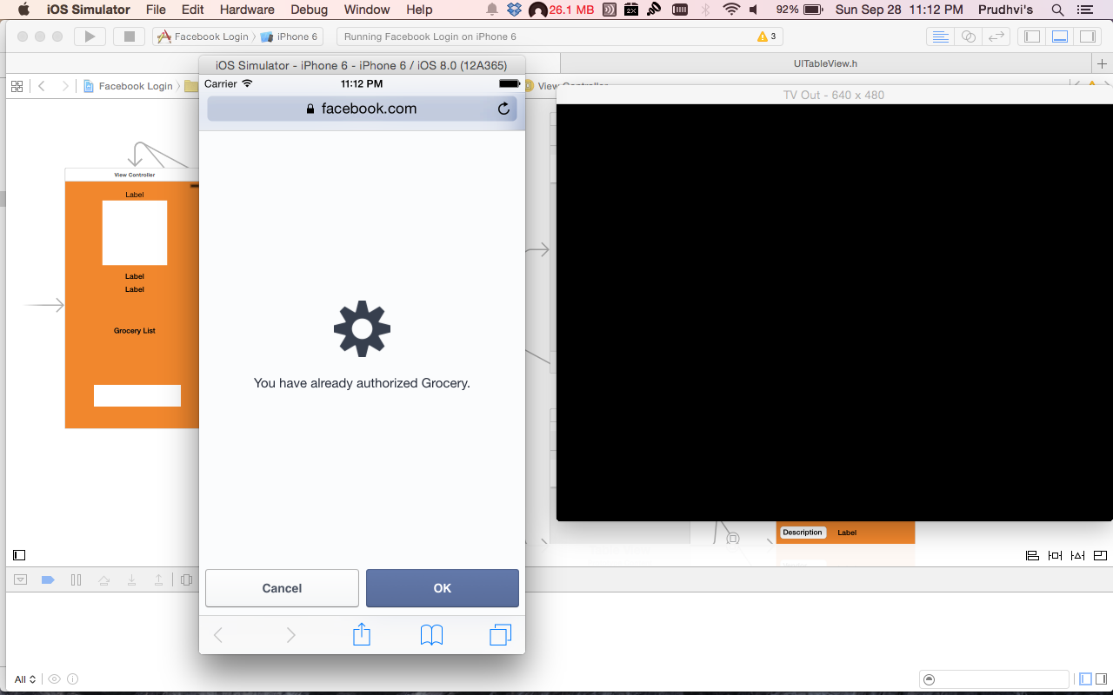

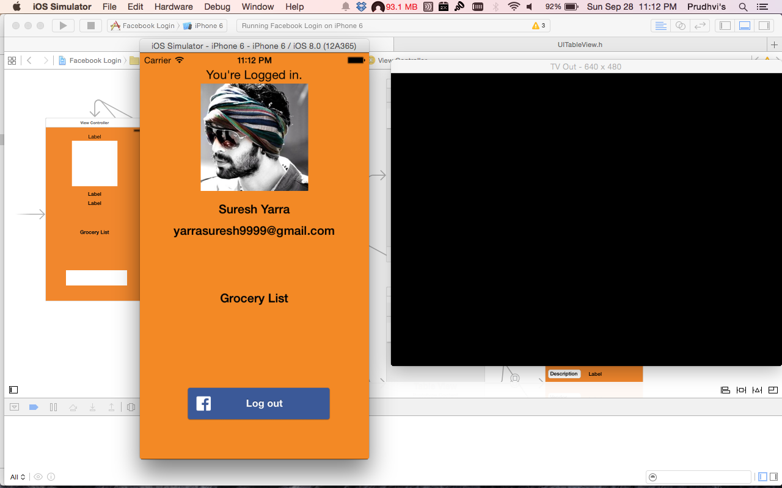

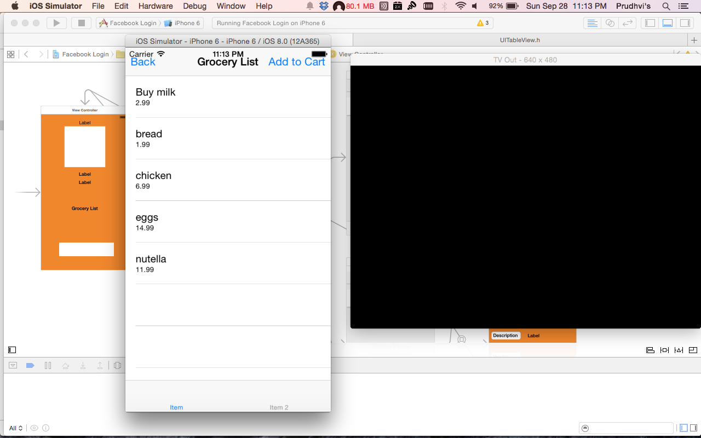



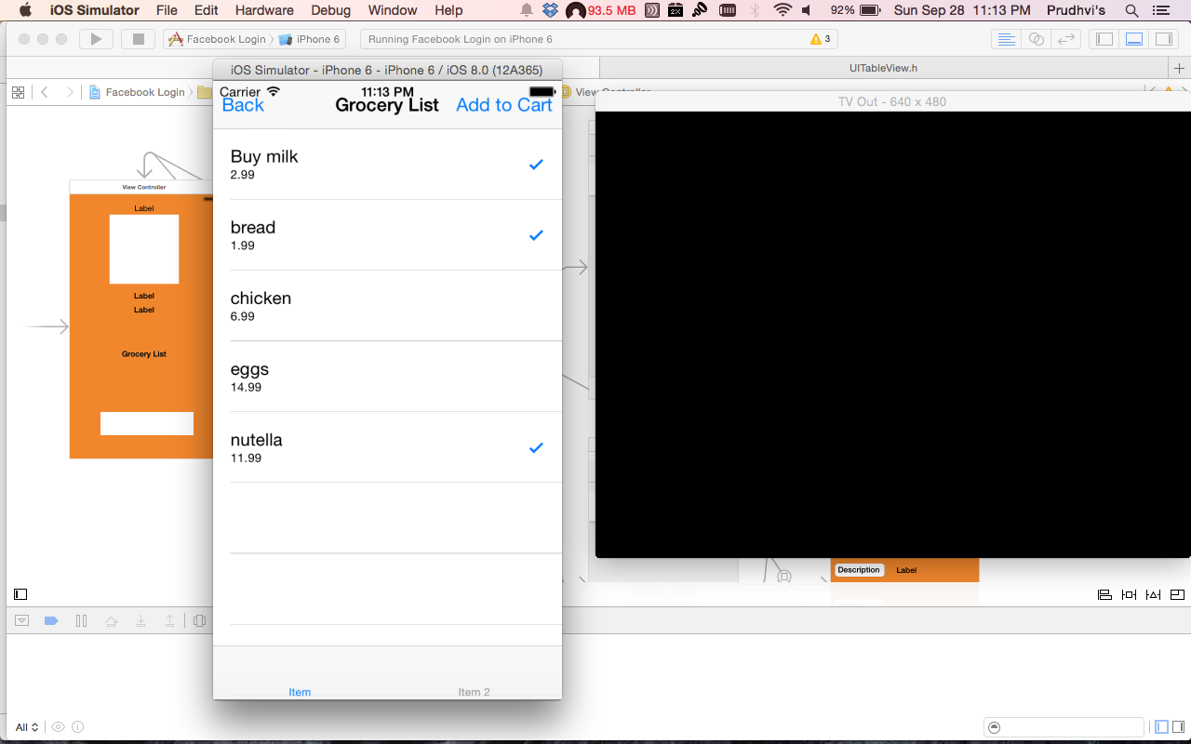

1. **Web Service URL:**

We developed an C# web service with database to get the all the Grocery data from the database which was deployed on the serever “KC-SCE-CS551.kc.umkc.edu” , the service URL is [http://KC-SCE-CS551.kc.umkc.edu/aspnet_client/Group3/C1/Restservice/Service1.svc/itemsdata](http://localhost/aspnet_client/Group3/C1/Restservice/Service1.svc/itemsdata)

1. **Github Url:**

Our project Github link is :

1. **Limitations:**

We have payment gateway in our application but it will be enabled once it turns out into a real time application by purchasing premium for using it, also we are using barcode api in our application but due to time constraint and real time data we are trying our best to implement that functionality in our application.

1. **References:**

* Facebook Developer Site[**https://developers.facebook.com/**](https://developers.facebook.com/)
* iOS learning <https://developer.apple.com/library/ios/navigation/>
* Barcode Scanner <http://www.programmableweb.com/api/barcode-scanner>
* Learning Objective - C<http://cocoadevcentral.com/d/learn_objectivec/>
* C# Restful web service development <http://msdn.microsoft.com/en-us/library/dd203052.aspx>