**Project Stat**

**Software Requirement Specification**

Version: 2.0

Date: 12-10-2019

**Team Members**

Samuel Chast, Thai Chu, Sabrina Chue

Patrick O’Neill, Harsh Patel, Danlin Zhao

**Stakeholders**

Dr. Sondergeld & Dr. Stone







**Table of Contents**

**Version History**3

**1.0 Introduction** **4-7**

1.1 Purpose 4

1.2 Background 4

1.3 Document Conventions 4

1.4 Document Overview 5

1.5 Intended Audience and Reading Suggestions 5

1.6 Scope 6

1.7 Definitions, Abbreviations, and Acronyms 7

1.8 References 7

**2.0 Overview** **8-15**

2.1 Product Perspective 8

2.2 User Classes and Characteristics 8

2.21 Physical Actors 8

2.22 System Actors 9

2.3 Users Needs 9

2.4 Product Features 10

2.5 Use Case Diagram 14

2.6 Design and Implementation Constraints 14

2.7 Assumptions and Dependencies 15

**3.0 System Features** **16-36**

Signup - Student 16

Signup - Teacher 16

Login 17

Statistical Calculators (Links) 18

Calculator Decision Tree 18

Video Lessons 19

Video Lesson - Questions 19

Video Lesson - Auto-Grading Questions 20

Video Lesson - Questions Feedback 20

Video Lesson - Quit 21

Labs 21

Lab - Auto-Grading Questions 22

Lab - Questions Feedback 22

Lab - Quit 22

Lab - Printable 23

Quizzes 24

Quiz - Auto-Grading Questions 24

Quiz - Quit 24

Quiz - Printable 25

Course Sequence Structure 26

Course Sequence Check 26

Teacher Course Monitoring 27

Teacher Registering Class 27

Admin Course Monitoring 28

Editable Account Info 28

Badge System 29

Email Sending System 29

Email Verification 30

Forgot Password 30

Students Registering a Teacher 30

First Time Login after Teacher Registration 31

Teacher Archiving A Student’s Progress 32

Export Database to CSV/JSON 32

All Questions Answered Check 33

Pre-Quiz 33

Log Out 33

Question Types - Multiple Choice 34

Question Types - True or False 34

Question Types - Multiple Selection 35

Question Types - Ranking 35

Contact Page 36

Two-Factor Authentication 36

**4.0 Interfaces** **37-41**

4.1 User Interfaces 37

4.2 Hardware Interfaces 40

4.3 Communication Interfaces 40

4.4 Client/Server Diagram 41

**5.0 Non-Functional Requirements** **41-43**

5.1 Performance Requirements 41

5.2 Security Requirements 42

5.3 Software Quality Requirements 42

# Version History

|  |  |  |  |
| --- | --- | --- | --- |
| Date | Version | Description | Authors |
| 11/19/2019 | 1.0 | Initial rough draft of Software Requirement Specification: this version did not include the intricacies of the System Features. | All members |
| 11/26/2019 | 1.1 | Updated the system features and clarified non-functional requirements to include measurable requirements. | All members |
| 12/19/2019 | 2.0 | Based on feedback, we have updated our formatting of the paper, as well as minor changes in miscellaneous sections (background, intended audience, system features, system requirements, scope, assumptions) for further clarification. We have also included a use case diagram and a client/server diagram to show how users will interact with these interfaces. | All members |

# 1.0 Introduction

## **1.1 Purpose**

The purpose of this document is to define the functionalities and details for an educational website called Project Stat, which teaches individuals rudimentary statistics.

Project Stat will allow for students to take a non-accredited online course about the fundamentals of statistics. Students will learn through online interactive lessons accompanied by online labs and quizzes to test their understanding of the course material. Through Project Stat, teachers will be able to use it as an additional resource, tailored to their in-person lessons to monitor student progress.

## **1.2 Background**

Our project will aim to provide STEM enrichment opportunities to middle school aged students to adults, especially those that are educationally disadvantaged. With individuals in science, technology, engineering, and mathematical fields underrepresented, it is critical for students to participate in competitions, research lab apprenticeships, and scholarships within the STEM fields to stay competitive and engaged. However, according to annual evaluation data by Army Educational Outreach Program (AEOP), reports have indicated that many students that participate in these programs are from underprivileged urban areas and do not have access to strong research design and statistical instruction necessary to fully utilize these opportunities.

Our project is to create a multi-module web interface that will provide interactive content, teaching statistics on an easy-to-use platform as a free, online educational resource. With this implemented, we can provide the teachings necessary for students participating in STEM opportunities and hopefully eliminate the knowledge gap of statistics in particular. On our website, we will be providing interactive modules to teach the content, labs to reinforce the learning, and quizzes to test their understanding of the many modules that will be available. Our stakeholders, Professor Toni Sondergeld of Drexel University and Dr. Gregory Stone of the University of Toledo and Chief Executive Officer of the Metriks Amerique Group will provide us with statistical content of our website. We will also be working with the Drexel server team for the technical aspects of our project.

## **1.3 Document Conventions**

This document details the technical requirements for the website Project Stat. As such, **bold** font and large wording is used to signify important sections of the document. **Bold** font may help readers quickly navigate through the document or find information in a section.

## **1.4 Document Overview**

1. **Introduction:** Provides a high-level description of the goals of Project Stat, outlines the document's sections, presents suggested sections for readers, defines the scope of the project, and recommends documentation for further reading.
2. **Overview:** Provides use cases for the website Project Stat, defines the different types of users, describes the users' software needs, details general software features/functionalities, specifies the constraints on users running the Project Stat website, and gives a list of assumptions and dependencies about the users.
3. **System Features:** Provides a comprehensive list of required features for the website Project Stat that includes a description of the feature, a priority level for development, a stimulus that details how this feature is triggered, and an account of all dependencies for a said feature.
4. **Interfaces:** Provides the wireframe mockups of the user interfaces, defines the requirements for users to interact virtually with hardware, and describes how the hardware communicates with the user's device, that should be connected to the internet.
5. **Non-Functional Requirements:** Provides details about requirements that are expected of the development team but have not been directly stated or made to be a deliverable.

## **1.5 Intended Audience and Reading Suggestions**

This document can be read and understood by users (e.g. teachers, students, and guests), developers, testers, and project managers. Upon completion of reading this document, the reader will understand the essential system specifications and why these features are needed in the project. Below is a list of recommended sections for each reader type and an explanation of why each reader type should read their recommended sections.

1. **Users (teachers, students, or guests):** The following sections should be read by users: Purpose, Background, Document Conventions, Document Overview, Definitions, Abbreviations, and Acronyms, Project Perspective, User Classes and Characteristics, Users Needs, Product Features, and all subsections in Interfaces.Users should read the following sections to understand the project's goals and to get their feedback on the project's features to see if additional work may be required.
2. **Developers:** The following sections should be read by developers:Purpose, Document Conventions, Document Overview, Scope, References, all of the Overview section except for Project Perspective, and the rest of the document. Developers should read the sections above to ensure that they fully understand the project's requirements and gain a basic understanding of the overall system architecture of the project's software design.
3. **Testers:** The following sections should be read by testers: Purpose, Document Conventions, Document Overview, Project Perspective, Product Features, all of the System Features section, and all of the Interface section, and all of the Non-Functional Requirements section. Testers should read the sections above to ensure that they fully understand the project's features. When testers go through the website and test the website's functionality, these sections in the document will allow them to understand what everything should accomplish, giving them the ability to find bugs/errors.
4. **Project Managers:** The entire document should be read by the project manager to ensure that the client's interests are clearly stated and that the development team has a comprehensive software requirement specification document.

## **1.6 Scope**

Project Stat will allow for students to take a non-accredited online course about the fundamentals of statistics. Students will learn about statistics through online interactive learning modules that will consist of videos, labs, and quizzes. As students advance through the course, they will earn badges to commemorate their accomplishments. Teachers and website admins can monitor students' achievements to see how well students are retaining the information they have learned from the online interactive learning modules. Students and users will also be given links to external sources that will allow them to use statistical calculators to aid them in their studies and future work.

The main purpose of this project is to develop a website that will allow for an individual that lives in an underprivileged urban area to obtain an understanding of statistics that they would not have gained without the use of our free online website.

**1.61 Out of Scope**

Functionality that are currently out-of-scope for our project include:

* Project Stat on mobile devices or tablets - Project Stat can only be utilized on a computer
* The ability for teachers to add their own content to the site - Stakeholders will be providing all the content for the website, therefore it will be a fixed course for ALL users
* Short answers and essay questions - Questions for interactive modules, labs, and quizzes are automatically graded and these types of questions cannot be checked automatically.
* The ability to participate in discussion boards - The course is led with a hands-off approach, so there will be little to no moderation in these channels.
* User Profile Customization - storage space is limited, so it is reserved for course content

## **1.7 Definitions, Abbreviations, and Acronyms**

**Statistical Calculator** - Tool that can be used by all the users (guests, students, teachers, admin) to perform simple statistical functions. Users can use this tool to perform basic statistical functions such as z-test, one-sample t-test, independent samples t-test, dependent samples t-test, pearson correlation, simple regression, and chi square

**Badging System -** A validated indicator of accomplishments in the form of digital badges that a student can earn after either completing every given module in a unit, completing each module’s quiz, or completing the full course.

**Interactive Modules -** All the content for each unit and module that are provided on this website will be provisioned in the form of interactive statistical lessons. Interactive statistical lessons will include multiple choice questions. User will have the option to either go back to the previous question, submit, or go to the next question.

**Hosting Server -** Drexel University’s server where all the statistical content that are available on the website will be hosted

**Decision Tree -** A decision support tool that uses a tree-like model of decisions and their possible results to conduct a statistical analyze on the type of data a particular user has in order to guide them on the type of calculator they should use and possibly suggest a lesson about it.

**Tracking Progress Tool** - A tool that will assist students in tracking their individual progress within the modules. It will also assist teachers in tracking the progress of students they register and help administrators in tracking any registered user using the website.

**Two-Factor authentication** - Abbreviated as **2FA,** it is a multi-step verification that adds another layer of security, supplementing the username and password model with a code that only a specific user has access to. This type of authentication will require a user to provide another piece of information other than their username and password to gain access. The second factor will come from something they have, such as a second email.

**Authentication** - It is the process of recognizing a user’s identity by associating an incoming request with a set of identifying credentials. The credentials provided are compared to those on a file in a database of the authorized user’s information to make an authorization check.

## **1.8 References**

1. Customer Requirements Document Version 1.1 - References to all the features that are implemented in the website along with detailed information on the required users and their functionalities.
2. Articulate Modules (Weblink) - References to the type of interactive module designed for the website: <https://360.articulate.com/review/content/861a8a5f-ace4-477a-b656-9204b7ca88cb/review>
3. Sample Content for Course Document - References to the type of statistical content and lessons that will be available on the website. It will provide information on the course description, course purpose, course objectives and learning outcomes, and the course design for each module in a given unit.
4. GUI Mockups Document - References to the wireframes, diagrams and User Interface prototypes that will be used in designing web pages such as Home Page, Sign Up page, Login page, Student dashboard, Teacher dashboard, Achievements Page that are integrated in the website.

# 2.0 Overview

## **2.1 Product Perspective**

Project Stat is an online course and shall be free to access. The website will be hosted on Drexel University’s server, but will be open to any person who would like to learn about statistics. Our target demographic is under-privileged individuals who have little to no access to STEM resources for the development of their statistics knowledge. Individuals should consider utilizing Project Stat because it is an informative and free resource for statistics. Through the interactive modules and lessons, students will have a better understanding of the content in an enjoyable way. The labs and quizzes for each unit will also help students retain the information at a higher rate. The achievement system, where students will be able to earn badges throughout the modules, would motivate them to complete the course in its entirety.

## **2.2 User Classes and Characteristics**

The users of this project shall be broken down into two distinct categories: physical actors and system actors. The physical actors shall be the users who will be interacting with the front end of our website to browse the initial user interface and accessing the information necessary to complete the course. The system actors shall be the functionality that runs in the background to ensure that the physical actors are able to access the interactive modules, lessons, labs, and quizzes while guaranteeing that the information is stored in the database.

### **2.21 Physical Actors**

**Guests** - Guests are the users who can browse the initial user interface which includes the overview of the website, contact page, and the statistical calculators. Guests can choose to become a student user in which they will utilize the sign up feature to create an account.

**Students** - Students are the main users who will be interacting with the client and user interface. Upon logging in, students will connect to the server in order to access the module information and take the labs and quizzes. Multiple students shall be able to connect to the server at the same time to complete the modules. Students can receive achievements upon completion of labs and quizzes, the full unit, and the full course.

**Teachers** - Teachers are the second main users who will be interacting with the client and user interface after logging in. As a teacher, users are also able to complete the modules, lessons, labs, and quizzes and receive achievements. However, they can view the course content of each unit without initializing the lesson in order to determine if they would like to use the online course for their classes. Teachers have access to invite students into the course by email and put them into their dashboard where they can monitor their progress.

**Admins** - Administrators are the essentially the stakeholders, who serves as monitors and collectors of data for basic analytic purposes. They are able to download teacher and student information and export data into a CSV or JSON format and study patterns as they see fit. The administrators are the designated contacts that other users will be able to contact with questions. They can be contacted through the contact us page if additional information is needed or for other inquiries related to the website, excluding any content help.

### **2.22 System Actors**

**Server** - The server is the system that accepts connections from the clients and saves the results of the modules, labs, and quizzes.

**Client** - The client is the computing system that connects to the website, which is made available by the server.

**Database** - The database is the system that stores all of the user information, such as birth year, state, and school in which the teacher is enrolled to, if applicable. As sensitive information is optional, there may be null fields within the database. For students, the database shall store progress for each unit and achievements. For teachers, the database shall store a list of the students under them as well as their progress of the course. Due to this, the database will contain sensitive information that needs to be secured. Ideally it will be stored on a separate server. Additionally stored files will be encrypting both personal information and account information.

## **2.3 Users Needs**

In using our website, our actors have the following needs:

* All users of the website have the need to seek out educational tools on statistics in order to learn more on the subject or guage how to better teach the course.
* Students are seeking to participate in an educational course on statistics and their objective is to learn the fundamentals of statistics by taking this course.
* Teachers are seeking additional resources to aid in helping their class learn about statistics and will use the website to help monitor and facilitate their classroom’s performance.
* Administrators are primarily monitoring the effectiveness of online learning and shall monitor the efficiency of the course by searching for patterns or stand-out statistics. They will also collect data on the user groups to see if there are correlations.

## **2.4 Product Features**

As mentioned above, Project Stat is a website that allows students to take a non-accredited online course about the fundamentals of statistics. As a website, Project Stat will include basic features such as:

|  |  |
| --- | --- |
| **Features** | **Description** |
| Sign Up | A sign up feature shall be implemented to give users the option to make an account to access the course. |
| Log In | A login feature shall be implemented in order for users who have created an account to keep track of their progress. |
| Log Out | A logout feature shall be implemented to allow users to securely exit their account. This will render the user status back to guest. |
| Reset Password | If users forget their password, they can select the “Forget Password?” button located on the login page. The user shall be prompted for their email that they have registered with, which shall send an email with further instructions to change their password. |
| Contacting Admins | Users shall have the option to contact the admins through a contact us page if additional information is needed. These emails will be sent to a shared email box that Dr. Sondergeld and Dr. Stone will monitor to answer the questions. |
| Dashboard | Once a user is logged in, their default home page shall become their dashboard. Depending on the type of user, their dashboard will vary. For students, it will display the units and their respective lesson progress, as well as allow them to go their achievements page and register their teacher. Teachers can monitor their class’s progress and enroll students in their dashboard. Admins can monitor the entire site. |

Moreover, students using Project Stat will be able to learn statistics through online interactive learning modules that will consist of videos, questions about the videos, labs, and quizzes. To accommodate that, Project Stat will incorporate the following features:

|  |  |
| --- | --- |
| **Features** | **Description** |
| Statistical Calculators | Information about different statistical calculators will be given. The calculators that will be discussed are z-test, one-sample t-test, independent samples t-test, dependent samples t-test, pearson correlation, simple regression, and chi-square. Links to external websites will be given so users can experiment with the calculators. |
| Interactive Modules | Content for each unit lesson shall be repackaged into interactive modules. Potential interactive activities shall include answering questions. Answers will pop-up on screen after user clicks submit with feedback. |
| Quizzes | * Pre-Quiz: Before each lesson, students shall have the option to test out of the module if the student has prior knowledge of the lesson. Students will have to score a 100% to test out and can only take each pre-quiz once. * Post-Quiz: After each lesson, students shall be tested on their retention of the lesson’s information in the form of a quiz. A passing score of 70% is required to move onto the next lesson. The post-quiz will have the same questions as the pre-quiz. * All quizzes will be 10 questions with potential question format being made up of multiple choice, matching, and true/false. |
| Labs | Per each lesson, students shall have the ability to complete labs to ensure they are retaining the information. Upon completion of the interactive module and labs, students shall be given access to the post quiz. |
| Answer Pop-Ups | Pop-ups shall aid students in the understanding of the answers to the questions in each lesson. Submitting their answer during a non-quiz question shall trigger the correct answer to be shown as well as an explanation for it. |
| Printing Capability | Users shall have the ability to print out the quizzes and labs to work on them. Any content printed from the site will be watermarked with Project Stat’s logo. |
| Automatic Grading | Student’s quizzes shall be graded automatically and immediately when students submit their answers, allowing scores and badges to be received at that time. |

While progressing through the course, students will be able to earn badges:

|  |  |
| --- | --- |
| **Features** | **Description** |
| Badging System | Students shall be able to receive badges in the following ways:   * Completing each lesson * Completing every lesson in a given unit * Completing the full course |

In Project Stat, the teacher and administrator role have different features when compared to students. Teachers will be able to register their students for the course. Both teachers and administrators will have the ability to monitor students' achievements and progress. Furthermore, only administrators can export information of all the users that participate in Project Stat:

|  |  |
| --- | --- |
| **Features** | **Description** |
| Progress Tracking Tool | Students shall have the ability to track their individual progress within the modules. Teachers shall have the ability to track the progress of all students they register. Admins shall have the ability to track any user using the website. |
| Exporting Information | Admins shall have the ability to export the database of all users who are signed up for the course. This information shall include the information they entered upon sign up. Admins can also export progress of all users. Exported files will be in a CSV format. |
| Registering Classes | Teachers shall have the ability to register their students for the course. This will allow the system to know that it is a class and these students belong to that specific teacher. |
| Students Registering with a Teacher | Students shall have the ability to register for a teacher's class. This will allow students who have already done work on Project Stat to join a teacher without needing to create a new account and losing all their progress. |

## **2.5 Use Case Diagram**

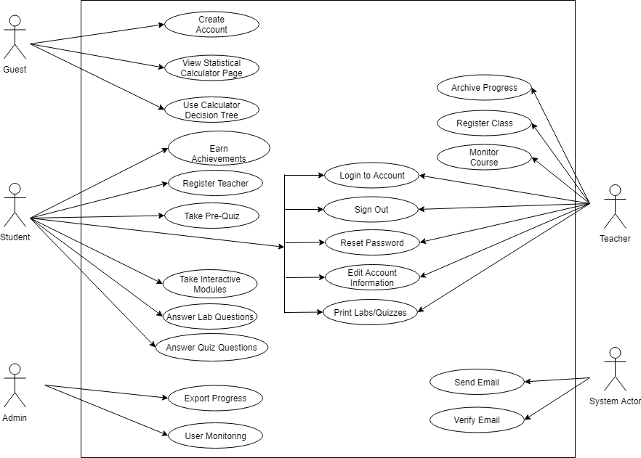

This diagram summarizes the information provided in the product features, showing each of the user’s interaction with the system and the different use cases.

## **2.6 Design and Implementation Constraints**

During the development of the website, the following are constraints with the design and implementation:

* The website will be hosted on Drexel University’s servers, so we will have to utilize Drexel’s website template and design schemes.
* As the website is handled with a hands-off approach, the grading of the activities will have to be automatic, making implementation of short answers impossible. This limits our testing style to multiple choice, numerical fill-ins, true and false, and matching problems.
* Given that the site will be hosted on Drexel University’s servers, our content must fit within the storage space and parameters given. This puts a constraint on our design process to have smaller sized files.
* The website will need to support around 1000 concurrent users. This puts some constraints on our design as we also need to make sure all Drexel University’s server requirements are met.

## **2.7 Assumptions and Dependencies**

**Assumptions:**

We assumed that the user’s system will meet the minimum requirements for an optimal experience as follows:

|  |  |  |
| --- | --- | --- |
|  | Windows Requirements | Mac requirements |
| Operating system | Windows 7 or later | Mac OS X Yosemite 10.10 or later |
| Processor | Intel Pentium 4 or later | Intel |
| Memory | 2 GB minimum, 4 GB recommended | |
| Screen resolution | 1280x1024 or larger | |
| Application window size | 1024x680 or larger | |
| Internet connection | Required | |

Users

* Users will use the website on a computer environment for optimal experience
* Users feel safe in sharing their information
* Users will contact admins when errors occur

Teachers/Administrators

* Teachers will enroll their students and use the system
* Teachers and Administrators will monitor classrooms

Team

* Requirements are defined
* Communicate with Stakeholders for clarifications or questions
* Contribute to the design and development of the website

**Dependencies:**

* Website will need to adhere to Drexel University’s server requirements
* Free, open source software for the design and development of the website

# 3.0 System Features

In the section below, we reference priority of the feature. To define priority: we label high for the items that will be of utmost importance to function properly. This is typically the content that our website is known for, whereas a medium priority signifies features that are typical industry standards for a website to have. Features within the medium and high priority range will both be delivered as they are required to run the platform; however more time will be spent ensuring items marked high priority features are fully working as intended. Features labeled as a low priority are viewed as items that are nice to have, but are not our primary focus to implement. Finally, the subsection functional requirements, details how each of the system features are related to one another, if applicable, and provides information about the dependencies of all system features.

## **Signup - Student**

Description:

* + 1. Students can sign up for our website by putting in the following information: first name, last name, and email address. Users will also be asked to give their age, gender, birthdate, state & county they live in, but this information is not required to register for the website.

Priority: **Medium**

Response Path:

**Preconditions**: The user is on the homepage for the website Project Stat

* + 1. The user clicks the button labeled “Log In”
    2. The user clicks the button labeled “Create an Account”
    3. Users interested in becoming a student should click on the tab labeled “Student” to create a Student account
    4. The user has to at least enter their first name, last name, and email address. Other entries are optional.
    5. The user will then click the “Sign Up” button
    6. The user should be redirected to their dashboard

Functional Requirements:

* + 1. Connected - None
    2. Connects - 3, 29, 42

## **Signup - Teacher**

Description:

* + 1. Teachers can sign up for our website by putting in the following information: first name, last name, and email address. Users will also be asked to give the state & county they live in and their school's name, but this information is not required to register for the website.

Priority: **Medium**

Response Path:

**Preconditions**: The user is on the homepage for the website Project Stat

* + 1. The user clicks the button labeled “Log In”
    2. The user clicks the button labeled “Create an Account”
    3. Users interested in becoming a teacher should click on the tab labeled “Teacher” to create a Teacher account
    4. The user has to at least enter their first name, last name, and email address. Other entries are optional.
    5. The user will then click the “Sign Up” button
    6. The user should be redirected to their dashboard

Functional Requirements:

* + 1. Connected - None
    2. Connects - 3, 29, 42

## **Login**

Description:

* + 1. When a user goes to log into their account, they will be asked to input their email address and password. If a user fails to login 5 times in a row, they will be required to complete a captcha. If the user still fails to entire their information correctly, the user can reset their password by clicking "forgot password?".

Priority: **Medium**

Response Path:

**Preconditions**: The user is on the homepage for the website Project Stat

* + 1. The user clicks the button labeled “Log In”
    2. The user enters their email address and password
    3. The user will then click the login button
    4. If the provided information was correct
       - The user should be redirected to their dashboard
    5. If the provided information was incorrect
       - The users will be promoted to try again
       - The users should not be told what information was incorrect, just that they failed to log in
    6. If the user fails to log in five times for a given instance
       - The user will need to complete a captcha before attempting to log in again

Functional Requirements:

* + 1. Connected - 1, 2
    2. Connects - 31, 36

## **Statistical Calculators (Links)**

Description:

Below is a list of statistical calculators that will be discussed on our website. Each of these calculators will have a webpage that discusses the calculator's functionality and its use case. Along with this description, there will be a link provided to an external website that has the calculator already programmed, and users can experiment with the calculator there.

1. z-Test Calculator
2. One-Sample t-test Calculator
3. Independent Samples t-test Calculator
4. Dependent Samples t-test Calculator
5. Pearson Correlation Calculator
6. Simple Regression Calculator
7. Chi-Square Calculator

Priority: **Low**

Response Path:

**Preconditions**: The user is on the homepage for the website Project Stat

* + 1. The user clicks the button labeled “Calculators”
    2. The user can then click and choose a calculator
    3. The user will load a new page that provides details about the calculator
    4. The user can click the external website link, and this will take them to another website where they will have a fully functioning version of the calculator the user wants to

Functional Requirements:

* + 1. Connected - None
    2. Connects - 5

## **Calculator Decision Tree**

Description:

* + 1. Users will be able to take a questionnaire that will ask them a series of questions about statistical data. Depending on the user's answers to the questions, a statistical calculator will be recommended that is optimal for the given scenario.

Priority: **Low**

Response Path:

**Preconditions**: The user is on the homepage for the website Project Stat

* + 1. The user clicks the button labeled “Which Calculator is Best?”
    2. The user will have to answer the questions and click submit to be recommended a statistical calculator

Functional Requirements:

* + 1. Connected - 4
    2. Connects - 37, 38, 39, 40

## **Video Lessons**

Description:

* + 1. All signed-in users can watch videos about statistical material. Users can fast forward videos, rewind videos, pause videos, rewatch videos, and skip parts of videos by clicking on different time stamps on the video progress bar.

Priority: **High**

Response Path:

**Preconditions**: The user is logged in and is currently on their dashboard

* + 1. The user clicks on one of the modules/units
    2. The user selects a lesson in the modules/units
    3. The user picks the video portion of the lesson
    4. The user watches the lesson’s video

Functional Requirements:

* + 1. Connected - None
    2. Connects - 7, 10

## **Video Lesson - Questions**

Description:

* + 1. All signed-in users can answer questions related to a lesson's video. Users can pause the lesson's video at any time and answer questions about the video. Alternatively, users can wait for the video to be finished before answering any questions. Users need to answer the questions and then submit them for grading. Note, questions will not be randomized in any way.

Priority: **High**

Response Path:

**Preconditions**: The user is watching/finishing a lesson’s video

* + 1. The user finishes the video portion of the lesson
       - The user is then prompted to answer the questions
       - The user answers the questions
       - The user clicks the button labeled “Submit”
    2. The user pauses the lesson’s video
       - The user clicks the question portion of the lesson’s video
       - The user answers the questions
       - The user clicks the button labeled “Submit”

Functional Requirements:

* + 1. Connected - 6
    2. Connects - 8, 9, 34, 37, 38, 39, 40

## **Video Lesson - Auto-Grading Questions**

Description:

* + 1. When a user submits the questions they have answered, the questions will be automatically graded, and the users will be given a score based on their results.

Priority: **Medium**

Response Path:

**Preconditions**: The user is submitting their questions for grading

* + 1. The user answers the questions and submits them for grading
    2. A popup window will appear informing the user how well they performed

Functional Requirements:

* + 1. Connected - 7
    2. Connects - 9, 28

## **Video Lesson - Questions Feedback**

Description:

* + 1. After a user’s questions have been graded, allow the user to go through the questions to be given feedback. Regardless of whether the user answered correctly or incorrectly, we will provide feedback explaining why the answer was such.

Priority: **Medium**

Response Path:

**Preconditions**: The user has received their grades on the questions

* + 1. The user will close the popup window
    2. The user will use buttons label “Next” and “Previous” to flip through the questions to view their feedback

Functional Requirements:

* + 1. Connected - 7, 8
    2. Connects - None

## **Video Lesson - Quit**

Description:

* + 1. At any point during the lesson’s video or questions, a user can leave and return to their dashboard. Since there will be no save functionality, a prompt will appear, notifying that all progress will be lost if the user leaves their current session.

Priority: **Medium**

Response Path:

**Preconditions**: The user is either watching the lesson, answering questions, or reviewing their feedback

* + 1. The user clicks the button labeled “Back”
    2. All other activities pause
    3. A pop-up window appears warning the user that all progress will be lost and whether or not they wish to continue
    4. The user clicks the button labeled “Yes”
       - The user is returned to their dashboard
    5. The user clicks the button labeled “No”
       - The pop-up closes and the user remain where they were

Functional Requirements:

* + 1. Connected - 6, 7
    2. Connects - None

## **Labs**

Description:

* + 1. All signed-in users can take online labs that are designed to reinforce the material taught in the video lessons. Users need to answer the questions in the lab and then submit for grading. Note, questions will not be randomized in any way.

Priority: **High**

Response Path:

**Preconditions**: The user is logged in and is currently on their dashboard

* + 1. The user clicks on one of the modules/units
    2. The user selects a lesson in the modules/units
    3. The user picks the lab portion of the lesson
    4. The user takes the lab and then presses the submit button for grading

Functional Requirements:

* + 1. Connected - None
    2. Connects - 12, 14, 15, 34, 37, 38, 39, 40

## **Lab - Auto-Grading Questions**

Description:

* + 1. When a user submits their lab, the questions in the lab will be automatically graded, and the user will be given a score based on their results.

Priority: **Medium**

Response Path:

**Preconditions**: The user is submitting their lab for grading

* + 1. The user answers the questions on the lab and submits them for grading
    2. A popup window will appear informing the user how well they performed on the lab

Functional Requirements:

* + 1. Connected - 11
    2. Connects - 13, 26

## **Lab - Questions Feedback**

Description:

* + 1. After a user's answers to the questions have been graded, allow the user to go through the questions to get feedback. Regardless of whether the user answered correctly or incorrectly, we will provide feedback explaining why the answer was such.

Priority: **Medium**

Response Path:

**Preconditions**: The user has received their grades for the lab

* + 1. The user will close the popup window
    2. The user will scroll through the lab’s questions to view their feedback

Functional Requirements:

* + 1. Connected - 12
    2. Connects - None

## **Lab - Quit**

Description:

* + 1. At any point during the lab, a user can leave and return to their dashboard.

Since there will be no save functionality, a prompt will appear, notifying that all progress will be lost if the user leaves their current session.

Priority: **Medium**

Response Path:

**Preconditions**: The user is either reading the lab, answering questions, or reviewing their feedback

* + 1. The user clicks the button labeled “Back”
    2. All other activities pause
    3. A pop-up window appears warning the user that all progress will be lost and whether or not they wish to continue
    4. The user clicks the button labeled “Yes”
       - The user is returned to their dashboard
    5. The user clicks the button labeled “No”
       - The pop-up closes and the user remain where they were

Functional Requirements:

* + 1. Connected - 11
    2. Connects - None

## **Lab - Printable**

Description:

* + 1. Users will have the ability to print labs out so they can work out the problems themselves on physical paper. Any lab that is printed out will have a watermark that will let people know that the lab is from Project Stat's website.

Priority: **Low**

Response Path:

**Preconditions**: The user is either reading the lab, answering questions, or reviewing their feedback

* + 1. The user clicks the button labeled “Print”
    2. A screen will popup that will allow the user to select their printing settings
    3. The user clicks the button labeled “Print” on the pop-up window
       - The document begins to print
       - The pop-up window closes
       - The view of the lab is returned
    4. The user clicks the button labeled “Cancel” on the pop-up window
       - The pop-up window closes
       - The view of the lab is returned

Functional Requirements:

* + 1. Connected - 11
    2. Connects - None

## **Quizzes**

Description:

* + 1. All signed-in users can take the quizzes that are designed to test the user’s knowledge of the material taught in the video lessons and labs. Users need to answer the questions in the quiz and submit for grading. Note, questions will not be randomized in any way. Note that quizzes will be retake able.

Priority: **High**

Response Path:

**Preconditions**: The user is logged in and is currently on their dashboard

* + 1. The user clicks on one of the modules/units
    2. The user selects a lesson in the modules/units
    3. The user picks the quiz portion of the lesson
    4. The user takes the quiz and presses the submit button once finished

Functional Requirements:

* + 1. Connected - None
    2. Connects - 17, 18, 19, 34, 35, 37, 38, 39, 40

## **Quiz - Auto-Grading Questions**

Description:

* + 1. When a user submits their quiz, the questions in the quiz will be automatically graded, and the user will be given a score based on their results.

Priority: **Medium**

Response Path:

**Preconditions**: The user is submitting their quiz for grading

* + 1. The user answers the questions on the quiz and submits them for grading
    2. A popup window will appear informing the user how well they performed on the quiz

Functional Requirements:

* + 1. Connected - 16
    2. Connects - 26, 35

## **Quiz - Quit**

Description:

* + 1. At any point during the quiz, a user can leave and return to their dashboard. Since there will be no save functionality, a prompt will appear, notifying that all progress will be lost if the user leaves their current session.

Priority: **Medium**

Response Path:

**Preconditions**: The user is either reading the quiz or answering questions

* + 1. The user clicks the button labeled “Back”
    2. All other activities pause
    3. A pop-up window appears warning the user that all progress will be lost and whether or not they wish to continue
    4. The user clicks the button labeled “Yes”
       - The user is returned to their dashboard
    5. The user clicks the button labeled “No”
       - The pop-up closes and the user remain where they were

Functional Requirements:

* + 1. Connected - 16
    2. Connects - 35

## **Quiz - Printable**

Description:

* + 1. Users will have the ability to print quizzes out so they can work out the problems themselves on physical paper. Any quiz that is printed out will have a watermark that will let people know that the quiz is from Project Stat's website.

Priority: **Low**

Response Path:

**Preconditions**: The user is either reading the quiz or answering questions

* + 1. The user clicks the button labeled “Print”
    2. A screen will popup that will allow the user to select their printing settings
    3. The user clicks the button labeled “Print” on the pop-up window
       - The document begins to print
       - The pop-up window closes
       - The view of the quiz is returned
    4. The user clicks the button labeled “Cancel” on the pop-up window
       - The pop-up window closes
       - The view of the quiz is returned

Functional Requirements:

* + 1. Connected - 16
    2. Connects - 35

## **Course Sequence Structure**

Description:

* + 1. Users will be able to take this online course in any manner that they choose. This means that users don't need to follow the sequential order of the course and can take lessons/units/modules out of order.

Priority: **Medium**

Response Path:

**Preconditions**: The user is logged in and is currently on their dashboard

* + 1. The user can click any modules/units/lesson they want

Functional Requirements:

* + 1. Connected - 26
    2. Connects - 21

## **Course Sequence Check**

Description:

* + 1. If a user decided to take the course out of order, a window will pop-up warning them that if they proceed, they may not understand the lesson/unit/module. This pop-up window will suggest other lessons/units/modules that should be completed before the current lesson/unit/module the user wants to take. This window will also give the user the option to disable this pop-up window.

Priority: **Low**

Response Path:

**Preconditions**: The user is logged in and is currently on their dashboard

* + 1. The user can click any modules/units/lesson they want
    2. The warning pop-up window will appear
    3. The user clicks the button “Continue Anyway” on the pop-up window
       - The pop-up window closes
       - The module/unit/lesson the user wanted to see is displayed
    4. The user clicks the button “Back” on the pop-up window
       - The pop-up window closes
       - The module/unit/lesson the user wanted to see is not displayed
    5. The user selects the button labeled “Don’t show me this again”
       - Any future warning messages about taking the course out of order are prevented from showing

Functional Requirements:

* + 1. Connected - 20
    2. Connects - None

## **Teacher Course Monitoring**

Description:

* + 1. A teacher can monitor their students’ progress by viewing what lessons they watched, what quizzes and labs they've taken, the badges they earned, and the last time they were online.

Priority: **High**

Response Path:

**Preconditions**: The teacher needs to be logged in, is currently on their dashboard, and has students already registered in their class

* + 1. The teacher clicks the button labeled “Class Monitoring”
    2. The teacher scrolls through the page to see how well their students are performing in the course

Functional Requirements:

* + 1. Connected - 23
    2. Connects - None

## **Teacher Registering Class**

Description:

* + 1. Users that enrolled as a teacher can register their classes to take the online course. The teacher will post a list of their students' emails in a text box. The list of emails needs to be separated in one of the following ways newlines, tabs, spaces, or commas. The list will be parsed, and the students will be sent their invitations via email.

Priority: **Medium**

Response Path:

**Preconditions**: The teacher needs to be logged in and is currently on their dashboard

* + 1. The teacher clicks the button labeled “Register My Class”
    2. A text area will explain how the emails should be separated to ensure intended functionality is achieved
    3. The teacher post the list of their students’ emails in the text box
    4. The teacher clicks the button labeled “Send Invitation”
    5. If invalid emails are present
       - A pop-up window will inform the teacher which emails were invalid.
       - Students that were sent an invitation will appear on the teacher’s monitoring page as “Pending” until the student accepts the invitation
    6. If no invalid emails are present
       - A pop-up window will inform the teacher that all the students were sent an invitation.
       - Students will appear on the teacher’s monitoring page as “Pending” until the student accepts the invitation

Functional Requirements:

* + 1. Connected - None
    2. Connects - 28, 23

## **Admin Course Monitoring**

Description:

* + 1. As an admin, users can monitor every users’ progress by viewing what lessons they watched, what quizzes and labs they've taken, the badges they’ve earned, and the last time they were online.

Priority: **High**

Response Path:

**Preconditions**: An admin needs to be logged in and is currently on their dashboard

* + 1. The admin clicks the button labeled “Course Monitoring”
    2. The admin will scroll through the page of users to see how well they are performing in the course

Functional Requirements:

* + 1. Connected - None
    2. Connects - None

## **Editable Account Info**

Description:

* + 1. Once a user is registered on our website, they will have the ability to change all of their personal information.

Priority: **Medium**

Response Path:

**Preconditions**: The user needs to be logged in and is currently on their dashboard

* + 1. The user clicks the button labeled “Account” found in the top right
    2. The account page will display all the user’s information
    3. The user can then edit any information they want
    4. The user clicks the button labeled “Save Changes”
    5. If a user tries to leave the page with unsaved changes
    6. A pop-up window will appear asking them if they wish to save changes
    7. If the user clicks the button labeled “Save changes”
       - Changes will be saved
       - The page will update to wherever the user was trying to go
    8. If the user clicks the button labeled “No, don’t save changes”
       - Changes will not be saved
       - The page will update to wherever the user was trying to go

Functional Requirements:

* + 1. Connected - None
    2. Connects - None

## **Badge System**

Description:

* + 1. All users can unlock badges/achievements for completing lesson videos, labs, quiz, and units/modules. These badges are meant to commemorate the users' progress and serve as a certificate of completion of the course material.

Priority: **High**

Response Path:

**Preconditions**: The user needs to be logged in and has just completed a quiz, lab, video, unit/module

* + 1. The user submits their assignment, and assuming they pass (with a score of 70% or higher), a pop-up window will appear
    2. A pop-up window will inform the user that they unlocked a badge for the task they have just completed and can view it by clicking the link provided in the pop-up (it will take them to their achievements page)

Functional Requirements:

* + 1. Connected - 7, 11, 16
    2. Connects - 20

## **Email Sending System**

Description:

* + 1. An email notification system will be used to send an invitation to students to join the website and reset passwords. These emails will contain a link that will redirect users back to our website where they can register for the course, register a teacher (students only), or change their password.

Priority: **Medium**

Response Path:

* + 1. See sections 1, 2, 23, & 29 to see when this feature is triggered

Functional Requirements:

* + 1. Connected - 1, 2, 23, 29, 30, 41
    2. Connects - 42

## **Email Verification**

Description:

* + 1. Whenever a user enters an email, we will need to verify that the email does, in fact, exist before making the account/updating the account on Project Stat

Priority: **Medium**

Response Path:

* + 1. See sections 1, 23, & 25 to see when this feature is triggered

Functional Requirements:

* + 1. Connected - 1, 23, 25
    2. Connects - 42

## **Forgot Password**

Description:

* + 1. If a user forgets their password for their account, this will allow them to reset it via an email with a link to reset their password.

Priority: **Medium**

Response Path:

**Preconditions**: The user is on the homepage for the website Project Stat

* + 1. The user clicks the button labeled “Log In”
    2. The user clicks the button labeled “Forgot Password?”
    3. The user enters their email address and the email is sent
    4. The user opens the email that was sent to their email address
    5. The user clicks the link in the email
    6. The user enters their new password in the text fields provided

Functional Requirements:

* + 1. Connected - None
    2. Connects - 27

## **Students Registering a Teacher**

Description:

* + 1. Users that have registered as a student will have the ability to register for a teacher's class. Students will enter their teacher's email in a text box and then select to join the teacher's class. Students can also change/remove their teacher by updating/removing the email.

Priority: **Medium**

Response Path:

**Preconditions**: The user needs to be logged in and is currently on their dashboard

* + 1. The user clicks the button labeled “Assign a Teacher”
    2. The user can then adds their teachers email to the box
    3. The user clicks the button labeled “Save Changes” (see section 25 for more info)
    4. If the email the student entered is invailed
       - Error message will appear and inform the user that the email is incorrect
    5. If the email is valid, a pop-up will appear asking the student to confirm this individual as their teacher
    6. If the user clicks the button labeled “Yes”
       - The student will be added to the teacher’s class
    7. If the user clicks the button labeled “No”
       - The student will not be added to the teacher’s class
    8. Note, the student might be denied if they are already in the teacher’s class or the teacher’s archives.

Functional Requirements:

* + 1. Connected - None
    2. Connects - 27

## **First Time Login after Teacher Registration**

Description:

* + 1. If a user was registered by a teacher, upon their first successful login, the user will be brought to their account page and asked to fill in the information. (Only first name and last name are required here)

Priority: **Medium**

Response Path:

**Preconditions**: The user has successfully logged in for the first time

* + 1. The user fills in the information required
    2. The user clicks the button labeled “Save Changes” (see section 25 for more info)

Functional Requirements:

* + 1. Connected - 3
    2. Connects - None

## **Teacher Archiving A Student’s Progress**

Description:

* + 1. Once a student has completed the course, a teacher will have the ability to remove them from the teacher’s active feed and place them in an archive. Alternatively, teachers can also archive their entire class at once.

Priority: **Medium**

Response Path:

**Preconditions**: The teacher needs to be logged in, is currently on their dashboard, and has already registered students

* + 1. The teacher clicks the button labeled “Register My Class”
    2. A list of active students emails will appear
    3. Each student will have the following next to their name, pending (the student has not accepted the invite yet) or registered (the student has accepted the invite). Next to pending or registering will be a button labeled "Archive". If clicked, the student will be removed from the teacher's active list and placed in the teacher’s archive.
    4. Alternatively, teachers can also click the button labeled “Archive All”
    5. A pop-up window will appear asking the teacher to confirm their action
    6. If “Yes” is selected, all the students in the active list will be moved to the teacher’s archive.

Functional Requirements:

* + 1. Connected - None
    2. Connects - None

## **Export Database to CSV/JSON**

Description:

* + 1. Admins will have the ability to export the database into a CSV or JSON file type.

Priority: **Medium**

Response Path:

**Preconditions**: An admin needs to be logged in and is currently on their dashboard

* + 1. The admin clicks the button labeled “Course Monitoring”
    2. The admin clicks the button labeled “Download” and the file will start to download

Functional Requirements:

* + 1. Connected - None
    2. Connects - None

## **All Questions Answered Check**

Description:

* + 1. Once a user clicks the submit button, a check will be run to ensure that the user has filled in all the required questions before the grading process begins.

Priority: **Medium**

Response Path:

**Preconditions**: The user is submitting any form of questions for grading

* + 1. The user answers the questions and submits them for grading
    2. A popup window will appear informing the user if they have forgotten to answer any of the questions

Functional Requirements:

* + 1. Connected - 7, 11, 16
    2. Connects - None

## **Pre-Quiz**

Description:

* + 1. A pre-quiz will allow students to attempt to skip an entire lesson only if they pass, and the pre-quiz functions exactly like a normal quiz. Pre-quizzes are different because they can only be taken once, and users will be blocked from taking the pre-quiz if they have started any of the videos or labs for that lesson.

Priority: **Medium**

Response Path:

**Preconditions**: The user is logged in and is currently on their dashboard

* + 1. The user clicks on one of the modules/units
    2. The user selects a lesson in the modules/units
    3. The user picks the pre-quiz portion of the lesson
    4. The user takes the quiz and presses the submit button once finished

Functional Requirements:

* + 1. Connected - 16, 17, 18, 19
    2. Connects - None

## **Log Out**

Description:

* + 1. Users can log out for our website, after which the user will be treated as a guest of the website and not a signed-in user.

Priority: **Medium**

Response Path:

**Preconditions**: The user is logged in and is currently on any page on the website

* + 1. The user clicks on the button labeled “Log out”
    2. The user is redirected to the home page of Project Stat

Functional Requirements:

* + 1. Connected - 3
    2. Connects - None

## **Question Types - Multiple Choice**

Description:

* + 1. This is one of the question types that users will be exposed to during labs, quizzes, and questions about videos. The user will be shown a question and a list of possible answers to the proposed question. The user can only select one option from the list of possible answers. The user can also change their answer by selecting a different option from the list of possible answers, which will deselect the user’s previous choice and select the user's new choice.

Priority: **Medium**

Response Path:

**Preconditions**: The user is logged in and taking a lab, quiz, or answering questions about a video

* + 1. The user reads the question
    2. The user clicks an option they believe to be correct
    3. The user can click another option and the previously selected option will unselected as the new option becomes selected

Functional Requirements:

* + 1. Connected - 5, 7, 11, 16
    2. Connects - None

## **Question Types - True or False**

Description:

* + 1. This is one of the question types that users will be exposed to during labs, quizzes, and questions about videos. The user will be shown a question and two possible answers, true or false. The user can only select one option. The user can also change their answer by selecting the other option, which will deselect the user's previous choice and select the user's new choice.

Priority: **Medium**

Response Path:

**Preconditions**: The user is logged in and taking a lab, quiz, or answering questions about a video

* + 1. The user reads the question
    2. The user clicks the options (true or false) that they believe to be correct
    3. The user can click another option and the previously selected option will unselected as the new option becomes selected

Functional Requirements:

* + 1. Connected - 5, 7, 11, 16
    2. Connects - None

## **Question Types - Multiple Selection**

Description:

* + 1. This is one of the question types that users will be exposed to during labs, quizzes, and questions about videos. The user will be shown a question and a list of possible answers to the proposed question. The user can select multiple options from the list of possible answers. The user can deselect an answer by re-clicking the option.

Priority: **Medium**

Response Path:

**Preconditions**: The user is logged in and taking a lab, quiz, or answering questions about a video

* + 1. The user reads the question
    2. The user clicks as many options as they see fit to answer the question
    3. The user can click an option a second time to deselect the option

Functional Requirements:

* + 1. Connected - 5, 7, 11, 16
    2. Connects - None

## **Question Types - Ranking**

Description:

* + 1. This is one of the question types that users will be exposed to during labs, quizzes, and questions about videos. The user will be shown a question and a list of possible answers to the proposed question. The user will use arrows (up and down) next to the options to organize the options' ranks.

Priority: **Medium**

Response Path:

**Preconditions**: The user is logged in and taking a lab, quiz, or answering questions about a video

* + 1. The user reads the question
    2. The user clicks the up arrow to increase the options rank
    3. The user clicks the down arrow to decrease the options rank

Functional Requirements:

* + 1. Connected - 5, 7, 11, 16
    2. Connects - None

## **Contact Page**

Description:

* + 1. The contact page will allow all users to send an email to the admins/stakeholders.

Priority: **Low**

Response Path:

**Preconditions**: The user is on the homepage for the website Project Stat

* + 1. The user clicks the button labeled “Contact”
    2. The user enters their email in the provided text box labeled “Enter your email address here”
    3. The user enters the subject of their email in the provided text box labeled “Subject line of email”
    4. The user writes the contents of their email in the provided text box labeled “Content”
    5. The user then clicks the button labeled “Send Message”

Functional Requirements:

* + 1. Connected - None
    2. Connects - 27

## **Two-Factor Authentication**

Description:

* + 1. When creating an account, all users will have the option of setting up a two-step verification process to ensure their account's security. Note, this is optional.

Priority: **Medium**

Response Path:

**Preconditions**: The user is attempting to create their account

* + 1. The user clicks the button labeled “Log In”
    2. The user clicks the button labeled “Create an Account”
    3. Users interested in becoming a teacher or student can select for either option (see system feature 1 & 2 for more info)
    4. On the create account page for either students or teachers there will be an option to add a second email to provide another layer of security.
    5. An email will be sent to this second email account to ensure the account is owned by the current user

Functional Requirements:

* + 1. Connected - 1, 2, 27, 28
    2. Connects - None

# 4.0 Interfaces

## **4.1 User Interfaces**

This is the interface for the **student dashboard**:

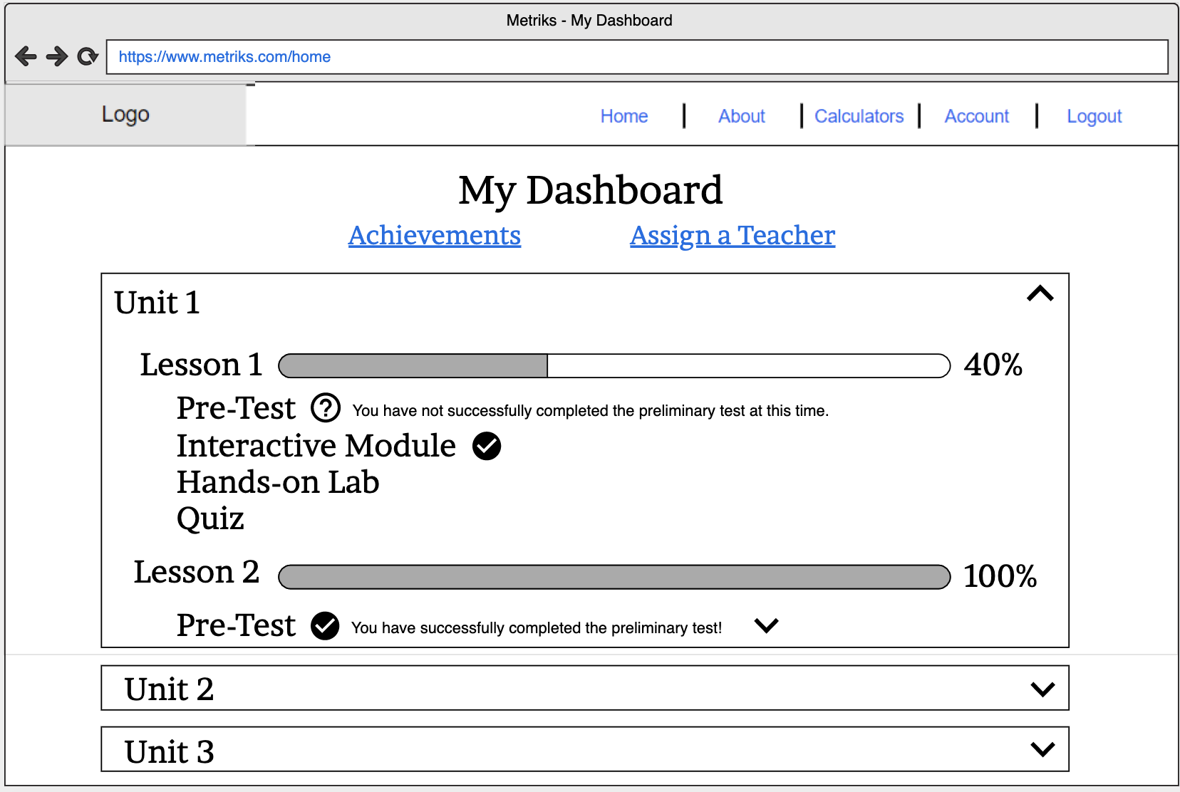

Students have the choice to inspect their achievements or assign a teacher in addition to taking modules, labs, or quizzes.

**Quiz:**

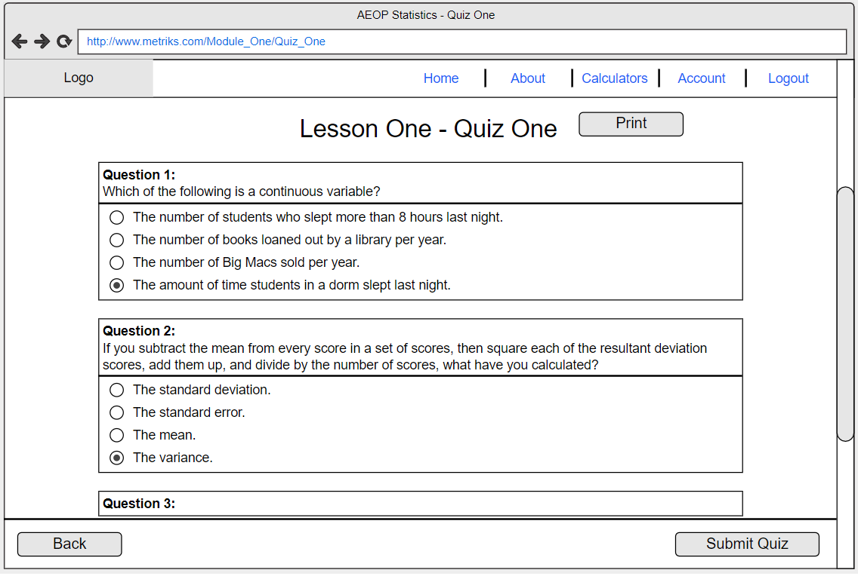

The quiz screen shows questions in a vertical format. Students can scroll up and down as well as submit or leave the quiz. When trying to leave the page, a window will pop up to make sure users don’t mistakenly leave the page. The quiz page also includes a print option for users.

**Admin Monitoring:**

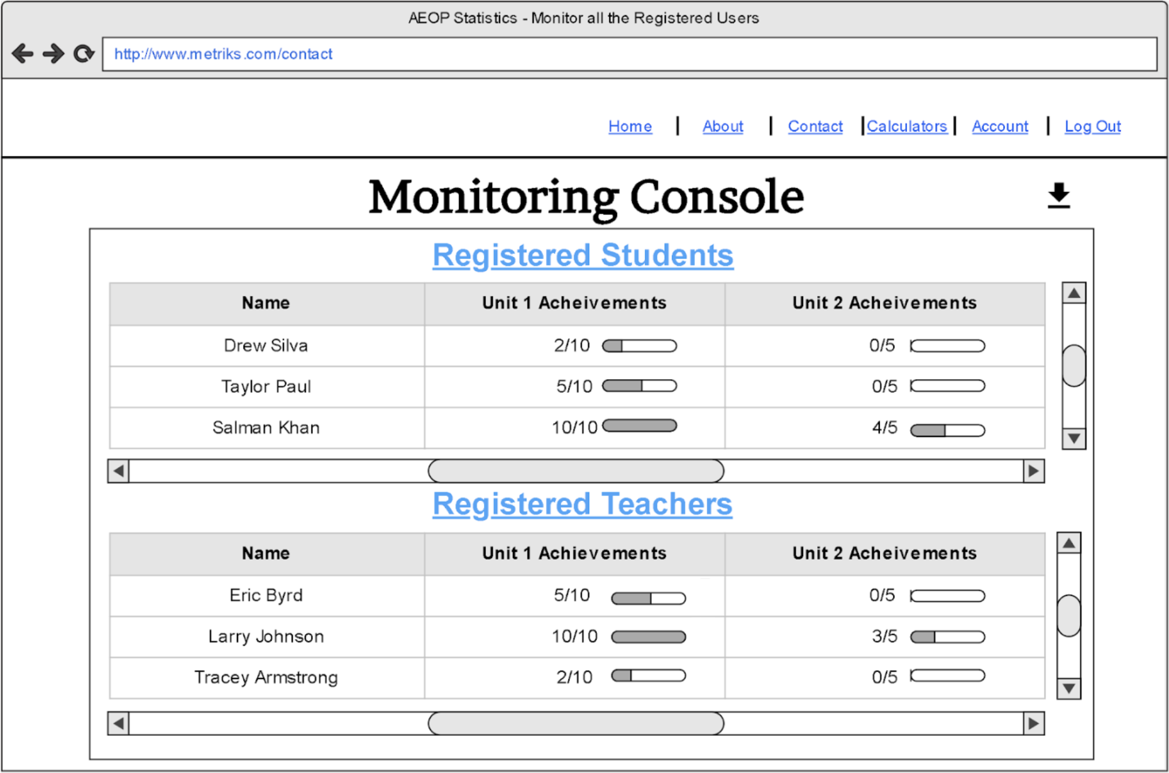

This page allows administrators to monitor all the participants. Administrators can export participant achievements, performances in this page.

**Lab:**

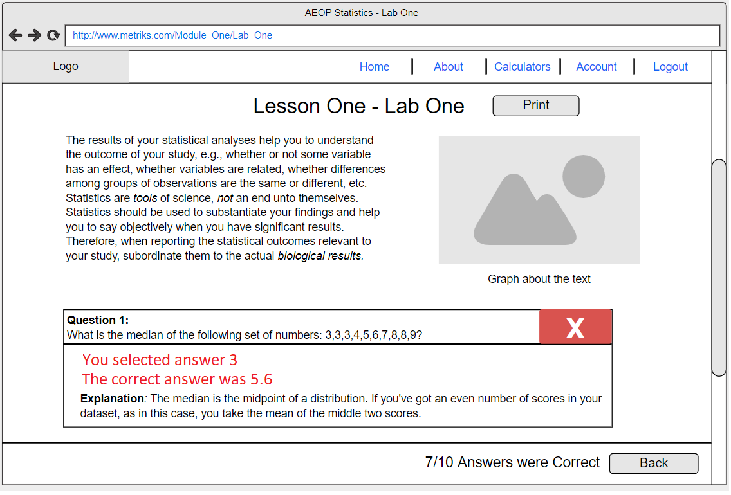

Similar to the quiz page, users can submit or leave as well as print the lab page. Furthermore, this screenshot shows how the feedback feature looks like.

**Interactive Module Lessons:**

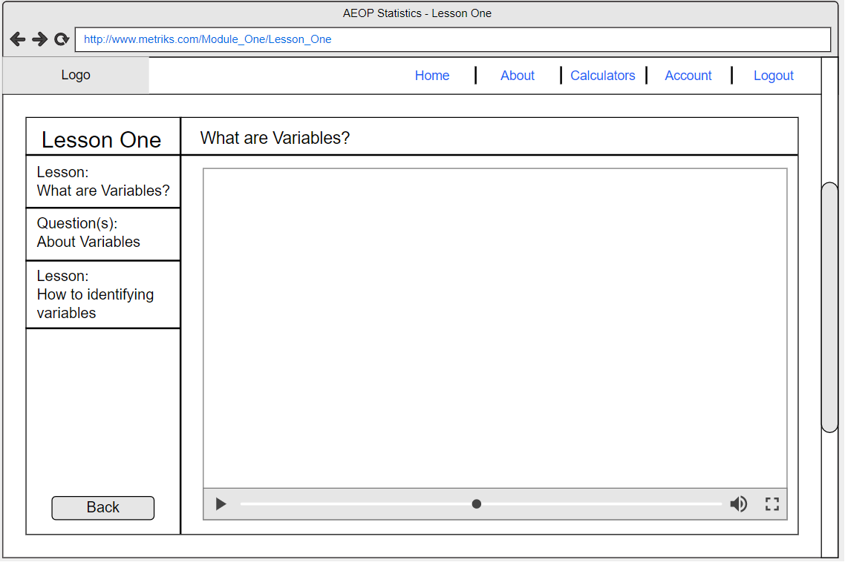

Interactive Module is made up of videos and questions. Users can watch video lessons in fullscreen or windowed; users can also skip or rewind the video to a specific time. During the modules, there will be questions to test their knowledge. Immediate feedback will be given to the user given their answers.

**Achievement Page:**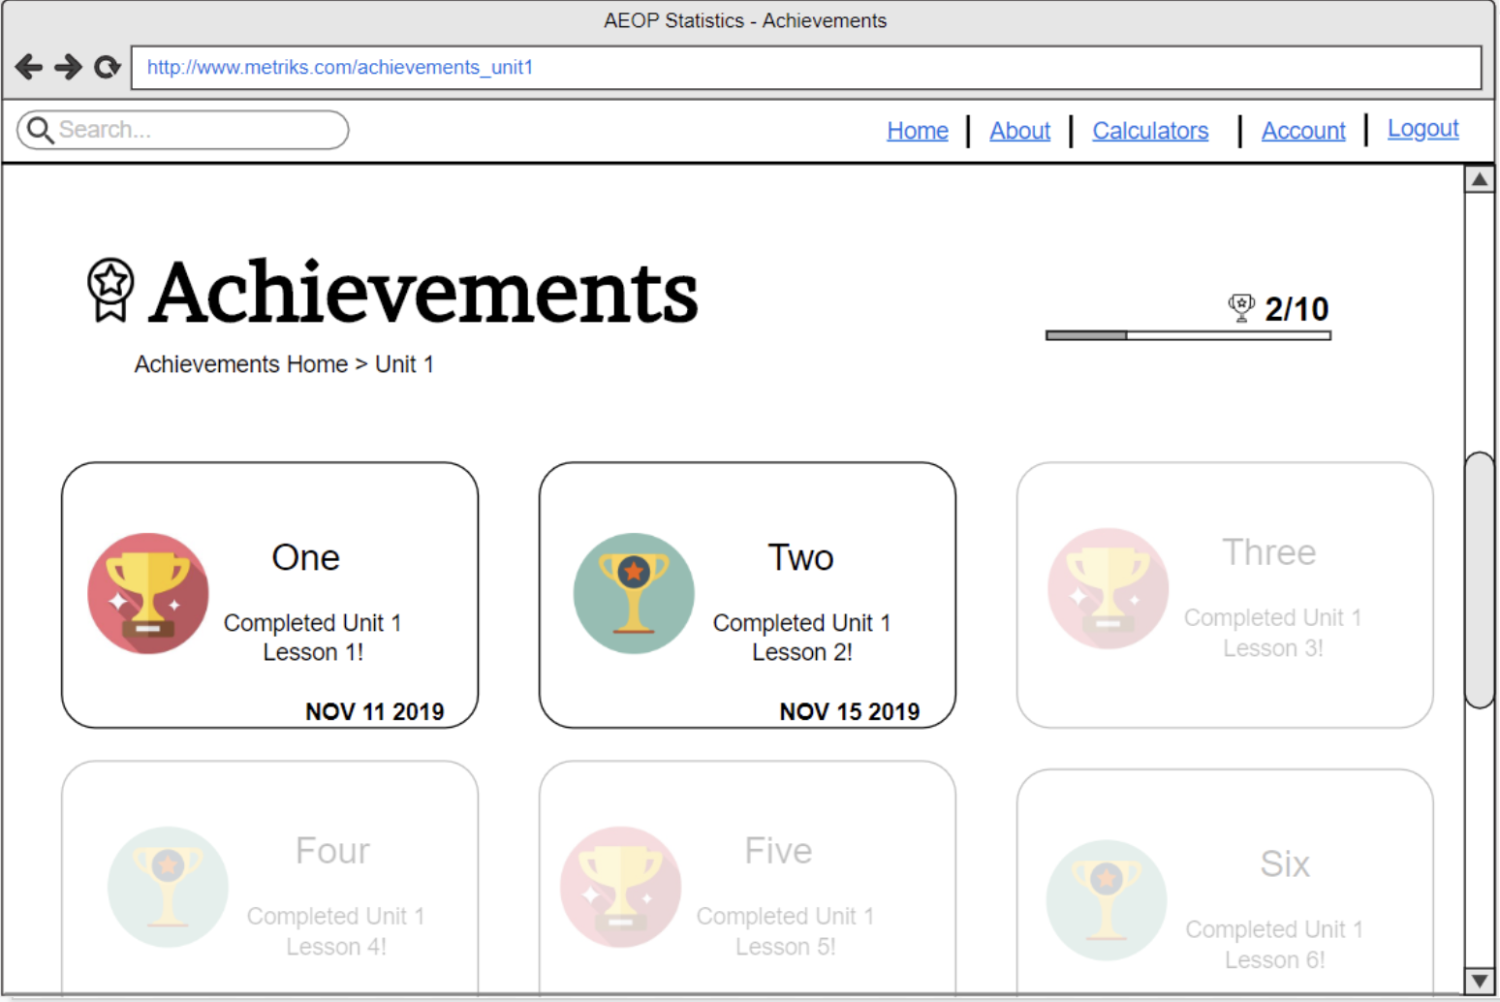

The achievement page showcases their completion of lessons within a unit. Students can also earn badges when they complete an entire unit and a final badge that commemorates completing the entire course. For each badge, date of completion will be shown on the bottom right corner.

## **4.2 Hardware Interfaces**

* **Servers:** Drexel’s Department of Education will be hosting the servers that the website will be present on. Depending on the amount of space available on the server, we will know what capabilities and content are to be prioritized.
* **Computers:** All users of our website (administrators, teachers, students, and guests) will need access to a computer to access the website and interact with the system as intended.

## **4.3 Communication Interfaces**

* **Hypertext Transfer Protocol Secure (HTTPS)** protocol will be used to provide encrypted communication over the internet with the web server. This protocol is encrypted so it will increase security of data transfer, especially when the website requires login credentials for any registered user.
* **Transport Layer Security (TLS)** cryptographic protocol will be used to provide authentication and data encryption for clients connecting to the web server.

## **4.4 Client/Server Diagram**

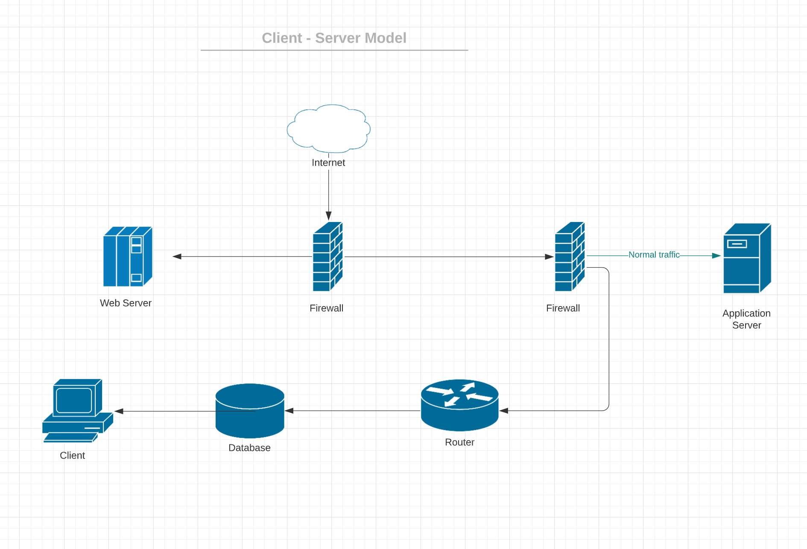

This is a Client-Server Diagram that will have two layers of firewall with one layer encrypting all the data going in and out of Web Server and the other layer encrypting all the data going in and out of Application server. The DMZ zone that exists between the external and internal network (LAN) separated by firewalls will provide another layer of protection for internal LAN and database to restrict direct access by intruders.

# 5.0 Non-Functional Requirements

## **5.1 Performance Requirements**

**Performance:** Ensuring that there is no noticeable delay on actions performed is important for a smooth user experience. In the case of pop-up windows, error messaging, and setting saving, there will be a slight delay, but with the proper connection, it should not take longer than 4 seconds. As for video buffering, the time taken to load will vary based on internet provider speeds. However, most lecture videos should be ready to play within a minute with buffer loading in general. Administrator file downloads on their monitoring pages should take no longer than 30 seconds, however times may increase slightly as user information reaches an upper threshold.

## **5.2 Security Requirements**

* **Two-Factor Authentication**: As defined in our glossary (section 1.7), two-factor authentication will require users to provide another piece of information in addition to their login credentials. Users will be prompted to check their email for a code and enter this into the system to verify that they are the intended user. This ensures an extra layer of security for users.
* **Secure Database**: As the data of student and teacher information are stored on our databases, we want to ensure that the information is encrypted, private, and secure. The database will contain their login credentials, some (optional) personal user information, achievements, course progress information, and their classroom details.
* **Encryption**: User logins and private information will be encrypted to make certain that all communication between the database and the user-end is secure.

## **5.3 Software Quality Requirements**

* **Availability**: This website should be available to all users in the United States 24 hours a day and 7 days a week. The only time this website should be offline is when the website is under maintenance. Users should be notified of maintenance via a page redirect if a user attempts to load into Project Stat's website. The website should be able to be fully loaded 10 out of 10 times in various locations and times, which will be tested with a VPN. A failed check caused by external factors (e.g. loss of internet connection) should not be counted as a failure.
* **Usability**: When users are on the website, they should be able to get to the labs, quizzes, videos, account settings, and calculators in under 5 page changing events (e.g. user clicks a button and a new page of the website is rendered). All website pages should be able to be fully loaded in under 30 seconds (assuming the user has at least the average US internet speed of 93.98 Mbps).
* **Functionality**: The software features on this website should never fail more than twice in one instance, so as to prevent user frustration (e.g. the website fails to submit a lab despite the user clicking the submit button). This will not include preprogrammed checks that hinder the user when they have forgotten to add the required information or have input incorrect information.
* **Maintainability**: The website should be understandable in the backend, such that the code written is structured and follows conventional formatting guidelines. If other programmers were to adapt our code base, they should be able to understand what each segment does without extensive outside research. Furthermore, should a failure to the website occurs, it should be able to be restored to operational status within an hour, with the exception of problems being caused by third party vendors that are beyond our control.
* **Scalability**: This refers to our website’s ability to accommodate rising resource demands without a noticeable burden on the user end. An estimation of our website’s scalability measure is being able to withstand a threshold of 1,000 concurrent users browsing or utilizing the course. For every 250 users simultaneously interacting with a lesson, our server-side-response should be able to process each of their responses almost immediately with a variance of 3 seconds.