Patrick Griffin

2/2/17

Class Participation #1

***Game_over.cpp***

Output screen of game_over.cpp

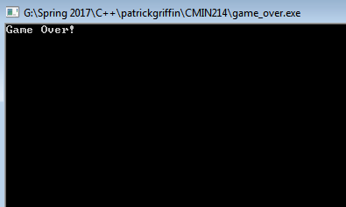

***game_over2.cpp***

Output screen of game_over2.cpp

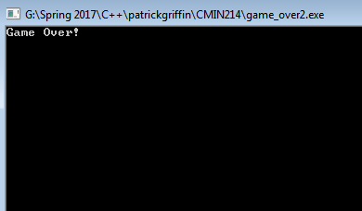

***game_over3.cpp***

Output screen of game_over3.cpp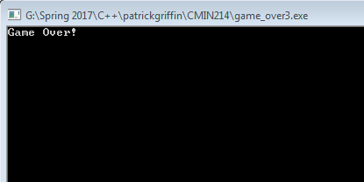

***Expensive_calculator.cpp***

Output screen of expensive_calculator.cpp

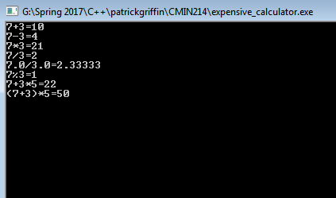

***gameStats.cpp***

First output screen for gameStats.cpp

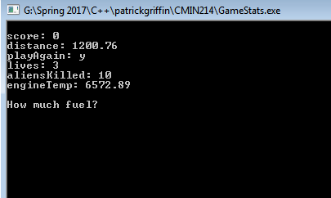

Input screen of gameStats.cpp

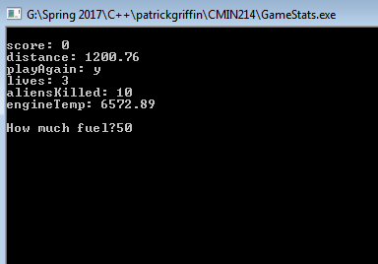

Second output screen of gameStats.cpp

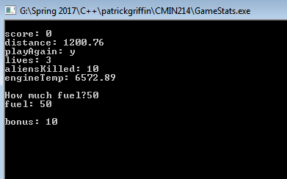

***gameStats2.0.cpp***

Output screen of gameStats2.0.cpp

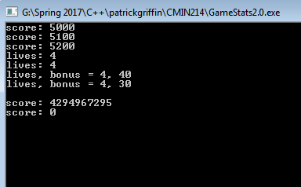

***gameStats3.0.cpp***

Output screen of gameStats3.0.cpp

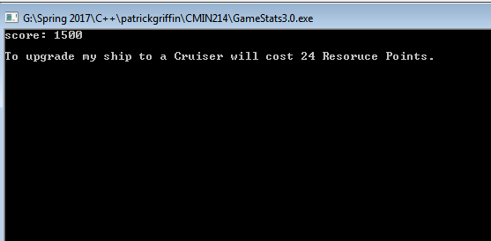

***lostFortune.cpp***

First output screen of lostFortune.cpp

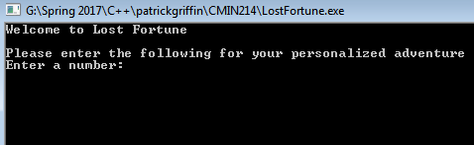

Input screen of lostFortune.cpp

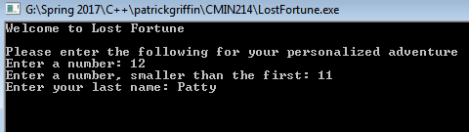

Second output screen of lostFortune.cpp

