Patrick Griffin

2/11/2017

Class Homework #1

***GameAverage.cpp***

Input for all three score variables

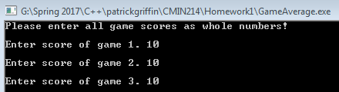

Output for the average variable