Patrick Griffin

4/22/17

Class participation #6

***…Pointing.cpp***

Output for Pointing.cpp

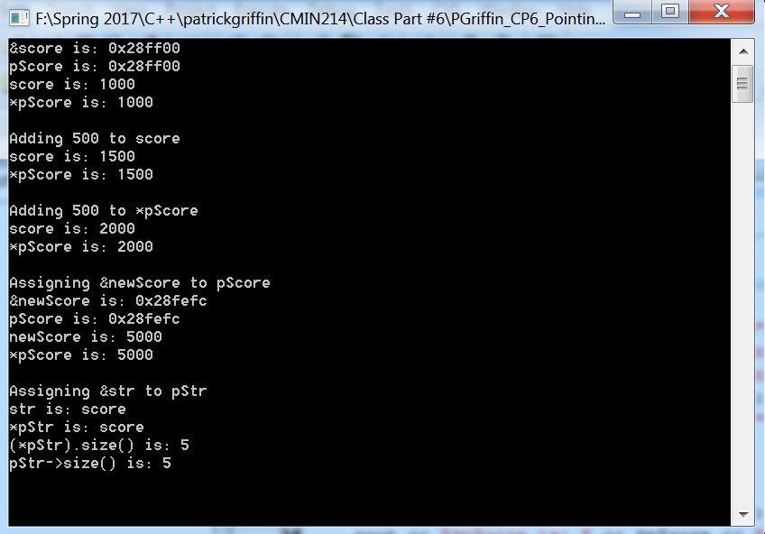

***…SwapPointer.cpp***

Output for SwapPointer.cpp

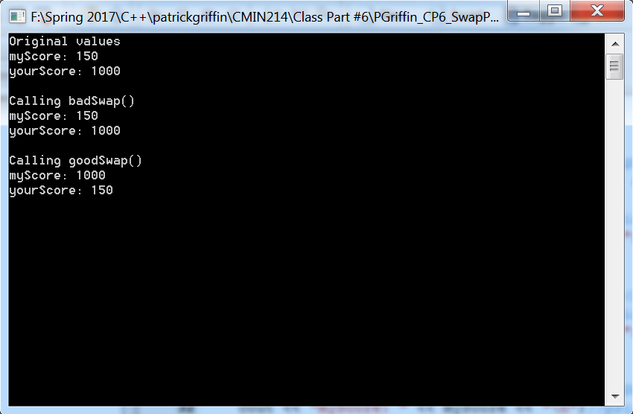

***…InventoryPointer.cpp***

Output for InventoryPointer.cpp

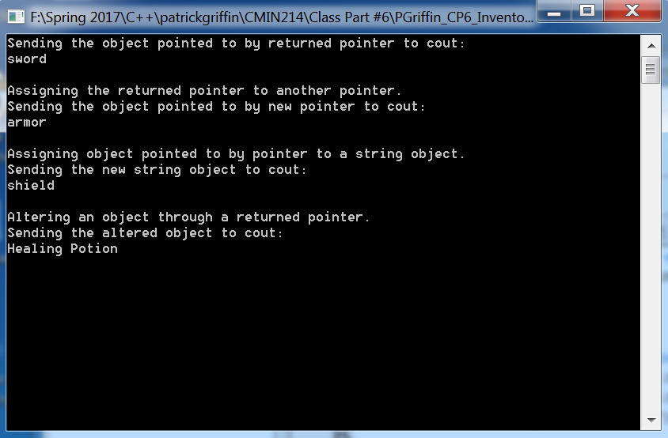

***…ArrayPasser.cpp***

Output for ArrayPasser.cpp

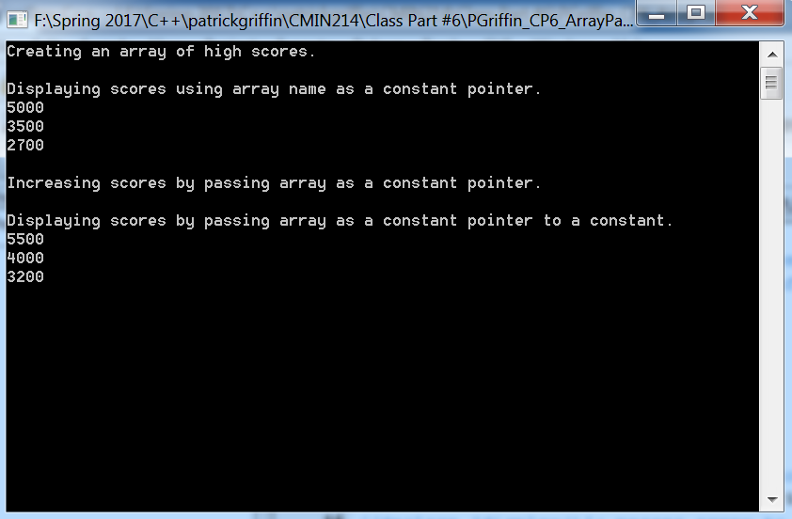

***…SwapPointer2.0.cpp***

Output for SwapPointer2.0.cpp

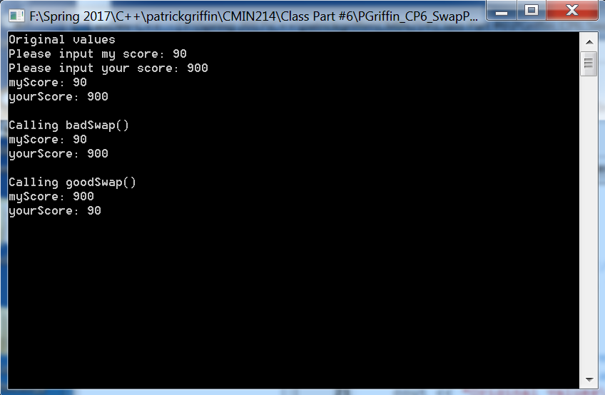

***…ArrayPasser2.0.cpp***

Output for ArrayPasser2.0.cpp