Patrick Griffin

3/25/17

Class Participation #4

***…Heros_inventory2.cpp***

Output for heros_inventory2.cpp

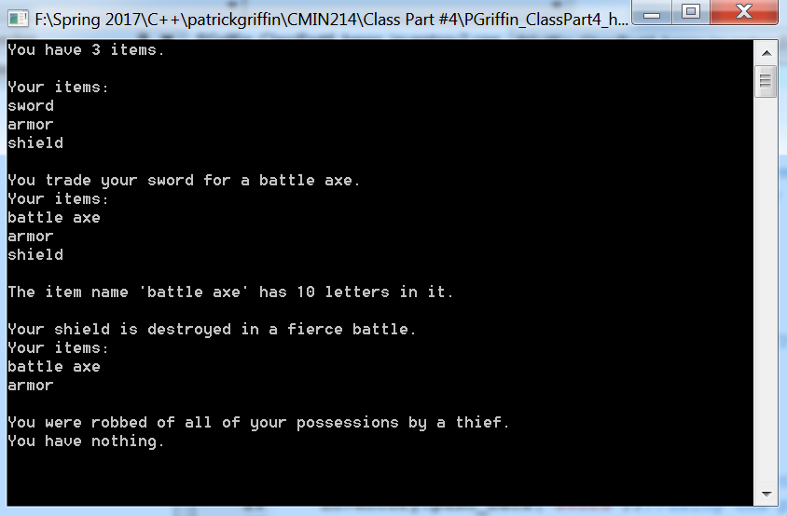

***…Heros_inventory3.cpp***

Output for heros_inventory3.cpp

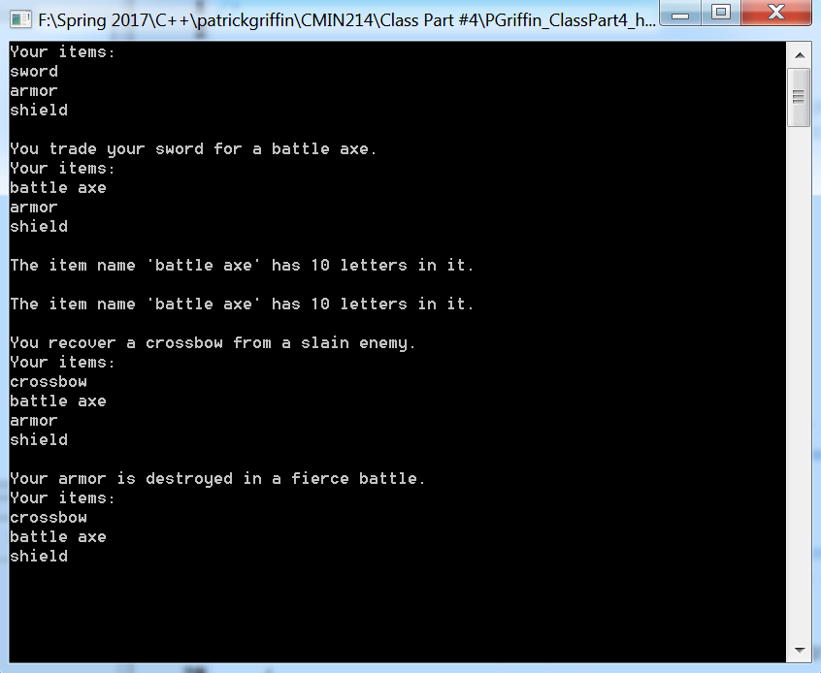

***…HighScores.cpp***

Input for highSchores.cpp

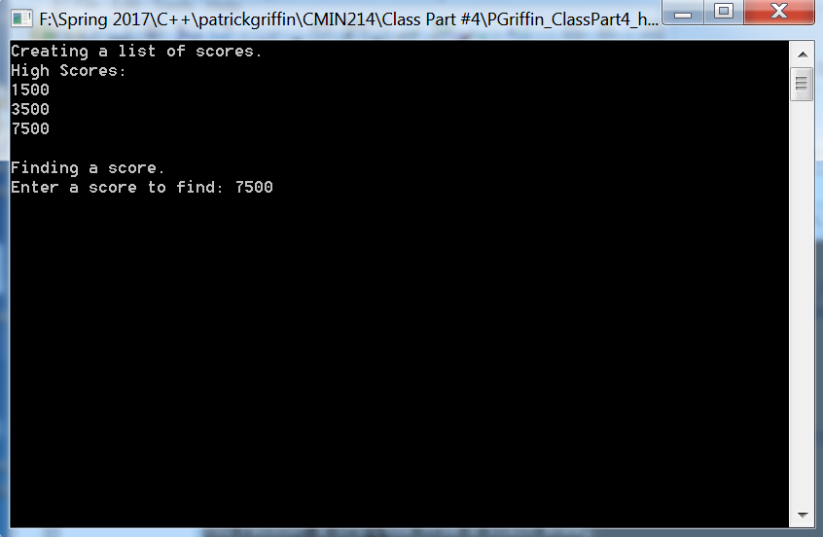

Output with score found

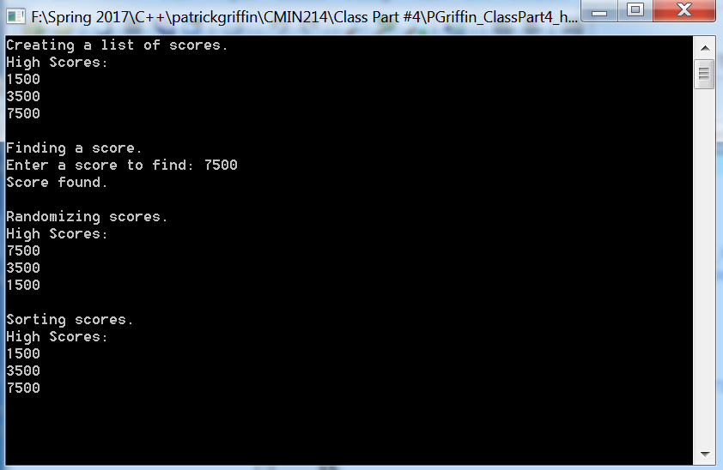

Input

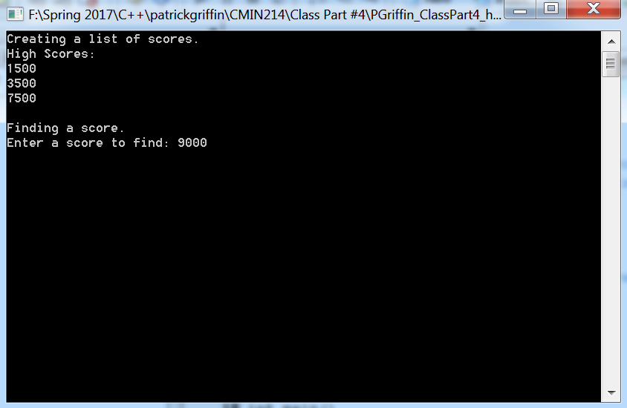

Output with score not found

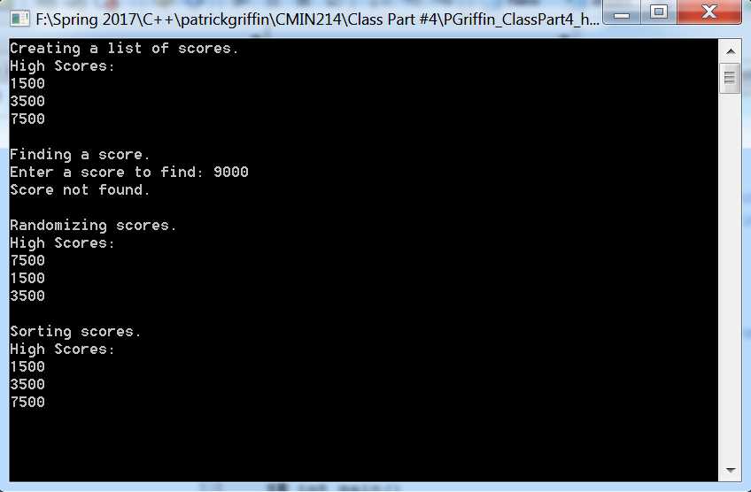

***…Hangman.cpp***

Output for hangman.cpp guessing correctly

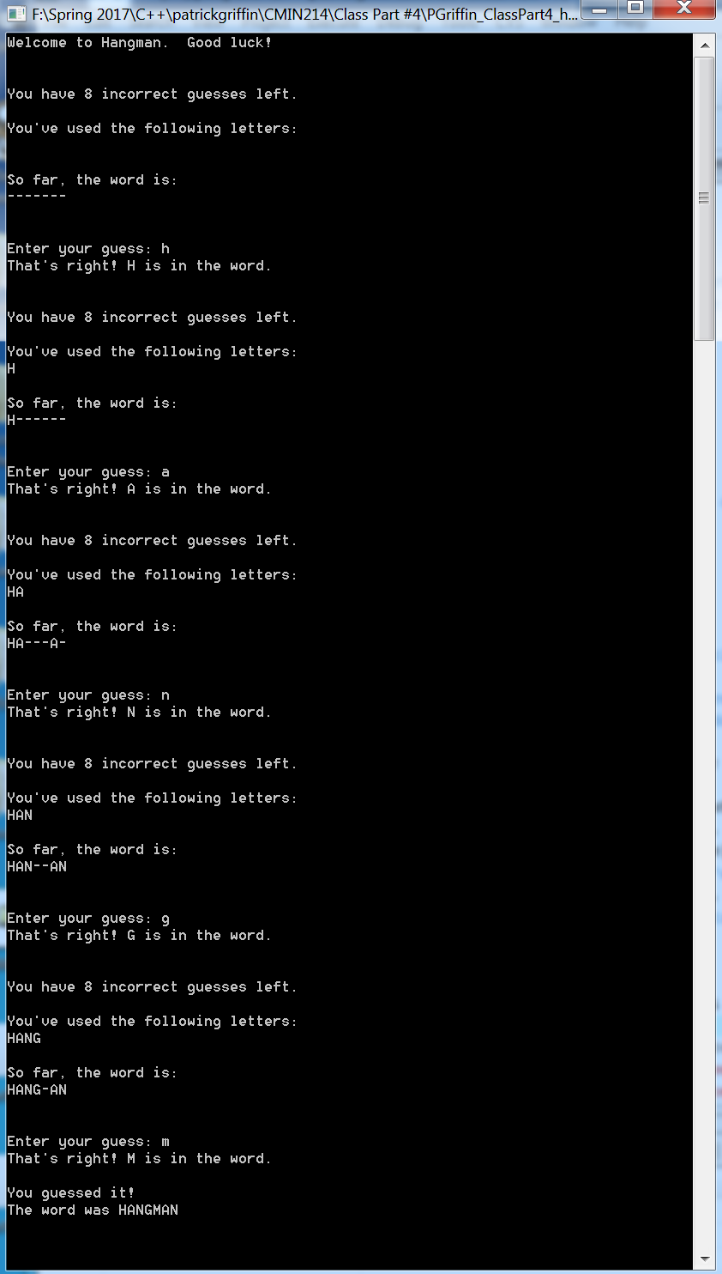

Output guessing incorrectly

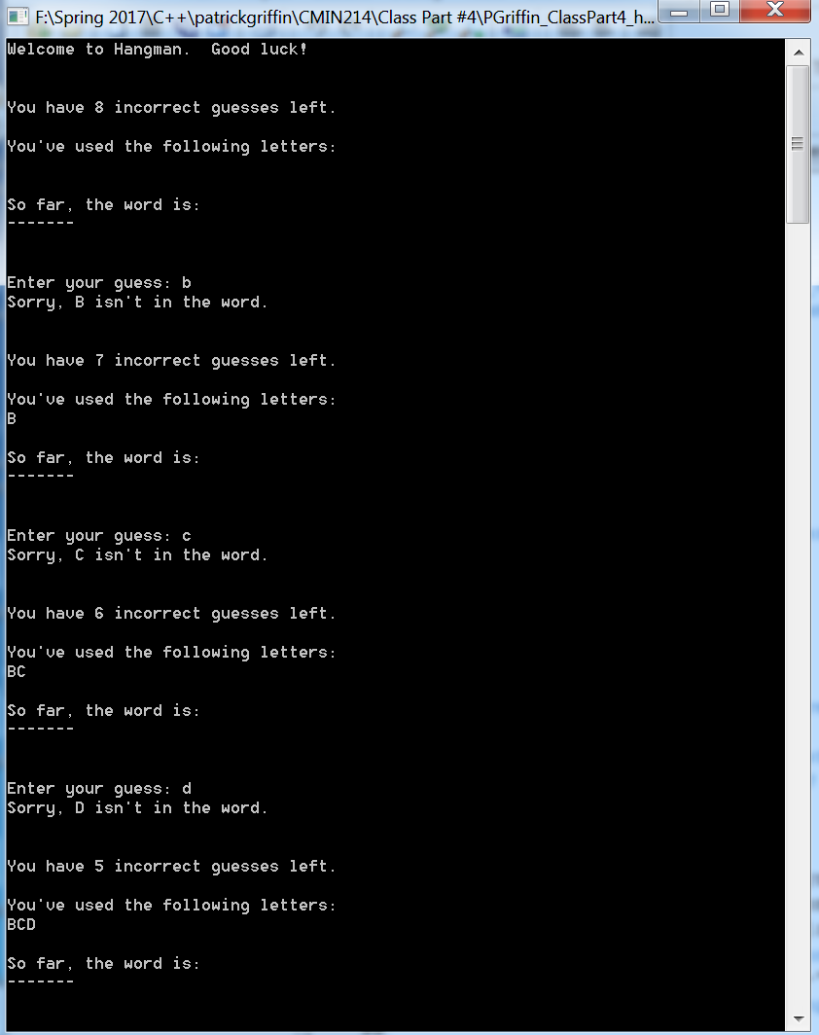

Continue with demonstration of duplicate guess

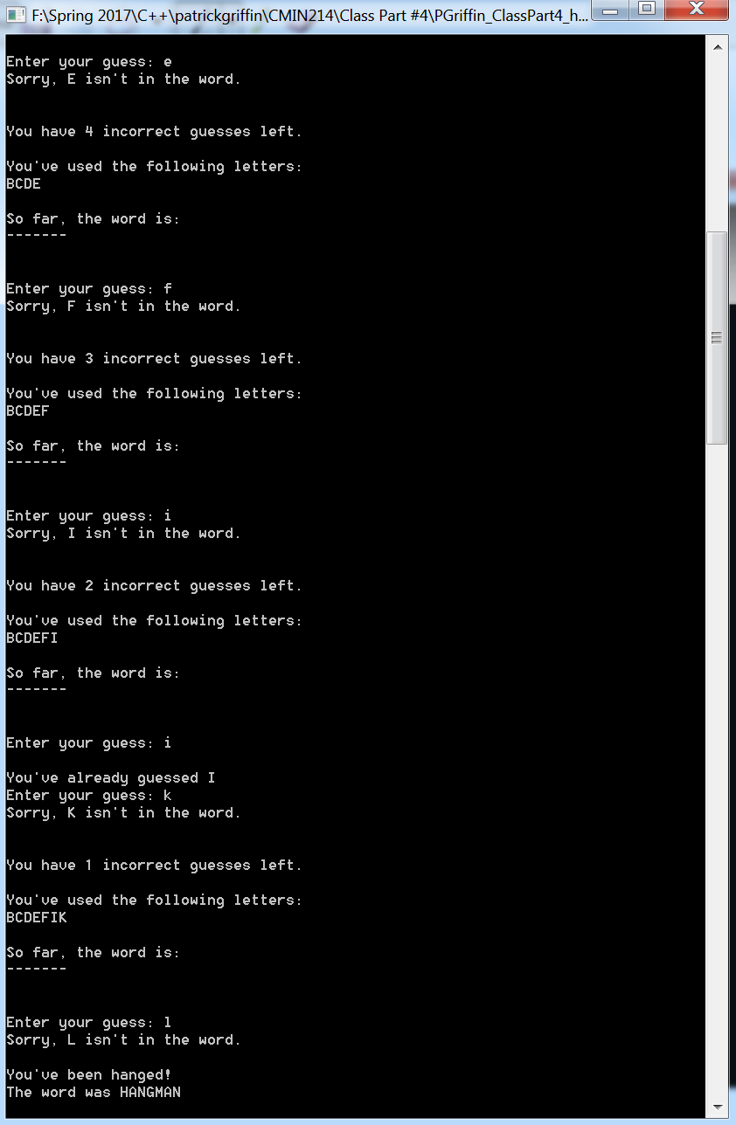

***…Highscore2.0.cpp***

Output for highscores2.0.cpp (set 1)

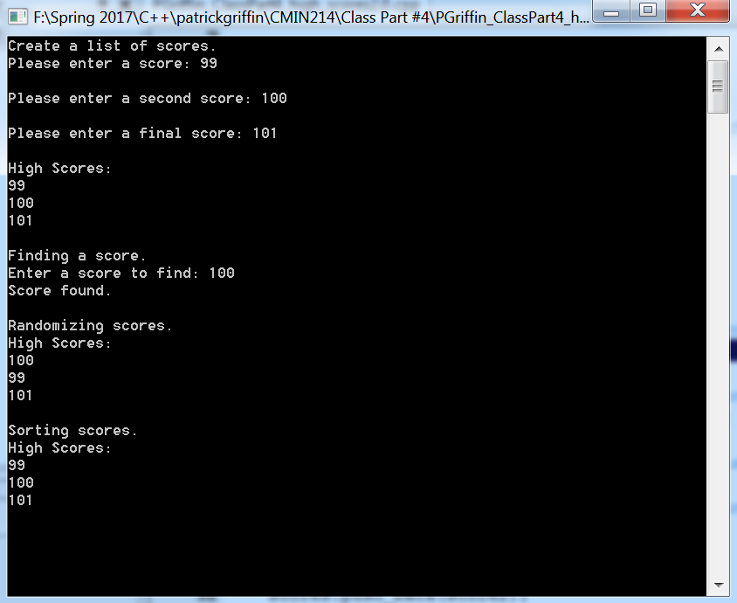

Set 2

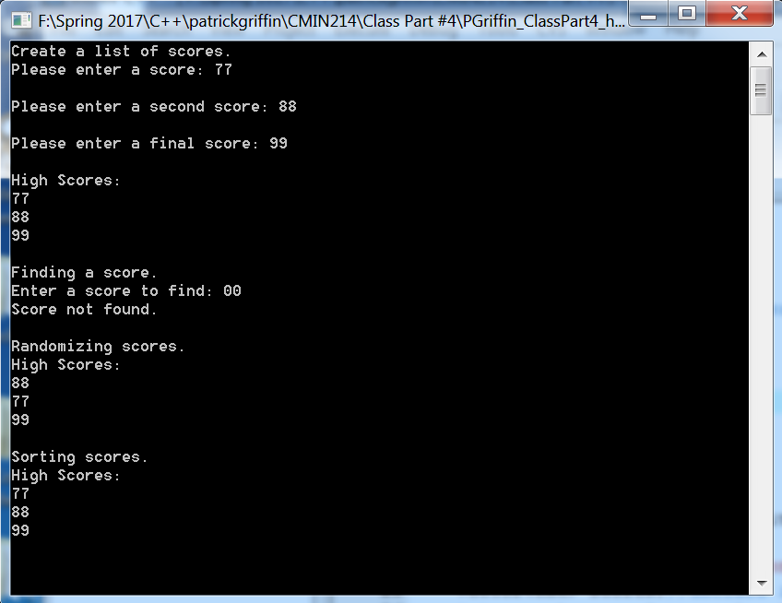

Set 3

