Patrick Griffin

3/19/17

Homework #3

***Griffin_HW3_WordJumble2.cpp***

Output demonstrating score count.

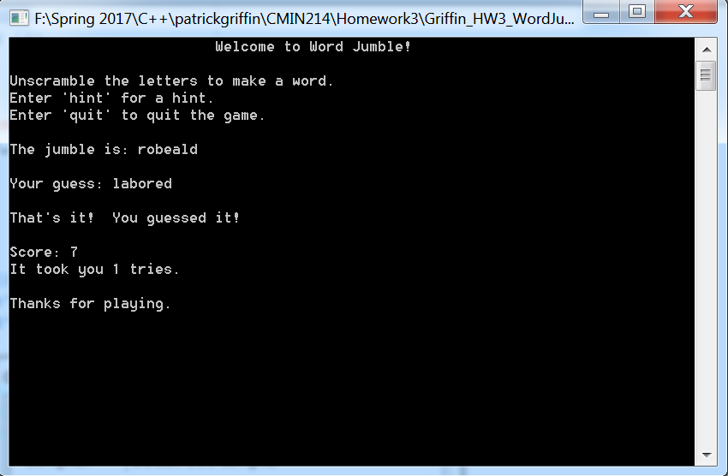

Output demonstrating try count.

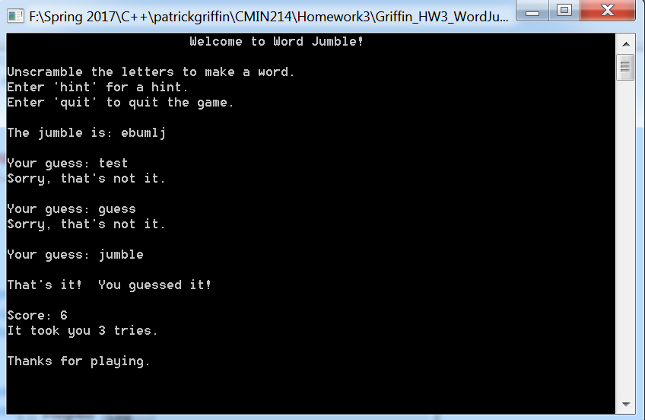

Output demonstrating hint system deducting points from score.

