Patrick Griffin

3/30/17

Homework #4

***…StarsLoop.cpp***

Output for StarsLoop.cpp

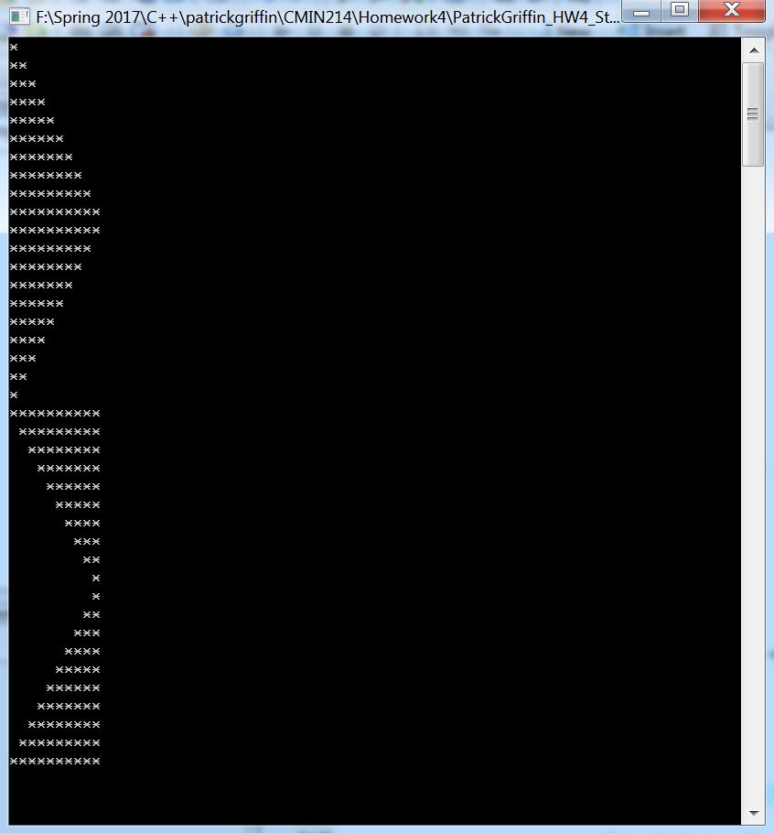

***…StarsLoopHorizontal.cpp***

Output for StarsLoopHorizontal.cpp

