CSCI 4525 Unit 3: Learning Assignment
Patrick Griffin

Q1)
a.

b.
P(a|heads) P(a|heads) P(a|tails) = .2 x .2 x .8 = 0.032
P(b|heads) P(b|heads) P(b|tails) = .6 x .6 x .4 = 0.144
P(c|heads) P(c|heads) P(c|tails) = .8 x .8 x .2 = 0.128
Coin b would most likely have been drawn.

Q2)
Consider the following data set comprised of three binary input attributes (A₁, A₂, and A₃) and one binary output:
Example | A₁ | A₂ | A₃ | Output y
x₁ | 1 | 0 | 0 | 0
x₂ | 1 | 0 | 1 | 0
x₃ | 0 | 1 | 0 | 0
x₄ | 1 | 1 | 1 | 1
x₅ | 1 | 1 | 0 | 1

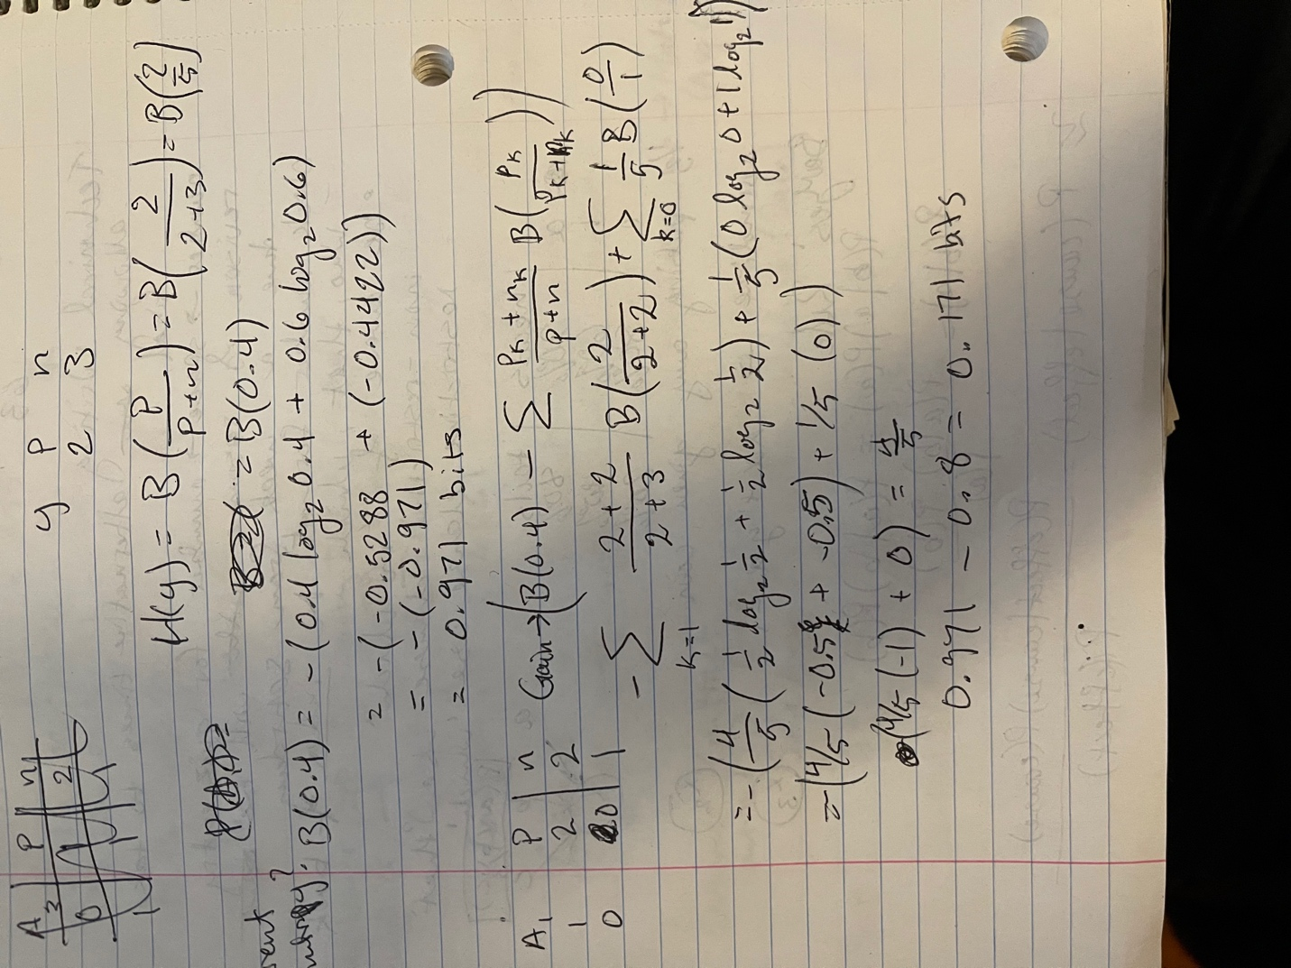
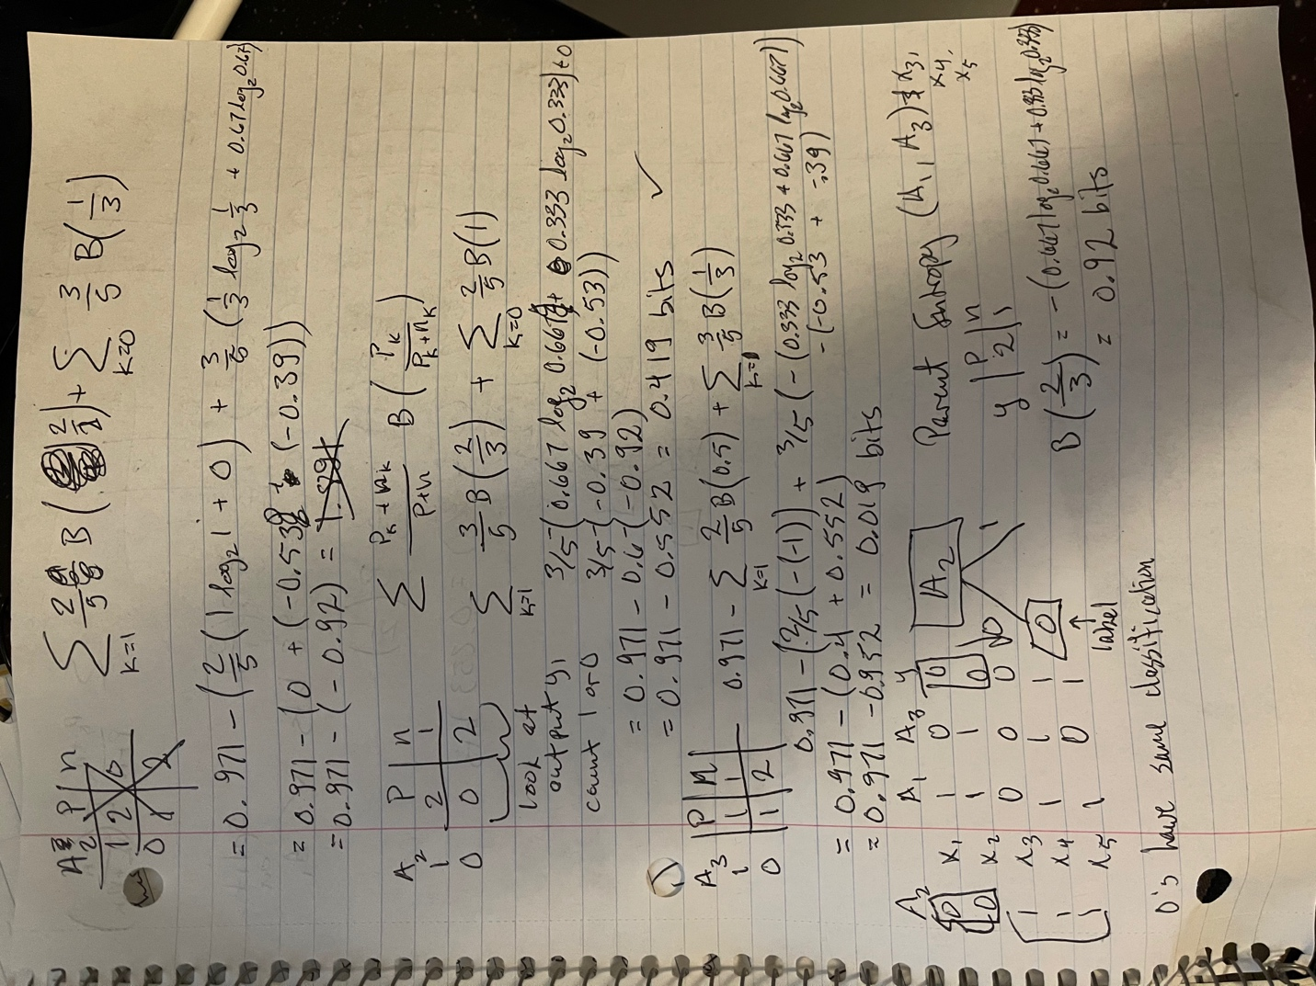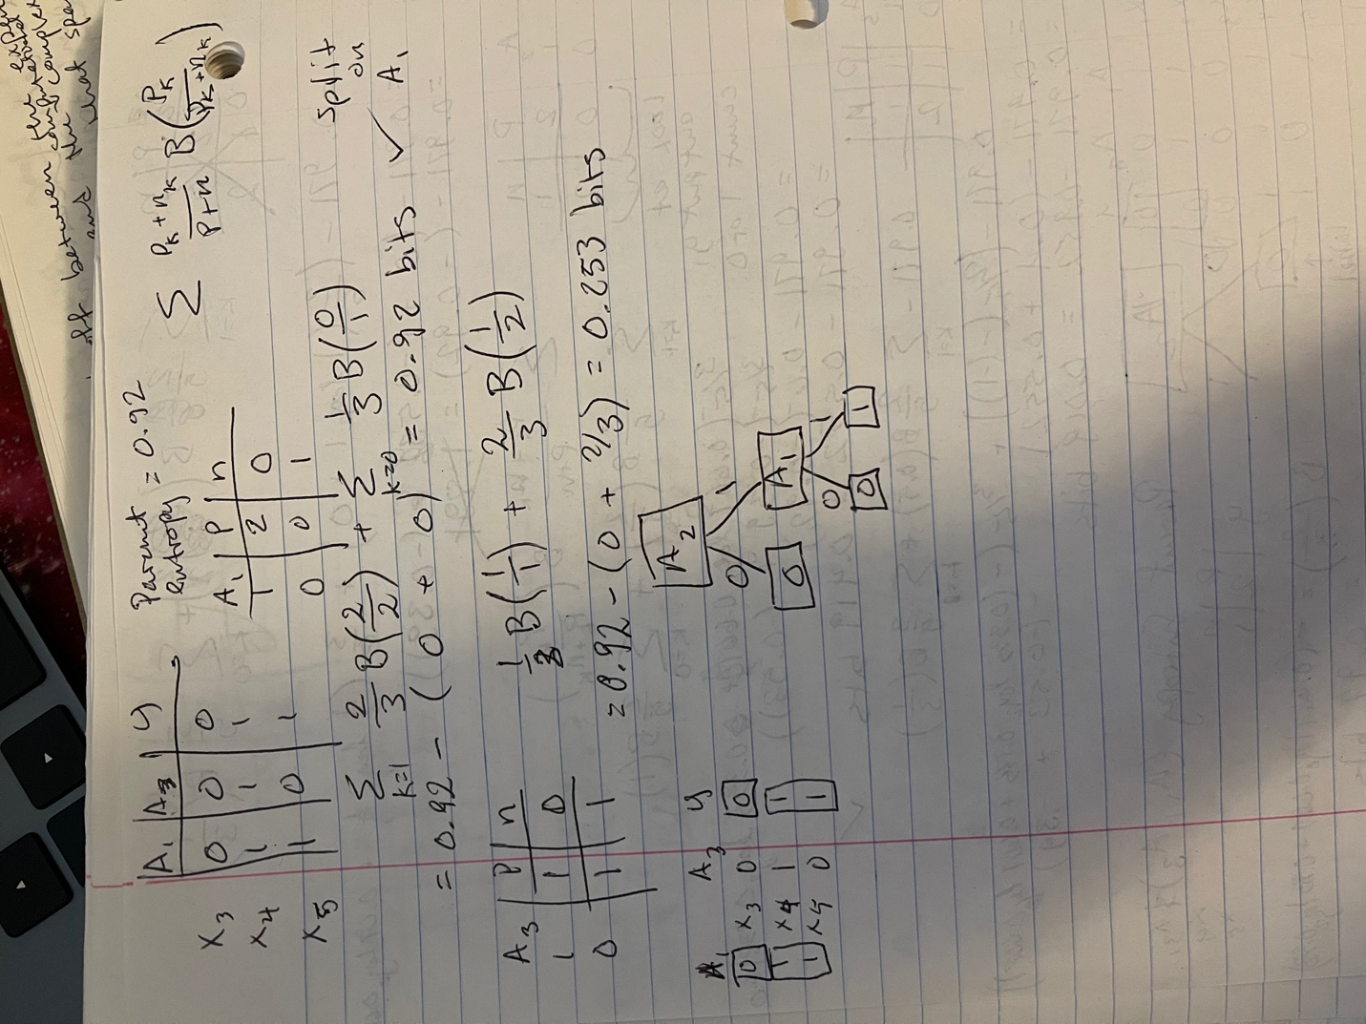

Q3)
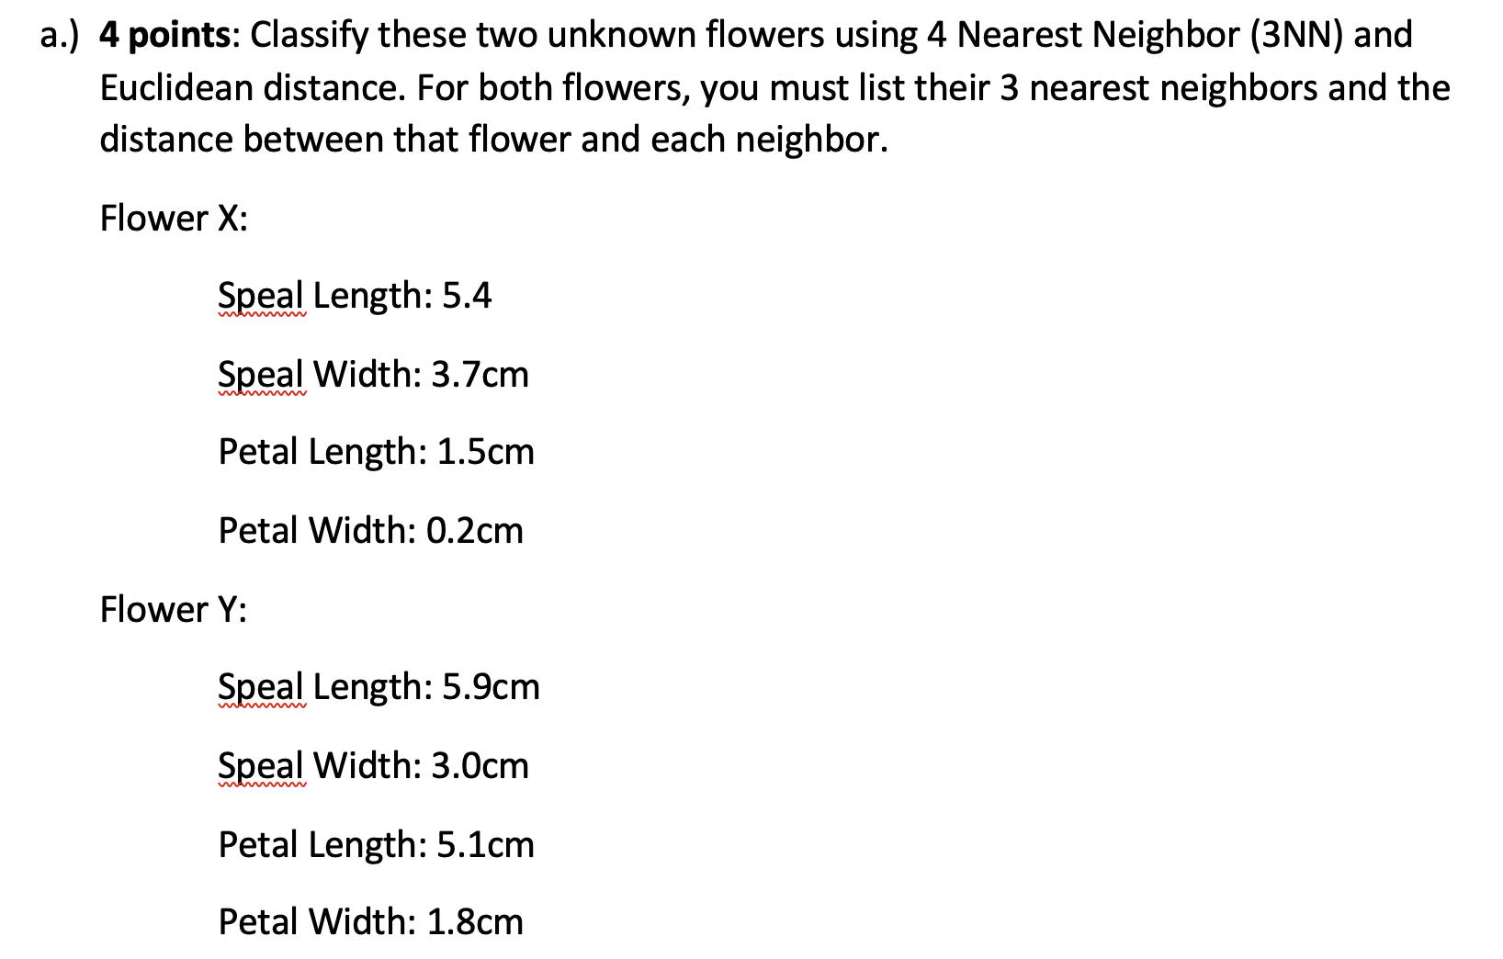
Flower X:
Flower 1 = 0.374
Flower 5 = 0.424
Flower 6 = 0.346
Classified as Iris-setosa.

Flower Y:
Flower 17 = 0.671
Flower 22 = 0.332
Flower 24 = 0.648
Classified as Iris-virginica.

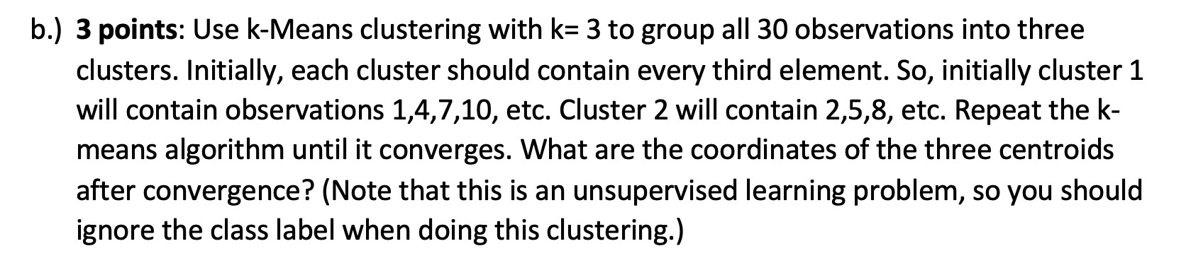

Cluster 1
1 | 5.1 | 3.5 | 1.4 | 0.2
4 | 4.6 | 3.1 | 1.5 | 0.2
7 | 4.6 | 3.4 | 1.4 | 0.3
10 | 4.9 | 3.1 | 1.5 | 0.1
2 | 4.9 | 3 | 1.4 | 0.2
5 | 5 | 3.6 | 1.4 | 0.2
8 | 5 | 3.4 | 1.5 | 0.2
3 | 4.7 | 3.2 | 1.3 | 0.2
6 | 5.4 | 3.9 | 1.7 | 0.4
9 | 4.4 | 2.9 | 1.4 | 0.2
total | 48.6 | 33.1 | 14.5 | 2.2
centroid | 4.86 | 3.31 | 1.45 | 0.22
cluster 2
11 | 7 | 3.2 | 4.7 | 1.4
17 | 6.3 | 3.3 | 4.7 | 1.6
23 | 7.1 | 3 | 5.9 | 2.1
26 | 7.6 | 3 | 6.6 | 2.1
29 | 6.7 | 2.5 | 5.8 | 1.8
13 | 6.9 | 3.1 | 4.9 | 1.5
19 | 6.6 | 2.9 | 4.6 | 1.3
22 | 5.8 | 2.7 | 5.1 | 1.9
25 | 6.5 | 3 | 5.8 | 2.2
28 | 7.3 | 2.9 | 6.3 | 1.8
12 | 6.4 | 3.2 | 4.5 | 1.5
15 | 6.5 | 2.8 | 4.6 | 1.5
21 | 6.3 | 3.3 | 6 | 2.5
24 | 6.3 | 2.9 | 5.6 | 1.8
30 | 7.2 | 3.6 | 6.1 | 2.5
total | 100.5 | 45.4 | 81.2 | 27.5
centroid | 6.7 | 3.02666667 | 5.41333333 | 1.83333333

cluster 3
14 | 5.5 | 2.3 | 4 | 1.3
20 | 5.2 | 2.7 | 3.9 | 1.4
27 | 4.9 | 2.5 | 4.5 | 1.7
18 | 4.9 | 2.4 | 3.3 | 1
16 | 5.7 | 2.8 | 4.5 | 1.3
total | 26.2 | 12.7 | 20.2 | 6.7
Centroid | 5.24 | 2.54 | 4.04 | 1.34

