GameScope Video Game Sales Analytics Dashboard
A Project Report Submitted in Partial Fulfillment of the Academic Requirement for the Award of the Internship Program Conducted by
ANDHRA PRADESH STATE SKILL DEVELOPMENT CORPORATION (APSSDC)
Submitted by:
PATAMATA PRANEEL
Roll No: 23HP1A1247
B.Tech – Information Technology
ANDHRA LOYOLA INSTITUTE OF ENGINEERING AND TECHNOLOGY, VIJAYAWADA

Internship Program:
Data Analytics Using Power BI

Mentor / Course Instructor:
Mr. Anji Reddy Bapathu

CERTIFICATE

This is to certify that the project entitled “GAME SCOPE: VIDEO GAME SALES ANALYTICS DASHBOARD” submitted by Patamata Praneel (Roll No: 23HP1A1247), B.Tech Information Technology, Andhra Loyola Institute of Engineering and Technology, Vijayawada, has been carried out under the guidance of Mr. Anji Reddy Bapathu, Mentor / Course Instructor, APSSDC.

This project is submitted in partial fulfillment of the requirements of the APSSDC Internship Program Data Analytics Using Power BI.

Project Guide / Mentor: Mr. Anji Reddy Bapathu
Student Signature: p.praneel

DECLARATION

My name is Patamata Praneel (Roll No: 23HP1A1247), student of B.Tech Information Technology, Andhra Loyola Institute of Engineering and Technology, Vijayawada, hereby declare that this project report entitled “GAME SCOPE: VIDEO GAME SALES ANALYTICS DASHBOARD” submitted to APSSDC in partial fulfillment of the requirements of the internship program Data Analytics Using Power BI, is a record of my original work carried out under the guidance of Mr. Anji Reddy Bapathu, Mentor / Course Instructor, APSSDC.

Student Signature: p.praneel

ACKNOWLEDGEMENT

I would like to thank APSSDC for giving me the chance to do my internship project on Data Analytics Using Power BI.I am very thankful to my mentor Mr. Anji Reddy Bapathu for guiding me and supporting me throughout this project. His help made it possible for me to finish this work.

I also thank my college Andhra Loyola Institute of Engineering and Technology, Vijayawada for encouraging me and giving me the support I needed during this internship.

Patamata Praneel (23HP1A1247)

ABSTRACT

This project is about analyzing video game sales data using Power BI. The dataset contains information about games released between 1971 and 2024, including details like publisher, console, genre, release year, and sales in different regions.

The main goal of the project is to turn this raw data into clear insights by using dashboards and visual reports. With Power BI, the data was cleaned, organized, and shown in charts and graphs that make it easy to understand. The dashboard highlights top-selling games, popular consoles, best publishers, and sales trends over the years.

This project proves how data analytics can help in understanding industry trends and making better decisions. By using Power BI, the video game sales data becomes simple to explore and gives a complete picture of how the gaming market has changed over time.

INTRODUCTION

The video game industry is one of the biggest entertainment markets in the world. Every year, thousands of games are released on different consoles and platforms, and millions of players buy them across regions like North America, Japan, and Europe. Because of this, sales data plays an important role in understanding how the industry is growing and what players prefer.

Normally, analyzing such a large dataset is difficult and takes a lot of time. This is where tools like Power BI help. Power BI makes it easy to clean, organize, and show data in the form of dashboards and charts. With these dashboards, we can quickly see which publishers are successful, which consoles are popular, which genres sell more, and how sales change year by year.

This project uses Power BI to study video game sales data from 1971 to 2024. The dashboard gives clear insights into top-selling games, regional differences, and overall industry trends. The purpose of this project is to show how data analytics can turn raw numbers into useful information that helps in making better decisions.

OBJECTIVES

The main objectives of this project are:
- Analyze video game sales: Study sales data from 1971 to 2024 to understand how the gaming industry has grown over time.

- Identify top performers: Find out which games, publishers, consoles, and genres have sold the most.

- Compare regions: Look at differences in sales between North America, Europe, Japan, and other regions.

- Show trends: Highlight how sales change year by year and which platforms or genres become popular.

- Use Power BI: Build dashboards and charts that make the data easy to understand.

- Support decision making: Show how analytics can help publishers, developers, and businesses make better choices.

METHODOLOGY

The project was done step by step using Power BI. The main steps are:
- Collecting data: The dataset of video game sales from 1971 to 2024 was taken, which includes details like publisher, console, genre, release year, and regional sales.

- Cleaning data: The raw data had missing values and errors. Using Power Query in Power BI, the data was cleaned and organized so that it could be used properly.

- Transforming data: Columns were adjusted, unnecessary data was removed, and the dataset was shaped to make analysis easier.

- Building dashboards: Different charts and visuals were created in Power BI to show sales by region, publisher, console, genre, and year.

- Analyzing results: The dashboards were studied to find insights like top-selling games, popular consoles, best publishers, and regional differences.

- Drawing conclusions: The final step was to summarize the findings and show how data analytics can help in understanding industry trends and making better decisions.

SYSTEM REQUIREMENTS

To complete this project using Power BI, the following minimum requirements are needed:
Hardware Requirements:
- Processor: Intel Core i3 / i5 / i7 or equivalent
- RAM: 8 GB or more (DDR4 recommended)
- Storage: 256 GB or more (SSD preferred)
- Graphics: Integrated graphics or dedicated graphics card
- Operating System: Windows 10 or later

Software Requirements:
- Power BI Desktop: for building dashboards and reports
- Microsoft Excel: for checking and formatting datasets
- Power Query: for cleaning and transforming data (used in this project)
- Dataset: Video game sales dataset (1971–2024)

Note: In Power BI, we can also use other features like DAX functions, measures, and calculated columns to perform advanced calculations. In this project, only Power Query transformations and calculated column were used.

DATASET DESCRIPTION

The dataset used in this project is about video game sales. It contains information about games released between 1971 and 2024. The data includes details such as:

- Name of the game (Text): Title of the video game
- Platform/Console (Text): The system on which the game was released (e.g., PlayStation, Xbox, Nintendo)
- Year of release (Number): The year the game was launched
- Genre (Text): Type of game (e.g., Action, Sports, RPG)
- Publisher (Text): Company that published the game
- Sales in North America (Decimal Number): Number of copies sold in NA region
- Sales in Europe (Decimal Number): Number of copies sold in EU region
- Sales in Japan (Decimal Number): Number of copies sold in JP region
- Global sales (Decimal Number): Total worldwide sales

The dataset is large and covers many years, which makes it useful for studying industry trends. By using Power BI, the data was cleaned and transformed to remove errors and make it ready for analysis.

IMPLEMENTATION

The project was implemented step by step using Power BI. The process included the following:
- Loading the dataset: The video game sales dataset (1971–2024) was imported into Power BI for analysis.

- Cleaning the data: Using Power Query, missing values and errors were handled. Unnecessary columns were removed to make the dataset neat and ready for use.

- Transforming the data: A new column was created to support analysis. This step helped in shaping the dataset for better visualization.

- Building dashboards: Different visuals such as bar charts, pie charts, etc.. were created. These dashboards showed sales by region, publisher, console, genre, and release year.

- Analyzing insights: The dashboards were studied to find top-selling games, popular consoles, successful publishers, and regional differences in sales.

- Final results: The findings were summarized to show how data analytics can help in understanding industry trends and making better decisions.

RESULTS

After building the dashboards in Power BI, the following results were observed:
- Sales summary: The dataset shows total global sales along with regional breakdowns (North America, Europe, Japan, and other regions). This helps in understanding how different markets contribute to overall performance.

- Top publishers: Companies like Activision, Electronic Arts, Ubisoft, Konami, and Sony Computer Entertainment appear as major contributors. Activision, for example, holds a significant share of global sales.

- Console analysis: Consoles such as PS2, Xbox 360, PS3, and Wii dominate total sales. PC also shows the highest count of critic scores, proving its importance in the gaming industry.

- Genre insights: Action, Shooter, and Sports genres lead in both developer count and total sales. Role-Playing games also show strong performance, especially in Japan.

- Release year trends: Sales peaked in the early 2000s, showing the golden era of consoles like PS2 and Xbox 360. After 2010, sales gradually shifted toward newer platforms like PS4 and Nintendo Switch.

- Top games: Titles like Grand Theft Auto V and Call of Duty: Black Ops series dominate the charts, with GTA V crossing 64 million global sales.

INSIGHTS

The analysis highlights how different factors such as publishers, consoles, genres, and regions together shape the gaming industry. Strong publishers like Activision, Electronic Arts, and Ubisoft show that long-term success depends on building franchises that players trust and enjoy.

Their repeated presence in the dashboards proves the importance of consistent releases and brand recognition. Consoles also play a central role. The PlayStation 2 and Xbox 360 created the golden era of gaming, while newer platforms like PS4 and Nintendo Switch carried the industry forward. This shows how hardware generations influence sales peaks and player engagement.

Genres reveal clear preferences among players. Action and Shooter games dominate globally, while Sports titles lead in Western regions and Role-Playing games remain popular in Japan. These differences highlight how cultural tastes affect market performance.

The release year trends confirm that physical sales peaked in the mid-2000s, but the industry adapted by shifting toward digital distribution, mobile platforms, and cloud gaming. Even with declining physical sales, demand for games remains strong, proving the resilience of the industry.

Finally, the top games list emphasizes the impact of blockbuster titles. Games like Grand Theft Auto V and the Call of Duty series show how a single franchise can drive massive global sales.

Overall, the dashboards prove that Power BI is effective in turning raw data into meaningful insights. For businesses, this kind of analysis supports better decision making about which genres to invest in, which regions to target, and how to plan future releases.

For academic study, it demonstrates how data analytics can simplify complex datasets and present them in a clear, visual format.

OUTPUTS

Sales and Publisher Insights:
This page shows overall sales summaries, sales by publisher, critic scores by console, and developer counts by genre.

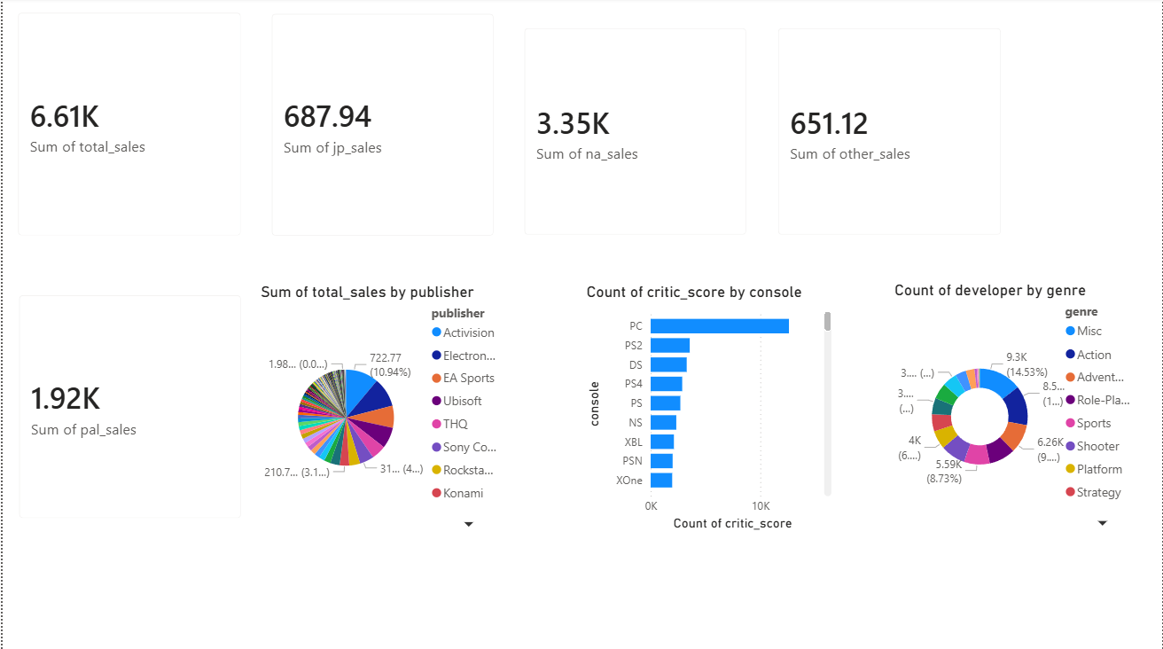

Console, Genre, and Regional Trends:
This page highlights genre distribution across consoles, Japanese sales by publisher, release year sales trends, developer distribution by publisher, and total sales by genre and console.

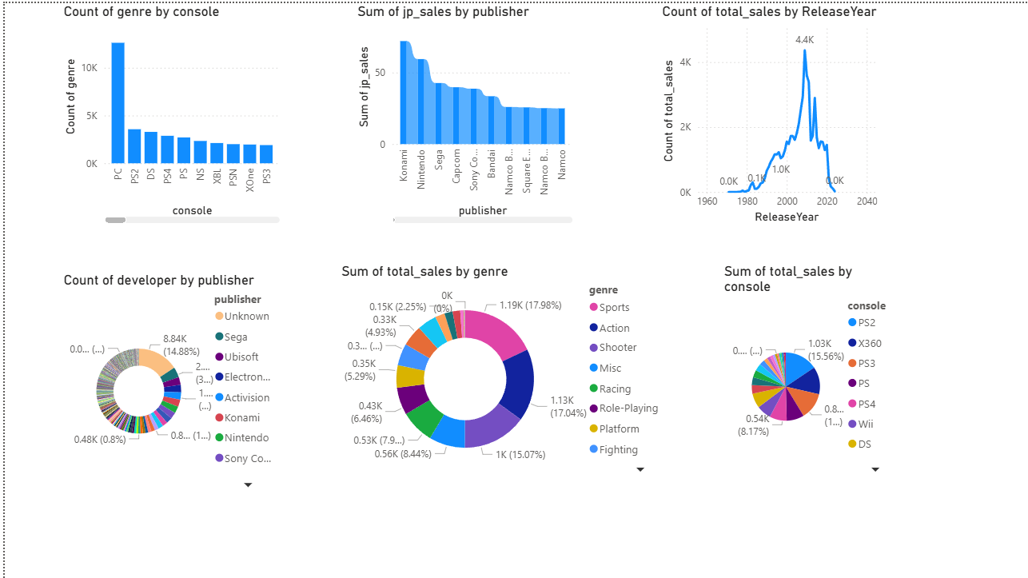

Top Games and Title Analysis:
This page presents the top 10 best-selling games, total sales count, console distribution by title and genre, and a list of released game titles.

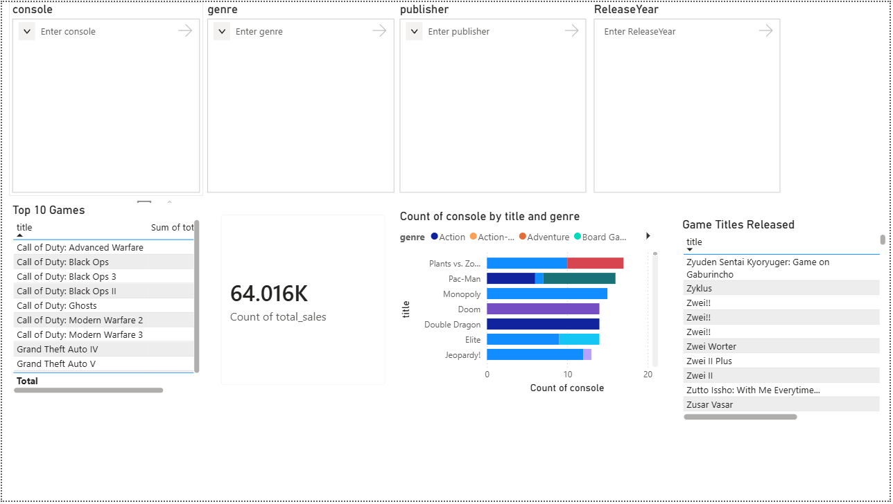

CONCLUSION

This project shows how Power BI can turn raw data into clear insights. By analyzing video game sales data from 1971 to 2024, the dashboards explained the role of publishers, consoles, genres, and regions in shaping the industry.

Strong franchises like Call of Duty, FIFA, and Grand Theft Auto proved their long-term success, while consoles such as PS2 and Xbox 360 defined the golden era of gaming.

The use of Power Query for cleaning and transformations made the dataset accurate and ready for analysis. Synced slicers across all pages allowed interactive filtering by console, genre, publisher, and release year, making the dashboards dynamic and easy to explore.

From a business view, the findings show how analytics can guide decisions about which genres to invest in, which regions to target, and how to plan future releases.

Action and Shooter games dominate globally, Sports titles perform strongly in Western markets, and Role-Playing games remain popular in Japan. These differences highlight how cultural preferences shape market strategies.

From an academic view, the project proves the value of Power BI as a learning tool. Students and professionals can practice cleaning, transforming, and visualizing data while gaining real-world insights.

Even without advanced DAX functions, the project showed that simple transformations and clear dashboards are enough to uncover useful patterns.

Overall, this project demonstrates that Power BI is not just a reporting tool but a complete analytics platform. It simplifies complex datasets, reveals hidden trends, and supports better decision making.

The video game dataset served as a strong example of how analytics can track historical changes, explain current market behavior, and even predict future opportunities.

FUTURE SCOPE

This project focused mainly on cleaning the dataset with Power Query and building dashboards with basic visuals. In the future, several improvements can be made to extend the analysis:
- Advanced DAX calculations: Using measures and calculated columns to perform deeper analysis, such as profit margins, growth rates, or ranking functions.

- Predictive analytics: Applying forecasting models to predict future sales trends based on historical data.

- Live data connections: Connecting Power BI to live databases or APIs so dashboards update automatically with new data.

- Interactive storytelling: Adding drill-through pages, bookmarks, and tooltips to make dashboards more engaging and user-friendly.

- Integration with other tools: Combining Power BI with Excel, SQL, or cloud services for more powerful analytics and reporting.

By adding these features, the project can move beyond descriptive analytics into predictive and prescriptive analytics, helping businesses not only understand past performance but also plan for the future.

REFERENCES

* Dataset: Siddharth Vora, Video Game Sales Dataset (Kaggle, 1971–2024). Available at: https://www.kaggle.com/datasets/siddharth0935/video-game-sales

* Tool: Microsoft Power BI Desktop
Microsoft Excel (for dataset formatting and preprocessing)

