Gecko: a gender bias coefficient based interface design utility

Geko: gener bias coefficient based interface design utility

The gender bias coefficient value is based on the “Gini” coefficient, where 0 represents an equal distribution, that is all the genders are equally represented/taken into account/pleased, and 1 when only one gender is represented.

How is the gbc computed?

Abstract

Gender topic

Introduction

The idea of this project is to provide the user interface designer a tool able to guide and help with the design of a gender-neutral design.

The main purpose of such tool is to make a designer **aware** of the gender bias coefficient (GBC) of a user interface based on some **criteria**, both *aesthetic* (Moss, G., Gunn, R. and Heller, J., “Some men like it black, some women like it pink: consumer implications of differences in male and female website design”, Journal of Consumer Behaviour, 5, 2006, pp. 328–341.) and *social* (where the **hell** was that **mentioned** on?), and **educate** and **guide** the user to shift the bias towards the expected target.

Criteria applied:

* Navigation issues
  + Number of links,
  + site map,
  + contents page,
  + subjects
* Language
  + Abbreviations,
  + self-denigration,
  + non-expert,
  + informal language
* Visual elements
  + Rounded shapes,
  + horizontal layout,
  + more colours for typography,
  + informal typography,
  + specific colours for typography.
  + Images depicting people of the target gender.
* Development
  + Designers (team) gender
  + Evaluation group gender

Since those parameters, especially the ones referred in the navigation group are dedicated to websites, we should allow for some of the parameters to be not applied.

Including GBC in design process.

Mirroring effect: make the interface suitable to a given gender

Design loop:

Analyse -> Design -> Build -> Evaluate

GBC can be considered before starting to build the prototype because it’s designed to access abstract factors that will probably affect the evaluation before it’s actually built.

Analyse -> Design -> GBC -> Build -> Evaluate

This however might include a novel approach to UX which is based on metered validation on final users. The idea would be to measure, for example using google analytics, the number of accesses and time spent using the user interface to validate the bias coefficient as it is computed by the Gecko application itself.

Usability is defined by **5 quality components**:

* **Learnability**: How easy is it for users to accomplish basic tasks the first time they encounter the design?

**Low**, I want a user to study and be prepared when using the interface. He will be able to understand the meaning of many parts of the interface using some helpers but overall, the user will need assistance at the beginning.

I could not understand the interface without help

The tool is intuitive

The application hints helped me understand how to use the tool

I could find the hints I needed very easily

* **Efficiency**: Once users have learned the design, how quickly can they perform tasks?

**Medium**. This is a production utility, user will want to achieve the task as quickly as he realized what he wants to do. However, I also want the user to be aware and involved into the productivity process, so the interaction will have to require a certain amount of focus and willingness

Once I understood how to use it, I could quickly achieve what I wanted to do

Achieving a result required too much effort

The tool is unnecessarily complicated

The relevant functions are readily available

The tool functionalities are well integrated and consistent

The tool helps me to be more effective

* **Memorability**: When users return to the design after a period of not using it, how easily can they re-establish proficiency?

**High**. User should be able to return and quickly recognize what’s the tool is made for and how to get the results.

I felt lost in the pages and dialogues

The tool is using the same layout/icons/keywords as many other tools I’ve been using (sticks to standard)

I can easily remember how to use it

The dialogues and messages are confusing

It seems I have to learn it from scratch every time I use it

I keep finding new functions in unexpected places

* **Errors**: How many [errors](https://www.nngroup.com/articles/slips/) do users make, how severe are these errors, and how easily can they recover from the errors?

**High**. Users will not do any unrecoverable error, however they could input a bad value. They can review and go back at any time, reset and restart if anything is not going as expected. The users should be aware if anything doesn’t look as expected.

I felt very confident using the tool

I could not find an easy way to undo what I’ve done

Error messages are clear and helpful

I could see at any time what I was doing (user feedback)

The tool behaves in unexpected ways

* **Satisfaction**: How pleasant is it to use the design?

**High**. Since this is a productivity tool, since this is optional and rarely used, satisfaction is very important. I want the user to enjoy the experience so that it will use it more often.

I would recommend it

I can think a number of ways the tool could be improved

I enjoyed using the tool

PACT

Activities

What is the overall goal of the activity ?

n  What has to be satisfied

n  Hedonic (for pleasure) vs. Pragmatic (towards specific goal)

? Temporal aspect

n  Length of time on tasks

n  Regular or infrequent

n  Continuous or interruptions

n  Processing time

? Cooperation

n  One or more actors involved

? Complexity

n  Well defined or vague ?

? Safety

n  Impact of error (how much?)

? The nature of the content

n  Type of data to be processed

n  Type of media

Context

? Where do the activities and interaction occur ?

n  Physical context

w  noisy, cold, wet, dirty, stressful, uses dangerous

materials, sunny

n  Social context

w  channels of communication, structure, centralization vs

decentralization, home, mobile, training materials

n  Organizational context

w  relationships with customers, other staff, effect on work

practices and job content

w  amount and type of support for activities

n  tuition, manuals, demonstrations, new knowledge,

new skills

Technologies

? Type

n  mobile, desktop

? Input

n  getting data in

n  getting commands

n  security

? Output

n  video vs. photographs

n  speech vs. screen

? Communication

n  between people

n  between devices

n  speed

n  real-time

? Content

n  what kind of data is in the system: a web site is all about content

People: Interface designers, they usually sketch stuff or use tools (Photoshop, Balsamiq)

Activities: keep track of submitted designs in terms of GBC, evaluate and address issues, also in team

Context: in the uffice, design process, where many different team members are included

Technologies: tools are mainly desktop based, even if tablet could be used. Web would allows users to easily access and share the tool in different places.

Personas

Sarah is a 72-year-old woman who lives with her

husband. She lives in a small house in Corbridge.

Sarah enjoys living in the rural community and has

a small number of friends who live nearby

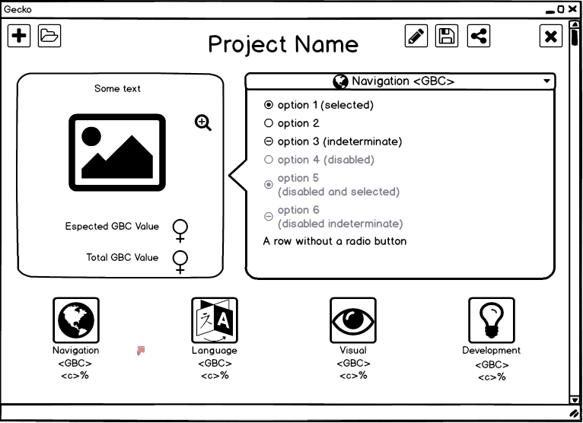

Initially considered a generic user interface utility, it has become evident how much the web design played a role in the business. Confirm!

# Project ideation

# Design space definition

Questionnaire on UI

Choice between desktop or web application: inspiration from

# First design

Big challenge in developing for mobile.

# Evaluation

# Data analysis and re-design