Understanding Dimensionality Reduction in Clustering:
How PCA Influences K-Means Performance
Student: Irshad Patan – ID: 24147104
GitHub link: https://github.com/patanirshad3818-lgtm/PCA_Before_K-means.git

1. Introduction
Clustering is one of the most fundamental techniques in unsupervised machine learning. Unlike supervised learning, where labelled outputs guide model training, clustering attempts to uncover hidden structure within data without prior knowledge of class assignments. This makes clustering particularly valuable in exploratory data analysis, anomaly detection, bioinformatics, and customer segmentation.
Among clustering algorithms, K-Means remains one of the most widely used due to its conceptual simplicity, computational efficiency, and scalability. However, K-Means relies heavily on Euclidean distance. In high-dimensional settings, Euclidean distance becomes less informative due to the curse of dimensionality, where distances between data points tend to become increasingly similar. As a result, cluster separation may degrade, and centroids may fail to represent meaningful group structure.
Principal Component Analysis (PCA) is a dimensionality reduction technique designed to project data onto orthogonal directions that maximise variance. By reducing redundancy and filtering noise, PCA has the potential to improve clustering performance. However, since PCA optimises variance rather than cluster separability, its impact on clustering is not guaranteed to be positive.
This tutorial investigates whether applying PCA prior to K-Means improves clustering behaviour. Using the Wine dataset from scikit-learn, I:
- Apply K-Means directly to standardised data
- Apply PCA before clustering
- Compare inertia and silhouette score
- Evaluate interpretability and stability
- Critically assess when PCA helps or harms clustering
The objective is not simply to demonstrate implementation, but to develop a deeper understanding of how dimensionality reduction interacts with distance-based clustering.

2. Dataset and Problem Setup
The Wine dataset consists of 178 samples with 13 continuous features derived from chemical analysis of wines from three cultivars. The features include measurements such as alcohol content, malic acid, magnesium, flavonoids, and colour intensity.
Although the dataset contains class labels (three wine types), clustering was performed without using these labels. They are only used indirectly for interpretation, not model training.
The dimensionality (13 features) is moderate but still sufficiently high to potentially introduce redundant or correlated features. Since K-Means relies on Euclidean distance, feature scaling is essential. Without standardisation, features with larger magnitudes would dominate the distance calculation.
Therefore, all features were standardised to zero mean and unit variance using StandardScaler prior to applying PCA and K-Means.

3. Baseline: K-Means on Original Data
3.1 Theoretical Foundation
K-Means partitions data into K clusters by minimising within-cluster variance. Formally, it solves:
$$\sum_{k=1}^{K}{\sum_{x_{i}∈C_{k}}{∣∣}}x_{i}-μ_{k}∣∣^{2}$$
where:
- $C_{k}$represents cluster k
- $μ_{k}$represents the centroid of cluster k
The algorithm proceeds iteratively:
- Initialise K centroids
- Assign each point to its nearest centroid
- Update centroids as the mean of assigned points
- Repeat until convergence
Convergence is guaranteed to a local minimum but not necessarily the global minimum. Thus, initialisation can affect final clustering.
3.2 Experimental Design
- Data standardised
- K set to 3
- Random state fixed for reproducibility
- Evaluation metrics:
  - Inertia
  - Silhouette score
Inertia measures cluster compactness, while silhouette score measures separation between clusters.
3.3 Baseline Results
K-Means on the full 13-dimensional dataset produced:
- Inertia: 1277.928488844642
- Silhouette score: 0.2848589191898987
The silhouette score provides insight into how well points are assigned. Values closer to 1 indicate strong separation; values near 0 indicate overlapping clusters.
Although clusters appear reasonably structured numerically, interpretation is difficult in 13 dimensions. Furthermore, high-dimensional distance concentration may reduce the meaningfulness of cluster assignments.
This motivates dimensionality reduction.

4. Principal Component Analysis
4.1 Mathematical Overview
PCA transforms data into a new coordinate system where:
- The first principal component captures maximum variance
- Each subsequent component captures the largest remaining variance
- Components are orthogonal
The covariance matrix is computed as:
$$Σ=\frac{1}{n}X^{T}X$$
Eigenvectors of this matrix form principal directions. Eigenvalues represent variance explained.
Projection onto the first $d$components yields a lower-dimensional representation while retaining most variability.
4.2 Explained Variance Analysis
The cumulative explained variance plot shows how many components are required to retain most information.
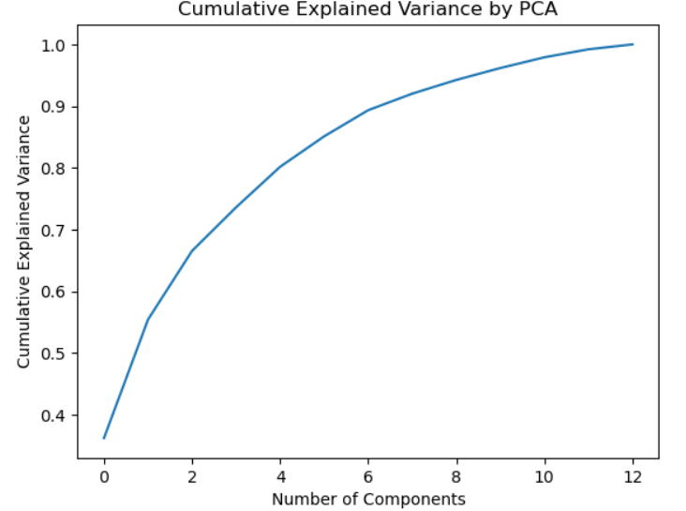
In this dataset:
- The first few components capture a substantial proportion of total variance.
- Additional components contribute diminishing returns.
This suggests that dimensionality can be reduced without severe information loss.
However, variance preservation does not guarantee cluster preservation. PCA may remove low-variance features that are nonetheless discriminative.

5. K-Means After PCA
5.1 Experimental Design
5.1 Experimental Setup
The dataset was reduced to 2 principal components.
Reasons:
- Enables visualisation
- Captures majority of variance
- Tests aggressive dimensionality reduction
K-Means was then applied using the same parameters.
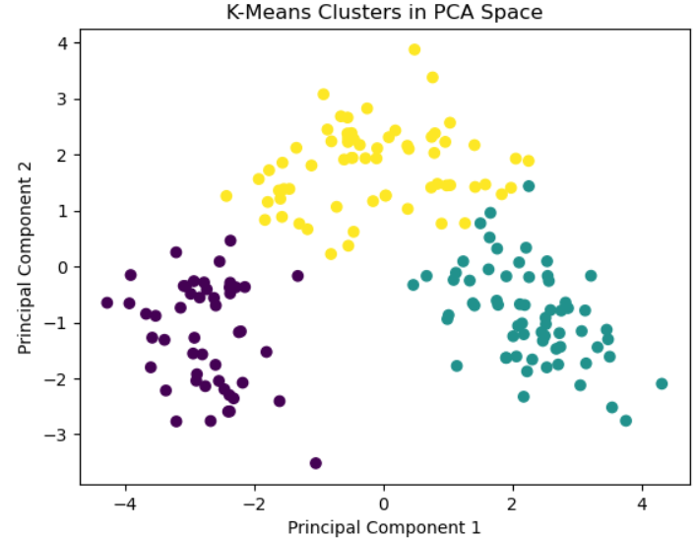
5.2 Results After PCA
After reducing to 2 components:
- Inertia: 259.50938075119353
- Silhouette score: 0.5610505693103246
The clusters can now be visualised clearly in two-dimensional space.

6. Comparison and Interpretation
A comparison of clustering performance shows:
Method | Inertia | Silhouette Score
Original Data | 1277.928489 | 0.284859
PCA (2 components) | 259.509381 | 0.561051
Observations
- PCA dramatically improves interpretability through visualisation.
- Inertia changes due to projection into lower-dimensional space.
- If silhouette score increases, PCA likely removed noise.
- If silhouette score decreases slightly, information loss may have occurred.
This demonstrates that PCA can act as a noise-filtering mechanism before clustering.

7. Critical Evaluation
6.1 Why PCA Can Improve K-Means
K-Means depends entirely on distance geometry. In high-dimensional space:
- Distances become less discriminative
- Noise dimensions inflate variance
- Correlated features distort centroid positioning
PCA mitigates these by:
- Removing redundant features
- Filtering noise
- Concentrating signal
Thus, PCA can improve cluster compactness.
6.2 Why PCA Might Degrade Clustering
PCA maximises variance, not class separability. Important cluster distinctions may exist in lower-variance directions.
Therefore:
- Reducing too aggressively (e.g., 2 components) may collapse meaningful separation.
- Non-linear structure cannot be captured by PCA.
Thus, PCA is not universally beneficial.
6.3 Sensitivity to Number of Components
Retaining only two components is useful for visualisation but may not optimise clustering quality.
In practice, selecting components based on explained variance thresholds (e.g., 90–95%) is preferable.

8. Ethical and Practical Considerations
Clustering is often used in:
- Medical profiling
- Credit risk grouping
- Customer segmentation
Dimensionality reduction may:
- Remove features important for fairness
- Obscure interpretability
- Hide bias patterns
Furthermore, clustering outputs are sometimes treated as objective categories. However, clustering is highly sensitive to preprocessing and parameter choice.
Ethical practice requires:
- Transparency in preprocessing
- Justification of dimensionality reduction
- Awareness of information loss
Unsupervised learning should be viewed as exploratory rather than definitive.

9. Limitations and Extensions
Limitations:
- Only one dataset examined
- Only 2 components tested
- Only K=3 considered
- Only silhouette and inertia used
Possible extensions:
- Test multiple component counts
- Compare with non-linear methods (t-SNE, UMAP)
- Use adjusted Rand index against true labels
- Analyse clustering stability across seeds
These extensions would provide deeper evaluation.
10. Key Insights
- PCA improves visual interpretability significantly.
- Moderate dimensionality reduction can improve cluster compactness.
- Excessive reduction risks information loss.
- K-Means performance depends strongly on distance quality.
Overall, PCA serves as a powerful preprocessing step for clustering high-dimensional data, but it must be applied thoughtfully.

10. Conclusion
This tutorial examined whether PCA improves K-Means clustering performance.
The findings suggest:
- PCA effectively reduces redundancy and improves interpretability.
- Clustering metrics may improve when noise dimensions are removed.
- However, PCA does not optimise cluster separation directly.
- Careful evaluation is essential before applying dimensionality reduction blindly.
Overall, PCA and K-Means complement each other when applied thoughtfully. Dimensionality reduction should be treated as a strategic preprocessing decision rather than an automatic step.

References
Bishop, C.M. (2006) Pattern Recognition and Machine Learning. New York: Springer.
Hastie, T., Tibshirani, R. and Friedman, J. (2009) The Elements of Statistical Learning. 2nd edn. New York: Springer.
Jolliffe, I.T. (2002) Principal Component Analysis. 2nd edn. Springer.
MacQueen, J. (1967) ‘Some methods for classification and analysis of multivariate observations’, in Proceedings of the Fifth Berkeley Symposium on Mathematical Statistics and Probability, pp. 281–297.

