1. Which command is used to know the current working directory?
2. Pwd is used to know the current working directory.
3. How would you find out its contents?

A)by using command ll

3. Identify the commands with inputs to do the following

a. create a directory d1

b. create a subdirectory d2 in d1

c. change to directory d2

d. create an empty file “f1.txt”

e. display the contents of “f1.txt”

f. view the contents of d1 from current directory d2

4.Use the ls command with its options. How will you identify directories from the listing?

A)ls command in linux to list directory contents.

5. Use ls to do the following

a. List files with single character names.

b. List hidden files also. [ Note : Hidden files are files having name started with a “.” ]

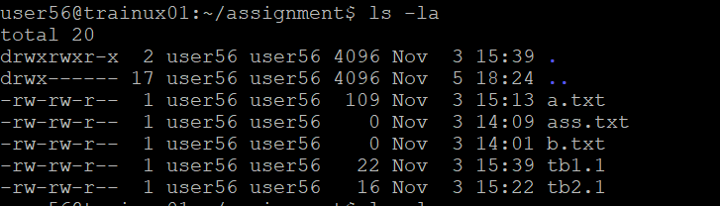

c. Suppose there are files tb1.1, tb2.1, tb3.1, ….tb10.1. Write command to list all the files [Hint: use wild card characters]

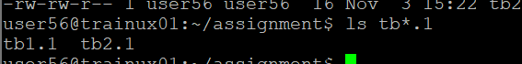

6. Write the command to list all files in descending order of their size.

A)ls -S to get all files in descending order of their size.

7. Suppose there are files temp1, temp2, temp3. Write command to remove the files without listing them explicitly.

A)We use rm command to remove the files.

A)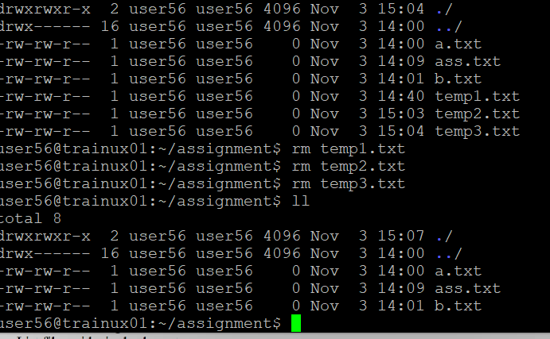

8. Which command is used to list top few lines in the file?

A)Head command is used to get top lines.

9. Create a directory “testdir”.

A)mkdir testdir

10. Use cp command to do the following

a. Copy the file tb1.1 (created above) in the same directory.

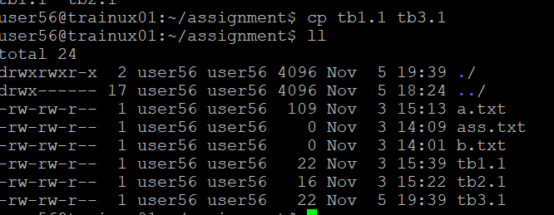

b. Write a command to copy all the files i.e tb1.1,tb2.1,tb3.1,…..tb10.1 in a new directory –“new”

c. Create a subdirectory in new in named“new1”.

d. Write a command to copy selectively only tb2.1, tb6.1, tb7.1 and tb10.1 in the directory new1.

e. Write a command to copy the entire directory “new” to a directory “newprogs”. [Note : use the –R option of “cp” command ]

11. Find out the difference between

a. ]“mv” & “cp”

A)”mv” command moves the file from one file to another and removes the old file. While, “cp” command copies the file from one file to another and will keep the old file.

b. “rm”, “rmdir”

A)”rm” command removes complete directories, including subdirectories and files. The rmdir command removes empty directories.

c. “mkdir” and “mkdir -p”

12. Use a single command rmdir once to remove “testdir” and all its sub directories and files created above.

A) rm -r testdir, it will remove testdir and all its sub directories and files

13. Which command is used to get the manual information of a command?

A)man cp, Here it will give detail information about copy

14. If you are not able to change to a directory what could be the likely cause?

A)it may cause

\*Drectory Does not exist

\*Permission denied

\*incorrect path