**Printf Scanf Assignment**

1. WAP with

1a. function readdisplay() to read the following data types only one at a time at run time and to display.

1. char type

2. integer type

3. char array of maximum 80 characters

4. short type

5. float type

TestData:

‘c’, 8978, “hello”, 8, 45.678

‘H’, 254, “hello Hi How”, 256, 145.2678

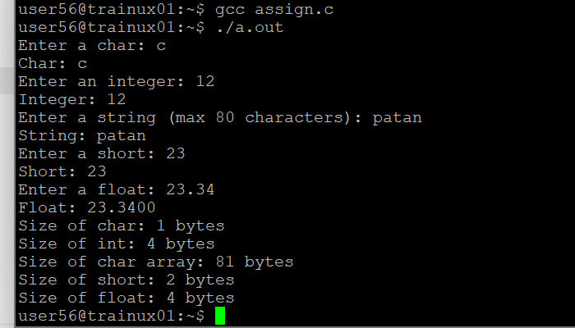

1b. Create a copy of readdisplay() as function readdisplay2() with changes below

· Instead of reading 1 data at a time, read all inputs using a single scanf().

Test readdisplay2() by changing the read order. Do you observe any issue?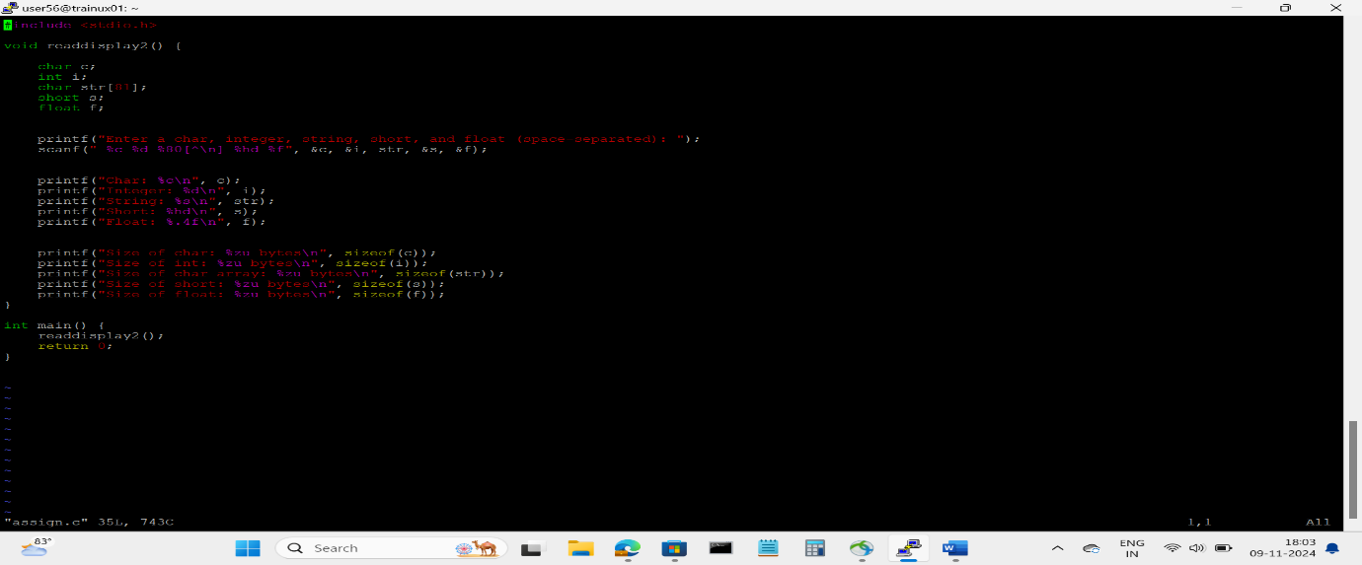

1c. display the char array content in upper case

A) for (int j = 0; str[j] != '\0'; j++) { str[j] = toupper(str[j]); }

1d. Add code to display the size of each data type mentioned in Q1a and sizeof the variables of each datatype (You may refer sample code in data_type_size.c )

1. The code for displaying the size of each data type is already included in both readdisplay() and readdisplay2(). The sizeof() operator is used to display the size of each variable, which is printed in the functions.

2. Try to run the program with code snippet below. Check the output and analyse. Fix it to get correct result.

#include<stdoh>

int main()

{

unsigned long int ul = 200333333334340;

printf("value is:%d\n", ul);

return 0;

}

A) The issue here is that ul is of type unsigned long int, but the printf format specifier %d is meant for int, which can lead to incorrect behavior when printing large numbers. Specifically, unsigned long int should use the %lu format specifier.