**Recursive Function Assignment**

1. WAP to calculate the maximum stack depth of a recursive call to a function. (For eg a factorial function ).

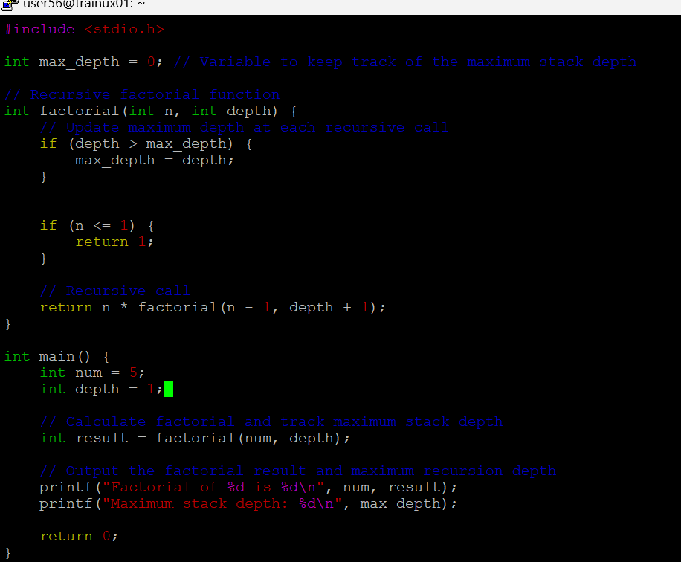

1. What is tail recursion? Why is it important? Give an example
2. Tail recursion occurs when a recursive function makes the recursive call as its last operation, meaning there is no additional work to be done after the recursive call returns. In a tail-recursive function, the result of the recursive call is immediately returned as the result of the current function call.



