**Multithreading – Thread Creation assignments**

**1.Refer the program in “thread_prg.c”. Complete the TBD sections , check the final solution for memory leak if any**

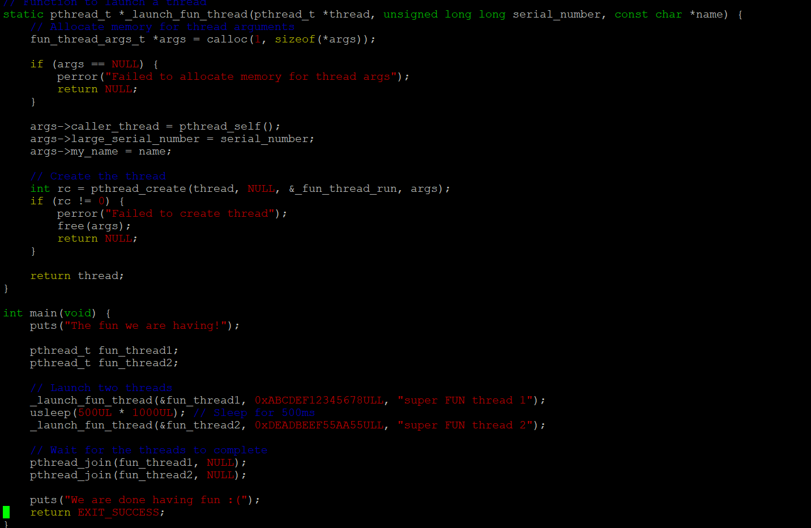

**2.Write a program**

**a. to read a set of words as command line arguments and to create an array of threads (Consider a maximum of 5 words )**

**b. process each word using an separate thread. Let each thread append “_ed” to the input word and return to main thread**

**c. main thread to wait for completion of each thread, retrieve returned string display with thread number, free memory**



