**Linux Environment Variable Assignment**

**1. State the command for the following.**

**a. view current environment variables**

**b. display the PATH evironment variable value**



**2. How will you make the environment changes applicable to all users? Which script is to be modified?**

**A)we can use command /etc/profile to make environment changes applicable to all users. As I don’t have permission to change.**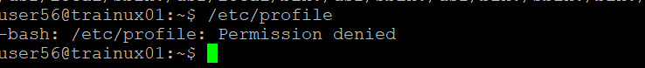

3.I have installed an application named “myapp”. After installation, if I invoke the application, it fails with error as “Command myapp not found”. How will you fix this?

A)If I encounter the error”command myapp not found” after installing the application, it typically means that the shell cannot find the executable file for “myapp” in its search path.