**Linux Environment Variable Assignment**

**1. Create a script named “myscript” in current directory to do the following.**

**a) create a dir named “subd1” in current directory**

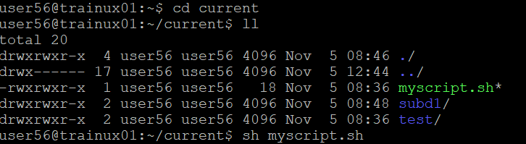

**b) create a file named “dircontent” with contents of the current directory**



**c) display the contents of the file “dircontent”**

**d) display the contents of a non existing file named “unknownfile”**

**2. Run the script and validate the output in following cases**

**a) Redirect only the stdout to an o/p file named stdout.txt**

**command: $ ./myscript.sh > stdout.txt**

**b) Redirect only the stderr to an o/p file named stderr.txt**

**command: $ ./myscript.sh 2> stderr.txt**

**c) Redirect both stdout and stderr to an o/p file named stdall.txt**

**command: $ ./myscript.sh &> stdall.txt**

**d) Display all o/p and error and also redirect both stdout and stderr to an o/p file named stdall.txt**

**command :$ ./myscript.sh |& tee stdall.txt**

**3. Redirect the output of command below using pipe (|) to wc and get the output .**

**ls -l**

**A)Here I have 8 lines 65 words 393 characters in my current directory.**

