**Shell Script Assignment**

1. **Create a script named “myscript” in current directory to do the following.**



**a)Display “hello user”**



**b)List files in current directory**

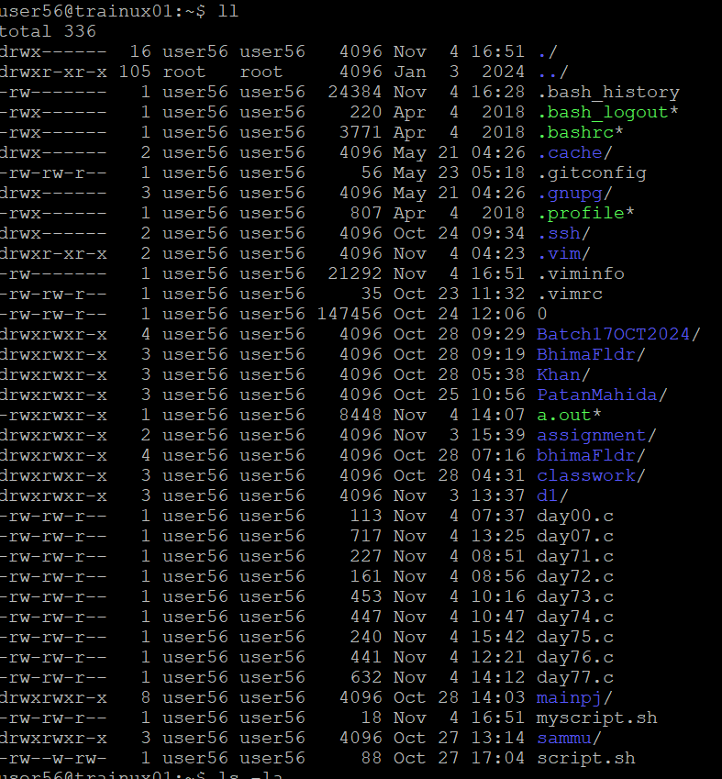

**c)Name of logged in user**

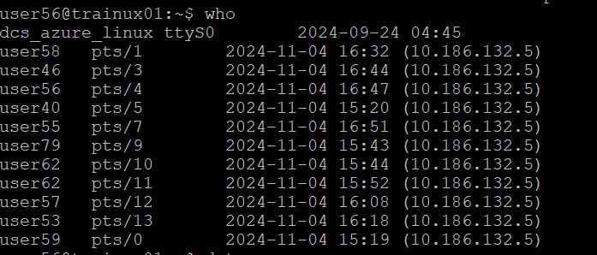

**d)date**



**2)Add execute permission and run the script from**

**a)current directory**

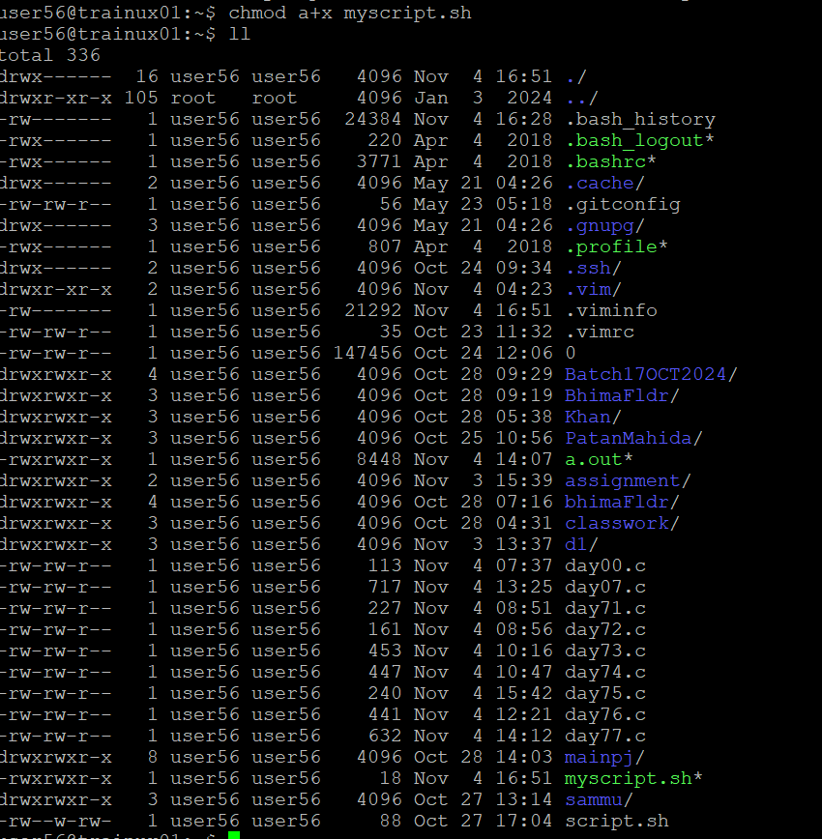

**3)Create a subdirectory named “test”**

**4)Change to “test” directory. Run the script “myscript”[Hint: you will have to update PATH to include the directory containg script to run script from any location]**

