->~/sammu$ cp –help: It gives information about how to copy directory. We can use any directory.

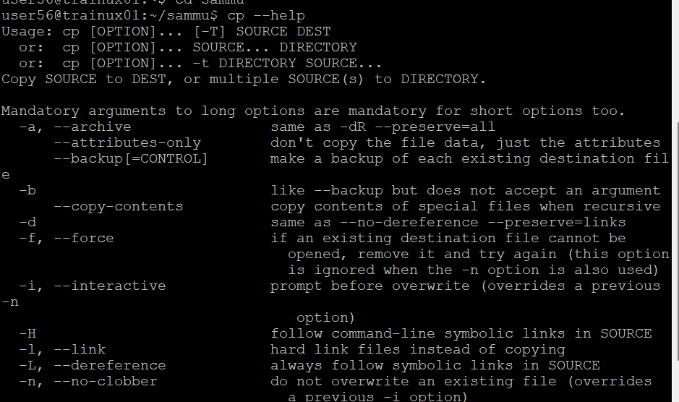

->~/sammu$ mkdir bo2 -v: Print a message for each created directory.

*As we can see below I created a bo2 directory using -v command , and it showed with words that my directory got created.

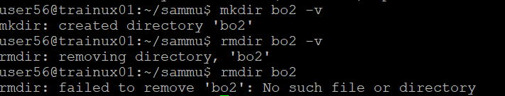

->~/sammu$ date: It will give current day with date,month, year and time.



->~/sammu$ cal: It will show current month calendar.

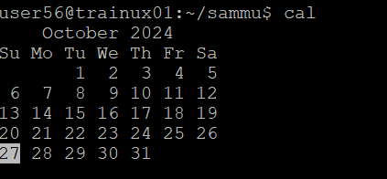

->~/sammu$ time: It will give current time.

->~/sammu$ nl file.txt: By using these command we can get the text that we have written in vi editior with line number.

**Can we create directory within another directory?**

*Yes, we can create directory within another directory

*In directory sammu I have created another directory which is multipledirs.

*In multipledirs I have created multiple directorys such as bin,etc,inc,lib,obj,scripts,src.

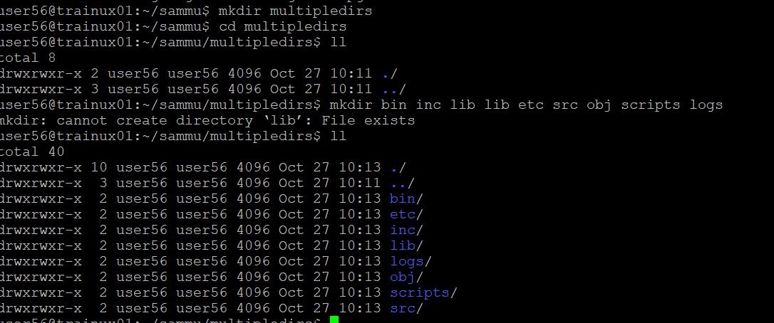

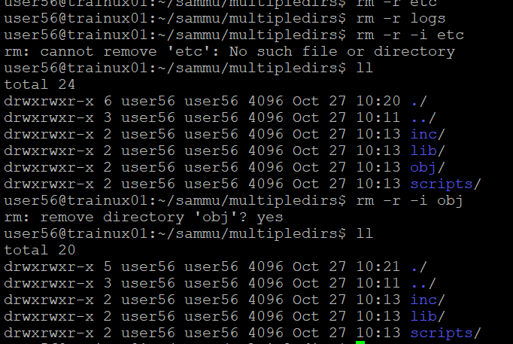

*As we can see I am trying to remove the multipledirectories which I have created.

*When I am trying to remove the obj directory ,I have mentioned -i command which gives us the option as yes or no , to remove the directory.

->If we touch file twice it just changes the timestamps which mean it will update the time.

**VimEditor**

->~/sammu$ ll: we can see if vimeditor is present are not.

->~/sammu$ vi .vimrc: To create vimrc which means to configure. After creating vimeditor we have to set autoindent, number, ts=4 (tabspace can be any number depending upon how much to keep)



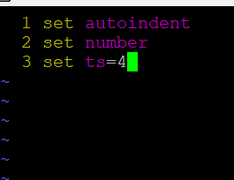

->~/sammu$ source .vimrc: After writing these we have to implement so, that it will work.

*For that we have to use these command.



->~/sammu$ sleep 10: It will take 10seconds to come back to command prompt.



->~/sammu$ ps -ef: We can check if sleep is completed or not after 10s. To reassure that it completed.

->~/sammu$ sleep 10 &: Sleep will run in background and we will able to access common prompt

->~/sammu$ cal;date : we can change multiple commands.

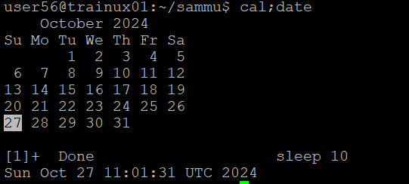

->~/sammu$ top: It will give top running tasks.

**Different modes of VI Editor**

*input: We can edit

*command: For searching and replacing

*ESC mode: We can’t edit, but we can save & quit.

*From input mode to command mode press <ESC>

*Some of the commonds we use in vieditor and there functions

**Commands Function**

1. Insert text to left of cursror.

I Insert text at beginning of line

1. Appends text to right of cursor

A Appends text at the end of line

o. Opens line below

O Opens line above

R Replacing the text from cursor to right

r. Replaces single char at cursor with char

s. Replaces single char at cursor with any no of characters

S Replaces enter line

h. moves cursor left

j. moves cursor down

k. moves cursor up

l. moves cursor right

^ moves cursor to begninig of first

$ moves cursor to end of line

Control-f full-page forward

Control-b full-page backward

Control-d Half-page forward

Control-u Half-page backward

**For Common mode**

To save : W

To quit :q

To quit without saving :q!

To save & quit :wq

Or :x

*dd: To completely delete a line

*dw: To delete a word

*x: To delete a single character

*cd: to change a sentence

*cw: To change a word

*R: To replace a character

*:w filename: If we didn’t save the file in commond prompt, after going to editir we cab save the file

*filename :w filename: It will get saved into another file with same content.

*/str: To search for any word--🡪Here str is a word that I want to search.

*:o: It will go back to first line from wherever the cursor is.

*:423: To go to 423 line🡪 Here 423 is the line where I want to go

*J: To join lines.

*O: To give space between two lines

*yy(yanking): To copy

*yand3: To copy multiple lines--> Here I want to copy three lines so, I chosen Y3.

*we can’t use ctrl+z because it is interupated signal.

*~/sammu$ dua -a: To see in a directory how many bites files occupied.