**SHELL:**

->.sh extension of shell

->~/sammu$ vi script.sh : I have created a script called script.sh

->~/sammu$ sh script.sh: To run my script that is script.sh

->~/sammu$ history : It will give history of commands that we are using

**Changing permissions**: We have three changing permissions

*chmod : To change the mode like read, write, executable.

*chown : To change ownership of the file.

*chgrp : To change the group of the file.

->~/ chmod g+x script.sh : I have given execuation permission to group.



->~$ chown patan ae-socket.c : * To change ownership

*Here Patan is the new owner name and-socket.c is filename.

*I can’t change the ownership because I am not the owner, only owners have the permission to change the ownership.

->~$ chgrp <groupname> <filename> : To change the group of the file

->~$ chmod 0226 script.sh : Here I have given only write permissions to owner,group and read,write permissions to others.

* 1->Execute

*2->write

*4->read

at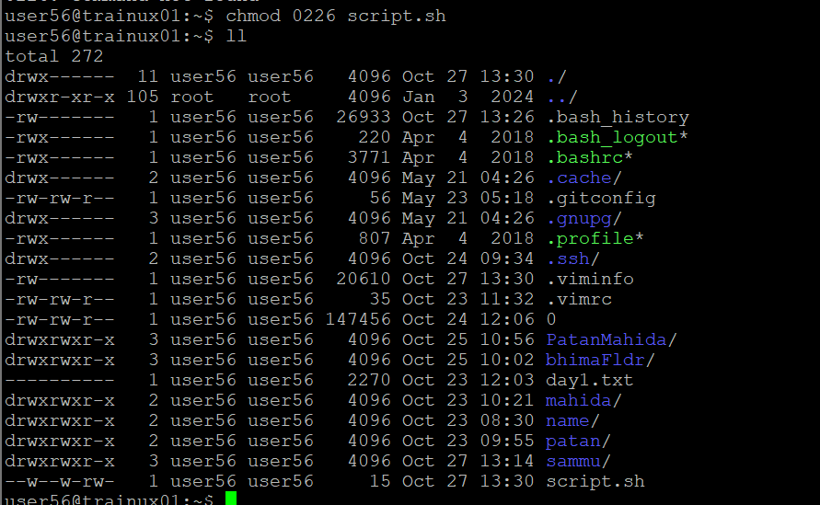

*When we pass command line argument in shell script it called special variable or positional parameters.

->$0 : It will give script name

->$* : No of Arguments names wii give

->$# : No of Arguments passed

->$1 : 1st Argument

->$$ : Gives the PID of the current shell

->$! : Gives the PID of the background shell

->$ wc filename : It gives no of lines ,words ,characters are there in a file.

->$ find ./ -name file.txt : It will give in which directory the file is present.

->$ find ./ -name “f*.txt” : it will give all the files that starts with letter f an in txt form.

**Filters**

*filters is a command that takes its input from standard input, processes it and sends its output to the standard output.

*some commonyly used filters : grep, sort, cut, paste, head, tail, wc, pg

*~$grep <pattern> <file name> :Here pattern is optional.

*options are: -n : prints line numbers

-v : The reverse search criteria.

-c : Display only a count of matching patterns.

“^” : Beginning of line

“$” : end of line

“.” : any single character

[…] : any one character from the line

->~$ grep -i “patan” script.sh : we get all names from script file that are patan irrespective of case sensitive.

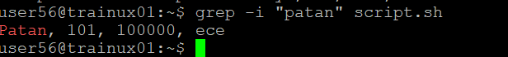

->~$ grep “^B” employee.dat : It will give details that end with B

->~$ grep “6…$” employee.dat : Display all the records whose salary is blw 6000 to 6999

->~$ grep cp test1.sh test2.sh : It will copy from one file to another file with in directory.