**Conditional Execuation: logical oprators && and || :**

**\*&& operator delimits two commands second command is executed only if the first succeeds.**

**\*|| operator delimits two commands second command is executed only if the first fails.**

**Logical operators:**

**Eq : =**

**Ne : !=**

**Qt : >**

**Gc : >=**

**It : <**

**Ic : <=**

**Logical operator**

**-a .AND**

**-O .OR**

**! NOT**

**Strings operators used by test:**

**-n : True, if str not a null string**

**-z : True, if str is a null string**

**S1 = S2 -> True, if s1 = s2**

**S1 != s2 -> True, if s1 # s2**

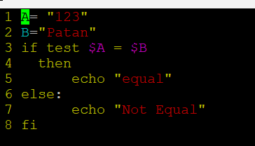

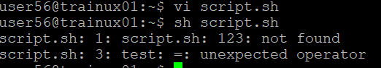

**->~$ -wall : It will give all notifications, errors, warnings.**

**->In below picture you can see that I have created a directory called mainpj in that I have created multiple directories such as inc, bin, lib, obj, scripts, src.**

**\*In inc directory I have created a file name as calc.h to include headerfile.**

**\*Then in src directory I have created a file as calc.c and main.c which our executable file.**

**\*Then we have converted our executable files into binary file using ~/mainpj$ gcc -c ./src/calc.c -I./inc/ -o ./obj/calc.o and gcc -c ./src/main.c -I./inc/ -o ./obj/main.o** 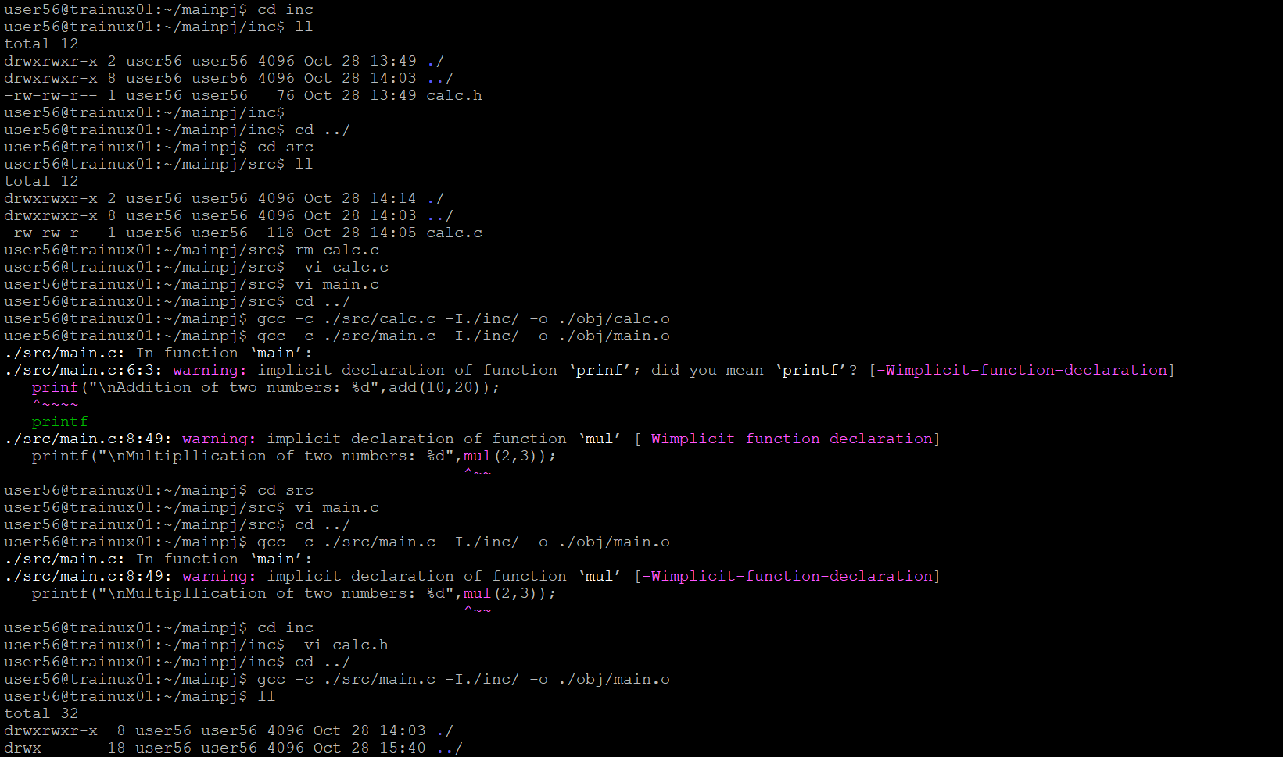

**\*Then I have created an app in bin directory to get my code executed.**

**~/mainpj$ gcc -o ./bin/app ./obj/calc.o ./obj/main.o**

**\*Then we executed our app which is under bin directory**

**~/mainpj/bin$ ./app**

