**/\*\*\*\*\*\*\*\*\*\*\*\*\*\*\*\*\*\*\*\*\*\*\*\*\*\*\*\*\*\*\*\*\*\*\*\*\*\*\*\*\*\*\*\*\*\*\*\*\*\*\*\*\*\*\*\*\*\*\*\*\*\*\*\*\*\***

**\* Programmer:** Razia Sultana Patan

**\* Project:** DistributedCryptocurrency Trading System using Java RMI

**\* Environment:** any machine with java setup.

**\* Files Included** PatanP2Server.java, PatanP2CryptoCoinServant.java, **\***PatanP2Coin.java, PatanP2CryptoCoinServicesInterface.java, **\***PatanP2CoinInteface.java, PatanP2ClientModel.java, userList.txt, **\***PatanP2Client.java

**\* Purpose:** The authorized user can use ‘Distributed Cryptocurrency Trading **\***Application’ to sell and buy coins which are created by the server.

**\* Input:** Messages from user inPatanP2Client.java, list of authorized users in **\*** userList.txt

**\* Preconditions:** User credentials must present in userlist.txt for a user to use the **\***application.

**\* Output:** The trading interactions between Client and the Server.

**\* Postconditions:** If user enters invalid inputs, he/she will not be allowed to trade his/her coins.

**\* Document:** This Document talks about algorithm, steps for running the application, Output screen shots, Class diagram and the flow chart for the application.

**\*\*\*\*\*\*\*\*\*\*\*\*\*\*\*\*\*\*\*\*\*\*\*\*\*\*\*\*\*\*\*\*\*\*\*\*\*\*\*\*\*\*\*\*\*\*\*\*\*\*\*\*\*\*\*\*\*\*\*\*\*\*\*\*\*\*/**

**Algorithm:**

**PatanP2CoinInteface:**

This interface **extends** **Remote** Interface and has following members, all related to a crypto coin:

**public** String getName() **throws** RemoteException;

**public** **void** setName(String name) **throws** RemoteException;

**public** String getAbbreviatedName() **throws** RemoteException;

**public** **void** setAbbreviatedName(String abbreviatedName) **throws** RemoteException;

**public** String getDescription() **throws** RemoteException;

**public** **void** setDescription(String description) **throws** RemoteException;

**public** **long** getMarketcap() **throws** RemoteException;

**public** **void** setMarketcap(**long** marketcap) **throws** RemoteException;

**public** **long** getTradingVolume() **throws** RemoteException;

**public** **void** setTradingVolume(**long** tradingVolume) **throws** RemoteException;

**public** **float** getOpeningPrice() **throws** RemoteException;

**public** **void** setOpeningPrice(**float** openingPrice) **throws** RemoteException;

**public** String getTimestamp() **throws** RemoteException;

**public** **void** setTimestamp(String timestamp) **throws** RemoteException;

**PatanP2Coin:**

This class implements **PatanP2CoinInteface** and **extends UnicastRemoteObject** , It implements all the methods of PatanP2CoinInterface and has Constructor with parameters.

**PatanP2ClientModel:**

This Class is **Seralizable** class, whose members are used to hold client state, it has constrctor with parameters and getter setter methods:

**private** String clientID;

**private** String clientName;

**private** **float** purchasePower;

**private** ArrayList<PatanP2CoinInterface> coins;

**PatanP2CryptoCoinServicesInterface:**

This interface **extends** **Remote** Interface and has following members, all related to a crypto coin services

boolean **buy** (String coinAbbreviation, **float** price, String username) **throws** RemoteException, FileNotFoundException, IOException;

boolean **sell** (String coinAbbreviation, **float** price, String username) **throws** RemoteException , FileNotFoundException, IOException;

boolean **autheticationCheck** (String username, String password) **throws** IOException, RemoteException;

PatanP2ClientModel **getClientStateFromFiles** (String clientID) **throws** RemoteException;

**PatanP2CryptoCoinServant:**

* This class implements **PatanP2CryptoCoinServant** and **extends UnicastRemoteObject** , It implements all the methods of PatanP2CryptoCoinServicesInterface.
* **synchronized boolean buy**(String coinAbbreviation, float price, String username)

1. The buy operation is enabled only if the price is same as the price of the coin and the coin exist at server side coins.
2. If price matches, it retrieves the client state using getClientStateFromFiles(username) and if the client is the new user, then it creates PatanP2ClientModel object for the client where its adds the bought coin and updating the purchase power of the client with trading amount.
3. It stores the client state using storeClientState(String clientID, PatanP2ClientModel clientState) method which serializes client object and stores it in a file ClientId.ser at server side for each client.
4. Once the trading operation is done, it updates the coin information using editcoin, in this application it subtracts trading amount from the volume of the coin.
5. If the coin mentioned is no present or price entered is not the price of coin, it returns false.

* **synchronized boolean sell**(String coinAbbreviation, float price, String username)

1. The sell operation is enabled only if the price is same as the price of the coin and the coin exist at server side coins.
2. If price matches, it retrieves the client state using getClientStateFromFiles(username) and if the requested coin to sell is already present for the client, it removes the coin from coins of the client and updating the purchase power of the client with trading amount.
3. It stores the modified client state using storeClientState(String clientID, PatanP2ClientModel clientState) method which serializes client object and stores it in a file ClientId.ser at server side for each client.
4. Once the trading operation is done, it updates the coin information using editcoin, in this application it adds the trading amount to the volume of the coin.
5. If the coin mentioned is no present or price entered is not the price of coin or the client is new user, it returns false.

* **boolean autheticationCheck**(String username, String password) retrieves the users data from "userList.txt" file and checks if the username and password are valid.
* **PatanP2ClientModel getClientStateFromFiles**(String clientID) reads the requested client sate into PatanP2ClientModel from clientID+".ser" file and if file doesn’t exist, it returns null.
* Apart from methods of PatanP2CryptoCoinServicesInterface, it also has other methods like

getCoins(), editCoin(), removeCoin(), addCoin(), unBinder(), storeClientState()

* **storeClientState**(String clientID, PatanP2ClientModel clientState) method serializes the client data into clientID+”ser” file stored at the server side.
* It has two HashMaps, one for storing the users from a file for login service and another for storing coins created by server which is static to provide coin data to all the authenticated clients.

Private Map<String, Object> coins

Private Map<String,String> userList

**PatanP2Server:**

* PatanP2Server creates coin by using PatanP2Coin constructor and uses PatanP2CryptoCoinServant services like addCoin(), getCoins().
* It binds servant class with url "rmi://localhost/"+"servant" in order to enable client for buy , sell, login, viewclientstate service.
* It binds all the crated coins with url : "rmi://localhost/"+"coin"+String.valueOf(j) where j is the index for a coin. In this way each coin has their own url.

**PatanP2Client:**

* PatanP2Client looks for "rmi://localhost/"+"servant" in rmiregistry and uses autheticationCheck() method to validate credentials entered by the user.
* Once user is authenticated, client provides following services:

System.out.println("*********************Services***************************"); System.out.println("Press 1 to display coins information");

System.out.println("Press 2 to buy a coin");

System.out.println("Press 3 to sell a coin");

System.out.println("Press 4 to view your account details");

System.out.println("Press 5 to exit");

* If client enters 1: It looksfor url = "rmi://localhost/"+"coin"+String.valueOf(i) iteratively with index value i into **PatanP2CoinInterface** and displays the coins information to the user.
* If client enters 2: It looksfor url = "rmi://localhost/"+"servant" into **PatanP2CryptoCoinServicesInterface** and passes the coin abbreviated name and amount to buy() method. Upon successful buying, it displays success message to the user.
* If client enters 3: It looksfor url = "rmi://localhost/"+"servant" into **PatanP2CryptoCoinServicesInterface** and passes the coin abbreviated name and amount to sell() method. Upon successful selling, it displays success message to the user.
* If client enters 4: It looksfor url = "rmi://localhost/"+"servant" into **PatanP2CryptoCoinServicesInterface** and uses **getClientStateFromFiles**

() method to display the users details like purchase power and coins the user bought.

* If client enters 5: this exists the application. As all the trading activities of a client are stored as clientID.ser file at server side, Next time when he/she logs in the client state is retrieved from .ser files using **getClientStateFromFiles** of **PatanP2CryptoCoinServicesInterface.**

**Steps for Implementing the Application:**

1. Place **PatanP2Client.class, PatanP2CryptoCoinServicesInterface.class, PatanP2CoinInteface.class, PatanP2ClientModel.class** files in **Client** folder.
2. Place **PatanP2Server.class, PatanP2CryptoCoinServant.class,**  **PatanP2Coin .class PatanP2CryptoCoinServicesInterface.class, PatanP2CoinInteface.class, PatanP2ClientModel.class** files in **Server** folder.
3. run command **rmic** **PatanP2CryptoCoinServant** and **rmic PatanP2Coin** at server folder using command prompt.
4. Copy **PatanP2CryptoCoinServant_Stub.class, PatanP2Coin_Stub.class** into the client folder
5. Run **rmiregistry** command at server folder folder using command prompt.
6. Open a new command prompt window at server folder and run the server using **java PatanP2Server**
7. Open command prompt window at client folder and run client using **java PatanP2Client.**

**Output Screenshots:**

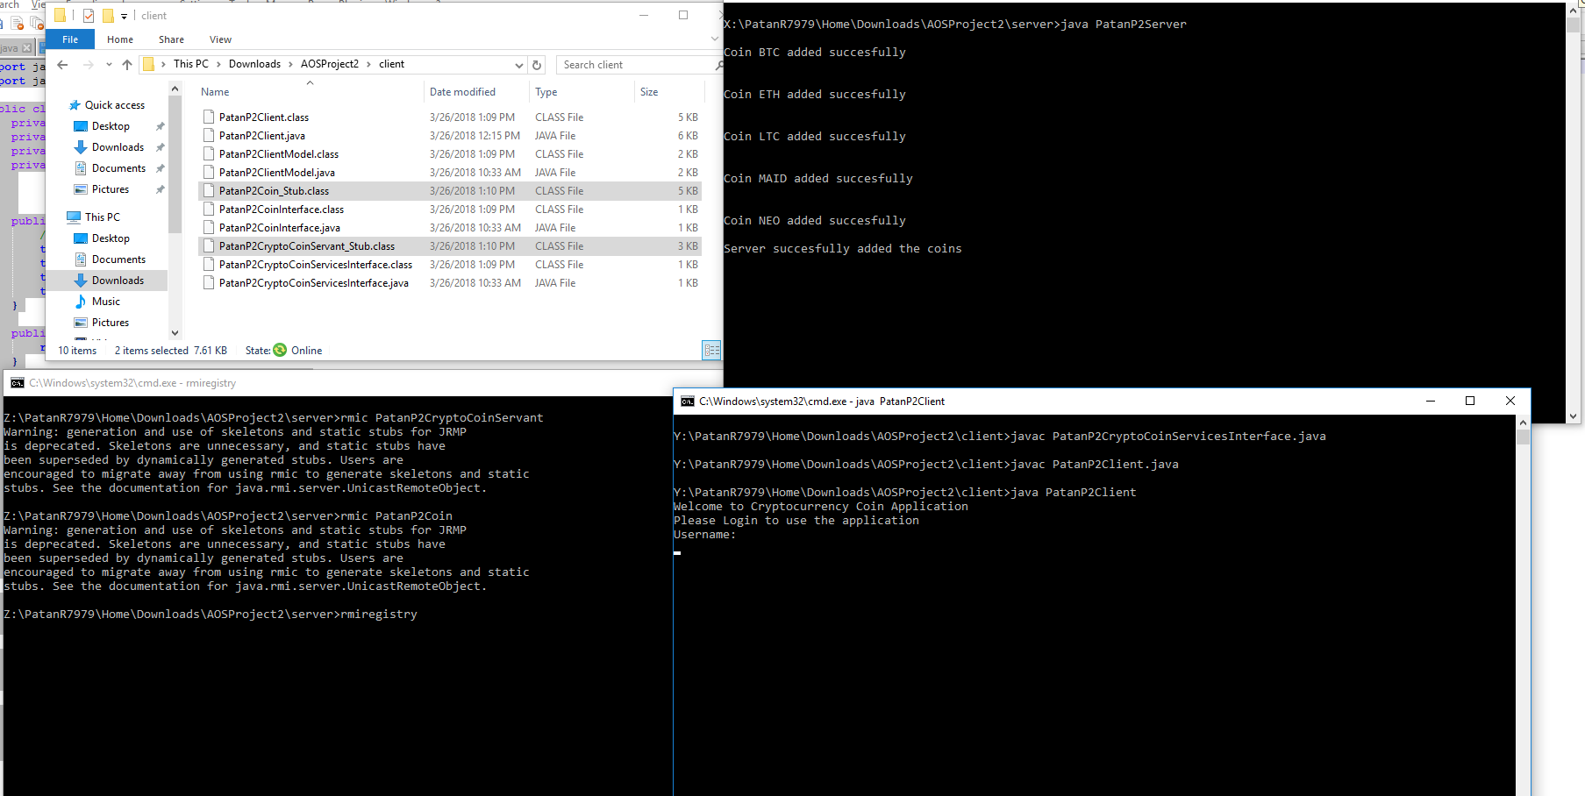

Client 1:

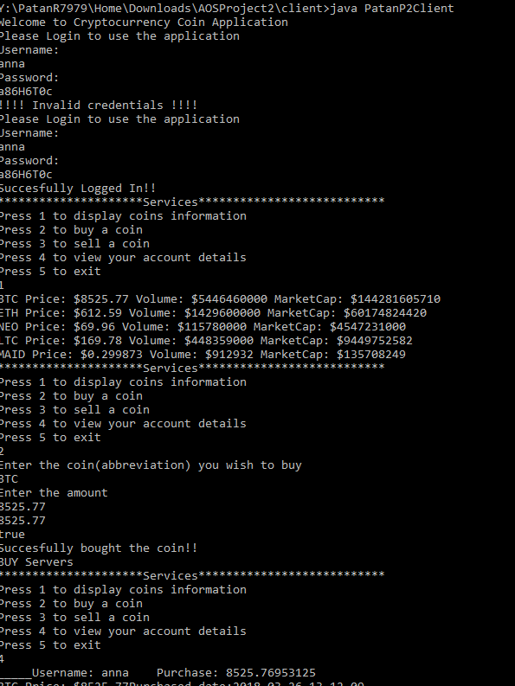

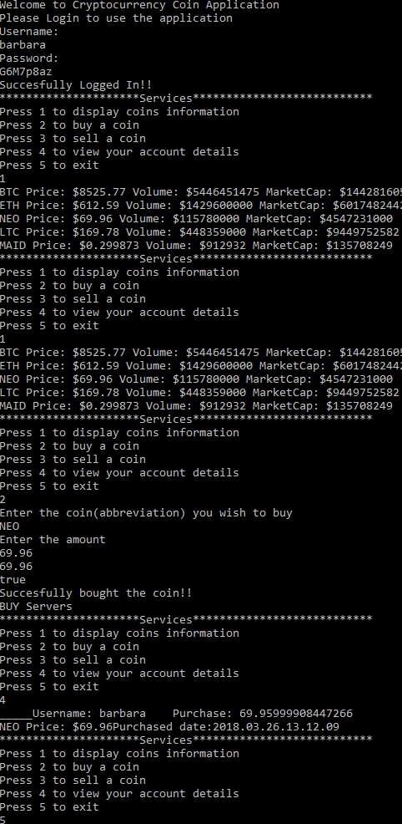Client 2:

Server:

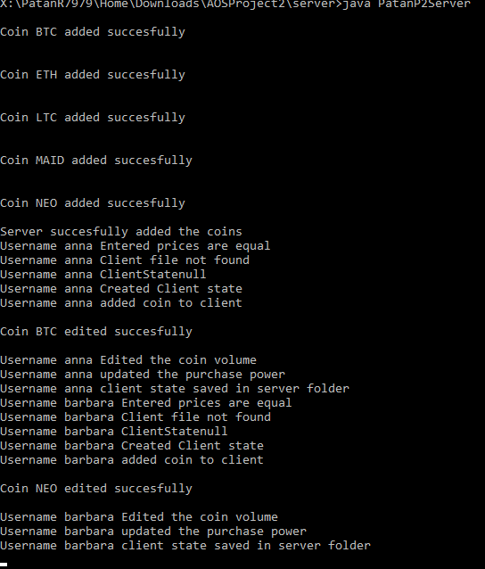

**Class Diagram:**

Remote

UnicastRemoteObject

PatanP2CoinInterface

* String Name
* String Abbreviatedname
* Float Price
* Float Volume
* MarketCap

PatanP2Coin

Serializable

PatanP2Coin(…) throws Remote Exception

* String ClientID
* Float purchasepower
* ArrayList coins

PatanP2ClientModel

PatanP2CryptoCoinServant

-Map<> coins

-Map<> userlist

creates

Addcoin(..), removeCoin(), unbinder(…), storeclientstate()

PatanP2Server

Createcoins()

Main()

PatanP2CryptoCoinServicesInterface

Synchronized Buy(….)

Synchronized Sell(….)

Authenticatecheck(..)

GetClientState(..)

Interacts

UnicastRemoteObject

PatanP2Client

Main()

Remote

**Flow Chart:**



**RMI**



Creates Coin

Accepts username, password



Binds servant object to url

Looks for servant reference in rmi





Binds Coins objects to url



1. Coins
2. Buy
3. Sell
4. getState
5. exit

Accepts input from user



Displays the coins data

 

Looks for Coin references in rmi



 

Uses buy() of servantInterface for trading operation

Looks for servant references in rmi

Accepts coin name and price





Accepts coin name and price

Uses sell() of servantInterface for trading operation

Looks for servant references in rmi





Displays client data

Looks for servant in rmi

Uses getClientState





Stores client state

Invalid Input