Abcdefghijklmnopqrstuvwxyz Abcdefghijklmnopqrstuvwxyz Abcdefghijklmnopqrstuvwxyz Abcdefghijklmnopqrstuvwxyz Abcdefghijklmnopqrstuvwxyz Abcdefghijklmnopqrstuvwxyz Abcdefghijklmnopqrstuvwxyz Abcdefghijklmnopqrstuvwxyz Abcdefghijklmnopqrstuvwxyz Abcdefghijklmnopqrstuvwxyz Abcdefghijklmnopqrstuvwxyz Abcdefghijklmnopqrstuvwxyz Abcdefghijklmnopqrstuvwxyz Abcdefghijklmnopqrstuvwxyz Abcdefghijklmnopqrstuvwxyz Abcdefghijklmnopqrstuvwxyz Abcdefghijklmnopqrstuvwxyz Abcdefghijklmnopqrstuvwxyz Abcdefghijklmnopqrstuvwxyz Abcdefghijklmnopqrstuvwxyz Abcdefghijklmnopqrstuvwxyz Abcdefghijklmnopqrstuvwxyz Abcdefghijklmnopqrstuvwxyz Abcdefghijklmnopqrstuvwxyz Abcdefghijklmnopqrstuvwxyz Abcdefghijklmnopqrstuvwxyz Abcdefghijklmnopqrstuvwxyz Abcdefghijklmnopqrstuvwxyz Abcdefghijklmnopqrstuvwxyz Abcdefghijklmnopqrstuvwxyz Abcdefghijklmnopqrstuvwxyz Abcdefghijklmnopqrstuvwxyz Abcdefghijklmnopqrstuvwxyz

Abcdefghijklmnopqrstuvwxyz Abcdefghijklmnopqrstuvwxyz Abcdefghijklmnopqrstuvwxyz Abcdefghijklmnopqrstuvwxyz Abcdefghijklmnopqrstuvwxyz Abcdefghijklmnopqrstuvwxyz Abcdefghijklmnopqrstuvwxyz Abcdefghijklmnopqrstuvwxyz Abcdefghijklmnopqrstuvwxyz Abcdefghijklmnopqrstuvwxyz Abcdefghijklmnopqrstuvwxyz Abcdefghijklmnopqrstuvwxyz Abcdefghijklmnopqrstuvwxyz Abcdefghijklmnopqrstuvwxyz Abcdefghijklmnopqrstuvwxyz Abcdefghijklmnopqrstuvwxyz Abcdefghijklmnopqrstuvwxyz Abcdefghijklmnopqrstuvwxyz Abcdefghijklmnopqrstuvwxyz Abcdefghijklmnopqrstuvwxyz Abcdefghijklmnopqrstuvwxyz Abcdefghijklmnopqrstuvwxyz Abcdefghijklmnopqrstuvwxyz Abcdefghijklmnopqrstuvwxyz Abcdefghijklmnopqrstuvwxyz Abcdefghijklmnopqrstuvwxyz Abcdefghijklmnopqrstuvwxyz

PATA MARTUA DOLI SIAHAAN

Asdasdas

Asdsadas

Dasd

Ad

Asd

Sa

Das

D

Sa

Das

Adasdsadsadsad

Wkwkwkwkwk

Anjay mabar

Da

Sadasdsadas

Das

Das

Dsa

Das

Asss

Sa

Dsa

Dsa

A

The last test

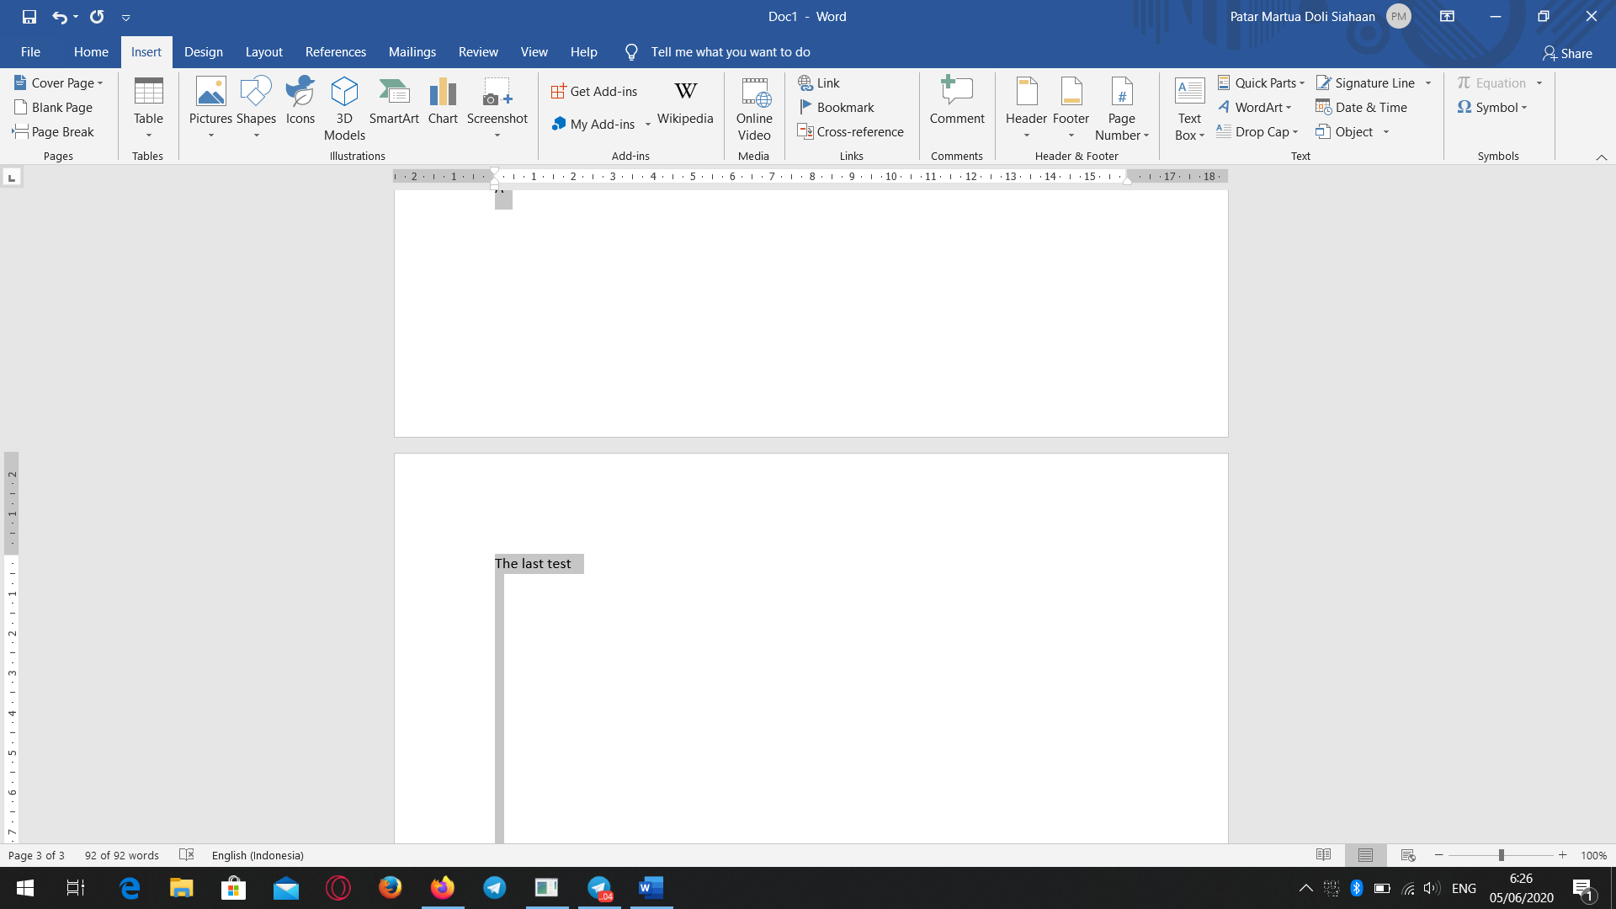

Image

Whwowoow

1. Asdsadsa
2. 2. Asdsadasda

## asdasdasdsadasdsa