COEN 122, 9:15, Quiz 2 Spring 2016 Student Name ________________

- (30 points) For the attached datapath, suppose the delay of adder, ALU, I-memory, Register file, and D-memory are 2 ns. Also assume the delay of the control is x ns. Other components have zero dealy.
- Express the execution times of R-type, lw, sw, beq, and jump as functions of x.
- What should be the cycle time when 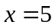?

- (50 points) We wish to add a new instruction beqM (branch when equal memory) to the single cycle datapath and control attached. The instruction beqM $2, $3, 400 does the following: PCmem[400] if $2=$3; otherwise, PCPC+4. The format is
beqM | 2(rs) | 3(rt) | 400

Add any necessary datapaths and control signals to the attached figure and define the control signals for beqM below:

Rgwrt | RgDst | Mem2Rg | ALUsrc | ALUop(2) | MRd | Mwrt | Brch | Jump

- (20 points) Assume we have two stuck-at-0 faults at MemtoReg and ALUsrc, i.e., MemtoReg =0 and ALUsrc=0 always. Which instructions, if any, would still work?

Solution Quiz 2 coen 122/9:15
1.
R: 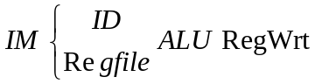, T(R)=2+max{2,x}+2+2=6+max{2,x}
lw: 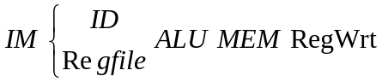, T(lw)=2+max{2,x}+2+2+2=8+max{2,x}
sw: 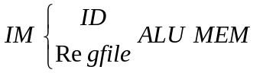, T(sw)=2+max{2,x}+2+2=6+max{2,x}
beq: 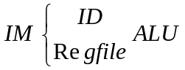, T(beq)=2+max{2,x}+2=4+max{2,x}
jump: , T(R)=2+x
when , cycle time = max{execution times}=13 ns.

Please note: there is only one cycle time that is equal to the maximum of these execution times.

2.

Rgwrt | RgDst | Mem2Rg | ALUsrc | ALUop(2) | MRd | Mwrt | Brch | Jump | beqM
0 | x | x | 0 | sub | 1 | 0 | 1 | 0 | 1

3. R, beq, jump will work.

