Matthew Koken

COEN 171

Homework 3

1) How does C++ support encapsulation?

C++ supports user created classes and data abstraction. Data can be hidden through being set as public, private, or protected.

2) What is the problem with multiple inheritance and how does C++ solve it?

With multiple inheritance, you may not be able to tell which class or function is being referenced when multiple implementations are available. Ambiguities are solved by namespaces or using explicit qualification. The class should be specified when called in order to disambiguate.

3) What does it mean to be a friend function?

The function is defined outside of the class. They specifically are not member functions. However, they behave like member functions in that they have access to private and protected variables.

4) Why do we use namespace in C++?

Namespaces allow for disambiguation. Multiple classes with the same name may be defined, and using a namespace will specify which implementation is intended. It also defines the scope for the contained code.

5) How are parameters passed into a function in C++?

Parameters are passed by value – the value is copied into memory for the function. It can also be passed by reference – the memory reference is passed and allows for direct access to the variable through its memory location.

6) Why is C++ not considered pure OOP?

Not everything in C++ is a class. Code can be written without a class implementation – as one would do in C, with no objects. It supports many paradigms, so it cannot be purely OOP.

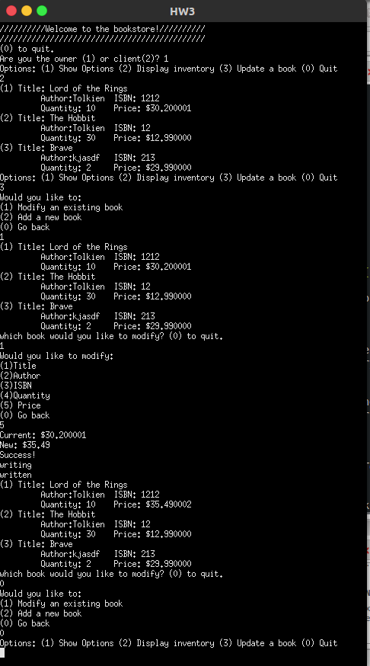

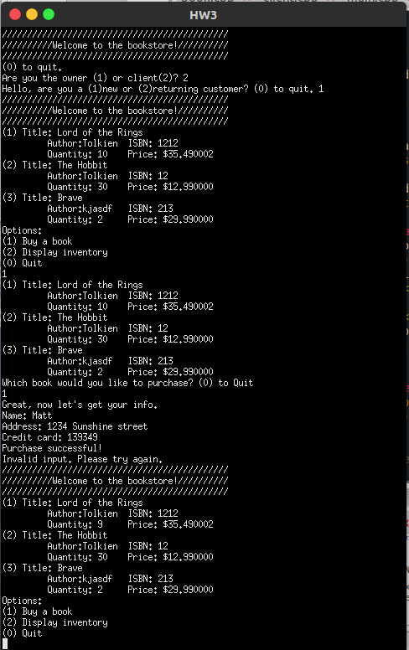

Valgrind results: no memory leaks

