Matthew Koken

COEN 171 Programming Languages

Homework 5

All questions answered using swi-prolog on 15.10

1. Write a Prolog program to check whether a word is a palindrome, and write a program to ask you for words and tell you if your input is palindromic.

palindrome :- write("Word: "),

read(Word),

name(Word, WordList),

reverse(WordList, WordList). %check if the reversed version is the same

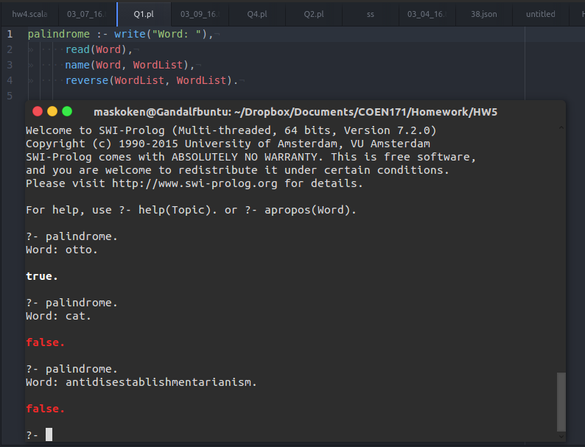

2. Write a Prolog program that finds the max of a list

find_max(List, Max) :-  
 select(Max, List, Tail), \+ (member(Element, Tail), Element > Max).

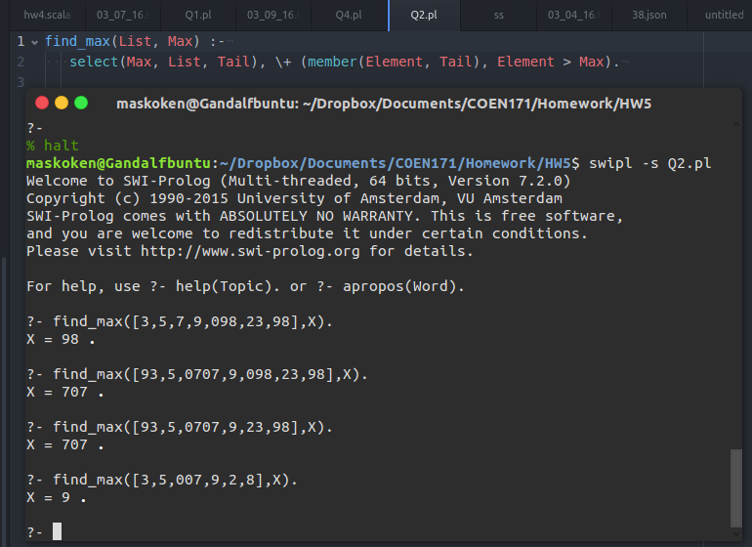

3. Write a Prolog program that returns the last element of a list

%move through rest until there is only the last

last([List|Rest], Last) :- last_(Rest, List, Last).  
 last_([], Last, Last).  
 last_([List|Rest], _, Last) :- last_(Rest, List, Last).

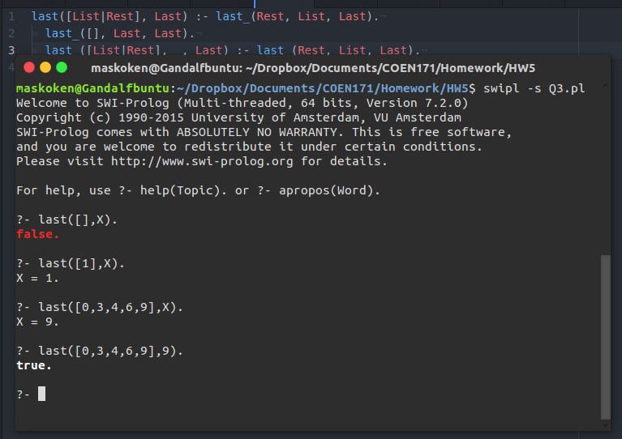

4. Write a Prolog program that implements insertion sort

insertionSort(List, SortedList) :-

iSort(List, [], SortedList).

iSort([], Accumulator, Accumulator).

iSort([Head | Tail], Accumulator, SortedList) :-

insert(Head, Accumulator, NewAccumulator),

iSort(Tail, NewAccumulator, SortedList).

insert(Elem, [Head | Tail], [Head | NewTail]) :-

Elem @> Head,

insert(Elem, Tail, NewTail).

insert(Elem, [Head | Tail], [Elem, Head | Tail]) :-

Elem @=< Head.

insert(Elem, [] , [Elem])

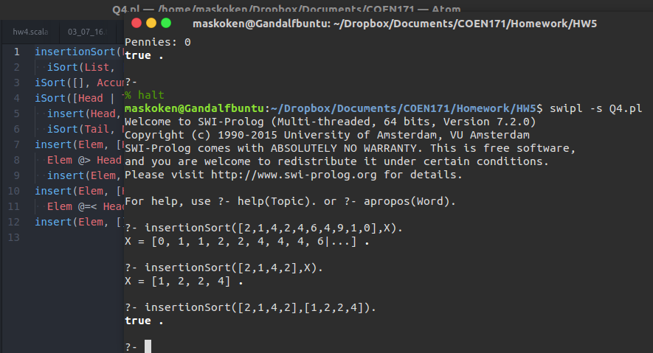

5. Write a Prolog program that checks or generates change adding up to a dollar consisting of half-dollars, quarters, dimes, nickels, and pennies

%price given in cents to keep with integers → prolog doesn't like float that much

change(Price, Paid, [HalfDollar,Quarter,Dime,Nickel,Penny]):-

member(HalfDollar,[0,1,2]),

member(Quarter,[0,1]),

member(Dime,[0,1,2]),

member(Nickel,[0,1]),

member(Penny,[0,1,2,3,4]),

Sum is 50*HalfDollar + 25*Quarter + 10*Dime + 5*Nickel,

Sum =< Paid-Price,

Penny is (Paid - Price) - Sum,

write("HalfDollars: "),write(HalfDollar),

write("\nQuarters: "),write(Quarter),

write("\nDimes: "),write(Dime),

write("\nNickels: "),write(Nickel),

write("\nPennies: "),write(Penny).

%want to use as many of the largest coins as possible

