**Pulsetool Demo: Calibrating RF Pulse Amplitude and BW**

1. Download the pulsetool.zip file, expand, open Matlab and change to the directory containing “pulsetool.m”. Run pulsetool
2. Press the **Load** button, navigate to the pulseshapes folder, open the file sinc3_201.RF. The RF pulse shape is displayed.
3. Set the pulse duration Tp to 5ms, b1max to 100 Hz, simulation BW to 2000Hz, and press **Simulate**. This will produce a plot of Mxy and Mz as a function of off-resonance values.
4. Find the RF pulse amplitude that produces a 90° flip on resonance. The RF pulse amplitude is shown in the gui as b1max (Hz), but this is technically gamma-bar B1max. This means Mxy at offset frequency = 0 should be 1, and likewise Mz = 0. Here are three ways to calibrate it:
   1. Trial and error. Keep changing b1max in small increments and re-simulate until you reach the desired flip.
   2. Start with a small flip (try ~20Hz). Measure the magnitude of Mxy on resonance, graphically. This magnitude is the sin() of the flip angle, which scales linearly with b1max.
   3. Press the **Calc Flip Angle** button and read the output. This method compares the integral of the RF pulse shape to a square pulse and calculates the flip on-resonance. This is not generally correct for frequency-modulated RF pulses.
5. Now graphically measure the bandwidth of the RF pulse. For an excitation of 90°, the most common definition of bandwidth is the full-width-half-max of Mxy. Use Matlab datatips to measure directly from the plot. In the example below, I measure the FWHM to be ~800Hz. If you want higher precision, interpolate, or simulate with more offset steps.

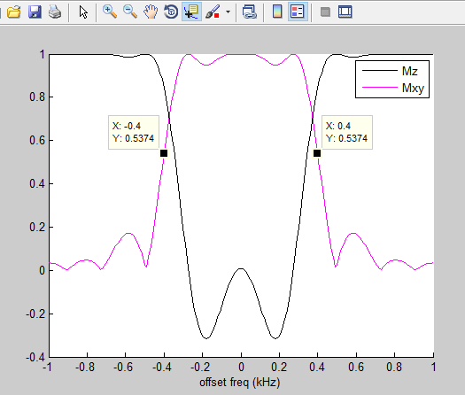 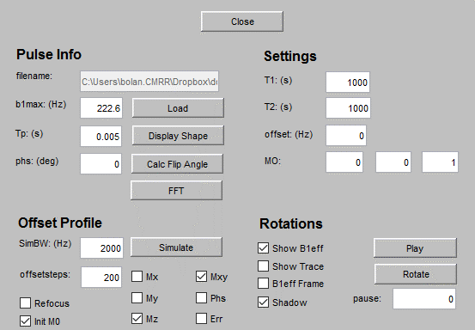

The controls mentioned above are circled in **red**. Feel free to explore the other controls.