**This is in process and changes repeatedly and quickly!**

**eCrime Taxonomy from Laws --> Technology**

**early to mid, 2012**

**The Rationale, or at least an Idea**

After considerable discussion (and beer) a different way to approach the issue was born. It sounds much easier to re-educate the technology professionals ('techies') than the legal professionals ('legal professionals') so this version starts by identifying the broad categories of crime via law. Those that would apply to Internet activity are noted, and are dissected and classified until the actual internet activity that violates that law is identified. For example, we would start with 'fraud' then dissect it onto the major categories of fraud, and eventually end up at 'phishing'. The hope is that by following the legal trail instead of the techie trail the end result will be more law-enforcement appropriate.

**The top-level crime definitions**

To generate a classification, we need to have top-level classes to split up. Although others have suggessted that a bottom up approach may work, this chart goes top-down. This is our cut of the major 'crime classes'. Note that we're not differentiating between electronic crime and traditional crime as we're just trying to figure out the major grouping.

Our crime classes (from answers.com):

1. Offenses against the public peace and order, such as treason, rioting, and any obstruction of the officers of the law. Offenses against the government are included in this category.

2. Offenses against the public health and morals, such as bigamy, the non medical sale of narcotics, or the pollution of public water supplies.

3. Offenses against the person, such as murder, manslaughter, or assault.

4. Offenses against property, including burglary, theft, fraud, and so on.

**The crime hierarchy visualization**

A mindmap was generated to help visualize the dissections. It is below. [Input welcome.] The crimes not expected to be seen on the Internet (e.g., murder) are in blue. They are listed for completeness.

Last modified: 10-July-2012

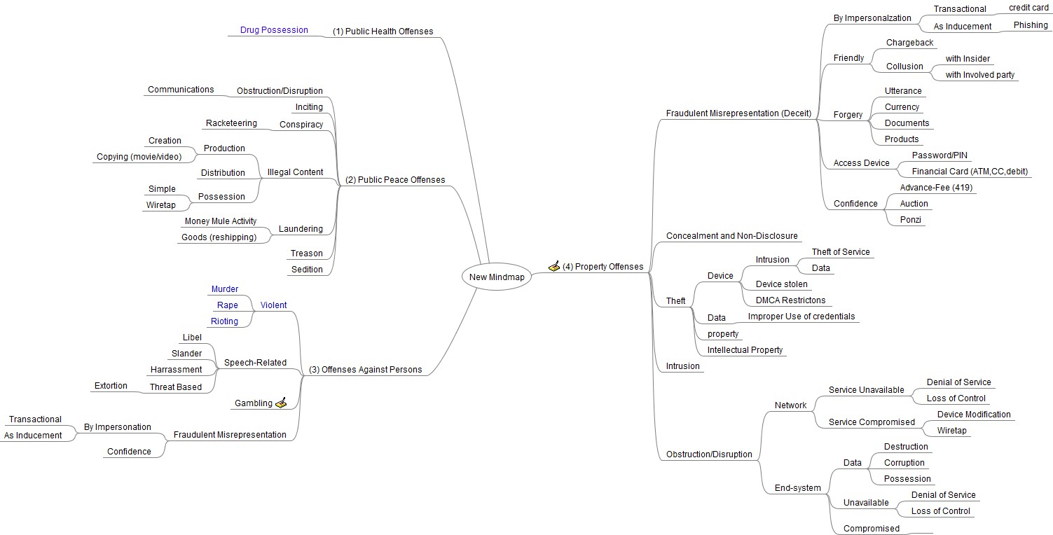

**The Next Great Step**

**Break down the four categories further**

Each of the four major categories has been subdivided (as shown in the mindmap above) into broad "offenses". Each of those offenses requires more subdivision. To minimize confusion, they were given their own space to enjoy:

[Offenses against the public peace and order](https://repoman.apwg.org/research/wiki/crimetype1)

[Offenses against the public health and morals](https://repoman.apwg.org/research/wiki/crimetype2)

Offenses against the person?

Offenses against property?

Develop definitions for each level of the map. [In process]

**References**

[[1]](https://repoman.apwg.org/research/changeset/1/forms) - The Restatement (Second) of Torts (1965)

[2] - Fraud can be perpetrated against persons or objects so is included multiple times.