Using the 100-1003 Vocal Filter
Revised May 17, 2003
Updated September 19, 2005

It should be noted, that due to the fact that the CA3280E is no longer made, I have lost interest in any commercial viability that this board may have had…so it is now in the Public Domain, and everything thing about it the user may do with as they please. I request that this file remain with the distribution.

Jim Patchell- September 19, 2005

I. Construction

Before you begin to build you board, please note that some of the values on the silkscreen are different from what they should be. Consult the below tables for a list of changes.

REV NC Board  Reference Designator | Silkscreen Value | Real Value
R128 | 200 | 270
R174 | 200 | 270
R220 | 200 | 270
R253 | 100K | 390K
R257 | 100K | 390K
R290 | 100K | 390K
R294 | 100K | 390K
R327 | 100K | 390K
R331 | 100K | 390K

My recommendation for solder is Kester 331 Organic Fluxcore solder. However, any high quality rosin core flux is also suitable. The advantage of the Kester 331 is that you can clean the board up with warm water. Just keep in mind that Kester 331 is a MUST clean flux. You should not even leave it overnight as the next day will be too late, and you could have significant corrosion take place. I generally mount most of the components in the board and solder them in the same sitting. Whether the board is finished or not, it gets cleaned when I am done for the day.

If you use Rosin core flux, it will be up to you to decide whether or not to clean it and with what. I just don’t like the nasty chemicals you have to use to do this.

Now, one thing to keep in mind, when you are wiring up the front panel, NEVER use Kester 331. The 331 flux will wick up between the insulation and wire where you cannot clean it, and eventually, the wire will fain due to corrosion. Use only a high quality Rosin Core or No Clean Flux on front panel wiring.

Before you being to build the board, you will need to decide just how much of the board you wish to build. For instance, there are three control voltage shapers on the board with four breakpoints each. I have found, in general, two break points to be adequate, and you can save a bit of panel space (this eliminates a total of 12 pots). You can determine which parts to leave off the board and thus save a bit on construction.

Also, there are 106 bypass caps on the board. You could probably leave some of them out, but, you are on your own if you do this. I prefer to have one bypass cap for every supply pin where practical.

Also, there are 9 CA3280’s on the board. While most parts are available from Mouser or Digikey, you will have to hunt around a bit for the CA3280’s. I do offer these for sale with the board. See the web page for the Vocal Filter Board for details.

It should also be noted that as of the date that this document was published, there were no circuit errors known on the board. Although, as noted above, there are some component value errors in the silkscreen. What this means is that at the moment there are no cuts or jumpers.

Transistor Matching

I use 2n3906 transistors for the exponential pairs. You should try to match these and then epoxy them together in pair. The PC board is laid out so that you can glue the flat sides together and insert them into the board. You do need to be careful when doing this, however.

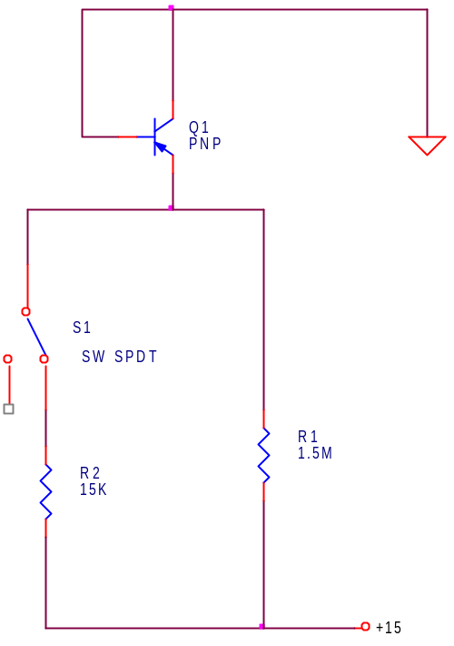
This is the circuit I use for matching transistors. Q1 is the device under test. I generally build this up on a solderless breadboard strip. Several things to keep in mind, do not handle the transistors with your fingers. The heat from your fingers will throw off the measurements. Remember, you get about 2 mV/ºC and it doesn’t take a whole lot to mess things up. Also, try to do this while the temperature is not changing much, like early evening. Also, I recommend the use of a 4 ½ digit voltmeter if you have one, however, a 3 ½ will work as well.

To make the measurements, connect the voltmeter between ground and the emitter of the transistor. You should get about -.6 volts when the 15K resistor is switched in, and less voltage when the 15K resistor is switched out. Record these voltages for each switch position for each transistor. When you are all done with a batch, you can then match up the closest candidates. What you are doing is basically matching the transistors at both high and low current. You need to match them to about 2 mV at both settings.

If you can’t find matches for a few of your candidates, you might as well throw the data away, because the next time you take data, your test conditions will be different and the old data will be meaningless.

Construction Options

1. Voltage Reference.

The schematic shows an LM336 2.5 volt reference being used (U2). You also have the option of using the LM4041-ADJ reference, which is actually the one I prefer to use. It can be substituted quite easily and the schematic would look like this:

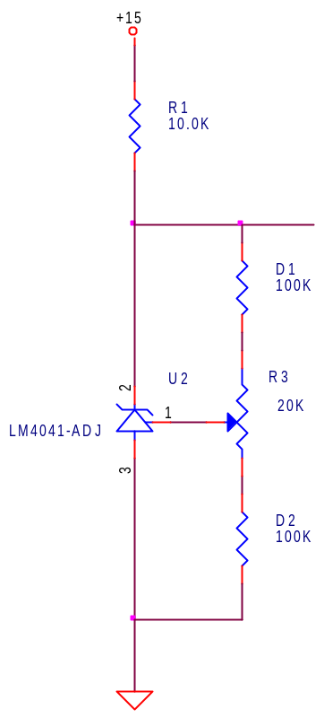
Figure 1
The LM4041-ADJ will fit exactly in the same place as the LM336 (i.e. same pin out). You do need to change the two diodes, D1 and D2 to resistors of 100K. You will still need to adjust the reference to get the + 10 volt reference to be 10.00 volts.

2. Clipping Diodes

In the voltage controlled filter sections there are a pair of 1N751 (5.1V) Zener diodes which will limit the signal swing (D21, D22 and D24, D25 and D27, D28). This is helpful, sometimes, at high resonance to keep the filter from saturating, however, this will also affect the way the filter sounds. You may, for instance, want to leave these diodes out. You may also want to change their voltage. However, going higher than 10V (1N758 or 1N5240) will pretty much be like leaving them out. You will have to judge which way sounds best to you. These diodes will have a major affect on the sound of the filter.

3. Diode Wave Shapers

There are three sets of diode wave shapers. These are what are used to control the vowel that is created by any particular control voltage. Each shaper has four breakpoints. You may feel that you don’t need or want four break points, so it is possible to eliminate two of them quite easily.

If you leave out U45, U46, U50, U51 , U55, U56 and their associated components you will have three shapers with two breakpoints each. This will save a bit of space of the front panel as well (a total of 12 pots). Each shaper section will still have 6 pots (4 for the break points, plus an offset and gain pot).

4. Front Panel

Refer to the front panel drawing and the front panel schematic, found else where in this document. One thing you will note is that the suggested front panel drawing below does not match the front panel schematic found else where. The front panel schematic reflects every possible thing you can do with the board, while the front panel drawing reflects what there is room for on the panel. As noted earlier, there are even other things you could eliminate as well, but, this is what I actually have on my front panel, and it seems to be more than adequate.

The solid black dots are knobs, the hollow circles are jacks. The jacks labeled shaper out goes into the corresponding frequency control input. I actually have the output of the shaper jack wired into the input switch of the jack, just to save three patch cords. This allows me, if I want to, to take the shaper output, process it further, and then return it back to the filter.

The Vowel ATN, Freq ATN and Resonance ATN knobs are connected to the appropriate input jacks so that the control signal can be attenuated. I use 100K pots for the attenuators, and 10K pots for the ones that just send control voltages to their inputs on the card.

The reason there is only one frequency control jack was because I didn’t put enough inputs on the card…dang it all. However, one master frequency CV input should be more than plenty.

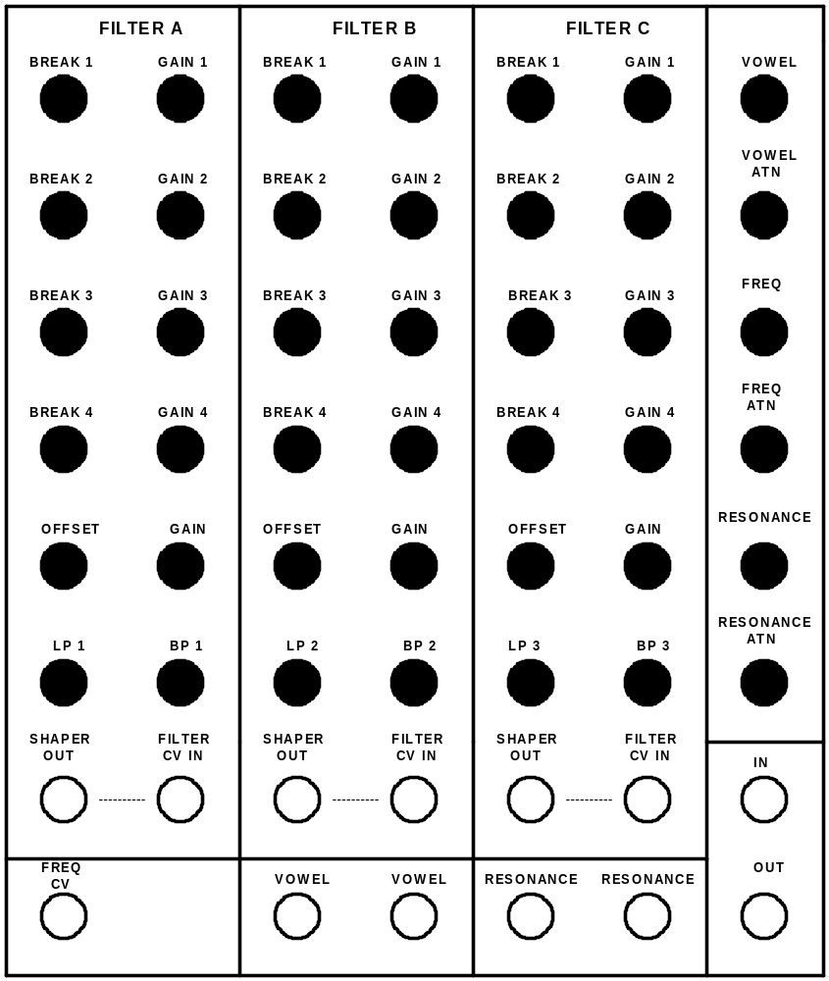

Theory of Operation

If you happen to have Electronotes, there is a fairly nice article on this type of filter in there. I wish I had had that article, as I would have made some minor changes to the features of this board, however, if you have a modular synthesizer, you can accomplish the same thing quite easily by using the vocal filter in conjunction with other modules. Electronotes 102, June 1979 has an article on what it calls a “Vocal Effects Waveform Animator”. Good reading and it may give you some ideas on additions you may want to make.

However, what this filter attempts to do is recreate the resonance’s that are present in the human vocal tract that allows us to produce vowel sounds. There are four significant resonance’s in the vocal tract, which can be controlled by how we shape our mouth, tongue, etc. To accomplish this electronically, we must use a voltage controlled filter. Four filters would have been a bit on the overkill side, and also much more expensive. Three seems like a good number, and that is what I use.

To control the vowels each filter has a wave shaper that is used to contour the control voltage. You can select resonant frequencies from a chart that shows the resonance’s for each vowel and use the wave shapers to put out the voltages necessary to create a series of vowels for a particular series of voltages. Or, you can do what I do, just mess with the knobs until you get something that sounds cool.

You are probably not going to get anything that sounds like human speech. If you want that, you need a vocoder. However, this module can make some very expressive sounds.

Circuit Equations you probably need to know

The following equations are going to refer to the schematic for Voltage Controlled Filter 1, which is on sheet 9 of the current version of the schematic (March 31, 2003).

Filter Scale

The filter scale mostly depends upon the gain of U20B. The exact gain of U20B is going to be a little difficult to determine because there is a parameter that we have little control over that determines the gain, but, we can get within the ball park. Why this is so will be discussed a bit later.

The gain of U20B is controlled by two different things, I_{ABC} and I_{D}. IABC is by far the easiest to deal with, so we will do that one first.

I_{ABC} = -(R138/(R141+R140)) * (V_{REF}/R145)

If you substitute in values, and for the sake of argument, the value of R141+R140 is about 100K, if you consider that the pot is in the center of travel, and keep in mind that VREF = -10Volts.

I_{ABC} = -(100K/100K) * (-10V/10K) = 1mA

Now, ID, on the other hand, is a bit more troublesome.

I_{D} = -(V_{BEQ6} / R121) * (R120/R128)

R120 = R128, and R121 = 620 ohms, so the above equation simplifies to

I_{D} = -V_{BEQ6}/620

Now, as you notice, there is a VBEQ6 term in there, so all we need to do is put in the value for VBEQ6. Well, it isn’t that easy. This value is not very determinate.

I_{C} = I_{S} * e^{Q*VBE/K*T}

We can assume that Q/KT = 1/0.026 at room temperature, IC will be 1V/R123 = 1/2.2M = .45uA. So, now we have:

0.45E-6 = I_{S} * e^{VBE/0.026}

Now, if we rearrange thing just a bit.

0.45E-6/I_{S} = e^{VBE/0.026}

Now, take the natural log of both sides

ln(0.45E-6/I_{S}) = V_{BE}/0.026

V_{BE} = 0.026 * ln(0.45E-6/I_{S})

So, now to find VBE, we only need to know what IS is. Well, this is a problem. IS is not a very well controlled parameter, plus, it doubles every 10 degrees Celsius. The value of IS is typically 10⁻¹⁴. From this we determine that VBE can be about 0.46 volts. Since the transistor in question is a PNP, this will actually be -0.46 volts. So, now we can use the above equation for ID.

I_{D} = 0.46/620 = 740uA

Now we can look at the OTA. The gain of the OTA will be:

I_{O} = V_{IN} * G_{M} * (R_{D}/2)/(R125+(R_{D}/2))

Where R_{D} is the small signal resistance of the linearization diode, and GM is the transconductance of the OTA. The RD/2 comes about because of the input structure. (Note, this may be incorrect, this was determined empirically).

From the Intersil data sheet for the CA3280 we get the equation for the small signal resistance of the linearization diode.

RD = .07/ID

And from the Secrets of OTA paper, we get the equation for GM.

GM = 19.2 * I_{ABC}

However, there is a fly in the ointment with the above equation. The CA3280 does not seem to follow this. According to the Data sheet, GM at IABC=1mA is actually 16mMHO, and not 19.2mMHO. I checked this empirically and indeed, the transconductance appears to be what it says in the data sheet. So, this will have to be verified at a later date as well.

So, now we combine all of this stuff we get the following.

I_{O} = V_{IN} * 0.016 * 94.6/20000 = V_{IN} * 0.000076

Using the above equation, the nominal resistance for R128 would be 240 ohms. Again, empirically, I have found that 270 is a better value.

USING the DIODE CONTROL VOLTAGE SHAPERS

Well, this is a dicey subject. Of all the things you need to do to use this module is learning how to deal with the control voltage shapers. Look at figure 2 below, which shows a typical layout for the front panel for one of the three shapers.

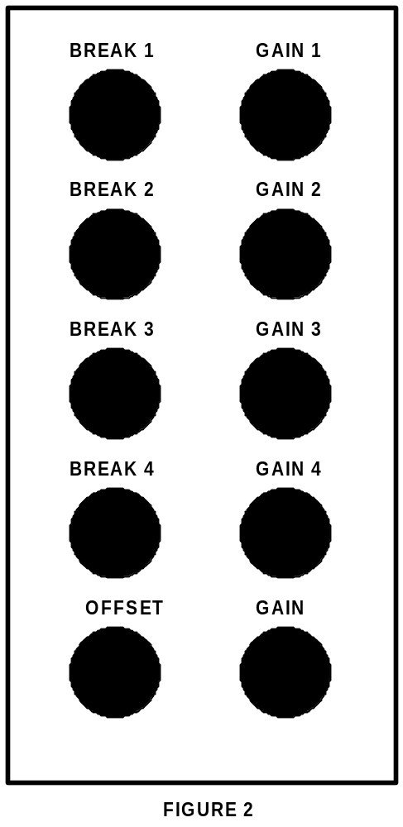
So, you can see the four break points and the four gain pots for each break point. If we just consider a single breakpoint, if we were to plot Vout vs Vin, we will get something that looks like figure 3. Changing the break point control will change the voltage where the transfer function breaks. Changing the gain control, changes how the voltage changes. Figure 3 shows what happens when the gain is positive.

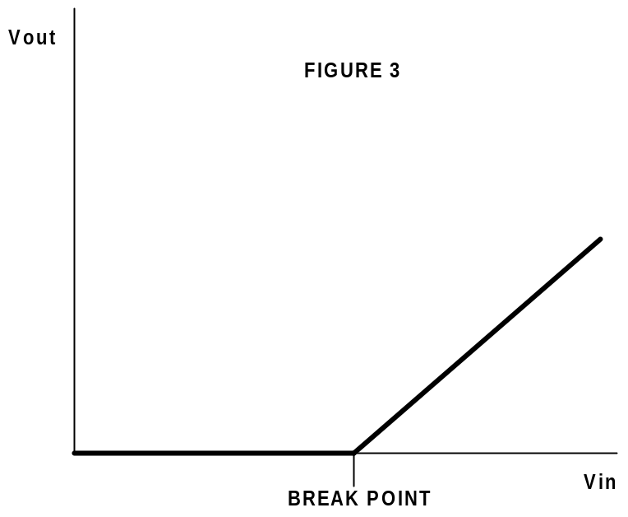

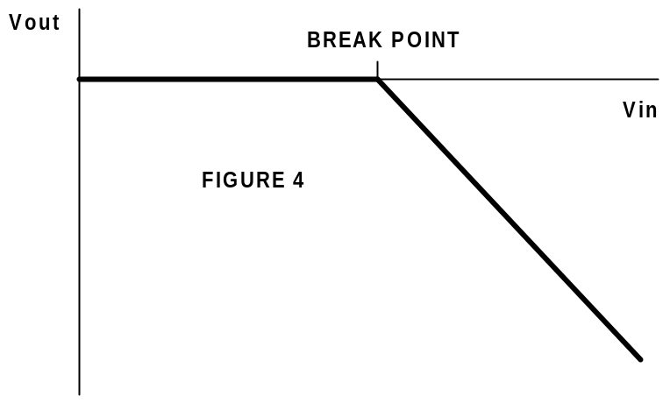
Figure 4 shows what the transfer function would look like if the gain was negative. If the gain was zero, the line would be flat, or 0 for all Vin.

Now, lets take a look at what happens when we combine two break points.

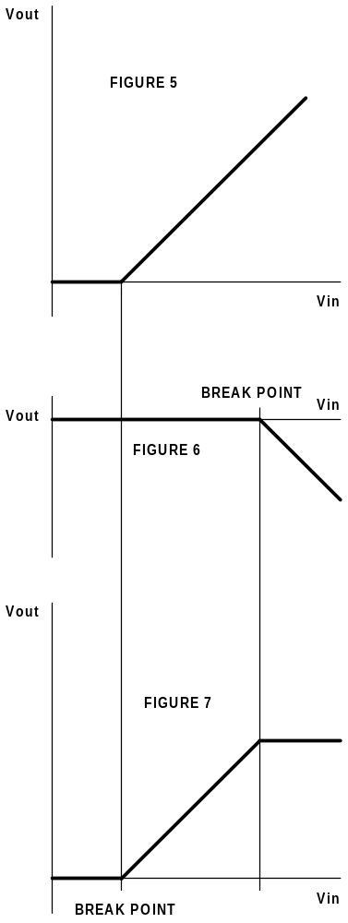
So, let us say we set BREAK1 and GAIN 1 to look like figure 5, and we set BREAK2 and GAIN2 to look like figure 6. In the actual electronics, you can not actually look at the transfer functions of individual break points, since they all get summed together before the go to the output. But knowing what is going on will help you understand what you are seeing when you look at it.

One thing we will assume is that GAIN2 is set equal and opposite to GAIN1, or, in other words, GAIN2 = - GAIN1. When you sum these two transfer functions together, the result you get is in Figure 7.

If you were to increase GAIN2 so that GAIN2 = - 2 * GAIN1, you would then see Vout decrease at the rate of –GAIN1 after the second break point.

Now, if you were in addition also have BREAK3 and BREAK4 in the mix, you can see you could begin to have some rather complex transfer functions.

Now it is time to discuss the bottom two controls, GAIN and OFFSET. These two controls are just your ordinary gain and offset controls and are quite simple, but allow you to add additional complexity to the transfer functions.

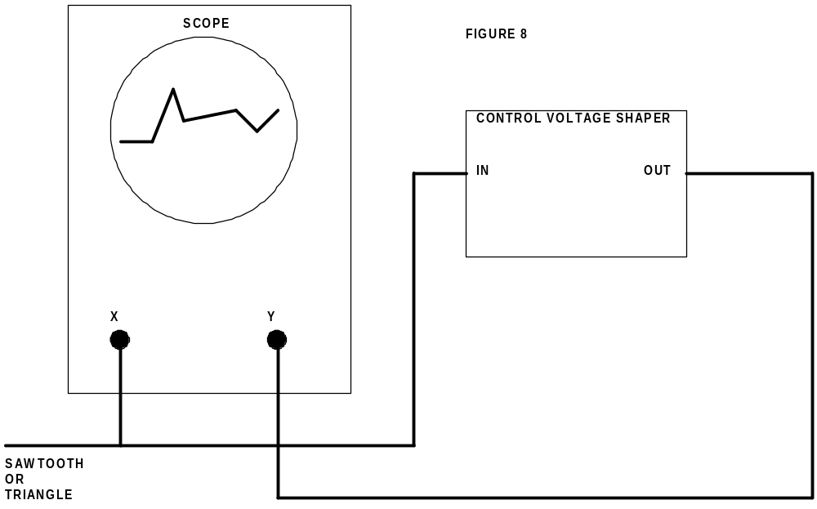

It is possible to actually see these transfer functions. If you have an oscilloscope that is capable of doing an X-Y plot, you can easily see what is going on. Consult the manual for your oscilloscope for detail on how to set your scope up. They are all different. You can use either a sawtooth or triangle wave form. It is probably best to use a wave form that goes from 0 to +10 volts if you can. Using the scope like this is highly recommended until you get the hang of the thing. I can now pretty much set it up by using my ear, although, if I was trying to do something very specific, I would probably go back to using the scope. You can also use this same technique for seeing the transfer function of a lot of other circuits.

