SIDsuite
A collection of tools for monitoring and analysis of Sudden Ionospheric Disturbances
Introduction
A collection of tools, known as SIDsuite has been developed as an open-source toolkit for monitoring and simple analysis of Sudden Ionospheric Disturbances, using simple VLF (Very Low Frequency) receiving techniques.
By receiving signals from distant, high-power transmitters that operate in the VLF spectrum, measurements can be made of the instantaneous apparent-reflectivity properties of the ionosphere on a path between the transmitter and our receiver. Propagation via the ionosphere is a distinctly variable phenomenon, with diurnal (daily) variation in apparent-reflectivity, and variability due to other effects such as lightning, gamma-ray bursts, and solar X-ray events.
Since the phenomenon may be conveniently studied at VLF frequencies, the equipment required is quite simple. A reasonably-modern PC, a sound card capable of sampling at rates of at least 96KHz, and a suitable antenna and possibly an amplifier.
Once the basic hardware is in place, a Software-Defined-Radio (SDR) approach may be used to build a quite sophisticated long-term monitoring capability.
The SIDsuite software is one such approach, based on the the open-source Gnu Radio SDR framework.
System Requirements
The SIDsuite software requires a reasonably-modern PC computer, with at least 2GB of memory, and preferably a fast single-core, or dual-core CPU of at least 2GHz clock speed.
The software is designed to run on a recent Linux distribution, and is known to work on recent Fedora and Ubuntu distributions.
A recent GIT image of Gnu Radio is required, and it should be built from source and installed.
A sound card that is ALSA compatible, and can sample at a minimum of 96KHz is required. Ideally, the system should have two sound cards of some sort. Often, an external USB sound system offers a lower noise floor. The Creative Soundblaster X-Fi USB sound module appears to work well with this software and has a good noise performance.
You may also need an amplifier between your magnetic-loop antenna, and the sound card. There are a number of designs for VLF amplifiers in existence, including the one used with the SuperSID hardware distributed by Stanford University and SARA. You might also consider getting a low-cost dynamic microphone preamplifier such as those used by musicians and audio technicians. They are typically very low noise, and have excellent frequency response, often exceeding 60KHz at the high end. The Behringer MIC800 is an economical example.
Installation
Once the Gnu Radio source tree has been built and installed, the sidsuite.tar.gz package should be unpacked, and then installed:

mkdir sidsuite
cd sidsuite
tar xf ../sidsuite.tar.gz
make -f Makefile.sidsuite install

The above “make” command will install all the individual components of SIDsuite into your $HOME/bin directory (it will create $HOME/bin if you don't already have one).
The sidstart command
The command that is used to start the monitoring application is called sidstart. Assuming that you've placed your $HOME/bin directory into your command search path, you can start up the monitoring application by simply typing sidstart at the command prompt.
The sidstart application takes several command-line parameters that are used to change various attributes from their defaults:
- -hw sets the ALSA-type name of the hardware used for signal input from the antenna.
        - This is often plughw:0,0 or plughw:1,0 the default is plughw:0,0
        - For arcane reasons, you must use the “plughw” format rather than “hw”
- -ohw sets ALSA-type name of the hardware used for audio output default is hw:1,0
- -srate sets the sampling rate, in Hz. This defaults to
- -hz sets the frequency used by your local power utility—used to program a comb filter.
        - Defaults to 60, but in other parts of the world, 50 should be used
- -integ sets the post-RMS-detector integration time, in seconds. Defaults to 5
- -ratio sets the ratio of baseband data that is recorded synoptically. Defaults to 10
- -gain sets the gain of the incoming baseband signal. Defaults to 1

Other non-option parameters given to sidstart are treated as frequency settings for each of the 6 channels supported by SIDsuite. The channel frequencies may be expressed either in straight Hz, or using scientific notation: 24000 and 24.0e3 can both be used and are equivalent.
Example:
sidstart -hw plughw:0,0 -ohw hw:1,0 -srate 96000 -hz 50 -integ 25 -ratio 40 -gain 1.0 24.0e3 25.2e3 24.8e3 40.80e3 19.80e3 21.4e3

Starts the main application using plughw:0,0 as the signal input device, hw:1,0 as the audio output device, using a sample rate of 96KHz. Clearly, this is not intended for North America, because the comb filter is set for a base frequency of 50Hz. Post-RMS-detector integration is set for 25 seconds, and the synoptic ratio is set to 40.
The first three channels are set for the U.S. NavyVLF stations, NAA (24.0KHz), NML (25.2KHz), and NLK (24.8KHz), and the three others at 10KHz, 12KHz and 14KHz.

Using the receiver application
When the receiver application is started, the main window looks like this:
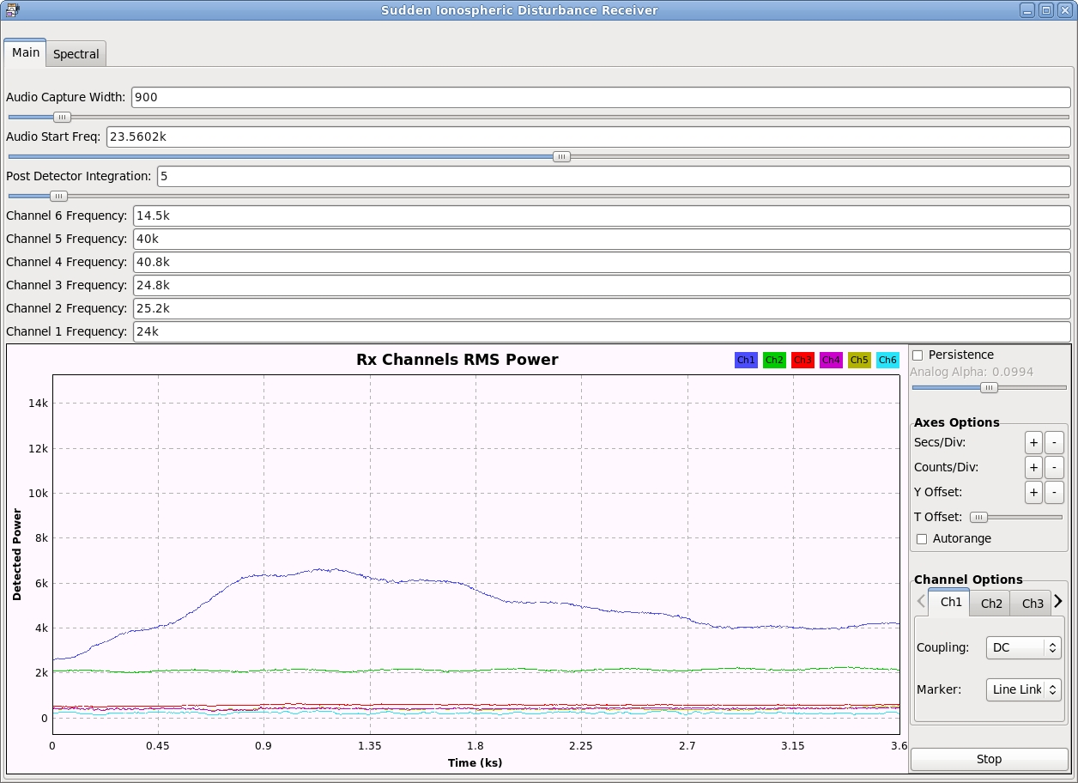

The main “Tab” in the interface shows a strip-chart of the 6 selected channels, giving the integrated RMS power for each channel in arbitrary units. The graph can be changed with respect to the Y axis, using the “Counts/Div” control and the “Y offset” control. Similarly, the “Secs/Div”control can be used to establish the timescale. By default a 1 hour “window” of integrated RMS power is shown.
The 6 channel frequencies may be set using the channel frequency controls, which are text entry boxes. The integration time may be adjusted using the Post Detector Integration slider control.
An arbitrary “chunk” of the incoming frequency may be copied the output audio device, using the Audio Start Freq and Audio Capture Width controls. This is useful to allow you to listen to a specific channel on the systems speakers.
The Spectral Window
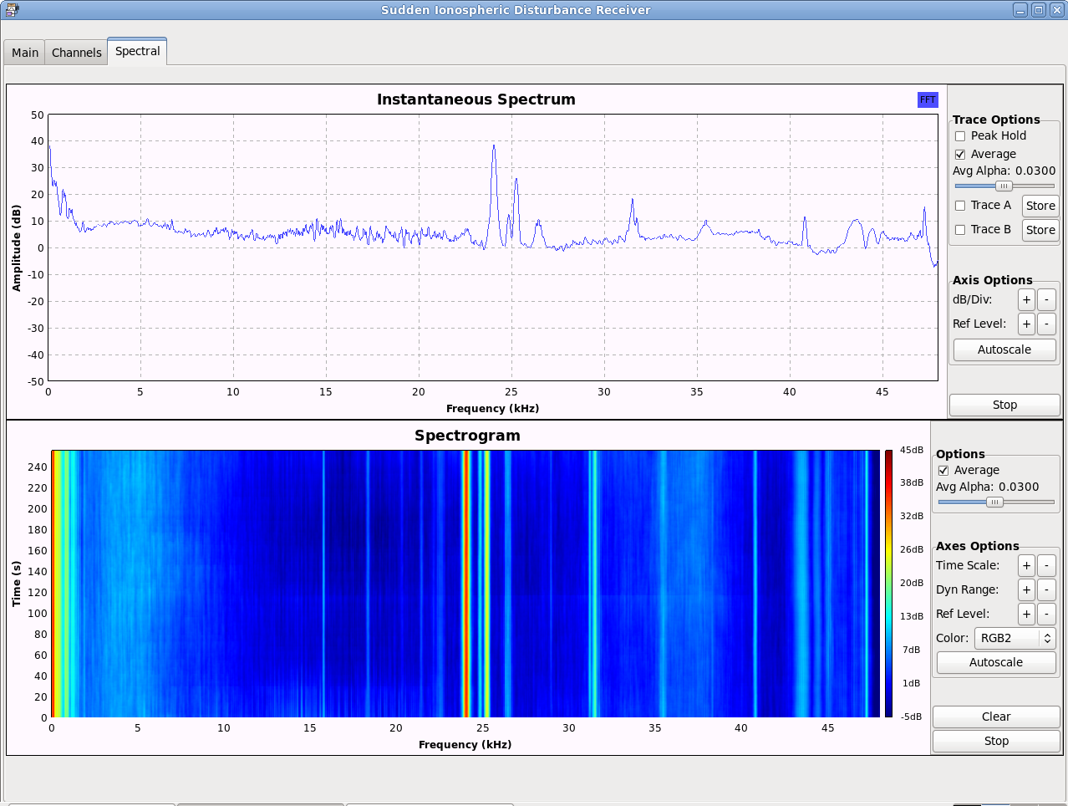
This window provides spectrum-related information over the entire baseband input signal, which for a sampling rate of 96KHz is the spectrum from DC to 48KHz.
It shows both “instantaneous” spectrum, and a spectrogram that shows the spectrum over a given time period, with magnitudes represented using a colour scale. Such a display is often referred to as a “Waterfall”, because of its visual appearance under some circumstances.
By default, averaging is turned on, and the so-called “Alpha” value can be manipulated to change the time constant of the averaging function.
Data files
When sidstart is first used, it creates a directory for maintaining data logs under your home directory, called $HOME/sid_data. This is where all data are logged, and organized according to UTC date and time.
Two types of files are created in this directory:
- chanN-YYYYMMDD.dat
- synoptic-YYYYMMDD.dat
The channel RMS-power data are logged in the chanN files, where N varies from 1 to 6. The given YYYYMMDD is a UTC date. Data in these files are logged at a rate of 8Hz, allowing for very high temporal resolution analysis of the data after it has been collected.
Channel data format
The data in the chanN-YYYYMMDD.dat files are formatted as regular text files with two fields:
- The UNIX-epoch time, in seconds since midnight, January 1st, 1970 as a decimal integer
  - This facilitates easy date processing with Gnuplot, which is used to produce graphs within the SIDsuite.
- The integrated RMS power value, in arbitrary units as a floating-point decimal number
The application automatically creates a new file when the UTC date changes.
Synoptic data format
The synoptic data are a representation of the raw base-band data coming from the sound card input, sampled at the input sample rate (typically 96KHz). The data are raw floating-point complex numbers in binary.
Synoptic data are sampled in two-second blocks, with a ratio of “logged vs not-logged” set by the synoptic ratio given on the command-line to sidstart which defaults to 10. What this means is that for every N two-second vectors of base-band data, only one in N of those vectors are actually logged.
Setting the synoptic ratio to lower values increases the rate at which synoptic data blocks are logged to disk, but increases the rate at which disk space is consumed to hold those blocks.
The synoptic data provides a mechanism for conducting detailed post-facto analysis of the received signals, which may include all manner of fourier analysis, phase analysis, etc. Obviously, with higher synoptic ratios, the temporal resolution of such analysis is reduced. Suitable decisions must be made between disk consumption rate, and temporal resolution available with the synoptic data.
Data reduction and plotting: sidprocess
The per-channel data produced by the monitor application are relatively easy to process using a variety of tools, but the SIDsuite package provides a tool for producing basic plot data for plotting with Gnuplot.
The sidprocess command takes a list of files, and produces a single output file that is suitable for plotting with the companion sidplot program.
The sidprocess command takes a number of optional parameters to control its behaviour:
- -f specify the name of the output file: Default is 'channel_output'
- -srate specify the sample rate of the input data: Default is 8Hz
- -btime specify the time period over which input data are averaged: Default is 90 seconds
- -start specify the starting UTC date/time to begin processing the input data:
        - “YYYY-MM-DD HH:MM” NOTE: parameter must be in quotes
- -end specify the ending UTC date/time to end processing the input data:
        - “YYYY-MM-DD HH:MM” NOTE: parameter must be in quotes

Example:
sidprocess -f naa.out -start “2010-04-28 13:50” \
-end “2010-04-28 14:40” $HOME/sid_data/chan1-20100428.dat

This would produce a file, 'naa.out' with a smoothed plot of RMS power data taken from the daily channel data file for 2010-04-28, and showing the period from 13:50 UTC to 14:40 UTC that day.
The sidplot command
Once a set of data have been processed with sidprocess, the sidplot command may be used to produce a plot into a graphical format “.png” file.
The sidplot command takes a list of files previously produced by sidprocess, and produces a graphic output file that contains the plot.
In the sidprocess example given above, we produced a processed output file, 'naa.out' that we can plot with sidplot:
sidplot naa.out
Which might produce a plot similar to this:
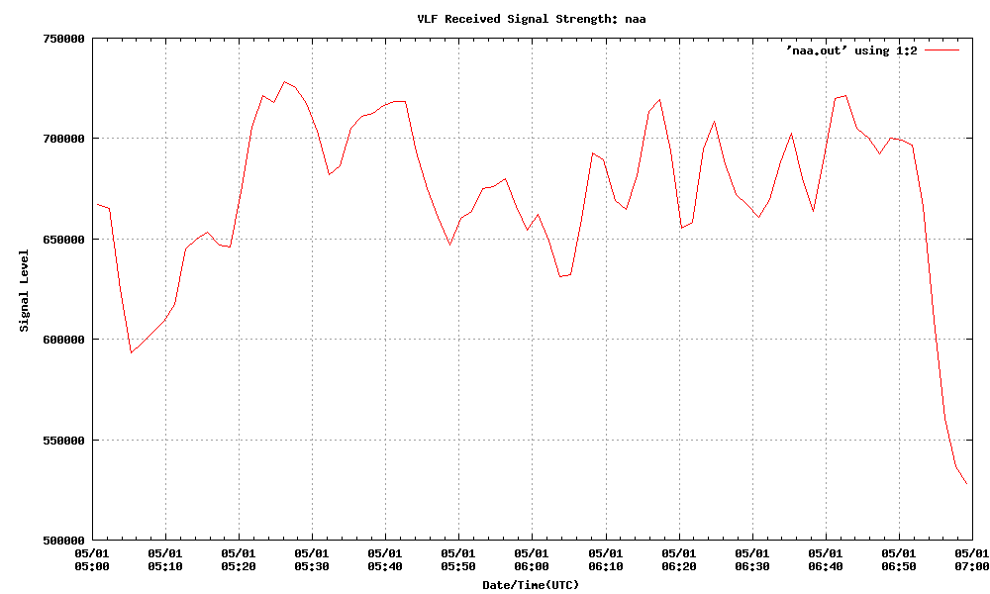
The sidplot command may also be used to produce “combined” plots—that is plots of different channels combined onto a single graph. Use the “-combine” option to accomplish this:
sidplot -combine naa.out nml.out
Which would produce a combined plot, similar to this:
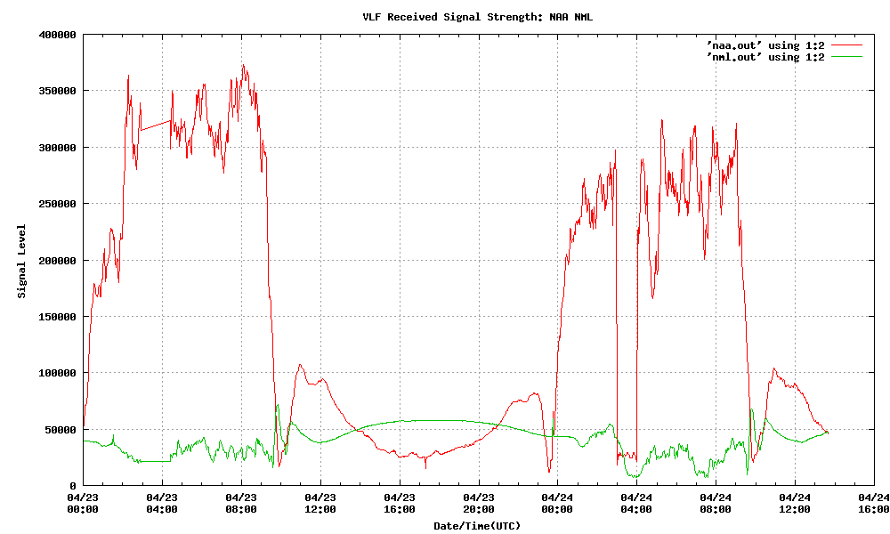
The sidplot command produces a message indicating the output filename it used to contain the graph. It uses the so-called basename of the input file(s) to produce the names of the output files. For example, if the input file to sidplot was naa.out, it will produce a graph, in PNG format, in the file naa.png. The PNG format is relatively common, but there are tools on Linux to convert between different graphical file formats. See man -k netpbm for more information.
Sending data files to the Stanford SID repository: the sidship command
The sidship command is used to send collected data to the Stanford SID repository, located at Stanford University, in California, USA.
The command takes a number of parameters:
- -frequency channel frequency, in Hz

- -name station name: e.g.: NAA

- -chan channel number 1-6

- -date YYYY-MM-DD

Use the -frequency option to specify the channel frequency associated with the data to be shipped, the station name is derived automatically from the frequency, but you may also specify the station name using the -name option. The -chan option specifies the channel number (1-6) that you want to “ship”, and the -date option specifies the UTC date.
By default, sidship uses the current UTC date for locating and “shipping” data files. But it is often the case that you want to ship data other than the current-UTC-day data, so the use of the -date option is strongly encouraged.
You must supply at least a channel number and frequency for sidship to proceed.
Because of the way the Stanford SID Ftp server is configured, you can't “ship” a file more than once—there's no way to over-write a file that is in the FTP repository, so you should make certain that your data are complete before shipping them with sidship.
The first time that sidship runs, it gathers some static configuration information related to your SID receiver setup and location, etc. This data is required to appear in the header information for all files that get shipped to Stanford SID repository. Should you ever need to change that information, it is kept in the $HOME/.sidshipinfo file.

See for example: http://www.radio-astronomy.org/node/142
See: http://www.behringer.com/EN/Products/MIC800.aspx

