# IMPORT DATA

import pandas as pd

df1=pd.read_csv("C:/Users/prati/Desktop/banking.csv")

print(df1)

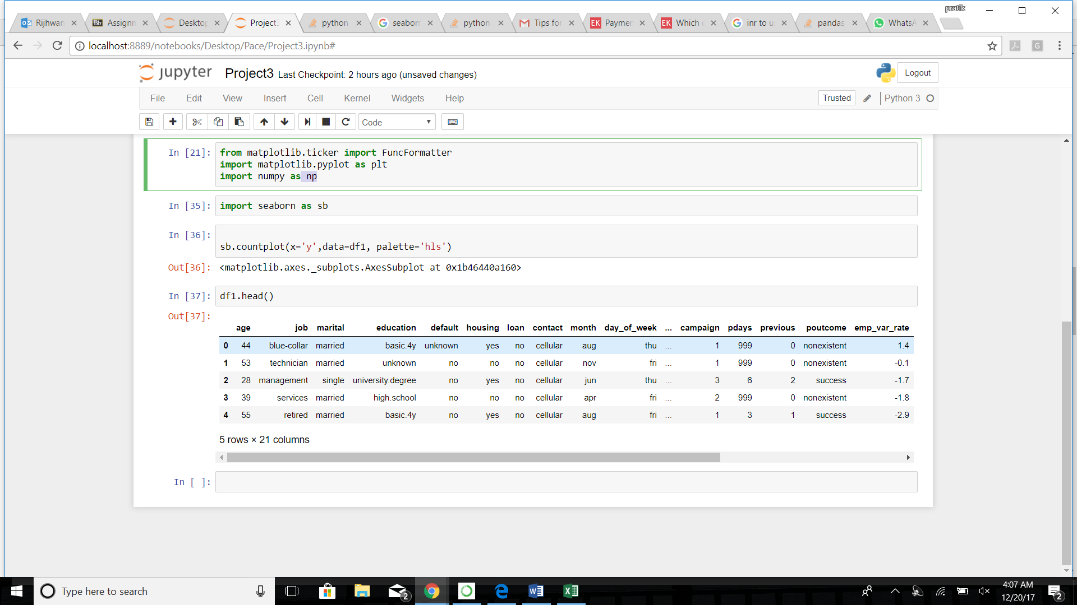

from matplotlib.ticker import FuncFormatter

import matplotlib.pyplot as plt

import numpy as np

import seaborn as sb

%matplotlib inline

sb.countplot(x='y',data=df1, palette='hls')

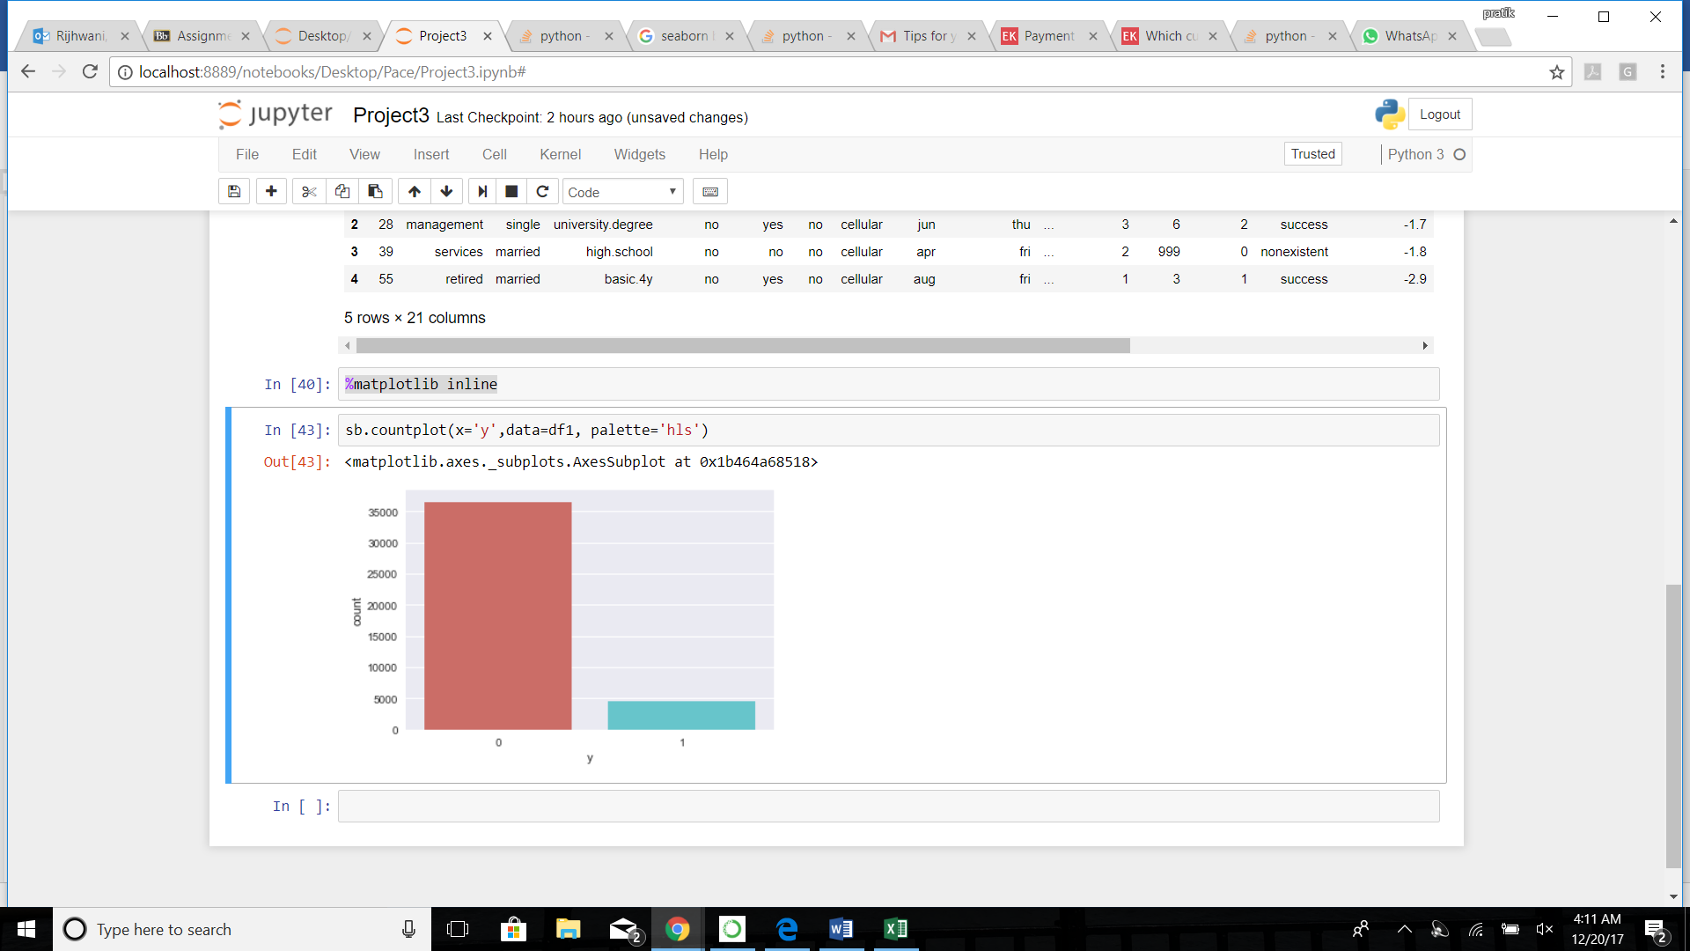

sb.countplot(x='job',data=df1, palette='hls')

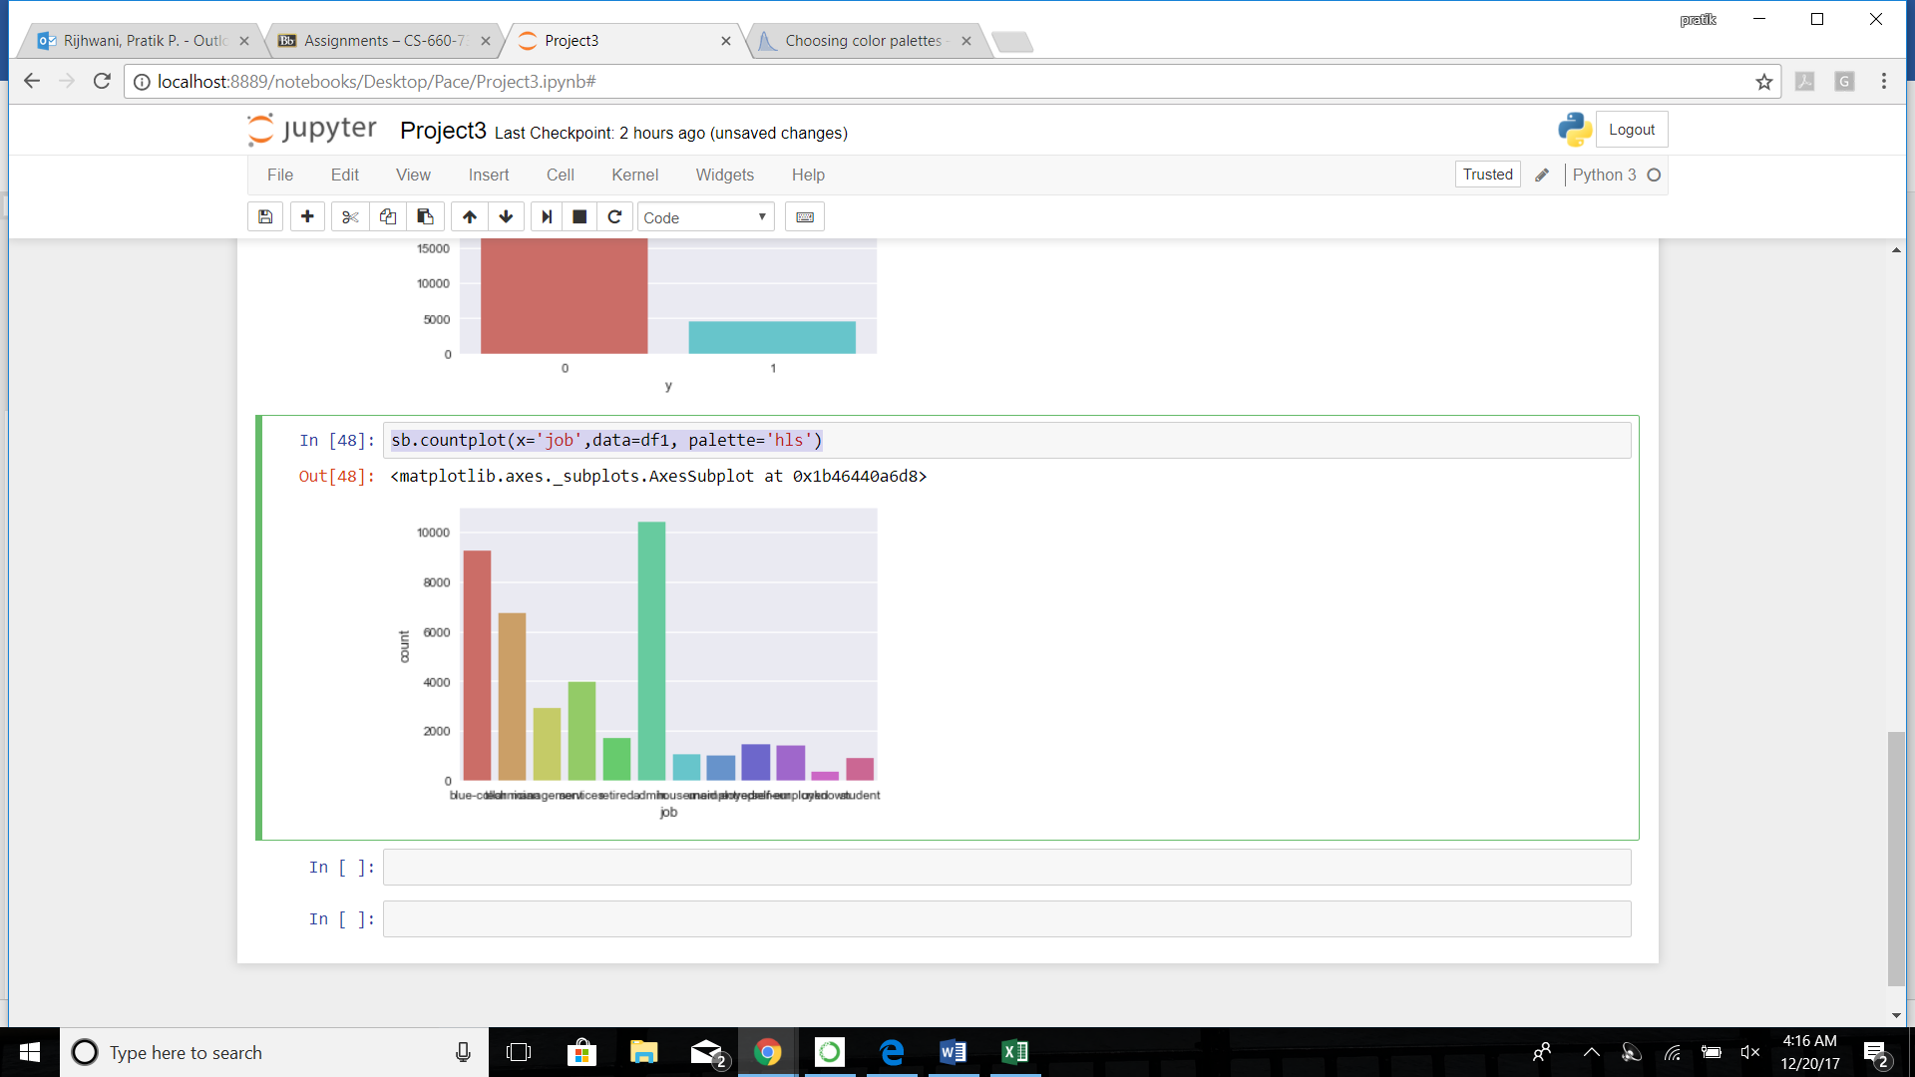

sb.countplot(x='marital',data=df1, palette='hls')

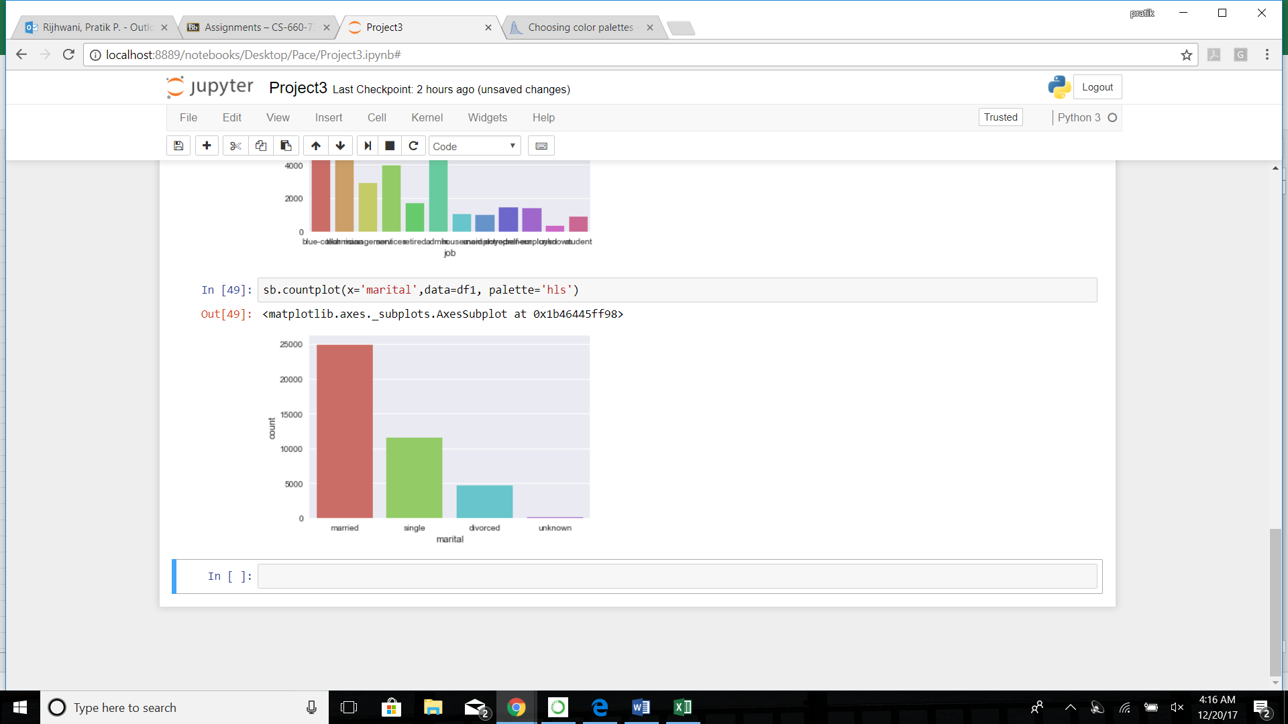

sb.countplot(x='default',data=df1, palette='hls')

sb.countplot(x='housing',data=df1, palette='hls')

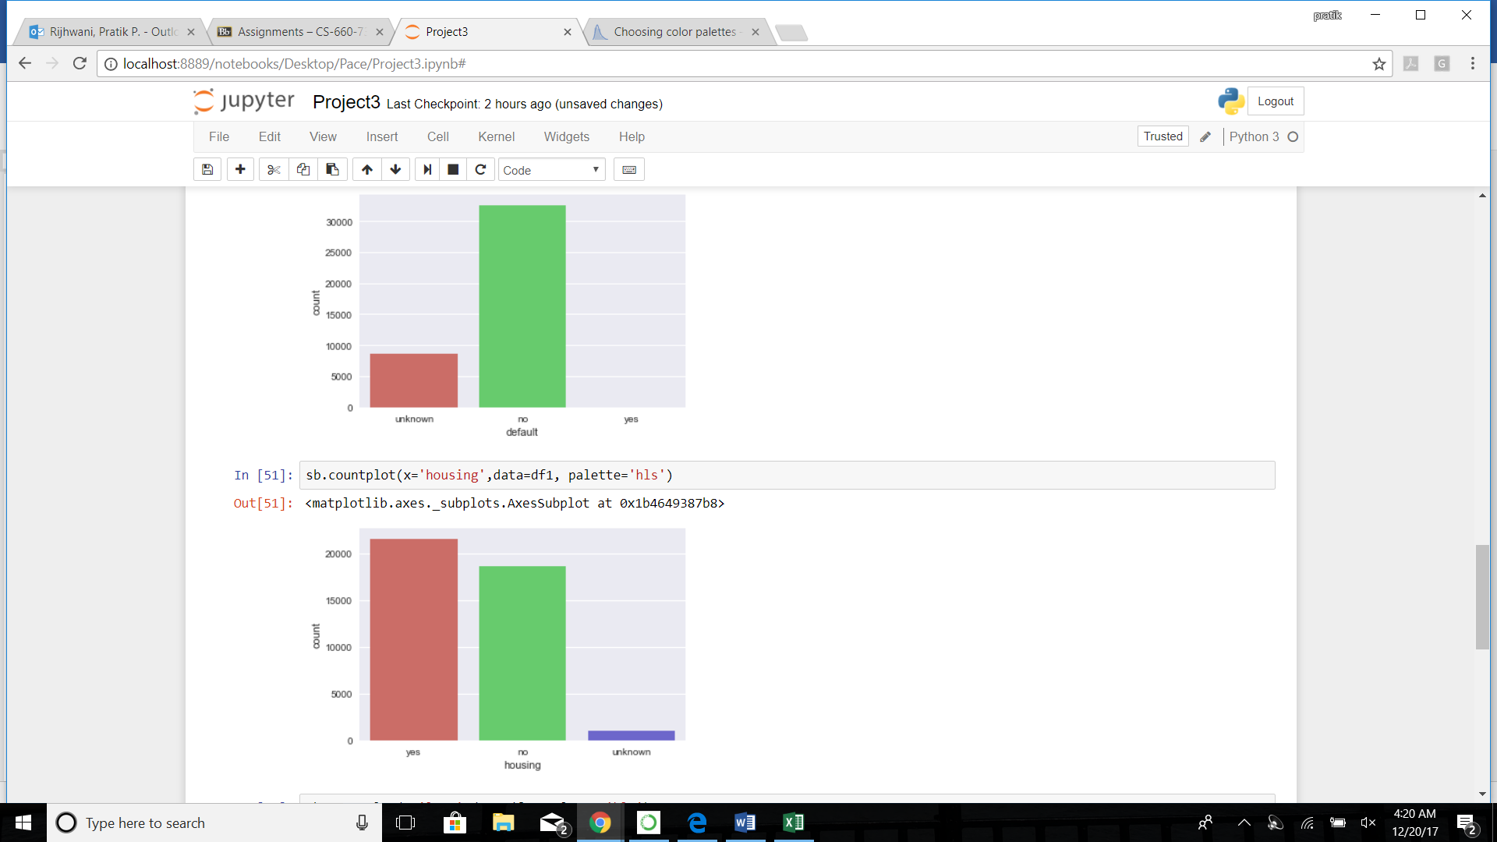

sb.countplot(x='loan',data=df1, palette='hls')

sb.countplot(x='poutcome',data=df1, palette='hls')

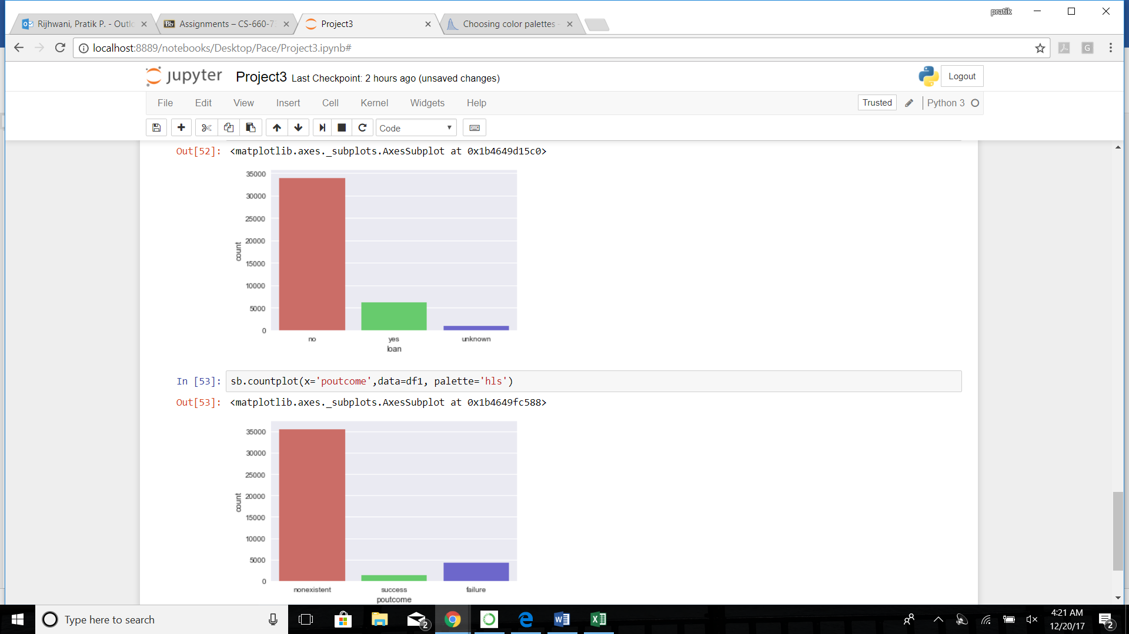

#check null values

df1.isnull().sum()

No null values

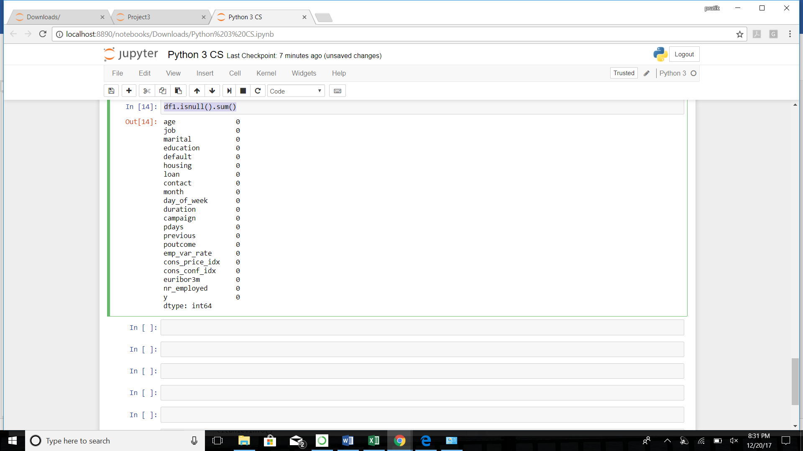

# create dummy variables

df_job = pd.get_dummies(df1['job'], drop_first=True)

df_marital = pd.get_dummies(df1['marital'], drop_first=True)

df_default = pd.get_dummies(df1['default'], drop_first=True)

df_housing = pd.get_dummies(df1['housing'], drop_first=True)

df_loan = pd.get_dummies(df1['loan'], drop_first=True)

df_pout=pd.get_dummies(df1['poutcome'], drop_first=True)

#sample poutcome dummies

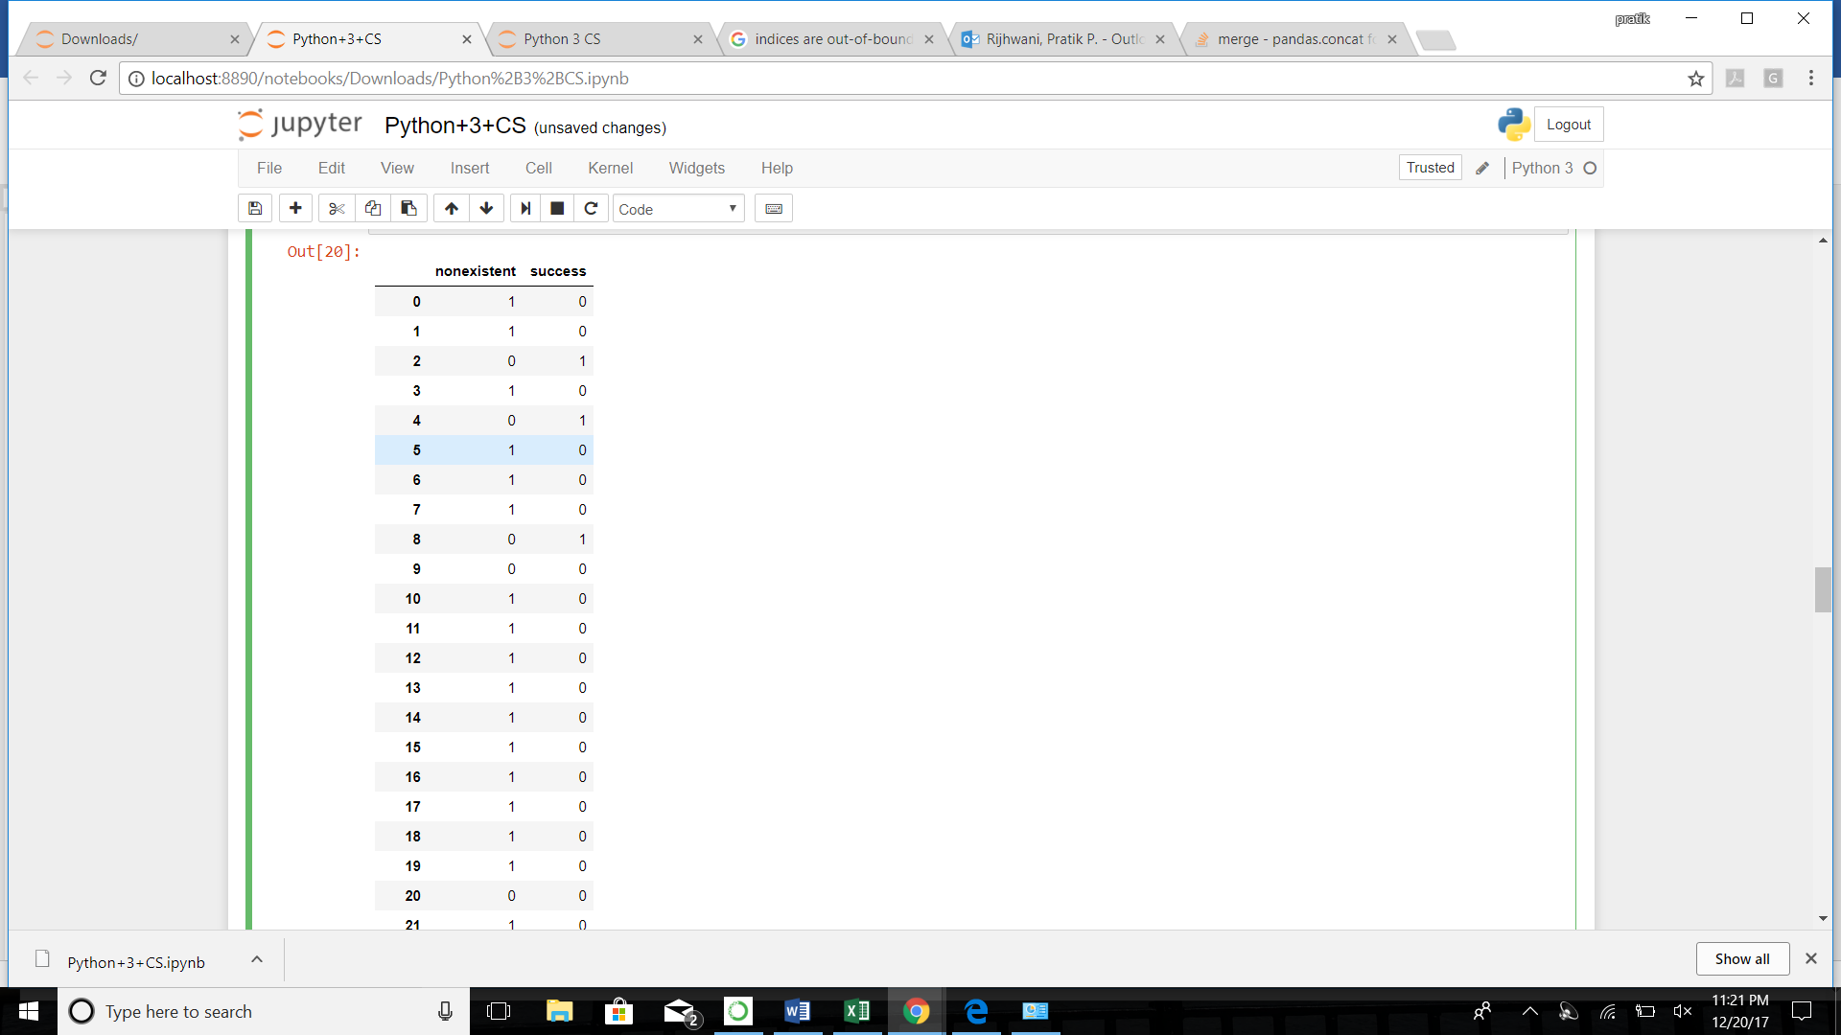

#droppping old columns and combining the dataframes

df1.drop(['job', 'marital','default','housing','loan','poutcome'],axis=1,inplace=True)

df1.head()

df2=pd.concat([df_default,df_housing,df_job,df_loan,df_marital,df_pout,df1],axis=1,)

df2.head()

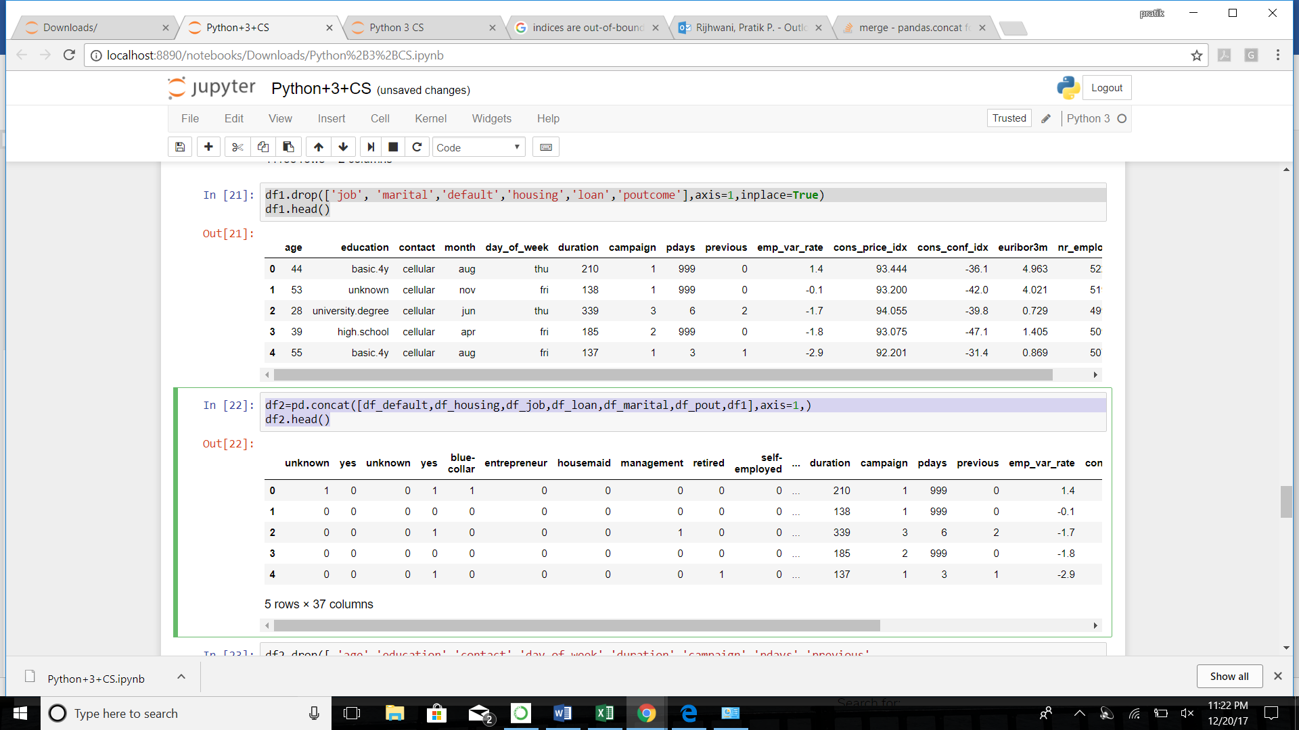

#dropping irrelevant columns

df2.drop([ 'age','education','contact','day_of_week','duration','campaign','pdays','previous',

'emp_var_rate','cons_price_idx','cons_conf_idx','euribor3m','nr_employed'],axis=1,inplace=True)

df2.head()

\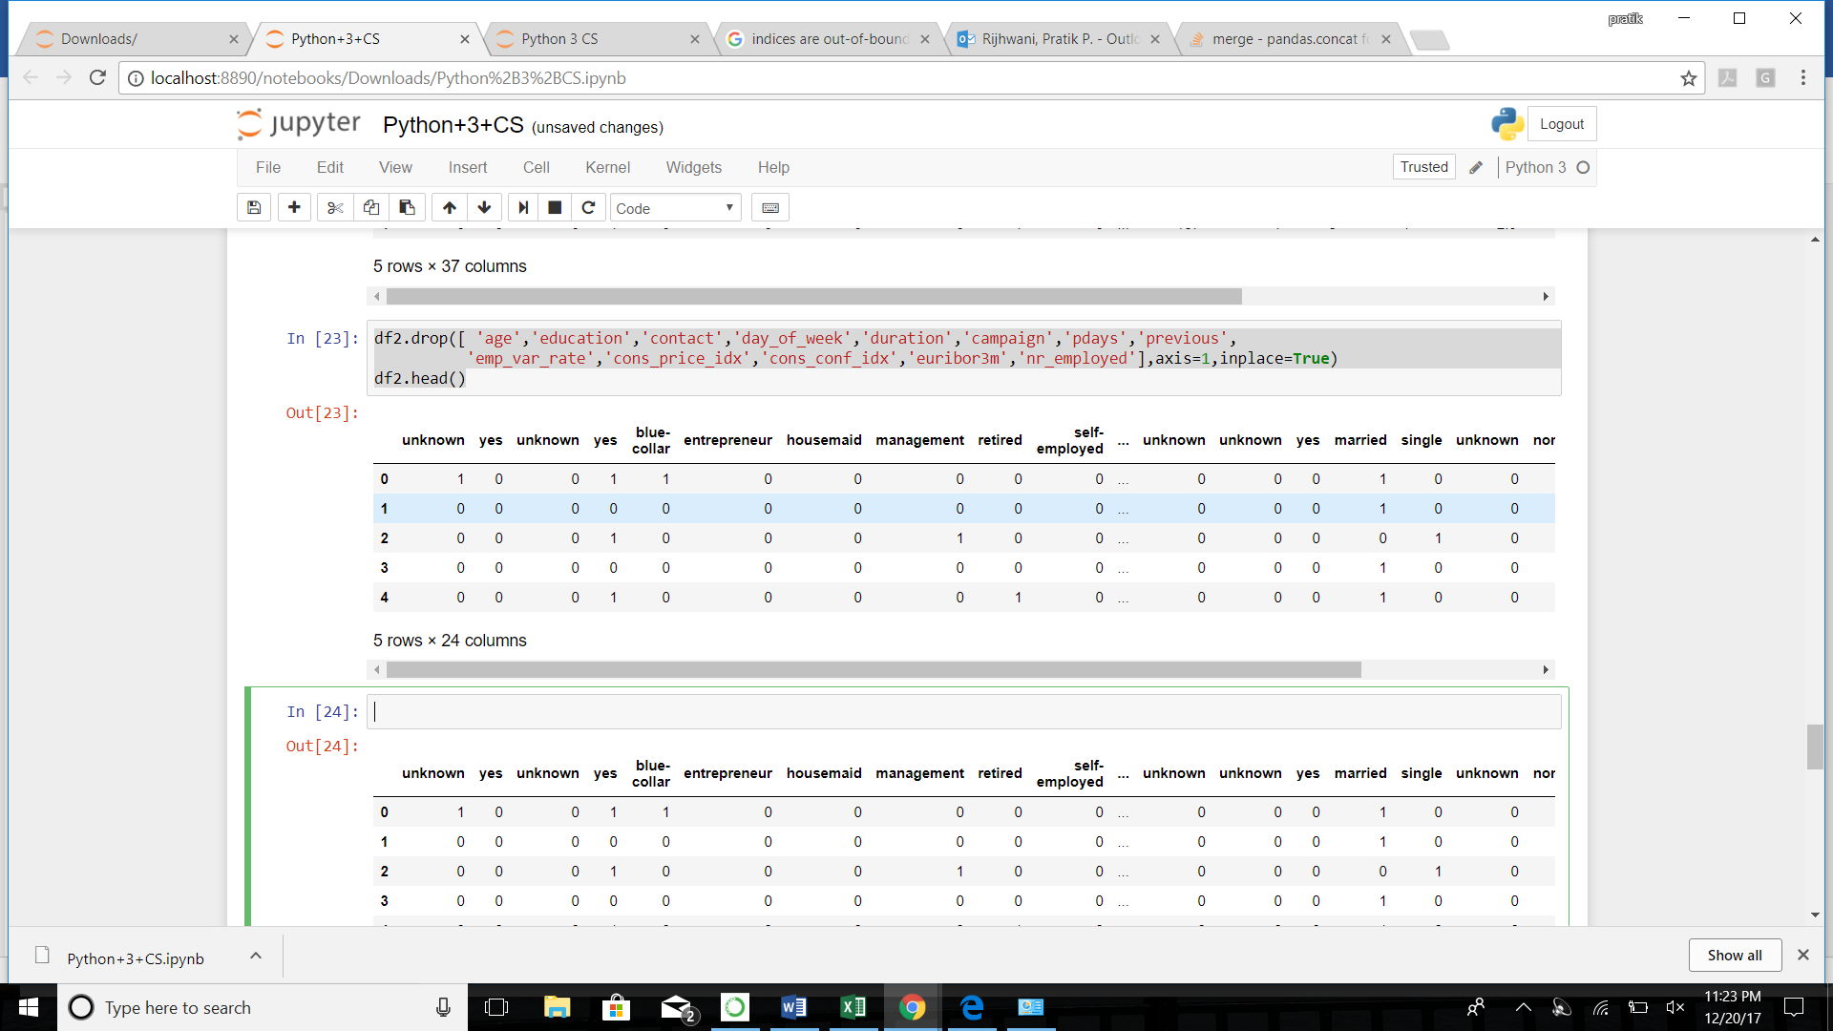

# import packages

from sklearn.cross_validation import train_test_split

import numpy as np

# deploying

X1 = df2.ix[:,(0,1,2,3,4,5,6,7,8,9,10,11,12,13,14,15,17)].values

y = df2.ix[:,16].values

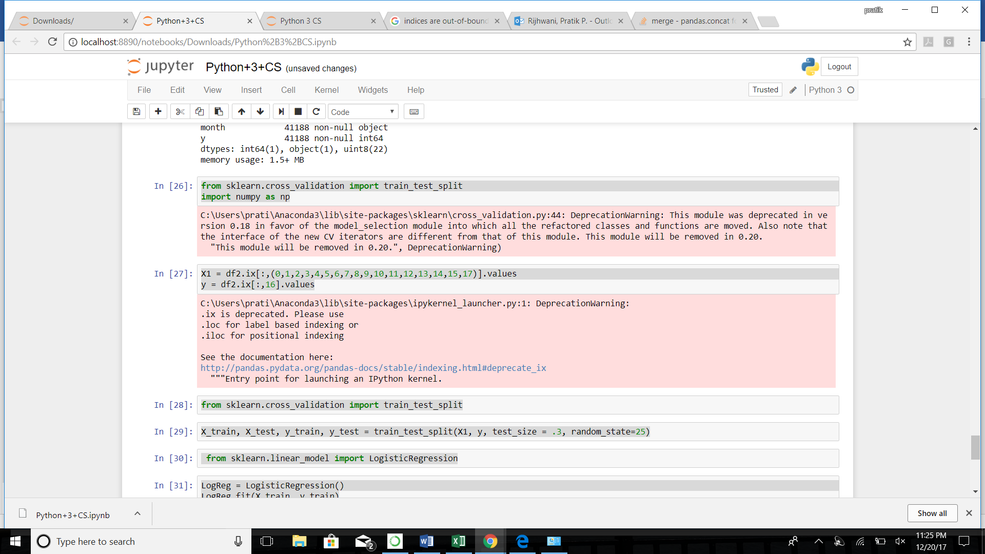

from sklearn.cross_validation import train_test_split

# split

X_train, X_test, y_train, y_test = train_test_split(X1, y, test_size = .3, random_state=25)

#logistic

from sklearn.linear_model import LogisticRegression

LogReg = LogisticRegression()

LogReg.fit(X_train, y_train)

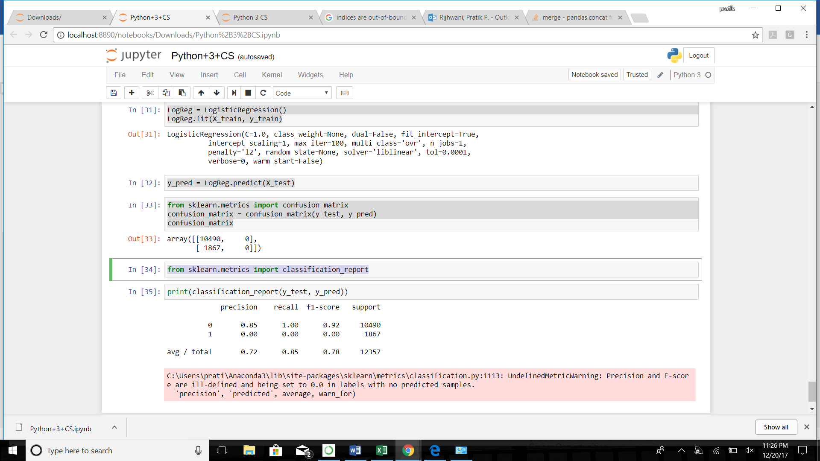

y_pred = LogReg.predict(X_test)

from sklearn.metrics import confusion_matrix

confusion_matrix = confusion_matrix(y_test, y_pred)

confusion_matrix

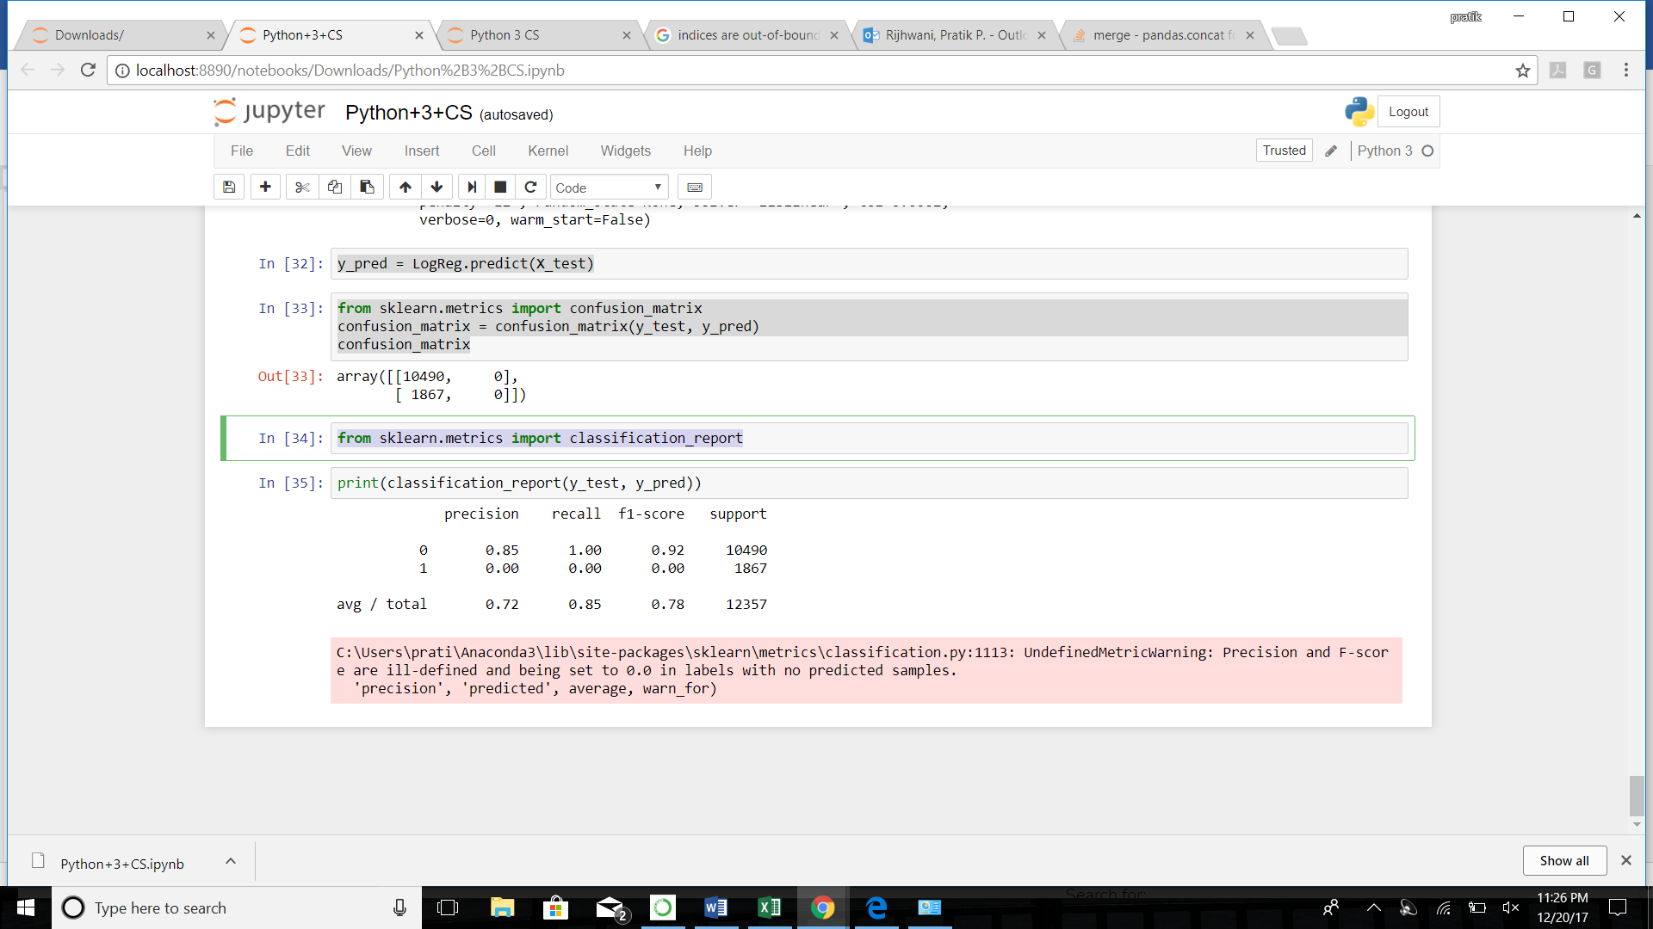

from sklearn.metrics import classification_report

