**CST-247 Report Template**

**Professor:** Micheal Pritchard

**Course:** CST-247

**Student:** Patrick Garcia

**Date:**  8/1/2020

**Title:** Activity2

Git Repo URL → <https://patdalcia@bitbucket.org/patdalcia/cst-247.git>

*Part One*

Screenshot 1

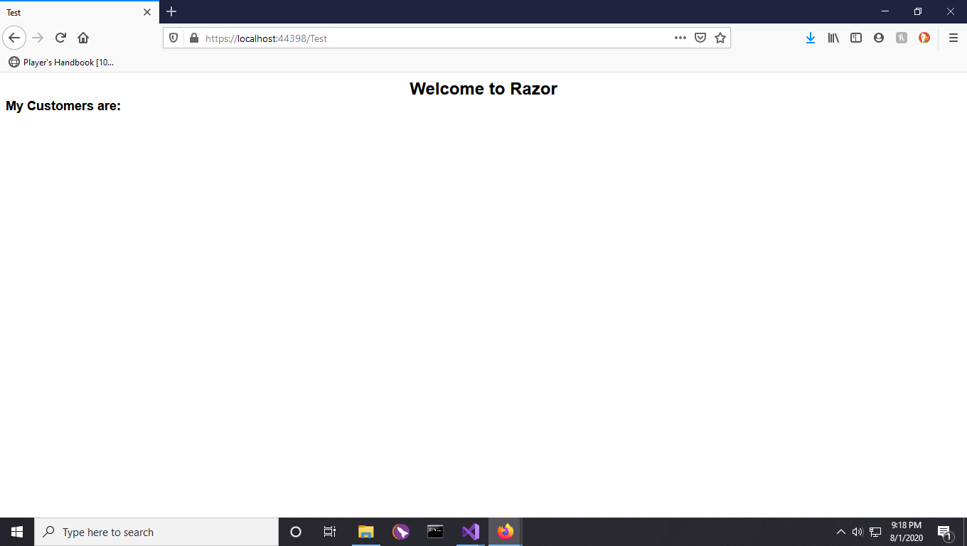

This screenshot shows the two labels created using html helpers.

Screenshot 2

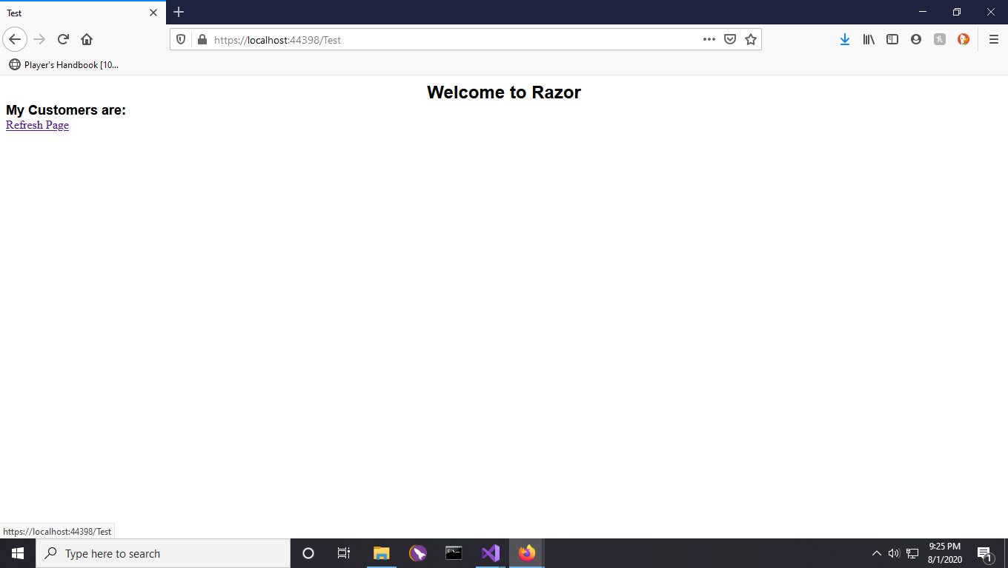

This screenshot shows the added Html action link. Notice the url at the bottom right indicating that the link will simply refresh the page.

Screenshot 3

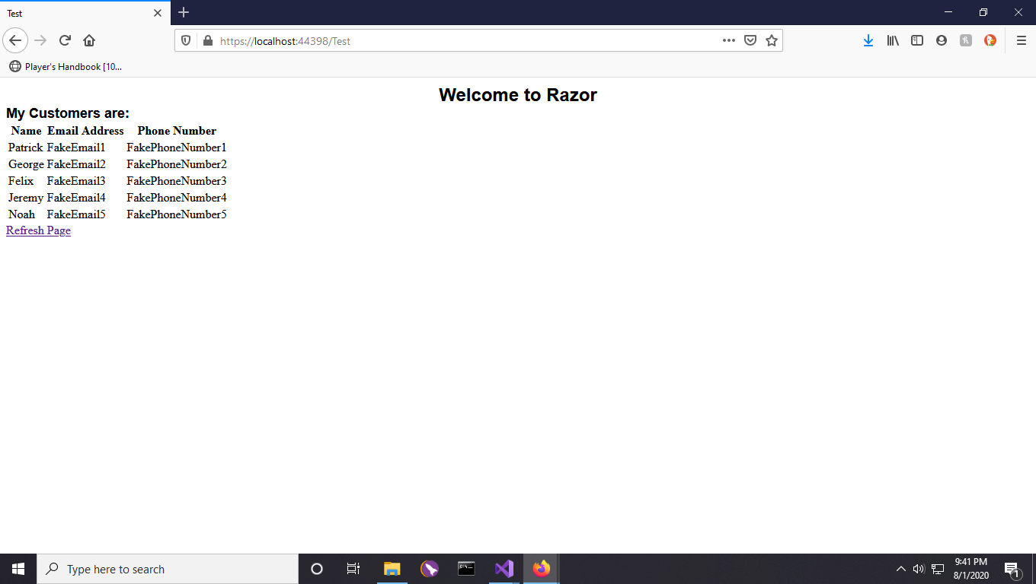

This screenshot shows the created table. The model data passed to the view is iterated over, and its contents are used to populate the table.

*Section 2*

Screenshot 4

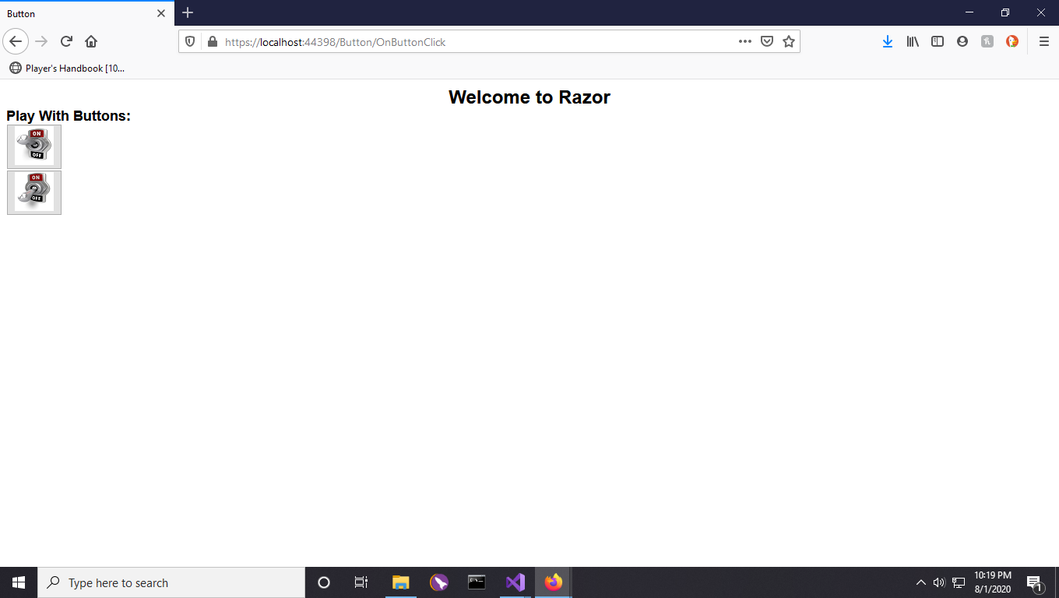

This screenshot shows the toggled buttons.

Screenshot 5

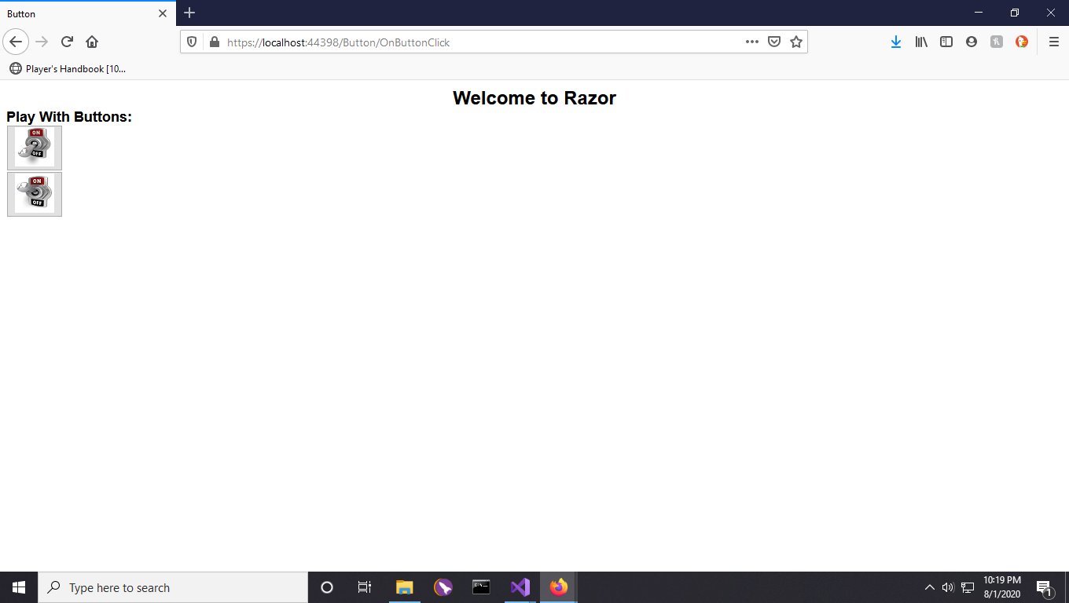

This screenshot also shows the toggled buttons.

Screenshot 6

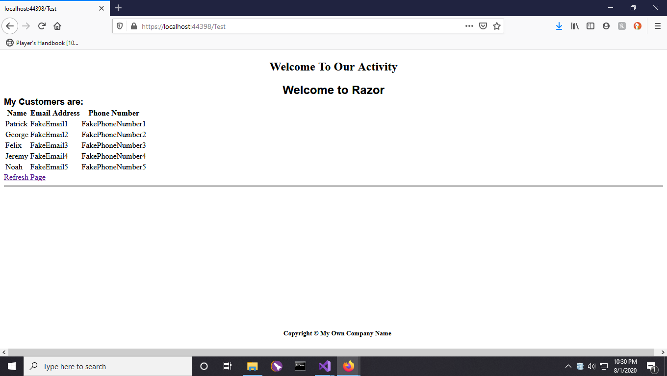

This screenshot shows the utilized layout page and the included header and footer.

Screenshot 7

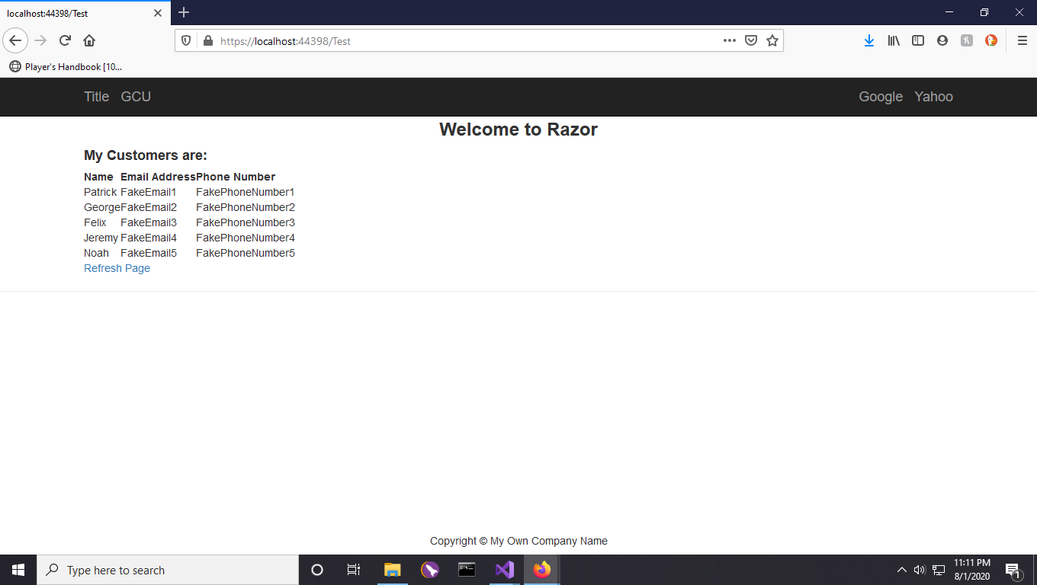

This screenshot shows the updated header and body, utilizing bootstrap.

*Part 3*

Screenshot 8/8.1

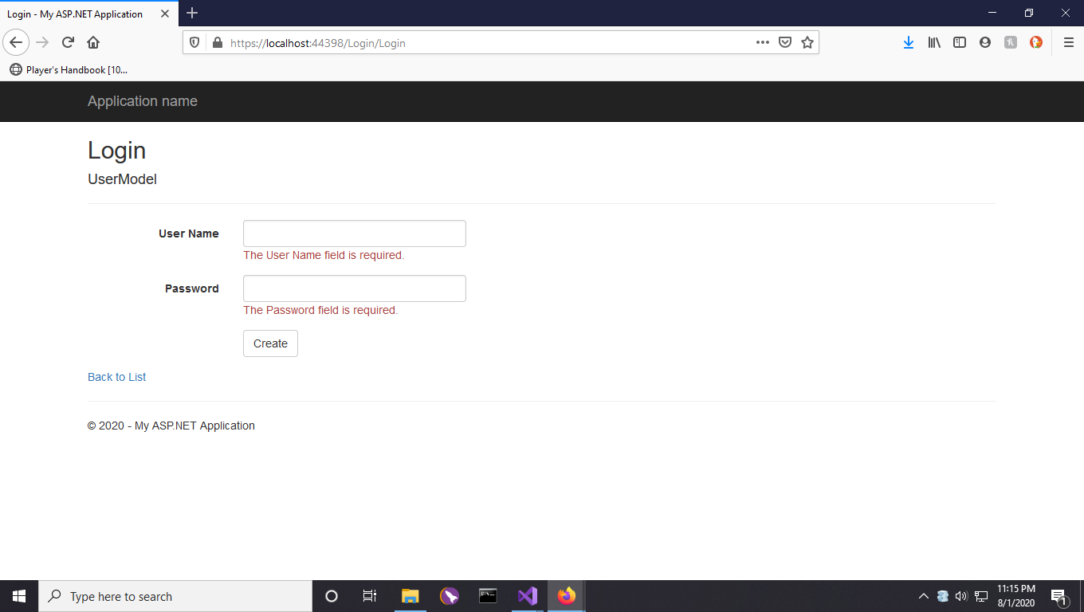

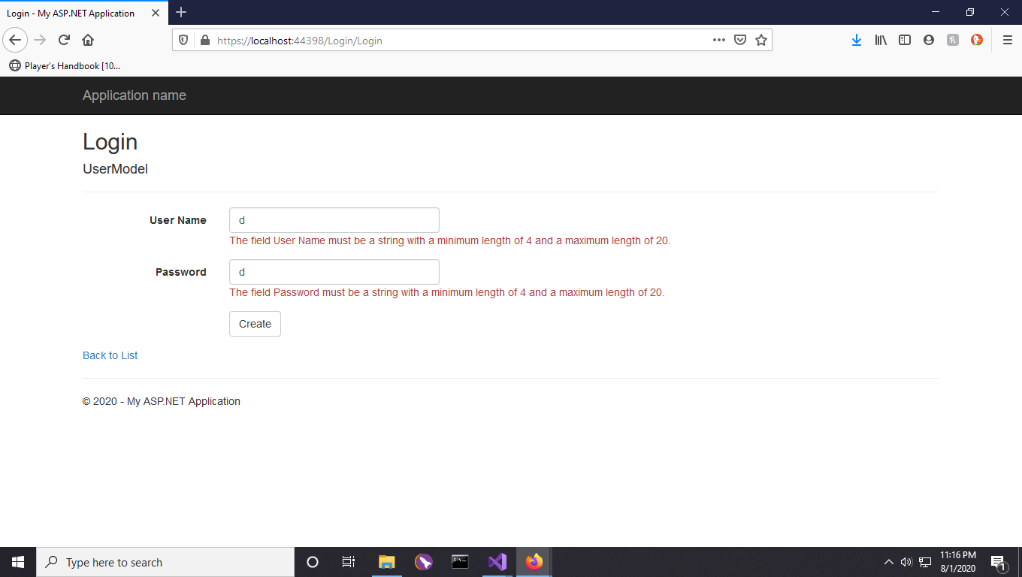

Data validation messages for login page.

Screenshot 9

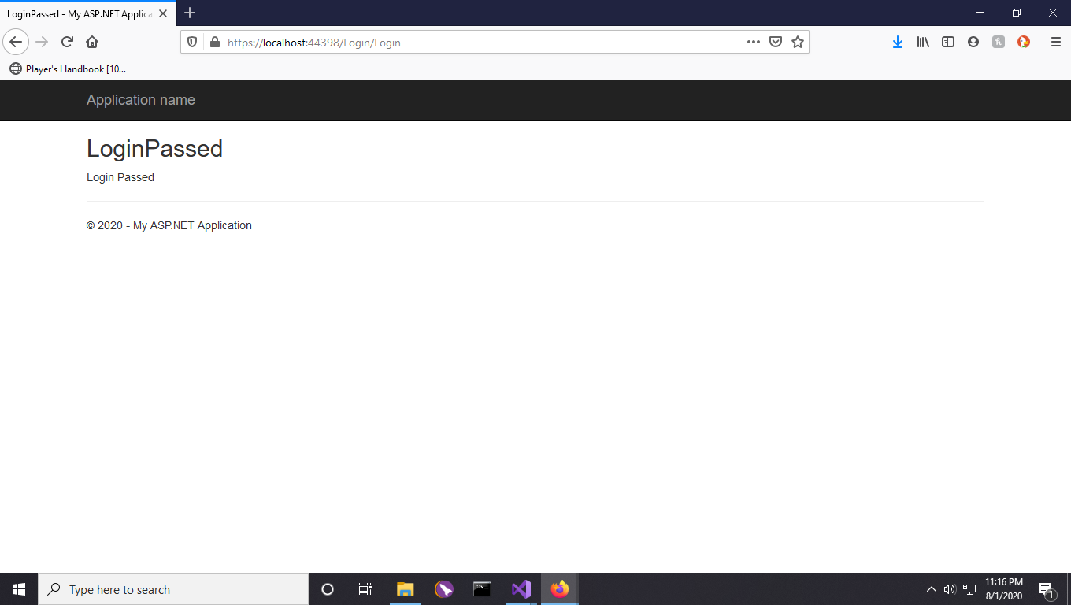

This screenshot shows a successful login.

*Part 4*

*See attached documents for scrum information.