**CST-247 Report Template**

**Professor:** Micheal Pritchard

**Course:** CST-247

**Student:** Patrick Garcia

**Date:**  7/30/2020

**Title:** Topic 5 Activity 3

Git Repo URL → <https://patdalcia@bitbucket.org/patdalcia/cst-247.git>

*Part 1*

Screenshot 1

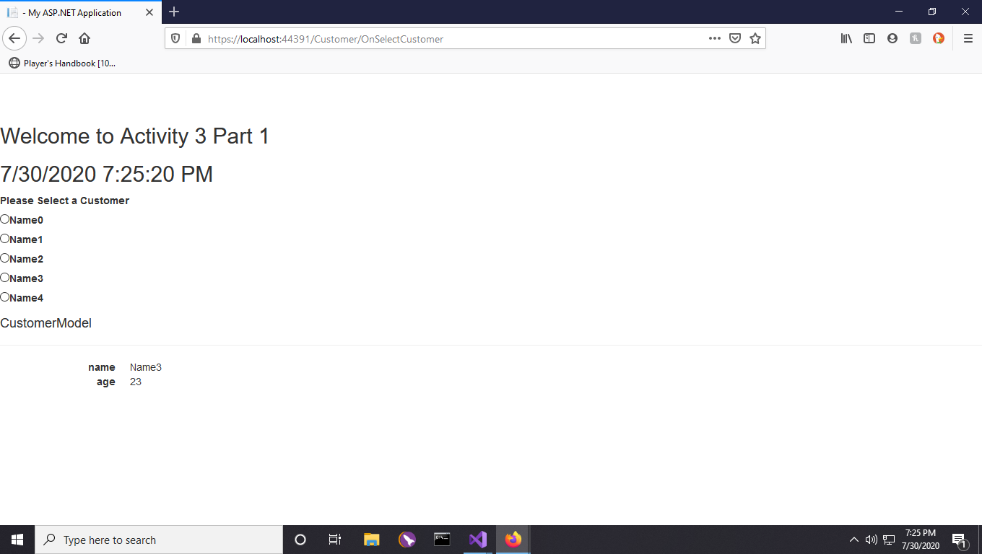

This screenshot shows the updated view, the entire page is refreshed.

Screenshot 2

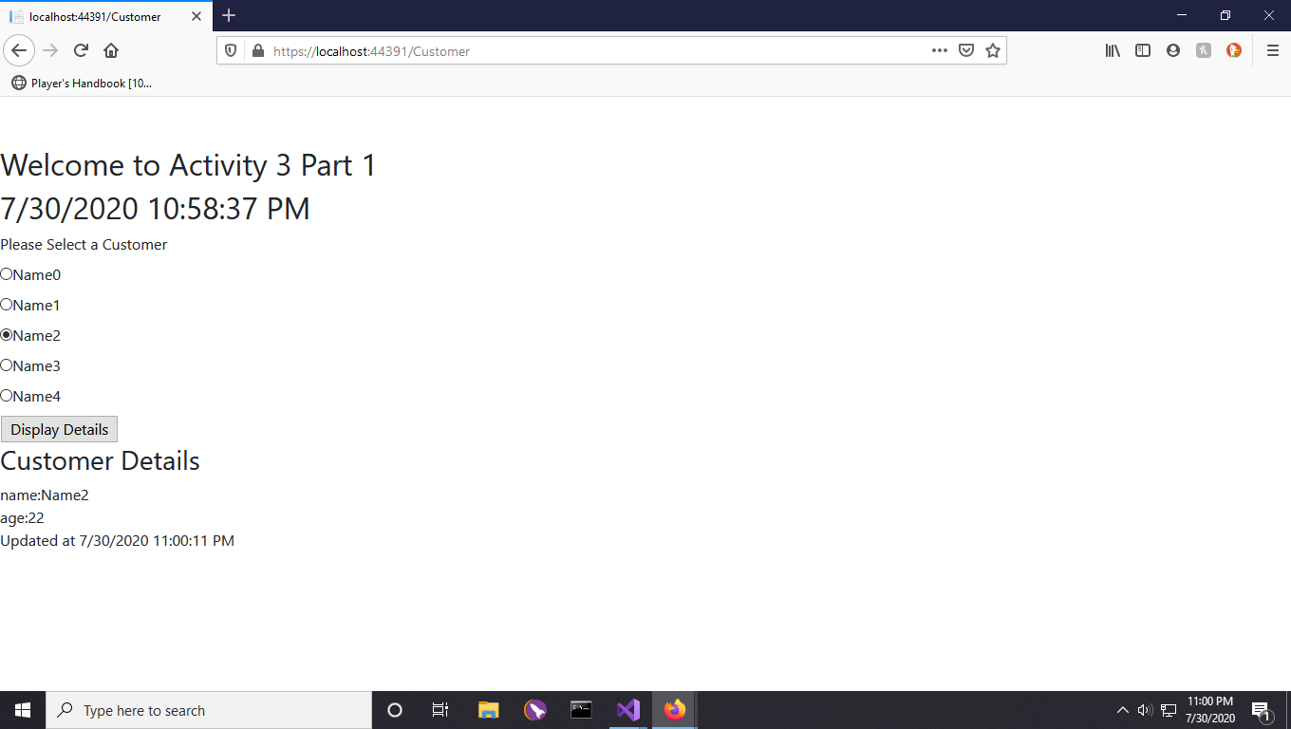

This screenshot shows the updated partial page. Notice the timestamp is different in the header.

Screenshot 3

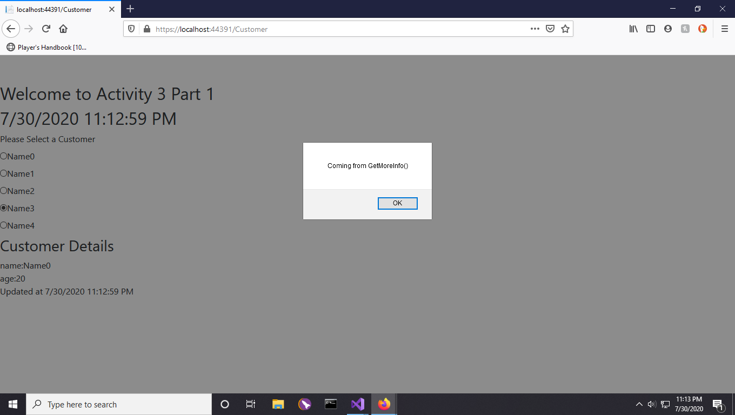

This screenshot shows the updated partial view, as well as the AJAX callback alert

displayed in JavaScript.

*Part 2*

Screenshot 4

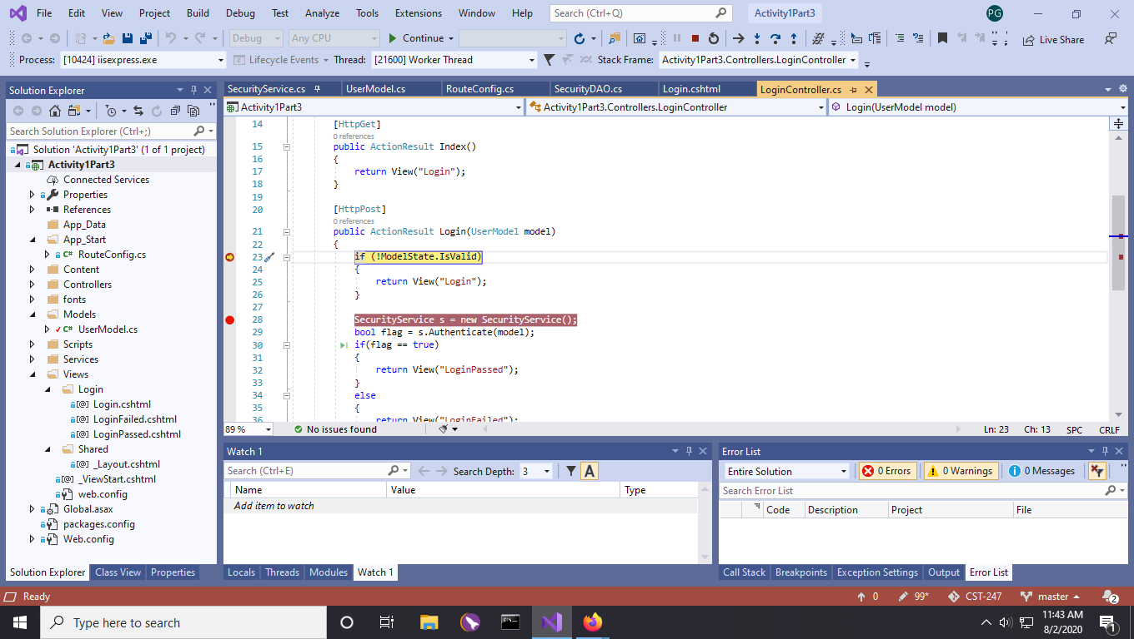

This screenshot shows the first breakpoint added.

Screenshot 5

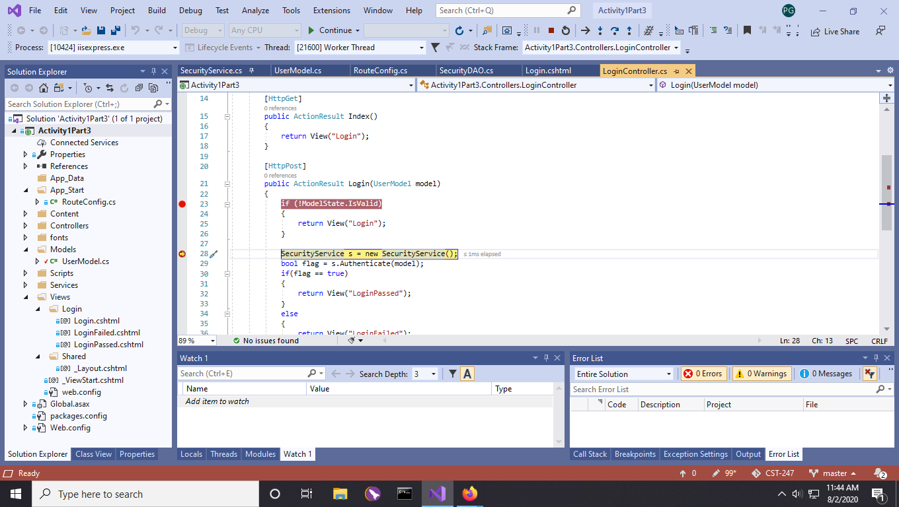

This screenshot shows the second breakpoint added.

Screenshot 6

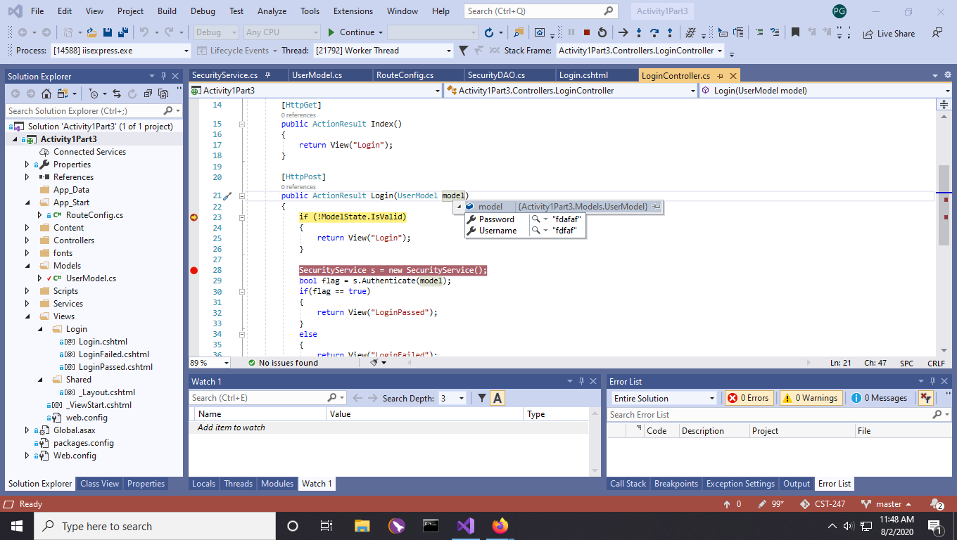

This screenshot shows the UserModel objects details. These were obtained by hovering over the object and selecting the drop down icon.

Screenshot 7

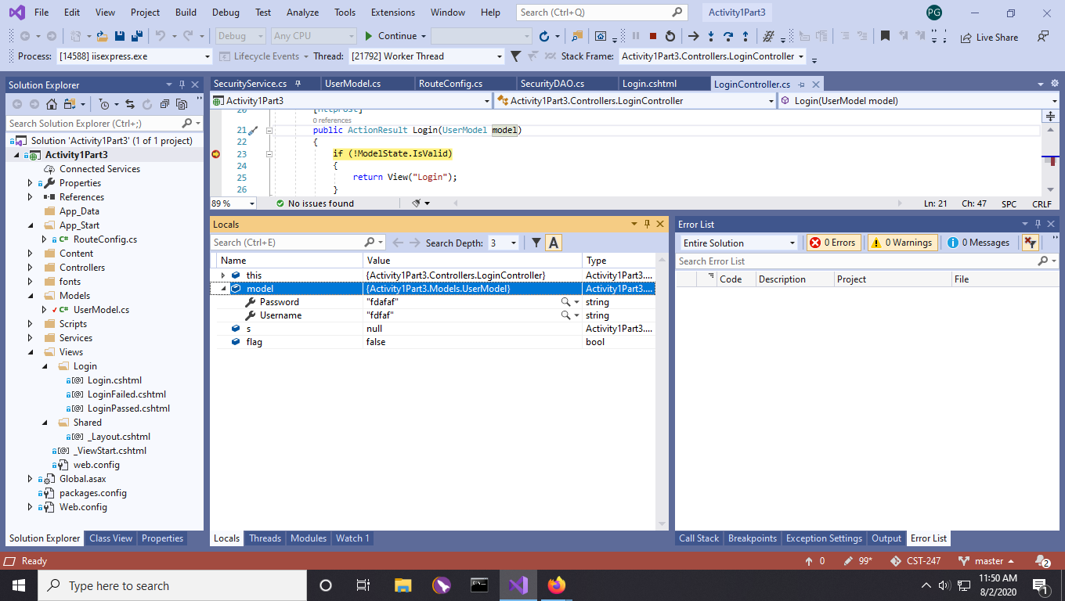

This screenshot shows the information displayed in the ‘locals’ window.

Screenshot 8

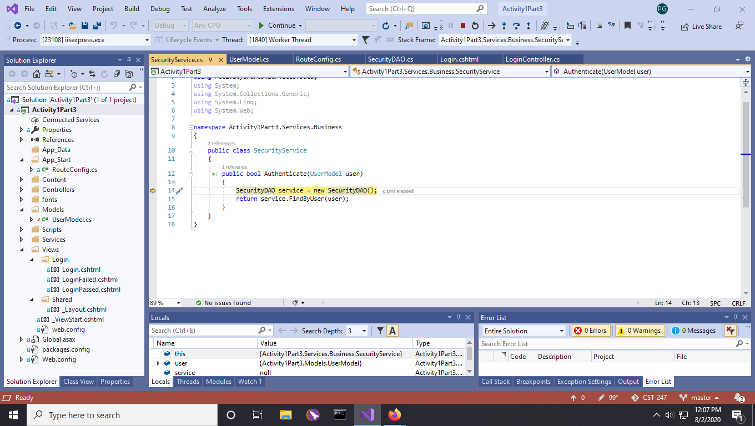

This screenshot shows the breakpoint set in the Security service.

Screenshot 9

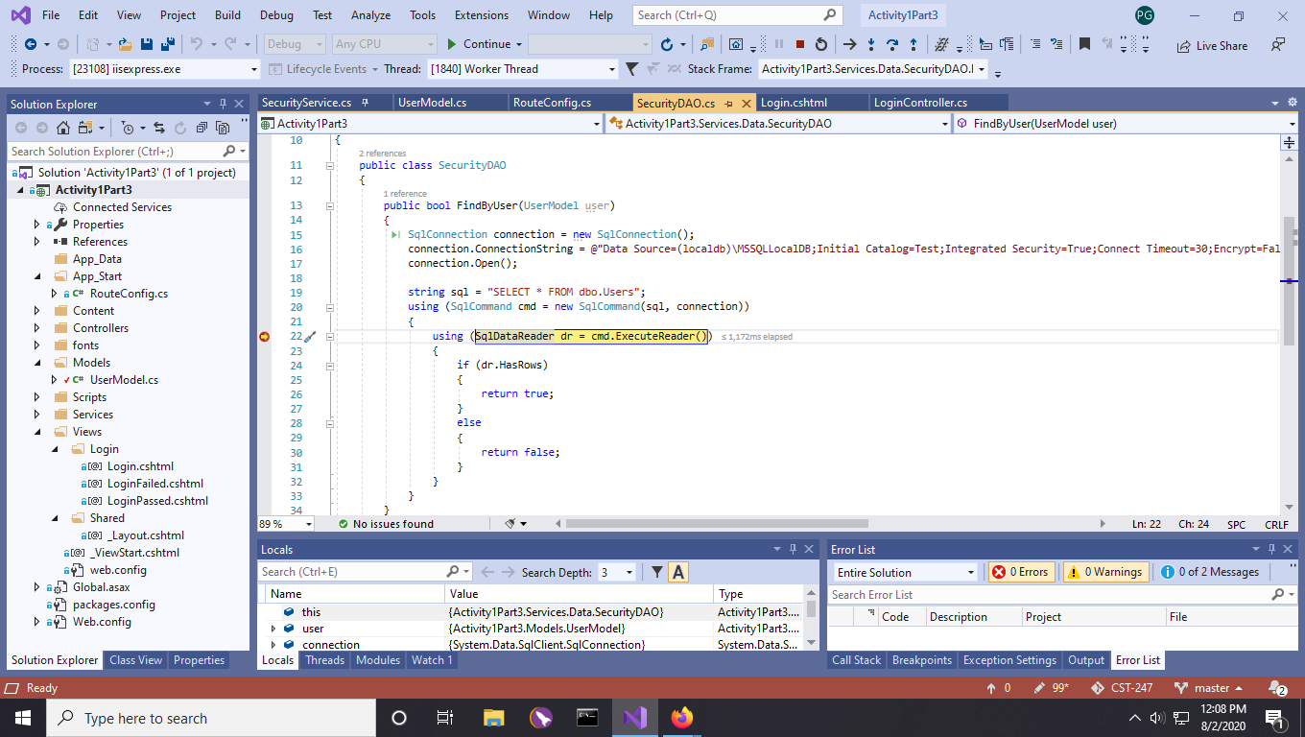

This screenshot shows the breakpoint in the securityDAO FindByUser class.

Screenshot 10

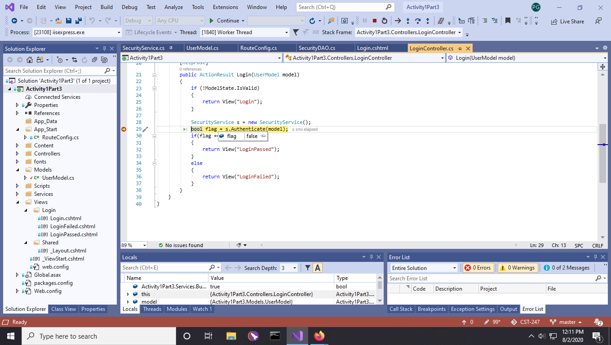

This screenshot shows the returned value from the authenticate method.

Screenshot 11

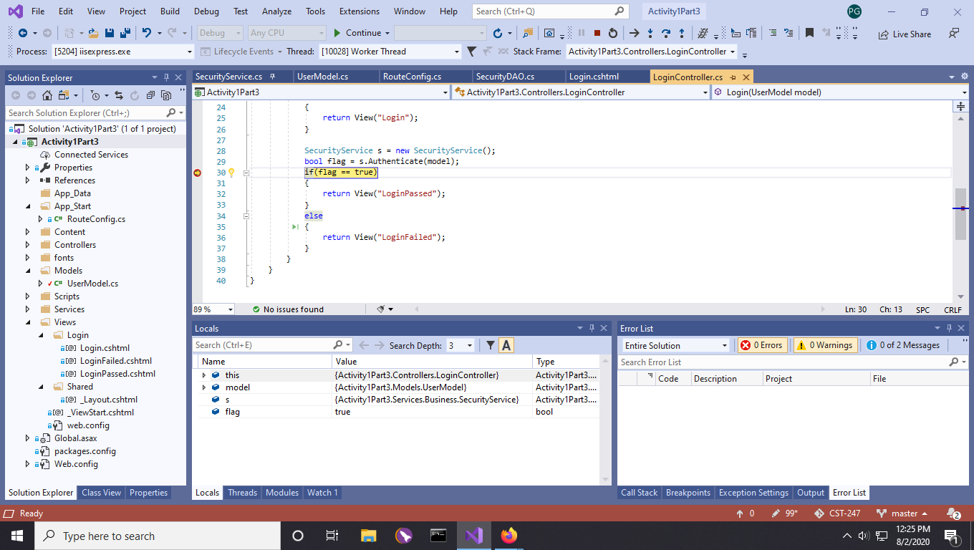

This screenshot shows the conditional breakpoint inside of the loginController.

Screenshot 12

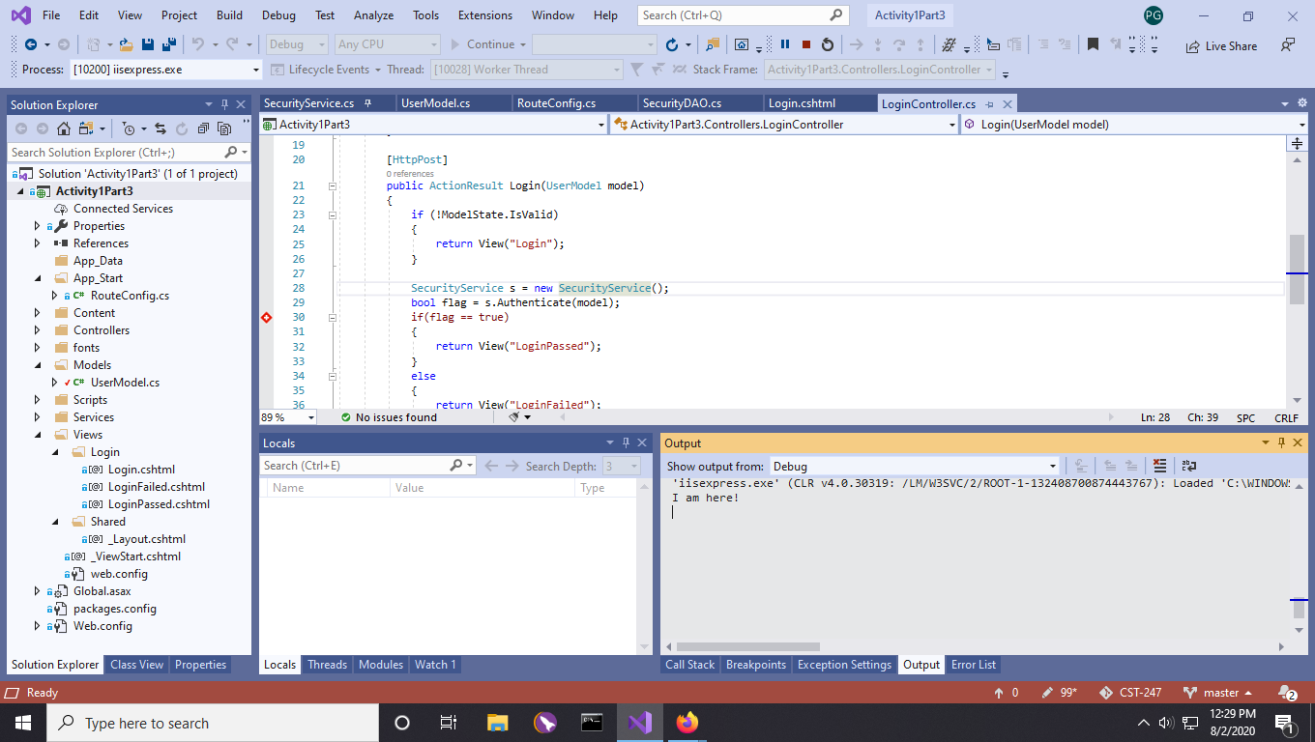

This screenshot shows the breakpoints message displayed in the output window.

Screenshot 13

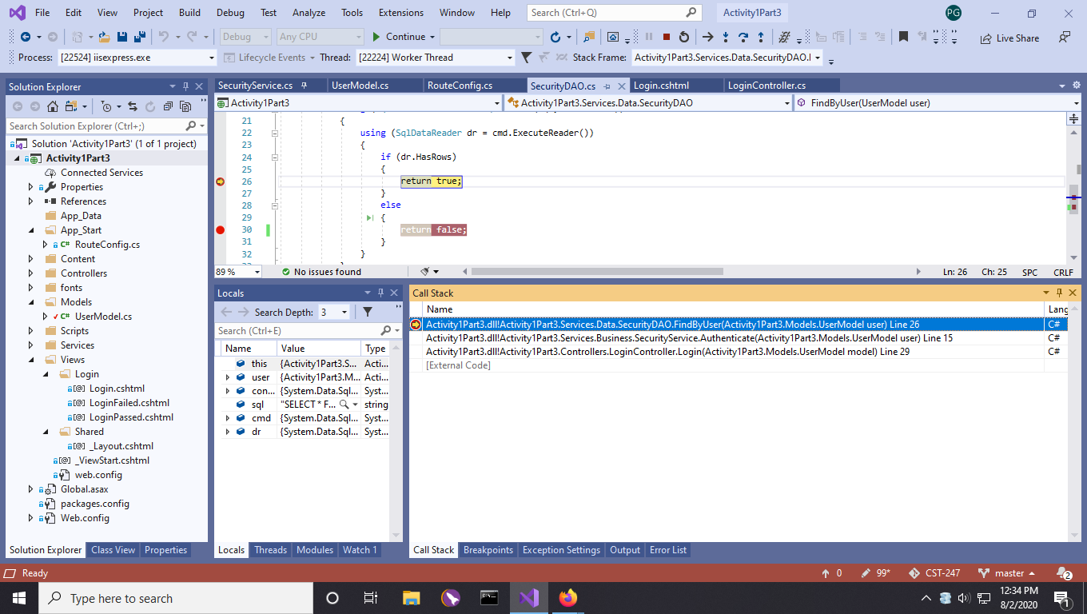

This screenshot shows the details of the call stack at a breakpoint.