**Methods**

Data

Survival estimates

We obtained survival estimates of raptor species as reviewed by Newton, McGrady, and Oli (2016). We extracted information from their database to only include studies with estimates for adult birds obtained through formalized statistical methods (i.e, Methods 3-6: capture-mark-recapture or resight, joint live encounters-ring recoveries, radiotracking, multiple data types), and studies that indicated their sample size. We used age-, sex-, year-, area-, and group-specific estimates of survival when available. However, where separate estimates for age groups were provided but age-specific sample sizes were not, we used the geometric mean among all age groups (same as for sex, year, area, and group). We then assigned each value of a survival estimate that was obtained through methods 3 and 5 as apparent survival estimate, and values obtained through methods 4 and 6 as true survival estimate.

Body mass

We used the average body mass (kg) of the adults of each species as reported by Ferguson-Lees and Christie (2001). When sex-specific survival estimates were provided, we used the average body mass for the given sex of a given species. Otherwise, we used the arithmetic mean of the body mass for both males and females of a given species.

Data Analysis

Beta-binomial model for evaluating survival-mass relationships

We evaluated the relationship between body mass and the survival estimates of raptor species using a hierarchical beta-binomial model. This approach is used to evaluate the probabilities of observing successes (i.e., total number of survivors) given a number of trials (i.e., sample size), with these probabilities assumed to follow a beta distribution (i.e., survival estimates; Lee and Sabavala, 1987). The versatility of this modelling framework has been widely used in the fields of epidemiology (Griffiths, 1973), medical diagnostics (Kuss, Hoyer, and Soms, 2014), mental testing (Lord, 1965), and human-environmental studies (Layton and Siikamäki, 2009). Here, we used a hierarchical beta-binomial model where the intercept was allowed to vary for each species and study. The model had the form:

$y_{i,j}=Binomial \left(n, p\right); p=Beta (α_{1}, α_{2})$ (Eqn. 1)

$α_{1}=p* Φ; α_{2}=(1-p)* Φ$ (Eqn. 2)

$p_{i,j}=inv_{logit}(β_{0i,j}+β_{1 }*mass +β_{2 }*estimate type)$ (Eqn. 3)

In Equation 1, yi,j is the total number of survived species *i* in study *j* drawn from a binomial distribution with the parameters *n* (sample size)and *p* (probability of survival). The probability parameter *p* is drawn from a beta distribution with shape parameters (α1 and α2). Each shape parameter is modelled as a function of the estimated survival probability with variance parameter ($Φ$). We modelled the *p* with the following parameters (Eqn. 3): β0 is the intercept for species *i* in study *j*, β1 is the slope for body mass, and β2 is the slope for the type of survival estimate (i.e., apparent or true).

Model implementation and diagnostics

We implemented the model in a Bayesian framework and used weakly-informed priors for all parameters, except the variance term for the shape parameters, which was informed through preliminary assessments (Gelman et al., 2008; See Appendix for more details on the preliminary assessments conducted). We based parameter estimates from the beta-binomial model on four chains of 3000 iterations with 1000 for warm-up period. We assessed model convergence and mixing of chains through visual inspection and by using the Gelman-Rubin (1992) diagnostic (R̂) and the effective sample size. We performed posterior predictive checks to evaluate deviations of model-generated data from the observed data. We interfaced to Stan using the ‘rstan’ package to fit our model in R (Stan Development Team, 2019; R Core Team, 2018).

Model interpretation

Because we standardized the variables in our model by centering each value on the mean, and dividing them by two standard deviations (Gelman, 2008), we were able to make direct comparisons of the effect sizes.

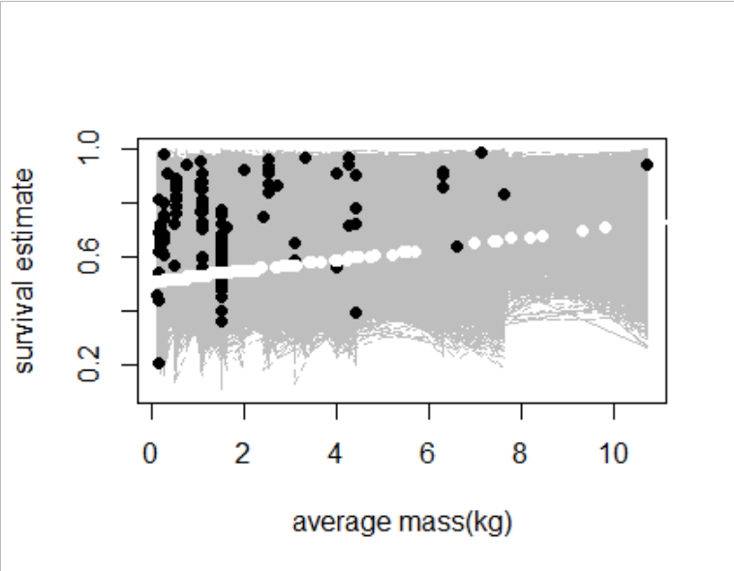

Estimated from other species: 0.51-0.73