The effects of biotic interactions on the breeding phenology of desert rodents

Pat Dumandan

**Introduction**

Identifying the mechanisms that underlie shifts in biodiversity patterns is often central to modern ecological research. This is in part due to the growing concern about climate change impacts on wildlife species (Bellard et al. 2012, Leadley et al. 2010). Commonly, correlative studies are done to determine how species abundance and richness are linked to various abiotic and biotic predictors (Grinnell 1917, Hutchinson 1957, MacArthur 1968). Other studies focus on assessing how factors important in population dynamics, such as phenology, or the timing of different life-history events (e.g., breeding, migration, dormancy) relate to environmental cues (e.g., photoperiod, precipitation, primary productivity; Charmantier et al. 2008, Parmesan 2006). Because shifts in phenology are on the clearest manifestations of climate change, there is a growing interest in understanding how these disruptions influence community dynamics and species interactions (Miller-Rushing et al. 2010, Forrest 2016, Scranton and Amarasekare 2017).

The timing of key life history events of interacting species can have profound impacts on community dynamics (Parmesan 2006). Moreover, biotic interactions are assumed to play a role in the origin and maintenance of species diversity (Bascompte 2007). The strength and distribution of different biotic interactions may impact network structures in ecological communities (Gaiarsa & Guimarães 2018). Temporal variation of species interactions creates dynamic processes that in turn, shape community structures (Harley 2003). However, the role of biotic interactions and seasonality of life cycles, and vice versa, remains poorly understood (Varpe 2017).

Reproduction is an energetically costly activity for organisms. During this period in their annual life cycle, they are expected to employ a variety of ecological strategies to achieve reproductive success while maintaining survival (Schwartz, 2003). In other words, efforts of breeding individuals need to be optimized to ensure that they can exploit resources while avoiding unfavorable conditions (Bradshaw and Holzapfel 2007). Oftentimes, environmental variables that signal abundance of resources (e.g., photoperiod, temperature, precipitation; Denny et al. 2014) are used to cue reproductive timing. However, because of the inherent challenge in collecting data on breeding individuals of wild populations, a comprehensive understanding of their reproductive phenology is often fragmentary. This is especially true for small mammals that are small-bodied and labor-intensive to monitor (McLean and Guralnick 2020).

Small mammals provide key ecosystem services as seed dispersers and prey items for larger carnivores (Fischer et al. 2017). Their community structure and dynamics are often linked to habitat features, precipitation, and primary productivity (McLean and Guralnick 2020), which can become increasingly variable in future climate change scenarios (Bellard et al. 2012). Moreover, interspecific competition is often considered an important determinant of habitat use among small mammals (Grant 1978, Maitz and Dickman 2001). As such, determining how the timing of their life history traits relate to abiotic and biotic factors (i.e., competition) can help us better understand the extent of the impacts of climate change on wildlife populations.

Models that are used to predict biodiversity patterns in future climate change scenarios are often built based on an understanding of the ecological dynamics in a given context. These are then used to predict the state of the system in different climate regimes or landscape layouts (e.g., species distribution models; Thuillier et al. 2013). However, these models rarely account for various biotic interactions, such as competition (Araujo and Lauto 2007). For example, the presence or absence of a dominant competitor in a system can reduce the reproductive output of the inferior competitor (e.g., reduced conception rate, higher abortion rate; Eccard and Ylonen 2003), and consequently alter its population structure. This can then modulate species’ response to environmental variables. Thus, estimating the effects of biotic interactions such as competition can provide us with a more accurate representation of how species should fare in different ecological contexts.

Here, we assessed the effects of biotic interactions (i.e., competition) on the breeding phenology of two inferior competitors in a study system: Bailey’s pocket mice (*Chaetodipus baileyi*; hereafter referred to as “PB”), and desert pocket mice (*C. penicillatus*; hereafter referred to as "PP”), and the presumably dominant competitor, the Merriam’s kangaroo rat (*Dipodomys merriami;* hereafter referred to as “DM”). We used a long-term dataset on the abundance of a rodent community subjected to a species removal experiment in a project site near Portal, Arizona since the late 1970s. Specifically, we determined the intensity of the reproductive phenophase (i.e., period in the annual life cycle of species when reproductive characteristics are exhibited; Denny et al. 2014), and assessed the relationship between the proportion of breeding individuals with primary productivity (i.e., normalized difference vegetation index (NDVI) and precipitation) in different biotic conditions (i.e., presence or absence of DM). We tested our hypothesis that the role of abiotic factors in driving the reproductive activities of small mammals can be modulated by biotic interactions (i.e., competition). By doing so, we gain a nuanced understanding of the extent and drivers of phenological plasticity.

**Methods**

*Data Curation and Manipulation*

We assembled a dataset on the observed abundance of individual PBs, PPs and DMs in Portal, Arizona that were exhibiting reproductive characteristics. We used the functionalities of the ‘portalr’ package (Yenni et al. 2019) to obtain partially cleaned individual-level data (i.e., removal of data with bad tags, periods, etc.). From this cleaned dataset, we created subsets for each type of plot (control and kangaroo rat exclosure) and sex (male and female). For our analysis, we assigned individuals as reproductive males for those that had testes described to be scrotal (descended), recently scrotal, or had minor signs of scrotal testes. We identified reproductive females as those that were described to be pregnant (after palpating the belly), and/or those with either red and/or enlarged nipples, and/or those with swollen and/or plugged vaginas. To limit the introduction of biases in our dataset through the inclusion of juveniles, we identified a minimum threshold of the body mass for the breeding individuals for each species and sex (McLean and Guralnick 2020). We filtered out individuals that had a body mass below the threshold for each group. Finally, we calculated the monthly proportion of breeding individuals for each species and sex by dividing the number of reproductive individuals observed by the total number of individuals for each species and sex in each plot type in each month of each year.

*Data Analysis*

*Breeding intensity*- We calculated the proportion of breeding male and female individuals of each species on each plot type to characterize the intensity of breeding activities given biotic context. However, because DMs are intentionally removed from the exclosure plots, analyses for their breeding intensity were only done using control plot data.

*Phenology model*- We used a generalized additive modelling (GAM) approach to characterize the breeding phenology of PBs, PPs, and DMs in different biotic contexts. Similarly, the breeding phenology of the dominant competitor in the system (i.e., DM) was only determined using control plot data. Additive models are useful in describing non-linear relationships between response variables and predictors through the incorporation of smooth functions (Wood 2006). Here, we fitted a model with the form:

In Eqn. 1, is the proportion of breeding individuals at time point *i*, which follows a binomial distribution with the parameters (i.e., total number of males) and (i.e., proportion of breeding males). is modelled as a logistic function of , the population-level intercept, and , the smooth function for month (Eqn. 2), which was parameterized using cubic cyclic regression splines (Pederson et al. 2019), , the smooth function for NDVI, , the smooth function for precipitation, and , the smooth function for year, parameterized using Gaussian process smooths (Wood 2006). To facilitate interpretation of the results, we standardized all predictors by centering each value on the mean and dividing them by two standard deviations (Gelman 2008). We implemented the model using a restricted maximum likelihood (REML) approach using the ‘mgcv’ package ver 1.8-31 (Wood 2011) in R ver 3.6.2 (R Core Team 2019).

*Model output interpretation*- We determined the reproductive phenophase of each species in each plot type based on the first derivatives of the smooth term for month. We described periods of significant positive and negative rates of change over the 12-month period that were estimated by the model. We identified the peak period of breeding activity as the month when the rate of change is zero after a period of significant positive rate of change. This period can also be estimated by determining the point wherein the regression line intersects with the slope at a constant rate (i.e., zero). We also assessed the long-term trends in the breeding proportion of different species in each plot type based on the smooth term for year. We described the relationships as either linear or non-linear. If the estimated degree of freedom(edf)=1, we interpreted it as a linear relationship. Finally, we determined context-dependent relationships of the proportion of breeding individuals with NDVI and precipitation based on the estimated smooth terms for each variable. Similarly, we identified significant linear or non-linear relationships between the variables.

**Results**

*Proportion of breeding individuals*

From 1995 to 2019, there were 3,529 records of male and 5,269 female PBs in both control and exclosure plots, of which ~11% (392 males and 577 females) exhibited reproductive characteristics (Fig.1). Records of reproductive individuals of both sexes were higher in exclosure plots (64% for males and 74% for females). On average, the proportion of breeding males and females were marginally higher in exclosure plots (13% for males, 12% for females) than in control plots (10% for males, 11% for females).

Unlike PBs, PPs were recorded on site since the beginning of the study, in 1977. Since then, there were 5,757 records of male PPs and 7,133 records of female PPs in both control and exclosure plots. Moreover, 14% (n=813) and 15% (n=1045) of the males and females, respectively, exhibited reproductive characteristics (Fig.1). Records of reproductive male and female PPs were roughly the same (~50%) in both types of plots (522 females in control and 523 in exclosure, 402 males in control and 411 in exclosure). As in PBs, the average proportion of breeding male and female PPs were marginally higher in exclosure plots (13% for males, 15% for females) than in control plots (12% for males, 14% for females).

DMs, which are presumably the dominant players in the system, were also recorded since the beginning of the study. There have been 7,527 records of male and 5,870 female DMs since 1977 on site. Moreover, 22% (n=1658) and 17% (n=981) of the males and females, respectively, exhibited reproductive characteristics (Fig.1). As expected, records of reproductive male and female DMs were higher in control plots, where they were not intentionally removed (21% for males and 16% for females). On average, the proportion of breeding male and female DMs in the control plots was at 23% and 18%, respectively.

*Reproductive phenophases of representative species*  
 *Bailey’s pocket mouse*- We detected two periods of significant increase in the breeding proportions of male PBs in control and exclosure plots, the first from January to March and the second in December (Appendix Fig. 1A). The estimated peak period of breeding activity was around the same period for both plot types, which was in March. Male PBs in control plots exhibited a longer period of decreased breeding activity from April to July than those in exclosure plots, which had decreased rates of change in breeding proportions around April to May. Female PBs only exhibited one period of increased breeding activity in both control and exclosure plots (Fig. 1B), which was around February to April. The peak breeding period was roughly the same in both plot types, which was in April. Females in control plots exhibited a prolonged period of decreased breeding activity from May to August while those in the exclosure plots exhibited two periods of significant declines, one in May and the other in July.

*Desert pocket mouse*- As in PBs, male PPs exhibited two periods of significant increased breeding activity, one from January to March and the other in December (Appendix Fig. 2A). The peak breeding period in the control plots was estimated to be around May while in the exclosures it was around April. Moreover, in the control plot, a significant decline in breeding activity was detected around the months of May to August while in the exclosure, it was from May to September. In contrast, female PPs exhibited only one period of significant increased breeding activity in both plot types, which was around the months of February to May in the control plots, and February to April in the exclosures (Appendix Fig. 2B). The estimated peak breeding period was the same in both plot types, which was in May. Finally, significant declines in breeding activity of female PPs occurred around June to September in both control and exclosure plots.

*Merriam’s kangaroo rat*- Male and females DMs in control plots exhibited two periods of significant increase in breeding activity (Appendix Fig. 3). For males, the first period occurred around January to March and the second in December. For females, the first period was from January to April and the second in December. Peak breeding activity for male DMs occurred around April while for female DMs, it was around May. Male DMs exhibited two periods of significant declines in breeding activity, in September and October while females exhibited three periods of significant declines: in June, August to September, and October to November.

*Relationships between abiotic variables and proportion of breeding individuals in different biotic contexts*

*Bailey’s pocket mouse*- We found a significant non-linear relationship in the smooth terms for the seasonal trends (i.e., month) of male PBs in control plots (edf=4.26, *p*<0.05). Long-term trends (i.e., year) and NDVI showed non-linear relationships with the proportion of breeding males but were not significant (year:edf=2.03,*p*=0.07; NDVI: edf=2.96, *p*=0.08; Fig. 3). The proportion of breeding male PBs in control plots exhibited a significant linear relationship with precipitation (edf=1, *p*=0.01). Moreover, the proportion of breeding male PBs in exclosure plots exhibited significant non-linear relationships with the smooth terms for the seasonal (edf=3.95, *p*<0.05) and long-term trends (edf=4.17, *p*<0.05), and precipitation (edf=3.16, *p*=0.02; Fig. 3). NDVI exhibited non-linear and non-significant relationships with the proportion of breeding male PBs in the exclosures (edf=1.3, *p*=0.83).

The proportion of breeding female PBs in control plots exhibited significant non-linear seasonal (edf=4.13, *p*<0.05) and long-term trends (edf=4.89, *p*<0.05). NDVI and precipitation showed non-significant linear relationships with the response variable (edf=1.00, *p*=0.15; Fig. 4). On the other hand, the proportion of breeding female PBs showed significant non-linear seasonal (edf=6.78, *p*<0.05) and long-term trends (edf=7.13, *p*<0.05) in the exclosure plots. NDVI (edf=5.07, *p*<0.05) and precipitation (edf=6.98, *p*<0.05) also exhibited significant non-linear relationships with the proportion of breeding females in exclosures.

*Desert pocket mouse*- The proportion of male PPs in control plots exhibited significant non-linear seasonal trends (edf=5.91, *p*<0.05) and linear relationship with NDVI (edf=1.00, *p*<0.05; Fig. 3). Long-term trends (edf=1.63, *p*=0.67) and relationship with precipitation (edf=1.37, *p*=0.25) were non-linear and non-significant. Similarly, the smooth term for the seasonal trends in the proportion of breeding male PPs in exclosure plots were non-linear and significant (edf=4.87, *p*<0.05). There was also a significant linear relationship between the proportion of breeding male PPs and year (edf=1.00, *p*=0.01). Additionally, NDVI exhibited significant non-linear relationship with the response variable (edf=5.02, *p*<0.05; Fig.3). Finally, precipitation exhibited non-significant non-linear relationship with the proportion of breeding male PPs in exclosures (edf=1.98, *p*=0.41).

The proportion of female PPs in control plots exhibited significant non-linear seasonal (edf=4.97, *p*<0.05) and long-term trends (edf=2.85, *p*<0.05). The response variable also exhibited significant non-linear relationships with NDVI (edf=7.14, *p*<0.05; Fig. 4) and precipitation (edf=5.54, *p*=0.01). Similarly, the seasonal (edf=5.26, *p*<0.05) and long-term trends (edf=2.53, *p*<0.05) of the proportion of breeding female PPs in exclosure plots were significantly non-linear. NDVI also exhibited significant non-linear relationship with the response variable (edf=6.13, *p*<0.05; Fig. 4). Finally, precipitation exhibited non-significant linear relationship with the proportion of breeding female PPs in exclosures (edf=1.00, *p*=0.36).

*Merriam’s kangaroo rat*- The proportion of breeding male DMs in control plots exhibited significant non-linear seasonal trends (edf=4.89, *p*<0.05) and non-significant non-linear long-term trends (edf=1.54, *p*=0.53). Moreover, the response variable exhibited non-significant linear relationship with NDVI (edf=1.00, *p*=0.06; Fig. 5) and non-linear relationship with precipitation (edf=1.14, *p*=0.22). Similarly, the proportion of breeding female DMs exhibited significant non-linear seasonal (edf=5.28, *p*<0.05) and long-term trends (edf=7.96, *p*<0.05). Moreover, the response variable exhibited a significant non-linear relationship with NDVI (edf=2.44, *p*<0.05; Fig. 5) and non-significant non-linear relationship with precipitation (edf=2.51, *p*=0.53).

**Discussion**

1. SUMMARY PARAGRAPH ON RESULTS. Species interactions such as interspecific competition can modify resource availability and response to local abiotic conditions (Lortie et al. 2004) but are rarely explicitly accounted for in population models due to limitations in data availability (Thuillier et al. 2013). Field experiments that intentionally remove certain species allow us to determine the effect of biotic interactions on the dynamics of other coexisting species. Using a long-term dataset on the abundance of rodent populations subjected to species removal experiments, we XXXXX
2. PARAGRAPH/S ON HOW THE DIFFERENT INTERACTIONS AFFECTED PHENOLOGY. PB breeding for males and females occur a month earlier than DM male and female. However, timing does not seem to differ in control and exclosure plots, unlike male PPs, which show a month delay (DM males peak in April). What seems to differ though is the breeding intensity of female PBs in both plot types (higher in exclosure). Interestingly, female PPs do not seem to be bothered since the peak period is the same in both plot types and is coincidental with female DM peak period. Although, PPs seem to delay their breeding phenology relative to PBs. (Ask Morgan why might this be) Ellen’s paper show shifts in PP habitat patch use-so maybe related to this? (PPs occupancy in k-rat exclosures declined when PBs became established in the system)
3. PARAGRAPH/S ON RELATIONSHIP BETWEEN P(BREEDING) AND NDVI AND PRECIPITATION. The importance of NDVI for male and female breeding varied for each plot type but mostly exhibited non-linear relationships (i.e., PB male in control linear relationship with precip, PB female relationship with NDVI and precip significantly non-linear in exclosure, Male PP linear with NDVI in control, non-linear in exclosure, Female PP non-linear with NDVI and precip in control and NDVI non-linear in exclosure. DM female non-linear with NDVI in control). Again, significant relationships between PP and abiotic variables mostly in control. Generally, higher NDVI, higher P(breeding) for male and female PPs in control and exclosure. Why higher P(breeding of male PBs) when precip is higher in control and P(breeding of male PPs) when NDVI is higher in control? Does the presence of dominant competitor not bother them if resources are abundant? PB females which had higher breeding intensity in exclosure and female PPs in control, which presumably are less bothered by DMs but more so by PBs, exhibited significant non-linear relationship with both NDVI and precip (in the absence of a dominant competitor, importance of resource availability emphasized?) Discuss with Morgan how to present these results and if there is a need to re-analyze using different subsets of data (when PBs established, when their population collapsed)

**Figures**

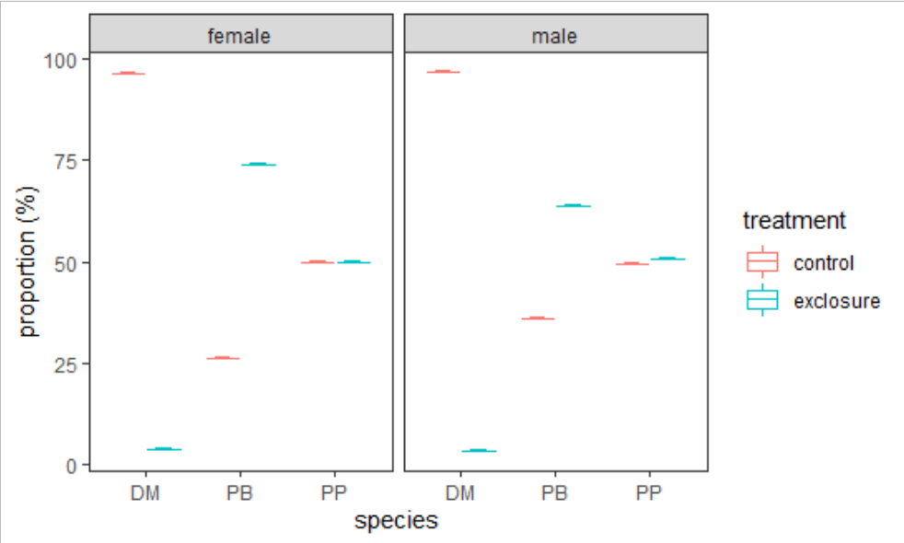

**Fig. 1.** Breeding intensity of male and female Merriam’s kangaroo rat (DO), Bailey’s pocket mouse (PB), and desert pocket mouse (PP) recorded in control and exclosure plots of a study site near Portal, Arizona from 1977 to 2019.

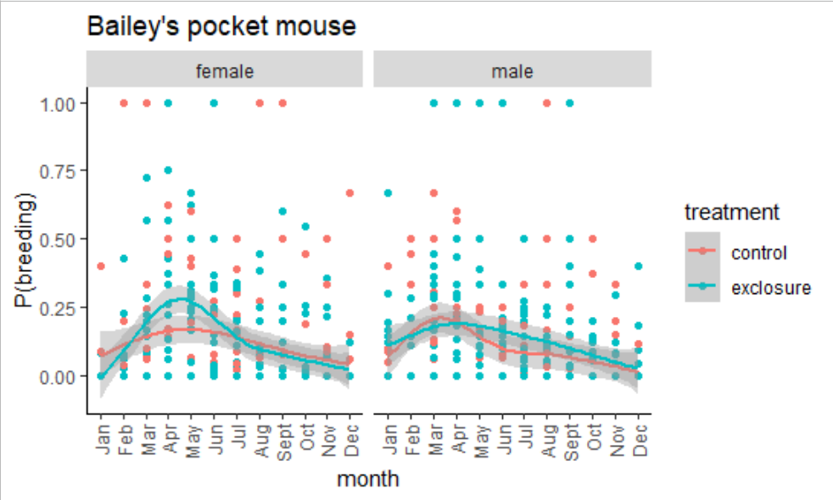

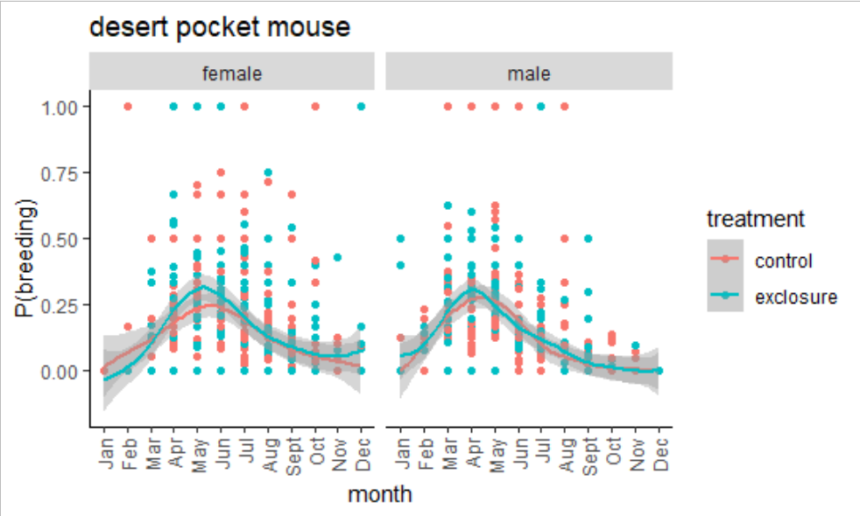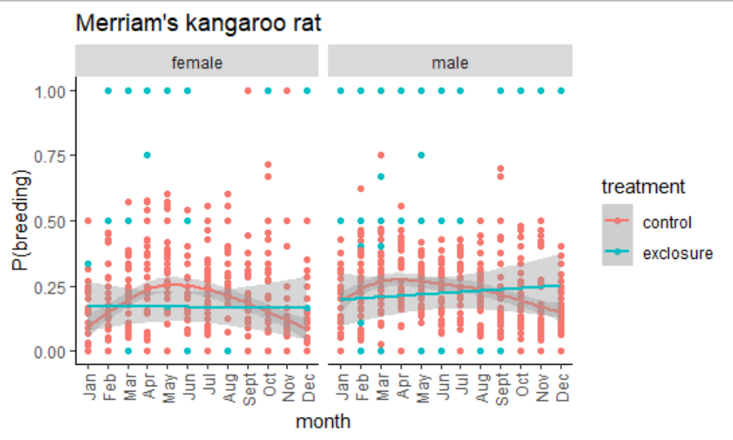

**Fig. 2.** Reproductive phenophase of female (top left panel) and male (top right panel) Bailey’s pocket mouse (*C. baileyi*), male (mid left panel) and female (mid right panel) desert pocket mouse (*C. penicillatus*), and male (bottom left panel) and female (bootm right panel) Merriam’s kangaroo rat (*D. merriami*) in control and exclosure plots from 1977 to 2019. Points indicate raw data. Regression lines fit using a generalized additive model (GAM) for each type of treatment plot. Shading indicates 95% confidence interval on the regression.

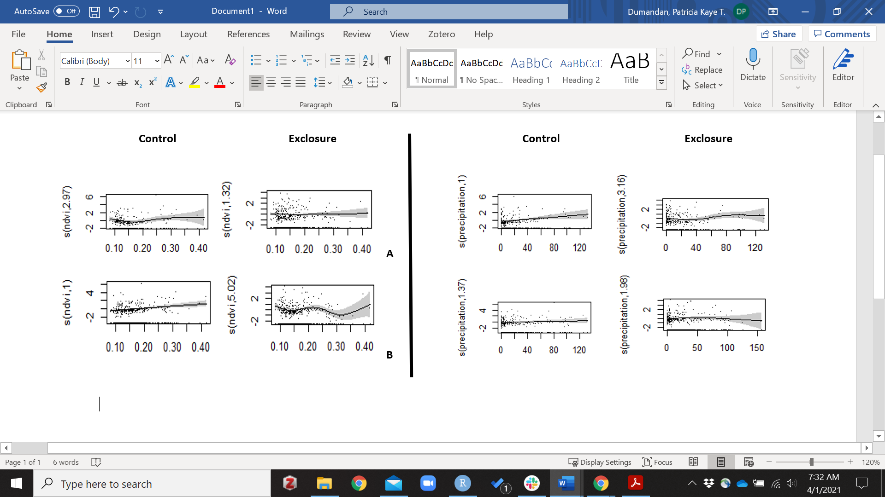

**Fig. 3.** Generalized additive model (GAM) plots showing the partial effects of NDVI (left panel) and precipitation (right panel) on the proportion of breeding male Bailey’s pocket mouse (A) and desert pocket mouse (B) recorded in control and exclosure plots in a long-term project site near Portal, Arizona from 1977 to 2019.

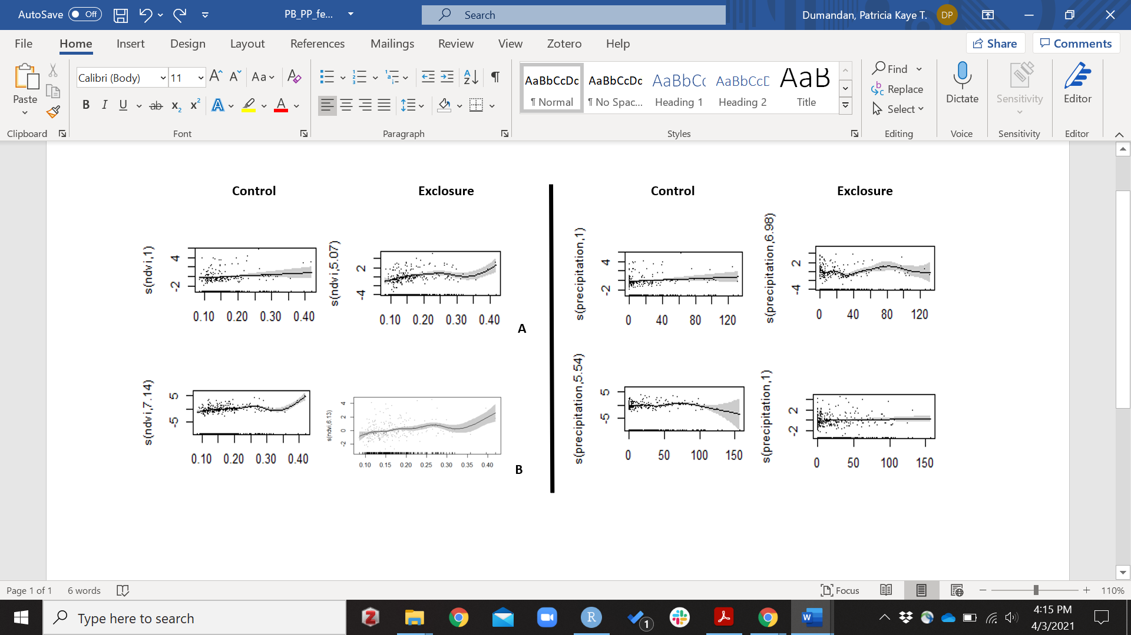

**Fig. 4.** Generalized additive model (GAM) plots showing the partial effects of NDVI (left panel) and precipitation (right panel) on the proportion of breeding female Bailey’s pocket mouse (A) and desert pocket mouse (B) recorded in control and exclosure plots in a long-term project site near Portal, Arizona from 1977 to 2019.

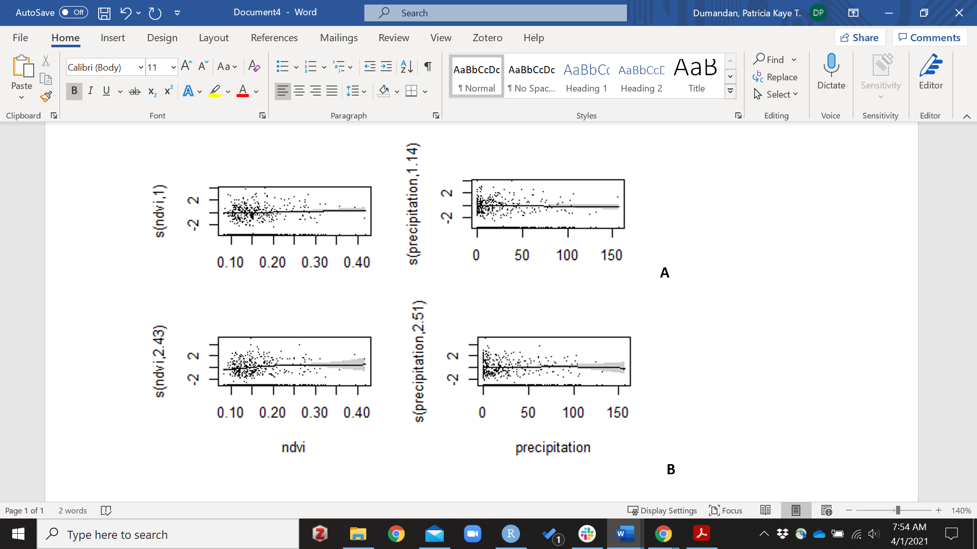

**Fig. 5.** Generalized additive model (GAM) plots showing the partial effects of NDVI (left panel) and precipitation (right panel) on the proportion of breeding male (A) and female (B) Merriam’s kangaroo rat recorded in control plots in a long-term project site near Portal, Arizona from 1977 to 2019.

**Appendix**

**CONTROL EXCLOSURE**

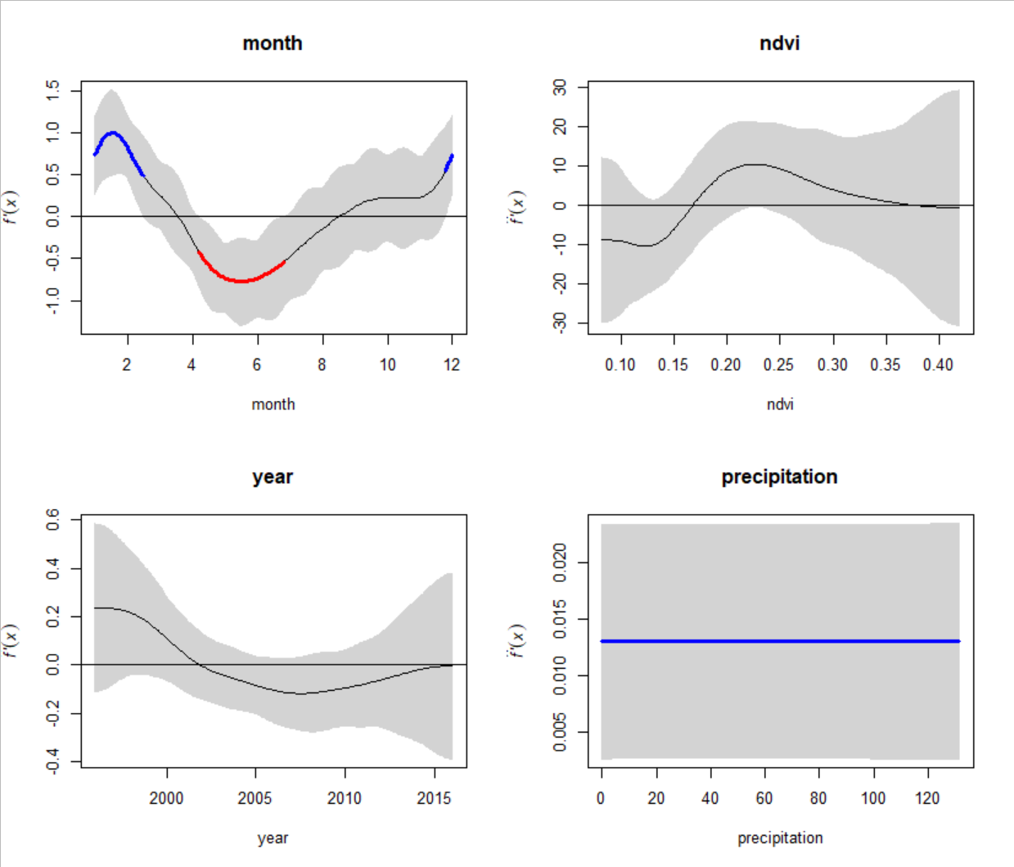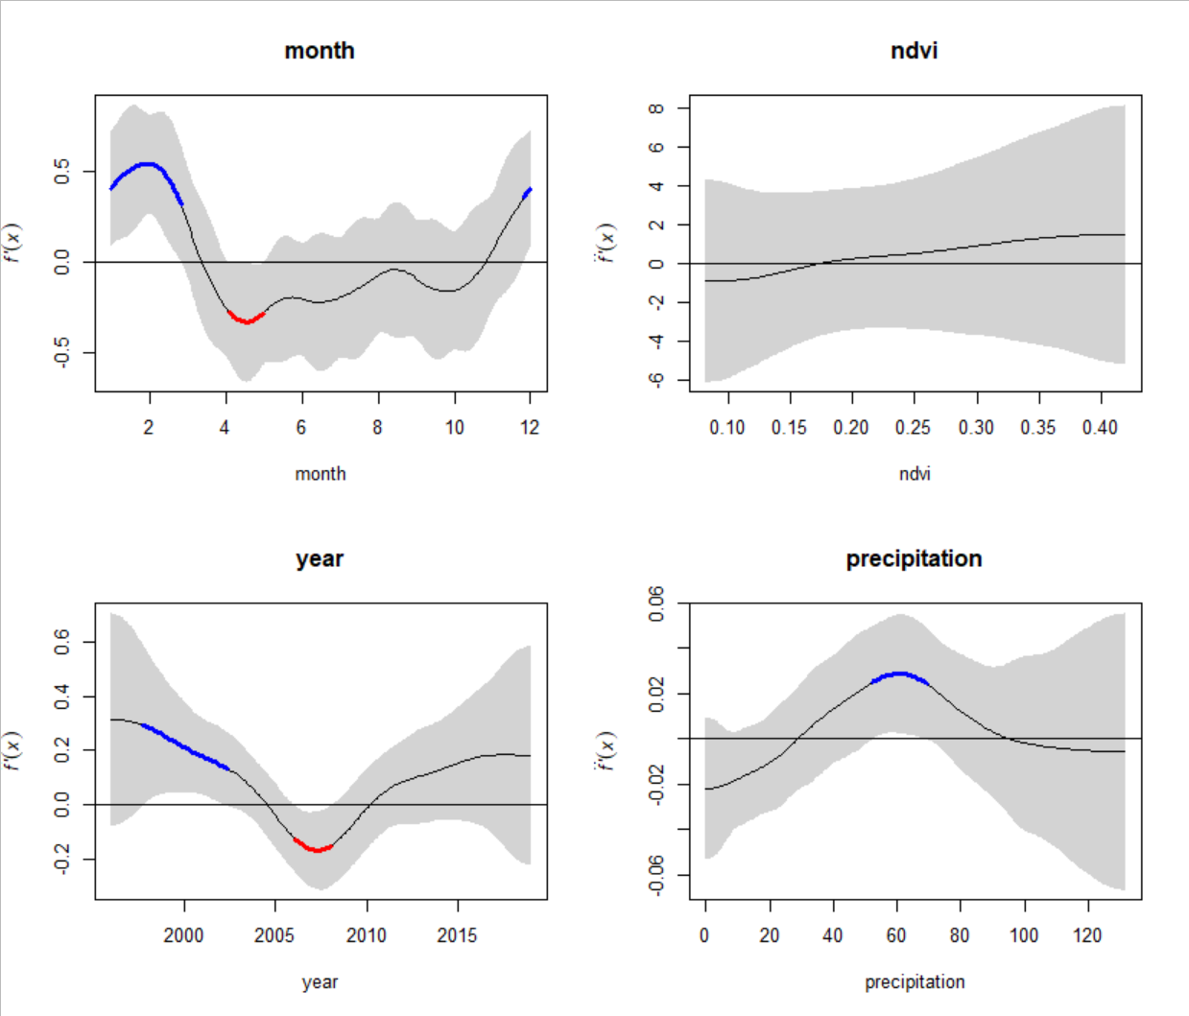 **A**

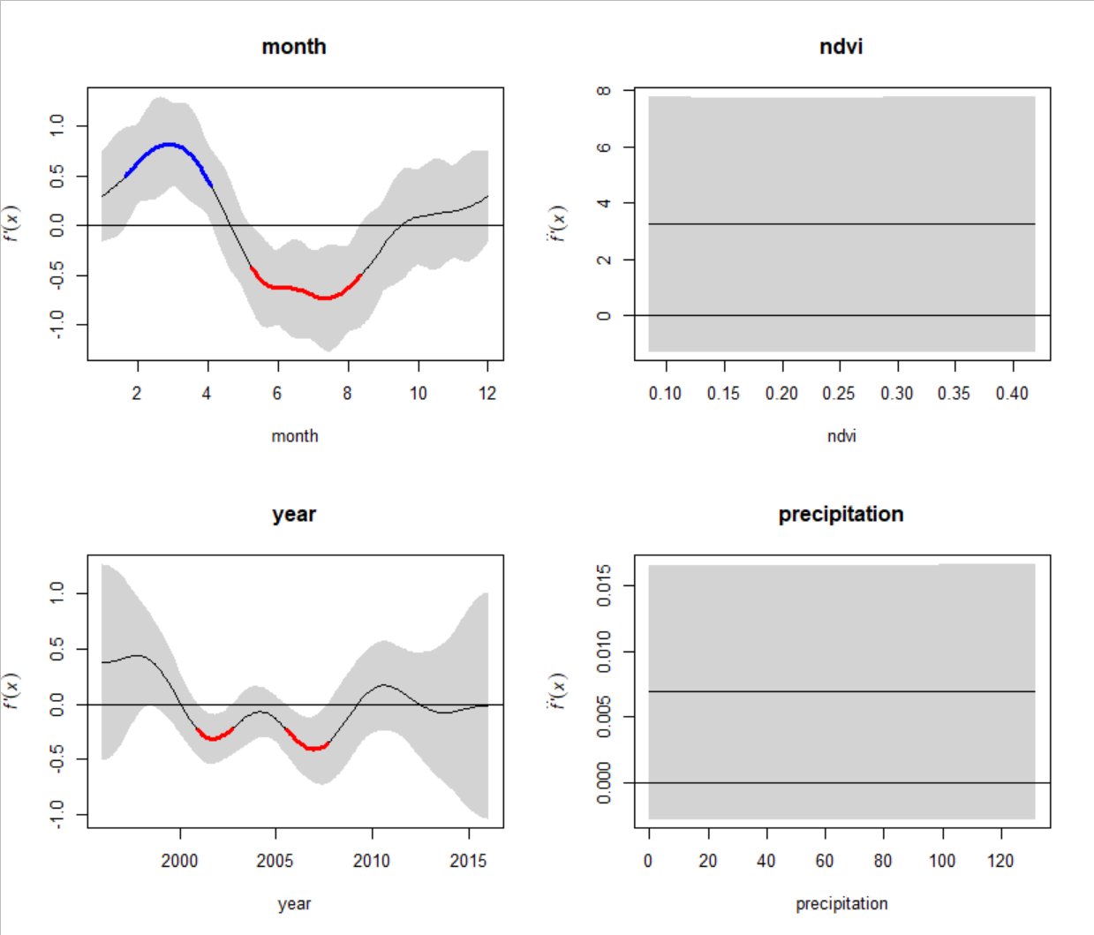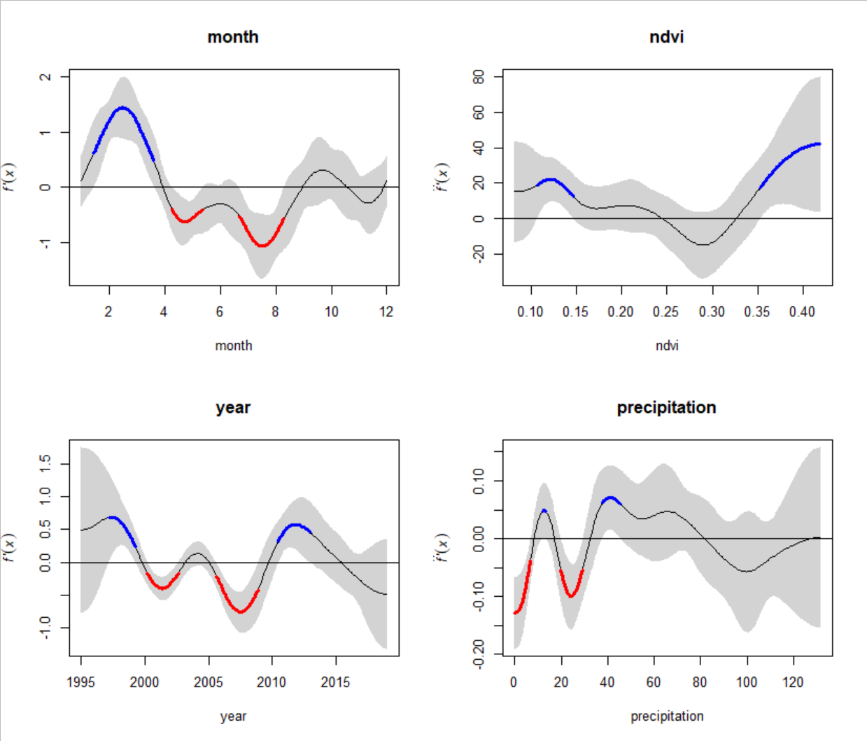 **B**

**Fig. 1**. Seasonal trends in proportion of male (A) and female (B) Bailey’s pocket mouse recorded in control (left panel) and exclosure (right panel) plots of a project study site near Portal, Arizona from 1995 to 2019. Periods of significant increase (blue) or decrease (red) are indicated by the colored sections of the trend line. Dashed vertical line indicates estimated peak period of breeding activity.

**CONTROL EXCLOSURE**

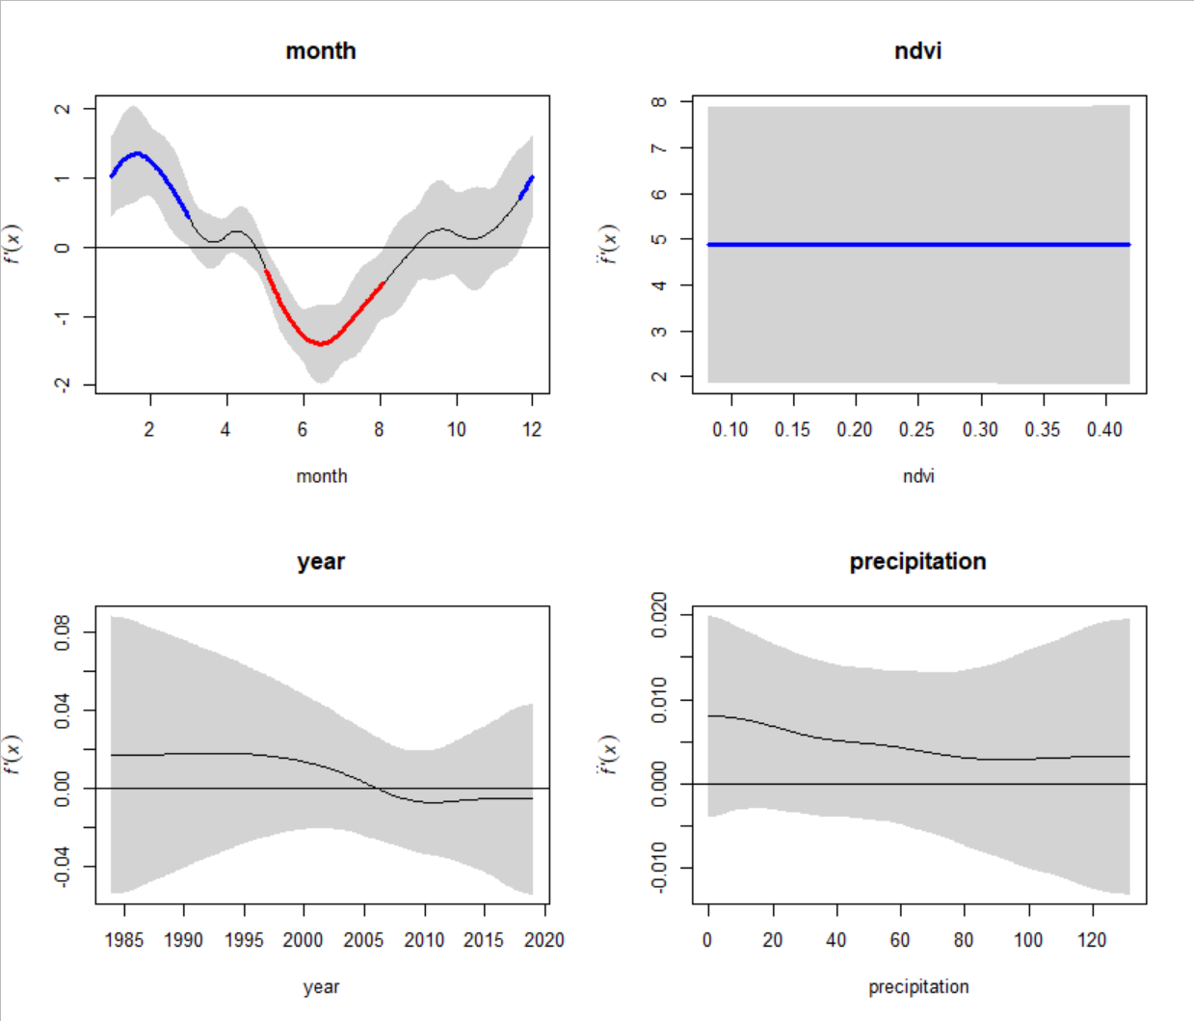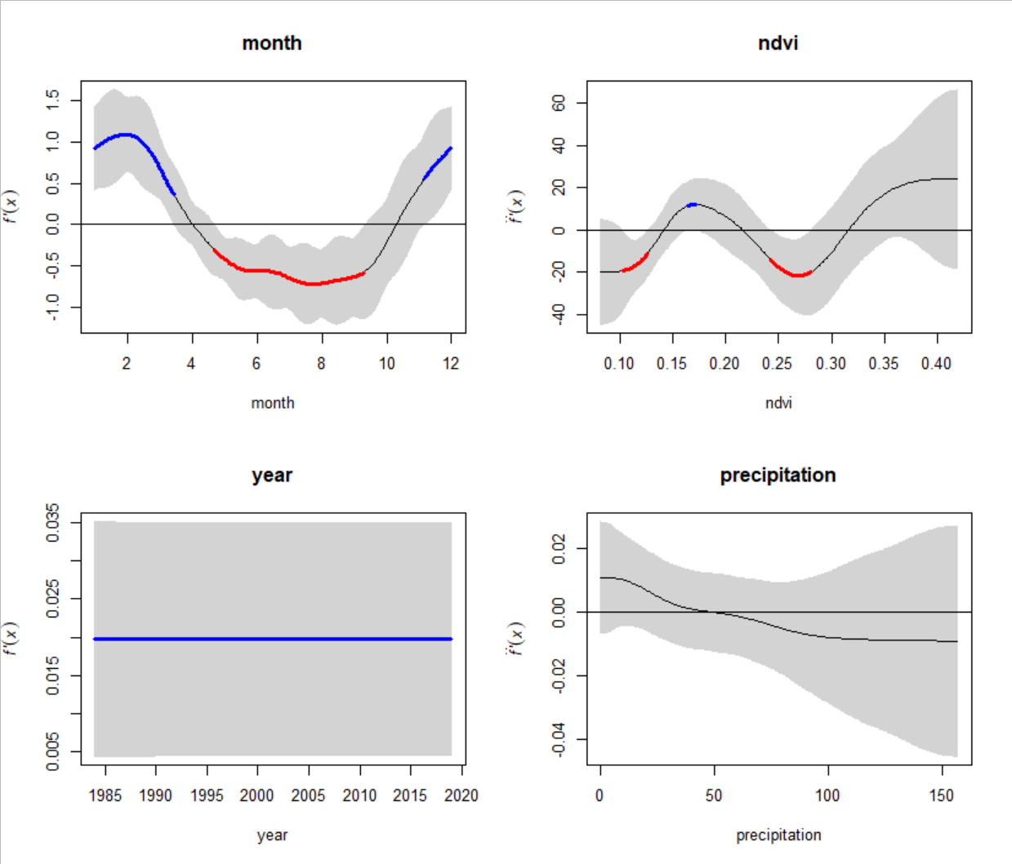 **A**

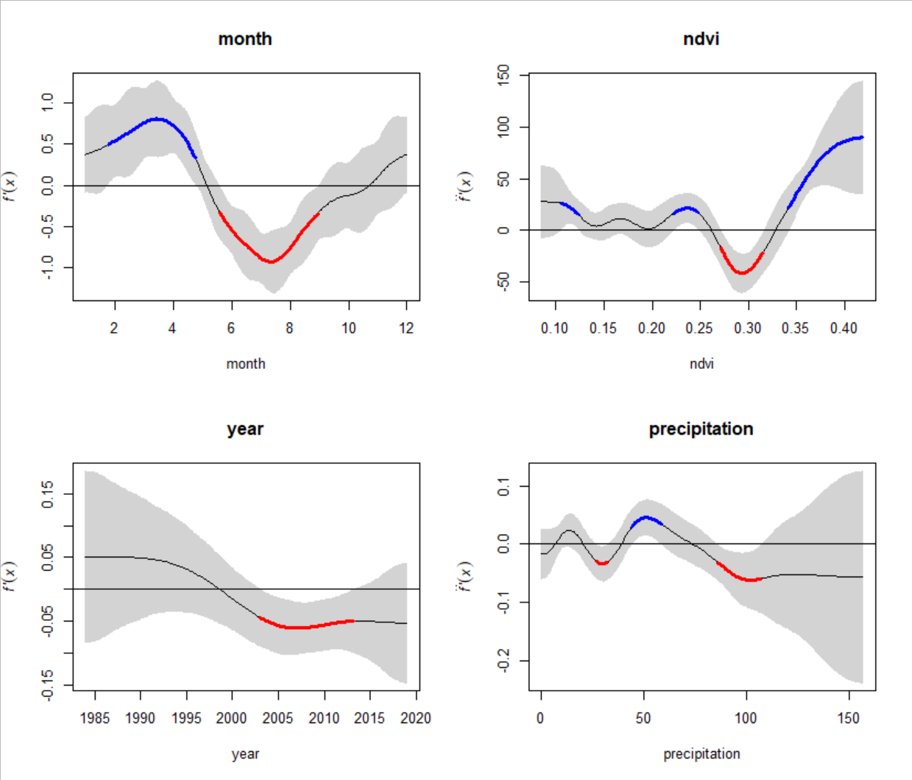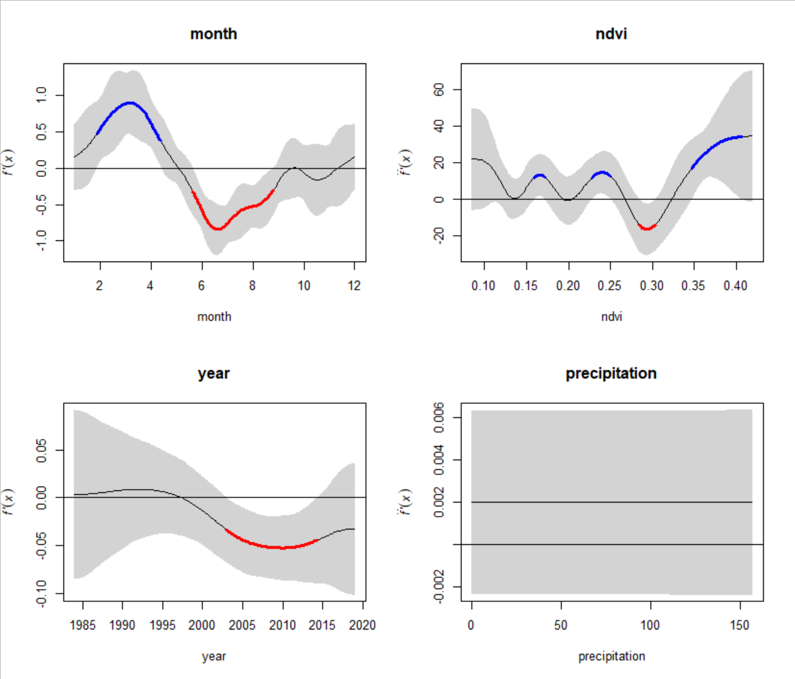 **B**

**Fig. 2.** Seasonal trends in proportion of male (A) and female (B) desert pocket mouse recorded in control (left panel) and exclosure (right panel) plots of a project study site near Portal, Arizona from 1995 to 2019. Periods of significant increase (blue) or decrease (red) are indicated by the colored sections of the trend line. Dashed vertical line indicates estimated peak period of breeding activity.

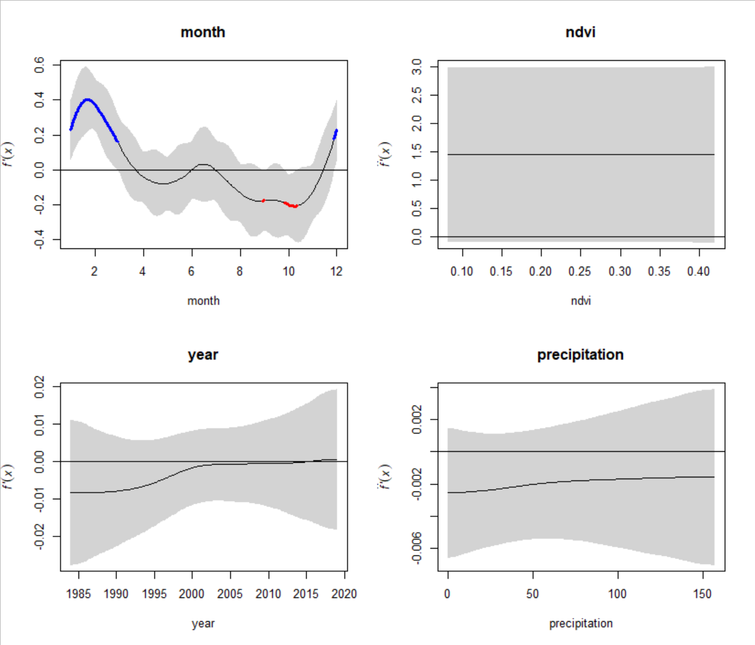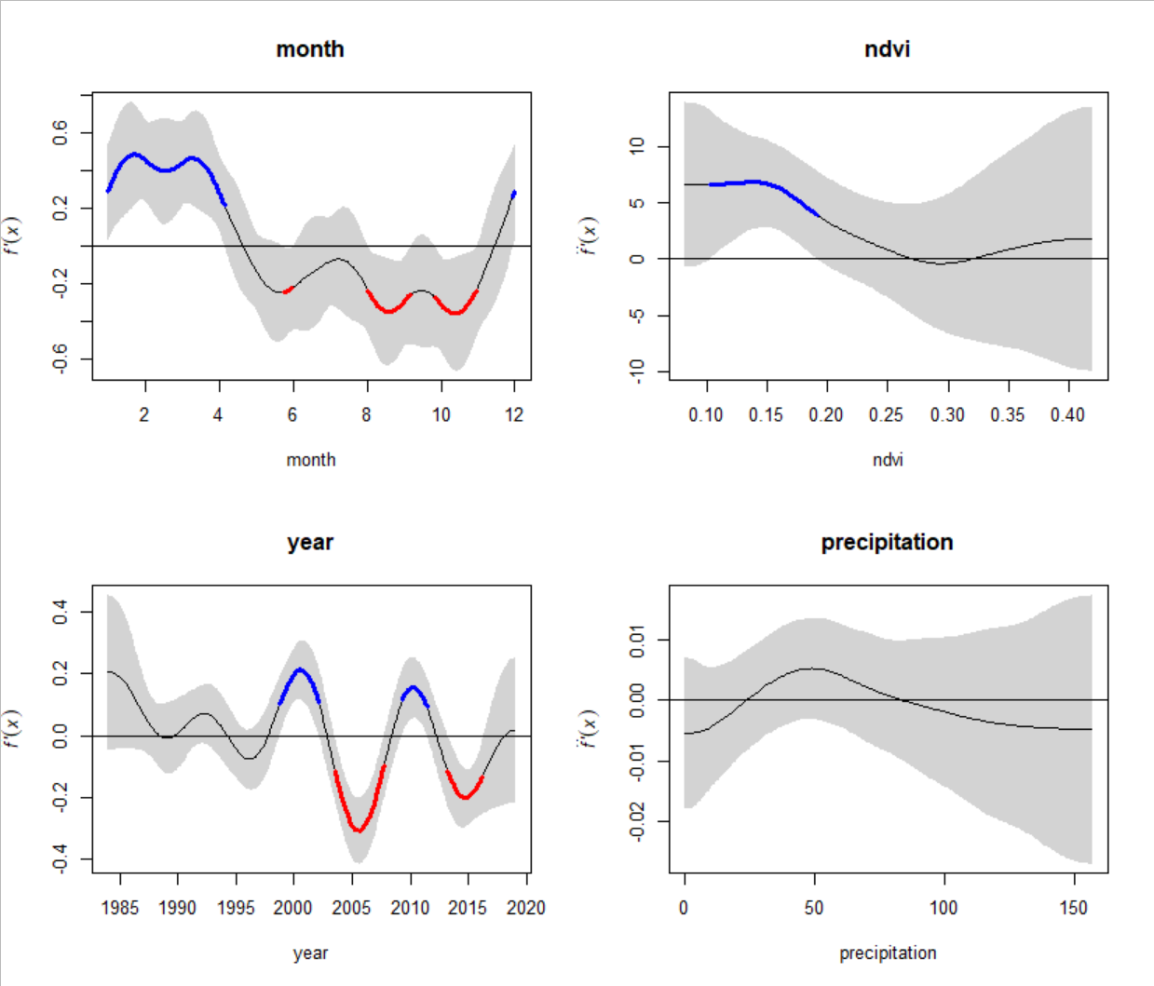

**Fig. 3.** Seasonal trends in proportion of male (left panel) and female (right panel) Merriam’s kangaroo rats recorded in control plots of a project study site near Portal, Arizona from 1995 to 2019. Periods of significant increase (blue) or decrease (red) are indicated by the colored sections of the trend line. Dashed vertical line indicates estimated peak period of breeding activity.